PRE

TMC Clusters

Azure portal - tanzuregistry

01-TBS

The simplicity with which we can build our container images is demonstrated here by manually typing in the commands into the CLI.

But for all practical purposes, a CI/CD pipeline can be used to even automate this process that can be started by a code check-in, be it GitHub, Azure DevOps, basically any code repository because it’s not part of the build process, just the source of code.

Also, DevOps teams no longer need to be burdened with managing and maintaining 1000s of Docker files.

02-TMC

The TMC portal gives instant visibility to all your workloads on a single control plane dashboard with a pretty slick user interface.

04-POLICY

Let’s talk about policy. This is where TMC really shines. This is where I can create a variety of policies that depending on what level below it is assigned, will cascade down to that cluster group (group of clusters) or workspace (group of namespaces).

* Access, RBAC for controlling who can do what in the cluster.
* Image Registry, limiting what container registries are approved.
* Network, ingress and egress rules.
* Security, defines what a pod can do in its environment, such as, escalated permissions to the host node.
* Quota, set limits on resource consumption.

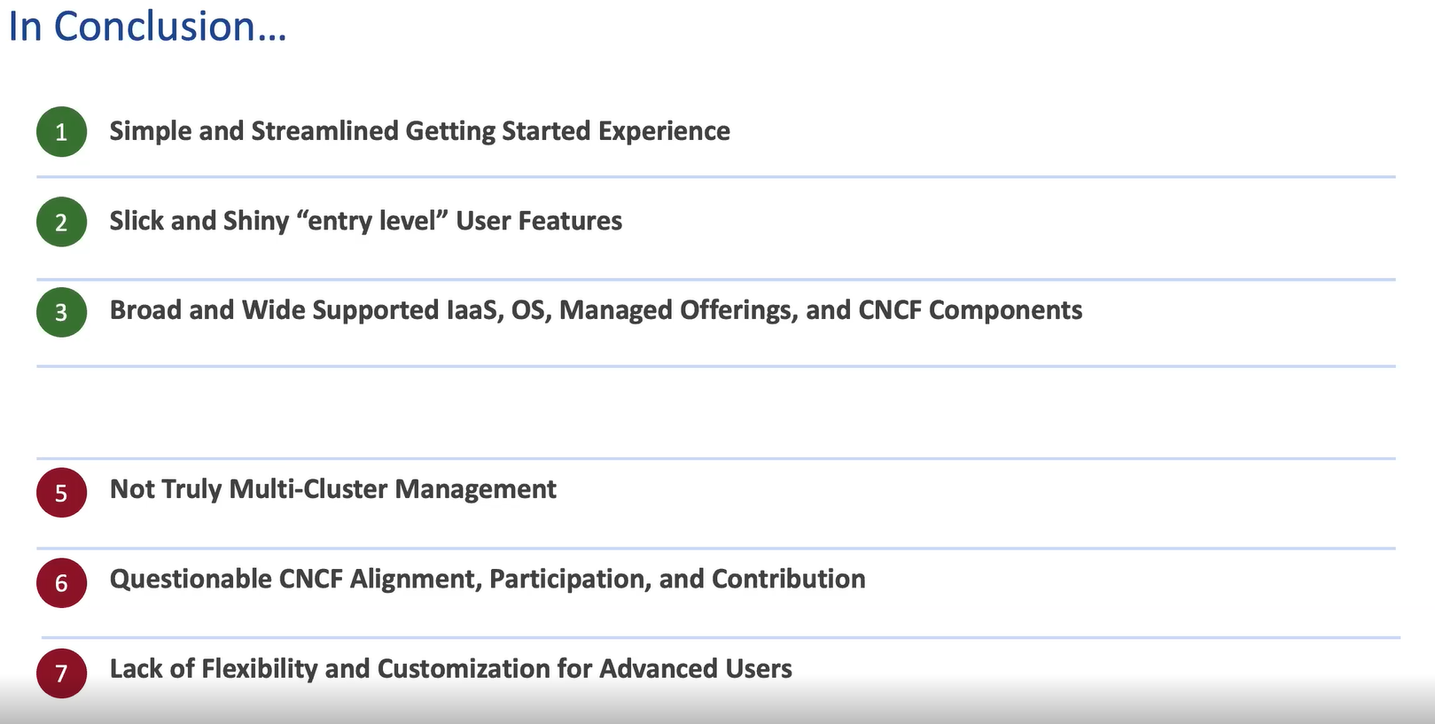

TMC is a SaaS.

Rancher is self-hosted, you manage it.

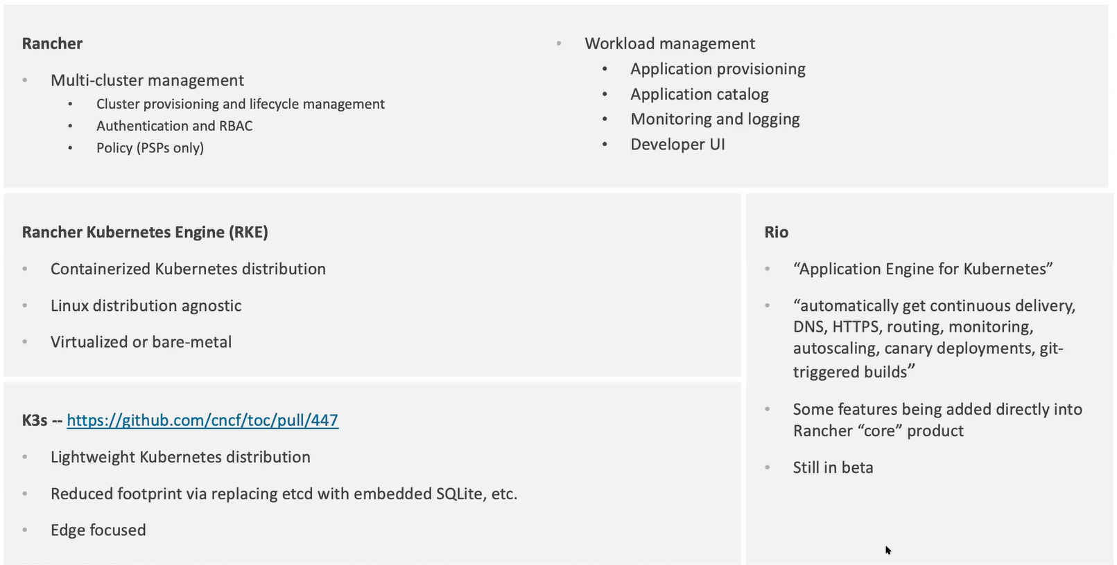

K3s is just a fork?

