# Data Modelling

# Task 1

**A book printer or book shop needs a basic data model to hold their database of Titles, Authors and Publishers. They have given you no further information so it is up to you to come up with a design to hold this data.**

# **Task 2**

**Using your data model build a database to hold the following book information**

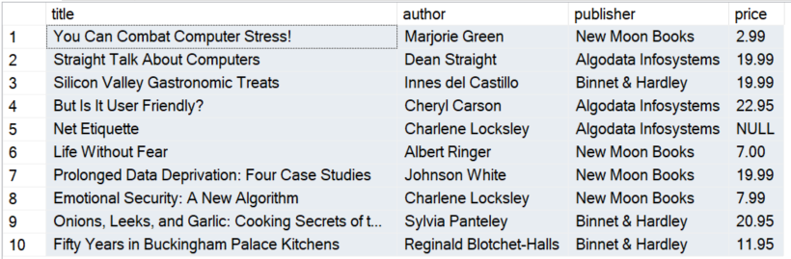

**Insert this data into your database and write the sql to generate this result set so the customer can see you have done what they ask.**

# **Task 3**

**The customer has now come back with some additional books they need to include in this database. Are you able to insert the books listed?**

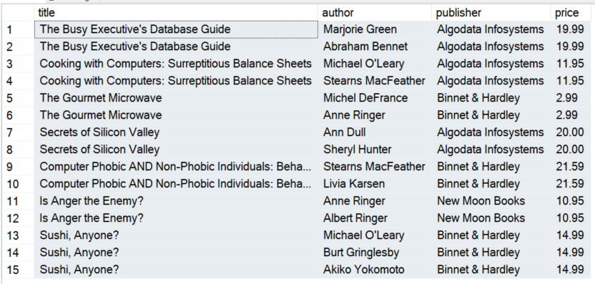

**Another way of looking at these books is as follows**

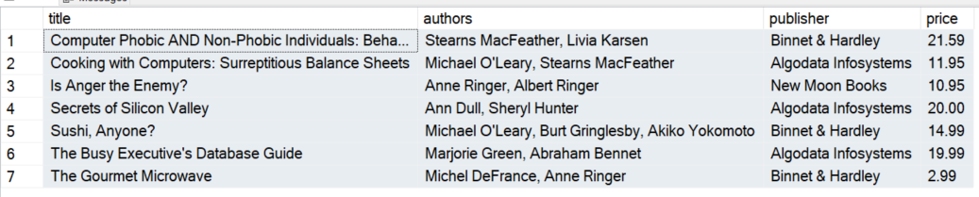

# **Task 4**

**The customer has now come back with some additional information the database needs to hold, . Are you able to modify your database to include this information?**

