Evaluated Team(GX-TY): | G1-T3
Evaluator(s) & your Team (GX-TY): | Teh Kaiwen G1-T1
Functionalities Tested:

Evaluators (Fill in Part A only): Use the heuristics listed below to find usability problems with this interface. (Longer descriptions of the heuristics can be found in the slides.) Each heuristic violation should include a concise description of no more than three lines of text. You should NOT propose solutions. Submission is via eLearn by individual evaluator.

Heuristics:  - Be consistent  - Focus on tasks  - Provide feedback  - Follow established conventions  - Speak the user’s language  - Prevent errors  - Minimize clicks  - Avoid scrolling  - Others | Severity  1 = Cosmetic problem only: need not be fixed unless extra time is available on project  2 = Minor usability problem: fixing this should be given low priority  3 = Major usability problem: imperative to fix this before product can be released

Facilitators/Project Team (Fill in Part B only): After the evaluation period, there will be a debriefing period in which you will merge each evaluator’s list, combining similar violations, and asking evaluators to agree on severity ratings. By one week after the date of this evaluation, your team should compile a single list that merges results from all rounds of evaluation and submit it into your team’s subversion. This list should propose solutions to violations of severity 3. Each proposed solution should be no more than three lines of text.

Example:
Part A – Filled in by Evaluator
Problem: | User need to click many times in order to complete a move
Found by: | yllee, hsong | Severity [1-3]: | 2
Short Description:
[Describes the violation so that the facilitator can understand it (in three lines or less).]

Example:
I have to select to move, click “yes”, then to confirm, I have to click “ok” again. 3 clicks to complete a simple move.

Part B – Filled in by Facilitators/Project Team
Proposed Solution:
[A solution of no more than three lines should be included if the severity of this violation is 3. Project team discusses and fills this in after class.]

Example:
Reduce the number of clicks by streamlining the move ‘process’ to complete it within 1 click.

Part A – Filled in by Evaluator
Problem: | CSS Not loaded
Found by: | Teh Kaiwen | Severity [1-3]: | 1
Short Description:
[Describes the violation so that the facilitator can understand it (in three lines or less).]

GET http://2013-g1t3.rhcloud.com/app3/countdown/assets/countdown/css/styles.css 404 (Not Found)

Part B – Filled in by Facilitators/Project Team
Proposed Solution:
[A solution of no more than three lines should be included if the severity of this violation is 3. Project team discusses and fills this in after class.]

Part A – Filled in by Evaluator
Problem: | Webpage not configured to be 1024x768
Found by: | Teh Kaiwen | Severity [1-3]: | 1
Short Description:

Elements overlap when using a 1024x768 resolution

Part B – Filled in by Facilitators/Project Team
Proposed Solution:
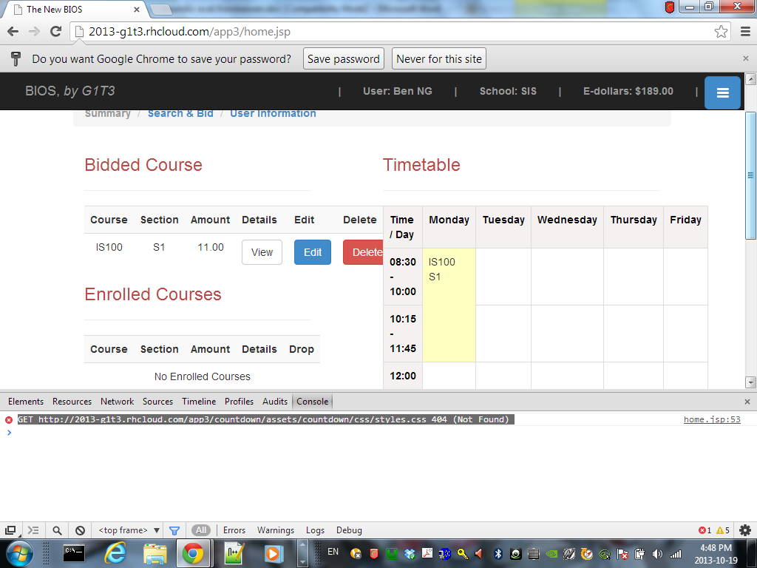

Part A – Filled in by Evaluator
Problem: | Hidden Side Bar
Found by: | Teh Kaiwen | Severity [1-3]: | 1
Short Description:
User needs to go back to previous page again to bid if he keys in an invalid bid

Might want to reconsider hidden side bar. Adds unnecessary complexity to the website

Part B – Filled in by Facilitators/Project Team
Proposed Solution:

