Evaluated Team(GX-TY): | G1T3
Evaluator(s) & your Team (GX-TY): | Kawi – G1T2
Functionalities Tested: | Add Bid, View Bids and Course

Evaluators (Fill in Part A only): Use the heuristics listed below to find usability problems with this interface. (Longer descriptions of the heuristics can be found in the slides.) Each heuristic violation should include a concise description of no more than three lines of text. You should NOT propose solutions. Submission is via eLearn by individual evaluator.

Heuristics:  - Be consistent  - Focus on tasks  - Provide feedback  - Follow established conventions  - Speak the user’s language  - Prevent errors  - Minimize clicks  - Avoid scrolling  - Others | Severity  1 = Cosmetic problem only: need not be fixed unless extra time is available on project  2 = Minor usability problem: fixing this should be given low priority  3 = Major usability problem: imperative to fix this before product can be released

Facilitators/Project Team (Fill in Part B only): After the evaluation period, there will be a debriefing period in which you will merge each evaluator’s list, combining similar violations, and asking evaluators to agree on severity ratings. By one week after the date of this evaluation, your team should compile a single list that merges results from all rounds of evaluation and submit it into your team’s subversion. This list should propose solutions to violations of severity 3. Each proposed solution should be no more than three lines of text.

Example:
Part A – Filled in by Evaluator
Problem: | All the 3 links on the navigation bar leads to the same page
Found by: | Kawi | Severity [1-3]: | 2
Short Description:
Username, School, and eDollar on the navigation bar all goes to the same page. Redundant click.

Part B – Filled in by Facilitators/Project Team
Proposed Solution:
[A solution of no more than three lines should be included if the severity of this violation is 3. Project team discusses and fills this in after class.]

Example:
Reduce the number of clicks by streamlining the move ‘process’ to complete it within 1 click.

Part A – Filled in by Evaluator
Problem: | Redundant Navigation
Found by: | Kawi | Severity [1-3]: | 2
Short Description:
There is another navigation bar below the black navigation bar. Why not put everything on the black navigation Bar?

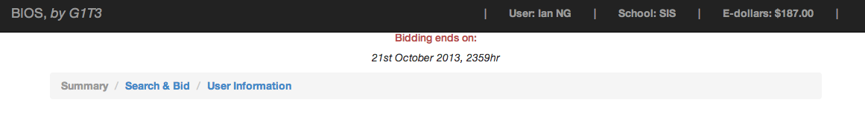.

Part B – Filled in by Facilitators/Project Team
Proposed Solution:
[A solution of no more than three lines should be included if the severity of this violation is 3. Project team discusses and fills this in after class.]

Part A – Filled in by Evaluator
Problem: | Adding bid is not so user friendly
Found by: | Kawi | Severity [1-3]: | 2
Short Description:
Why suddenly something pop-out from the right instead of leading me to a new landing page? Because user is not expecting that.

Part B – Filled in by Facilitators/Project Team
Proposed Solution:

