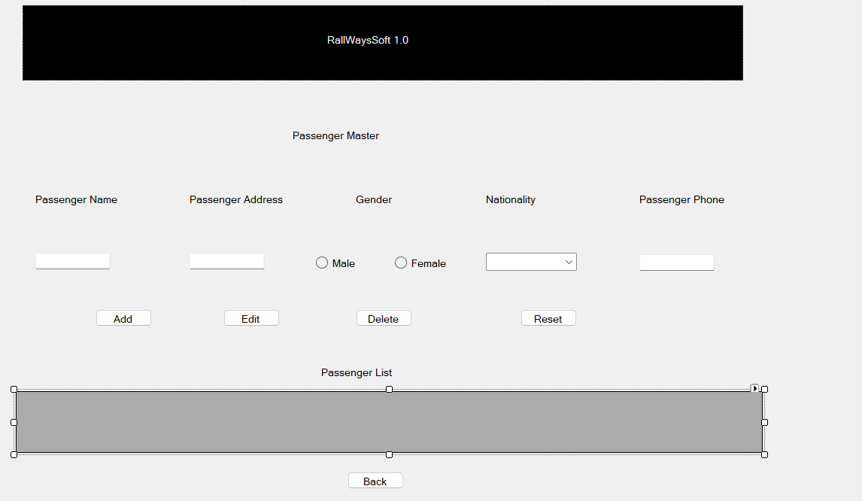

using System;
using System.Collections.Generic;
using System.ComponentModel;
using System.Data;
using System.Drawing;
using System.Linq;
using System.Text;
using System.Threading.Tasks;
using System.Windows.Forms;
using System.Data.SqlClient;

namespace WindowsFormsApplication1
{
public partial class Form1 : Form
{
SqlConnection con = new SqlConnection(@"Data Source=(LocalDB)\v11.0;AttachDbFilename=C:\Users\Lenovo\Desktop\3cs-5\student.mdf;Integrated Security=True;Connect Timeout=30");

public Form1()
{
InitializeComponent();
}

private void button1_Click(object sender, EventArgs e)
{
string pname = textBox1.Text;
string paddress = textBox2.Text;
string pphone= textBox3.Text;
string pnationality = comboBox1.Text;

string gender;
if (radioButton1.Checked == true)
{
gender = "male";
}
else
{
gender = "female";
}
string Class = comboBox1.SelectedItem.ToString();
con.Open();
MessageBox.Show("Connection Opened");
string qry = @"insert into pinfo(Name,Addres,Phone,Nationality,Gender)values(@p1,@p2,@p3,@p4,@p5)";
SqlCommand cmd = new SqlCommand(qry, con);
cmd.Parameters.AddWithValue("@p1", pname);
cmd.Parameters.AddWithValue("@p2", paddress);
cmd.Parameters.AddWithValue("@p3", pphone);
cmd.Parameters.AddWithValue("@p4", pnationality);
cmd.Parameters.AddWithValue("@p9", gender);
cmd.ExecuteNonQuery();
MessageBox.Show("Data Inserted!");
con.Close();
}

private void button2_Click(object sender, EventArgs e)
{
int id = Convert.ToInt32(comboBox1.SelectedItem.ToString());
string pname = textBox1.Text;
string paddress = textBox2.Text;
string pphone = textBox3.Text;

string pnationality = comboBox1.SelectedItem.ToString();

con.Open();
string qry = @"update Stu set Attno=@p1,Phno=@p2,Class=@p3,Address=@p4 where ID=@p5";
SqlCommand cmd = new SqlCommand(qry, con);
cmd.Parameters.AddWithValue("@p1", pname);
cmd.Parameters.AddWithValue("@p2", paddress);
cmd.Parameters.AddWithValue("@p3", pphone);
cmd.Parameters.AddWithValue("@p4", pnationality);

cmd.ExecuteNonQuery();
MessageBox.Show("Data updated");
con.Close();
}

private void button3_Click(object sender, EventArgs e)
{
con.Open();
int id = Convert.ToInt32(comboBox1.SelectedItem.ToString());
string qry = @"delete from pinfo where Id=@p1";
SqlCommand cmd = new SqlCommand(qry, con);
cmd.Parameters.AddWithValue("@p1", id);
cmd.ExecuteNonQuery();
MessageBox.Show("Data Deleted");
con.Close();
}

private void Form1_Load(object sender, EventArgs e)
{
con.Open();
string qry = @"select* from pinfo";
SqlCommand cmd = new SqlCommand(qry, con);
SqlDataReader rdr = cmd.ExecuteReader();
DataTable table = new DataTable();
table.Load(rdr);
dataGridView1.DataSource = table;
con.Close();
}
}
}

