**Program 01: The program takes two strings from the user: first_name, last_name. Pass these variables to the full name function that should return the (full name).**

**GITHUB LINK: https://github.com/nyeldi/NNDL**

**NIKITHA YELDI**

**700758003**

**Summer 2024: CS5720**

**NEURAL NETWORK AND DEEP LEARNING ICP 02**

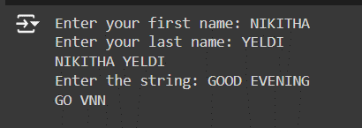

**Program 02. The program to find the word count in a file (input.txt) for each line and then print the output.**

Explanation:

1. The user strings are taken, stored in the “first_name”, “last_name” variables, sent to the function “full_name” and concatenated into a single string using the ‘+’ operator.

2. The user string is taken, stored in the “original_string” variable, sent to the function “string_alternative”.

3. Then alternate characters are returned from the function using the slicing operator with a step of 2.

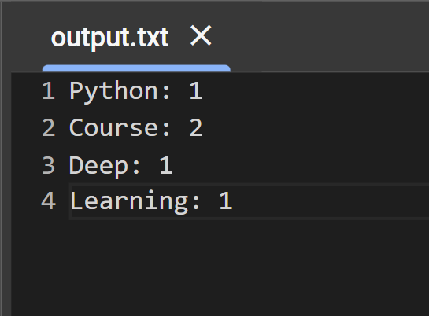

***\*\*\*Thank You\*\*\****

**Program 03: Python program which reads heights (inches.) of customers into a list and convert these heights to centimeters in using:**

1. **Nested Interactive loop.**
2. **List comprehensions.**

Explanation:

1. input.txt file is uploaded into the jupyter Notebook and is accessed with open() method in read only access mode.

2. Contents in the file are accessed and stored in a list called “contents”.

3. The words in the list count are maintained in a dictionary and are used for writing the output into a file.

4. The open() is used to create a file called “output.txt” and contents in the dictionary are copied to the file and are downloaded to the local.

Explanation:

1. The program takes a series of heights in inches as input from the user.

2. First, the heights are converted into inches using a loop. Second, heights are converted into centimeters using list comprehension.

3. The resultant lists are printed on the console.

