**NIKITHA YELDI**

**700758003**

**Summer 2024: CS5720**

**NEURAL NETWORK AND DEEP LEARNING ICP 04**

**GITHUB LINK: https://github.com/nyeldi/NNDL**

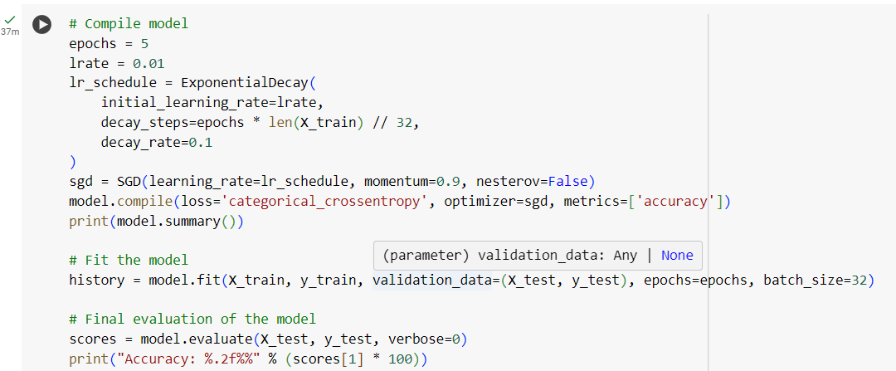

***Thank You***

