**NIKITHA YELDI**

**700758003**

**Summer 2024: CS 5710 –Machine Learning**

ent-2**

a. Using NumPy create random vector of size 15 having only Integers in the range 1-20.

1. Reshape the array to 3 by 5

2. Print array shape.

3. Replace the max in each row by 0

Create a 2-dimensional array of size 4 x 3 (composed of 4-byte integer elements), also print the shape, type and data type of the array.

GITHUB LINK:

**https://github.com/nyeldi/machinelearning**

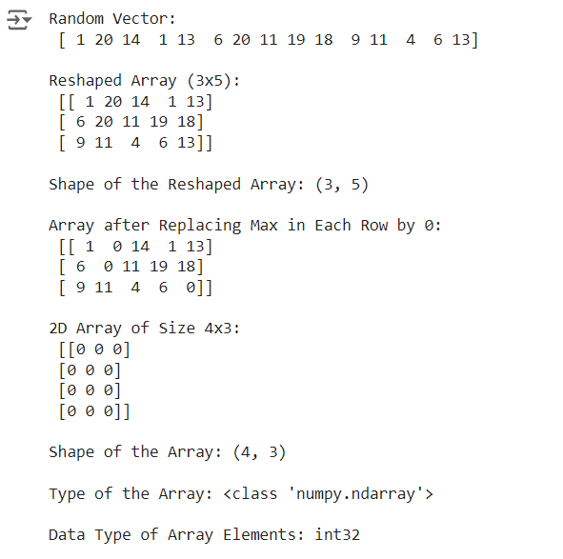

b. Write a program to compute the eigenvalues and right eigenvectors of a given square array given below:

[[ 3 -2]

[1 0]]

d. Write a NumPy program to create a new shape to an array without changing its data.

Reshape 3x2:

[[1 2]

[3 4]

[5 6]

Reshape 2x3:

[[1 2 3]

[4 5 6]]

c. Compute the sum of the diagonal element of a given array.

[[0 1 2]

[3 4 5]]

**\*\*\*THANK YOU\*\*\***