# **Medical Health Record Sharing System ®**

PROVIDED BY

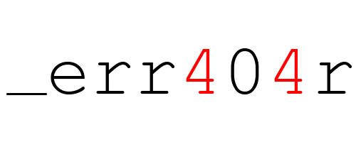

# INTRODUCTION TO THIS PRODUCT

Our team developed a module/feature for Open EMR medical system, that will save time and effort in sharing patient information between medical offices. This feature will be user-friendly, intuitive and simple to use.

There are 3 main components of this feature:

* Extracting the patient’s record from the openEMR database
* Sharing the exported patient record through email
* Decoding existing encoded patient record

These will be discussed in detail in the following sections.

# 1. 1 EXPORTING THE PATIENT’S RECORD FROM THE OPENEMR DATABASE

Exporting the patient’s record from the database follows the below stated procedure in sequential way:

* Establishing connection to the openEMR database with the predefined credentials which will have certain access privileges.
* Querying the database for a specific record.
* Converting the returned results from the query to a special XML format for medical records, CCD (Continuity of Care Document) which is a standard format for electronic health record.
* Protecting the converted CCD file by 128bit AES encryption before sending.

# 1.2 SHARING THE EXPORTED PATIENT’S RECORD

The sharing the record is through email API (JavaMail) which is *implemented* and *pre-configured* in the feature to send email with the health record as an attachment.

Sending the CCD file can be seen as a procedure that follows the following pattern:

* Attaching the CCD file which is located on a temporary directory on the sending workstation will be done in the background.
* Getting the email address from the html form on the feature’s page and setting it as the target email.
* Sending the email with the attachment through the preconfigured SMTP protocol.

# 1.3 DECODING EXISTING ENCODED PATIENT RECORD

The decoding will be done in a way that gets the filename which is the timestamp and the last 4 digits of the patients Social Security Number as a key and decrypts the file using 128bit AES decryption.