**Clustering: Using K – Means to Cluster fire image “Door to Hell” in Turkmenistan.**

**Introduction**

In this project, I am going to show, method of image clustering as well as basic K-Means clustering collection of exact data.

I will be checking the burning areas in the crater, which located in Turkmenistan.

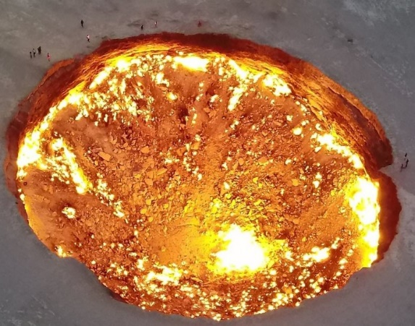

*https://video.nationalgeographic.com/video/travel-source/00000163-03ae-d820-a1e3-73efd2b70000*

Aim of the project, to make from which part of crater natural gas comes out more.

**Data preparation**

*install.packages("jpeg")*

*install.packages("factoextra")*

*install.packages("gridExtra")*

*install.packages("ggplot2")*

*install.packages("rgdal")*

*library(jpeg)*

*library(ggplot2)*

*library(cluster)*

*library(dplyr)*

*library(raster)*

*library(rgdal)*

*setwd("D:\\R and R Studio\\Clustering.project\\image")*

*if(!"raster" %in% rownames(installed.packages())){install.packages("raster")}*

**Loading data**

*image <- stack("fire.jpg")*

Now, I will make some experemental segmantation. Just to see fire in diffrent vision.

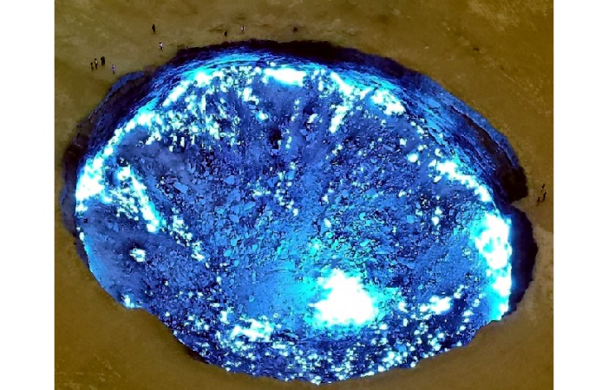

*rgb = brick(b,g,r)*

*plot(rgb)*

*plotRGB(rgb, r = 3, g = 2, b = 1, stretch = "lin")*

As you can see, fire in the crater is much visaible and clear than orginal photo.

**Import bands individually**

Now, once again, we will be having experemental import of the craters image in the bands.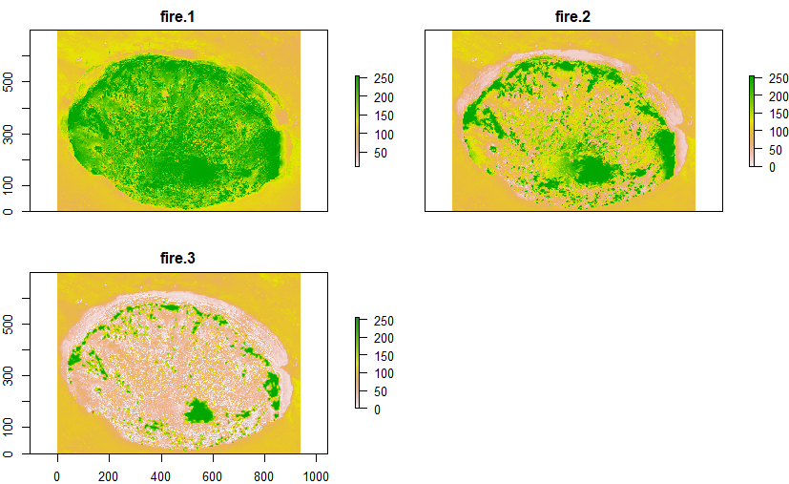

*r = raster("fire.jpg", band = 3)*

*g = raster("fire.jpg", band = 2)*

*b = raster("fire.jpg", band = 1)*

*rgb = brick()*

*plot(b,g,r)*

*After such experiment, we can select one of the band, according to its clearness. İ chose:*

*g = raster("fire.jpg", band = 2)*

*plot(g)*

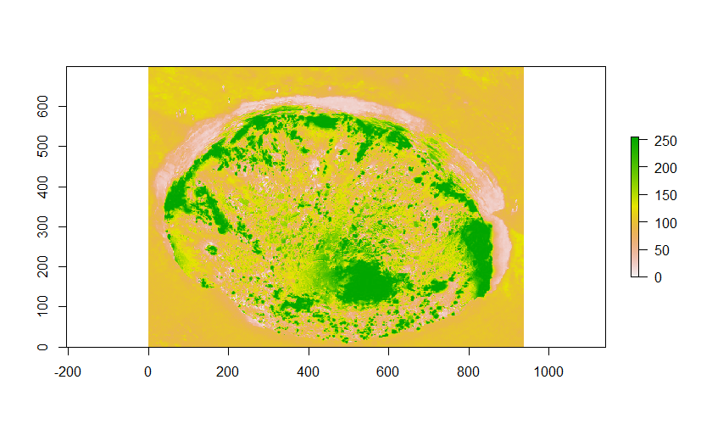

**Compute and export NDVI**

**What is the NDVI? =** The normalized difference vegetation index.

It is a simple graphical indicator, used for, to analyze remote sensing measurements.

Just before we go kmeans clustering, I would like to experment once agian, I would like to NDVI, this to create a single value roughly reflecting the photosynthetic activity occurring at a pixel.

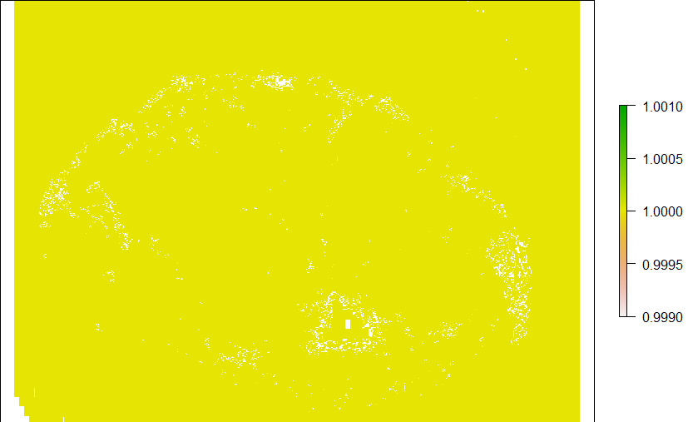

*ndvi = (mbr$fire.1 - mbr$fire.2)/(mbr$fire.1 - mbr$fire.2)*

*plot(ndvi)*

**K-means clustering**

**What is the K-means clustering?**

It is algorhimic function used for to define data which is unlabed, even in many categories.

At this clustering, I will be making 3 type of the k-means clustering.

**First:**

*kMeansResult <- kmeans(image[], centers=2)*

*result <- raster(image[[1]])*

*result <- setValues(result, kMeansResult$cluster)*

*plot(result)*

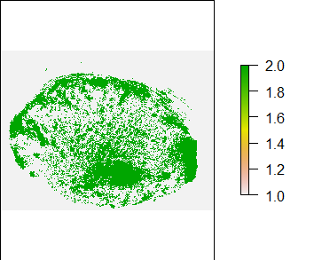

***Second:***

*kMeansResult <- kmeans(image[], centers=2)*

*result <- raster(image[[1]])*

*result <- setValues(result, kMeansResult$cluster)*

*plot(result)*

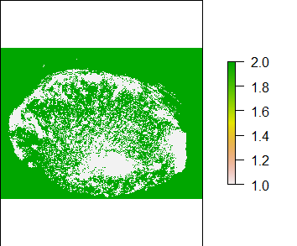

***Third:***

*kMeansResult <- kmeans(image[], centers=3)*

*result <- raster(image[[1]])*

*result <- setValues(result, kMeansResult$cluster)*

*plot(result)*

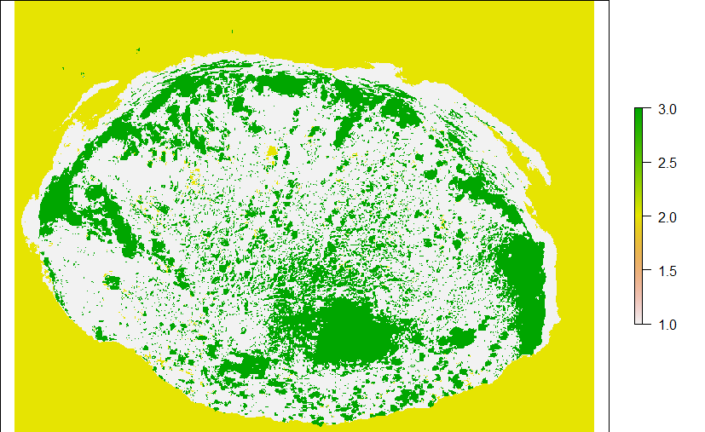

To make some clearness where are gas comes out I used. following function, meantime it has the same value with third kmeans results is for having more colorful result.

*plot(result, col=c("black", "orange","red"))*

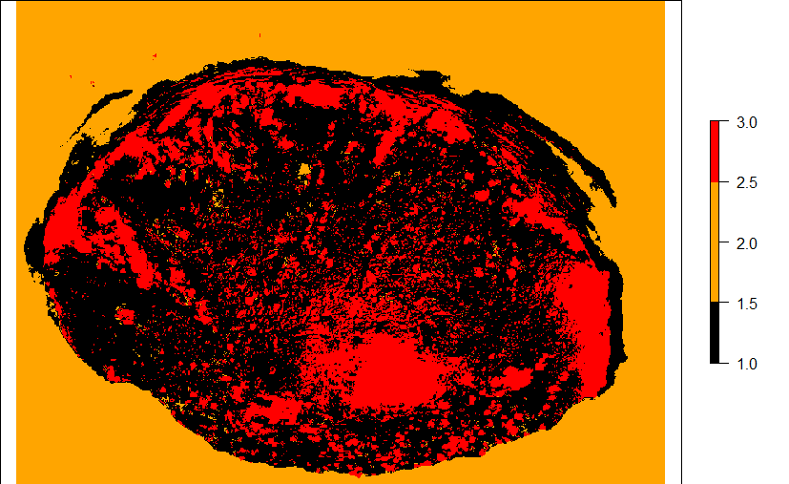

*>length(kMeansResult$cluster[kMeansResult$cluster==3])/length(kMeansResult$cluster)*100*

*[1] 18.86048*

According to the research, gas escapes from about 18.8% of the crater area.

**Conclusion**

To sum up, I would like to say that, k-means clustering is very useful method to get some exact data and very useful for calculating specific subjects on that data.

But...

If you had paid attention on the image export NDVI (even more specification) and importing image as band also gives similar effect.

**Reference**

Project was inspired by following reference:

[*https://rpubs.com/ozgur/usl-01-kmeans*](https://rpubs.com/ozgur/usl-01-kmeans)