Create automate_setup.sh bash script file to install a Linux machine   
step to run these script files:

* Open a terminal and navigate to the directory where the automate_setup.sh script is located.
* Run the following command to grant execution permission to the script:

**chmod +x automate_setup.sh**

* Execute the bash script by running the following command:

**./automate_setup.sh**

when we run this script file it will install the docker in our Linux machine and it will also clone the Github repo (https://github.com/silarhi/php-hello-world) and create docker file for building docker image for above Github repo Application, then it will push that docker image to docker hub.

Create a docker compose file that contain yml configuration to run Jenkins locally  
Steps:

docker-compose up  
http://localhost:8080  
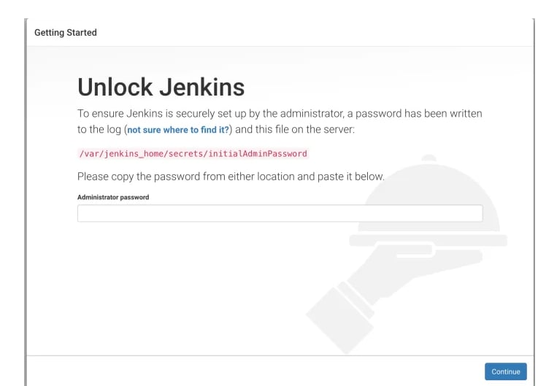

we have to put initial password provided by Jenkins. Jenkins prints the initial password to standard output too. So, you can retrieve it from the Docker log.

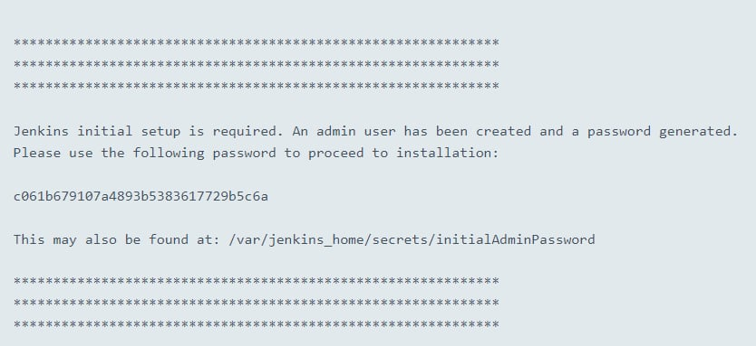

When Jenkins finishes, it will prompt you for a new admin user and password. Enter a user name and password and click Save and Continue.

Install Necessary Plugins Log in to the Jenkins web interface. Navigate to "Manage Jenkins" > "Manage Plugins" > "Available". Search for and select the necessary plugins for your CI/CD pipeline, such as: Git Plugin Docker Pipeline Plugin Pipeline Plugin GitHub Plugin Any other plugins required for your specific setup. Install the selected plugins and restart Jenkins if prompted.

**Configure Jenkins Freestyle Project**

Create a new Jenkins Freestyle project: Click on "New Item" on the Jenkins dashboard. Enter a name for your project and select "Freestyle project". Click "OK" to create the project. Configure the project settings: In the project configuration, navigate to the "Source Code Management" section. Select "Git" and provide the URL of your GitHub repository. Optionally, configure credentials if your repository requires authentication. In the "Build" section, add build steps to execute the Docker command  
  
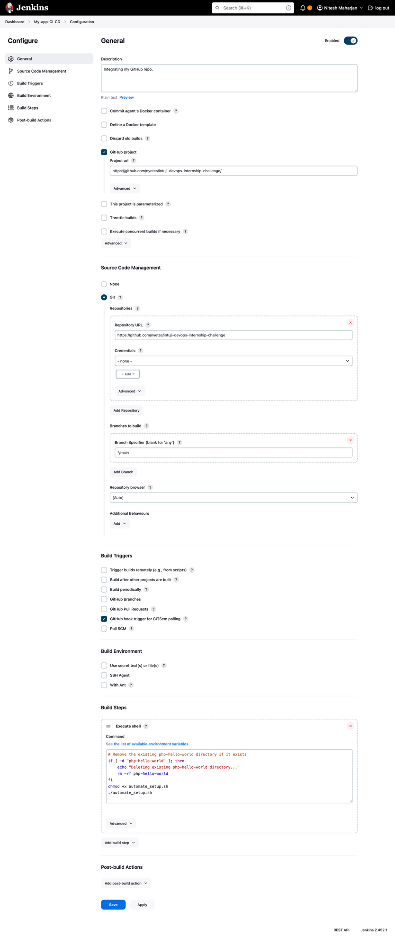  
  
  
  
For trigger we have to configure Github repo and add webhook.  
for payload URL we have install ngrok because our Jinkins URL is localhost, once we install and run ngrok it will forward

https://8f96-2400-1a00-b080-c83c-459e-562a-c3f6-aa5d.ngrok-free.app -> http://localhost:8080