

In partial fulfillment of requirements in
Web Systems and Technologies 2 Laboratory
ITS122P
St.Ives School Learning Management System (LMS) Portal
Project Proposal

Submitted by:
NCAALB
Group 6

MEMBERS:
CRUZ, Euan Mykel
BARCELITA, Aaliyah Jane
DE GUZMAN, Krystel Cassandra
DE LUNA, Gian Antonio

PROFESSOR:
MA. JASMIN, Crisanta

June 15, 2026
- INTRODUCTION

St. Ives School is a private educational institution established in 1994 and formally recognized by the Department of Education (DepEd). While it opened its doors that year as a simple one-story building with just 18 nursery and kindergarten students, its roots trace back to 1992, born from the vision of founders Atty. Ricardo Cruz and his wife, Erlinda, aim to provide accessible, quality private education to the community. The school serves a diverse student demographic across its complete K-12 academic pathway, including primary, junior high, and specialized senior high school tracks. The institution operates with a core mission focused on academic excellence, holistic student development, and community accessibility. As an active partner in local and national educational subsidy initiatives, such as the Senior High School Voucher Program and the Taguig Learners Certificate (TLC), St. Ives School serves as a vital stakeholder in the regional academic ecosystem.

Due to the rising student count, the school is constantly catering to their essential needs. Because of this, an online learning system for students is necessary for modern-day remote operations. The school will need an app to not only help students but also teachers and admins access school documents and be able to reach out to students not only through face-to-face but with the possibility of online messaging and emailing.

- PROBLEM STATEMENT
Currently, St. Ives School does not have a dedicated Learning Management System (LMS) to serve as a centralized platform for learning materials, academic activities, and communication between teachers and students. At present, learning materials are primarily delivered through classroom discussions, physical textbooks, printed handouts, and other traditional methods. While these approaches remain effective for face-to-face learning, students may have limited access to lessons and materials outside school hours. Teachers may also find it challenging to distribute resources, provide updates, monitor student submissions, and keep academic materials organized in one accessible location.

As the school continues to promote academic excellence and accessible education, there is a need for a more efficient and organized way of providing educational resources and supporting learning beyond the classroom. The increasing use of digital technology in education also highlights the importance of having an online platform that allows students and teachers to access learning resources anytime and anywhere.

- OBJECTIVES
To address the current challenges, the project aims to develop a web-based Learning Management System (LMS) Portal for St. Ives School. Specifically, the project aims to:
- Develop a web-based Learning Management System that provides administrators, teachers, and students with a centralized and user-friendly platform to manage and access academic resources and activities.
- Allow teachers to upload additional learning materials, create assignments, and post announcements, while allowing students to easily access lessons, submit requirements, and view updates online.
- Improve the accessibility, efficiency, and organization of academic processes by providing a single platform that supports communication, better distribution of learning materials, and student engagement beyond the classroom.

- UN SDG INVOLVEMENT
SDG 4 - Quality Education
This project is aligned with SDG 4, which focuses on ensuring inclusive and equitable quality education and promoting lifelong learning opportunities for all. The Learning Management System supports this goal by making learning materials more accessible to students regardless of time and location. It helps improve the learning experience by allowing teachers to upload lessons, assignments, and quizzes in an online platform. Students can also review lessons and submit requirements even outside the classroom, which supports continuous learning. Overall, the system helps enhance the quality of education by making learning more flexible, organized, and accessible.

SDG 9 - Industry, Innovation and Infrastructure
The project also supports SDG 9, which promotes innovation and the development of reliable and sustainable infrastructure. By developing a responsive and user-friendly web-based Learning Management System, the project promotes the use of modern technology and digital infrastructure in education. It improves current processes by introducing a more efficient and organized online system that improves school operations. This allows faster communication, easier access to information, and better management of academic activities, encouraging the use of technology to strengthen both teaching and learning processes.
- PROJECT SCOPE
The scope of this project follows the creation of a functional and effective Learning Management System (LMS) portal for the client school. The project should achieve the following functional and non-functional requirements:
FUNCTIONAL Requirements
Requirement | Description
User Management | The system should allow Administrators to create, update, and manage accounts.
Account Management | The system should track user profiles and activities.
Course/Subject Management | The system should allow admins to create and manage courses and subjects.
Learning Management | The system should allow professors to upload learning materials that students can access.
Grade Management | The system should allow teachers to encode and update grades.
Attendance Monitoring | The system should allow teachers to track student attendance.
Announcements | The system should allow for admins and teachers to communicate with students through announcements.

NON-FUNCTIONAL Requirements
- Performance: The system should be quick and efficient.
- Security: Should keep information and data private
- Usability: Intuitive and user-friendly interface.
- Reliability: the system should always be up and running (minimum downtime).
- Compatibility: The system should function on major web browsers and different devices.
- DATABASE DESIGN
[Complete ERD]
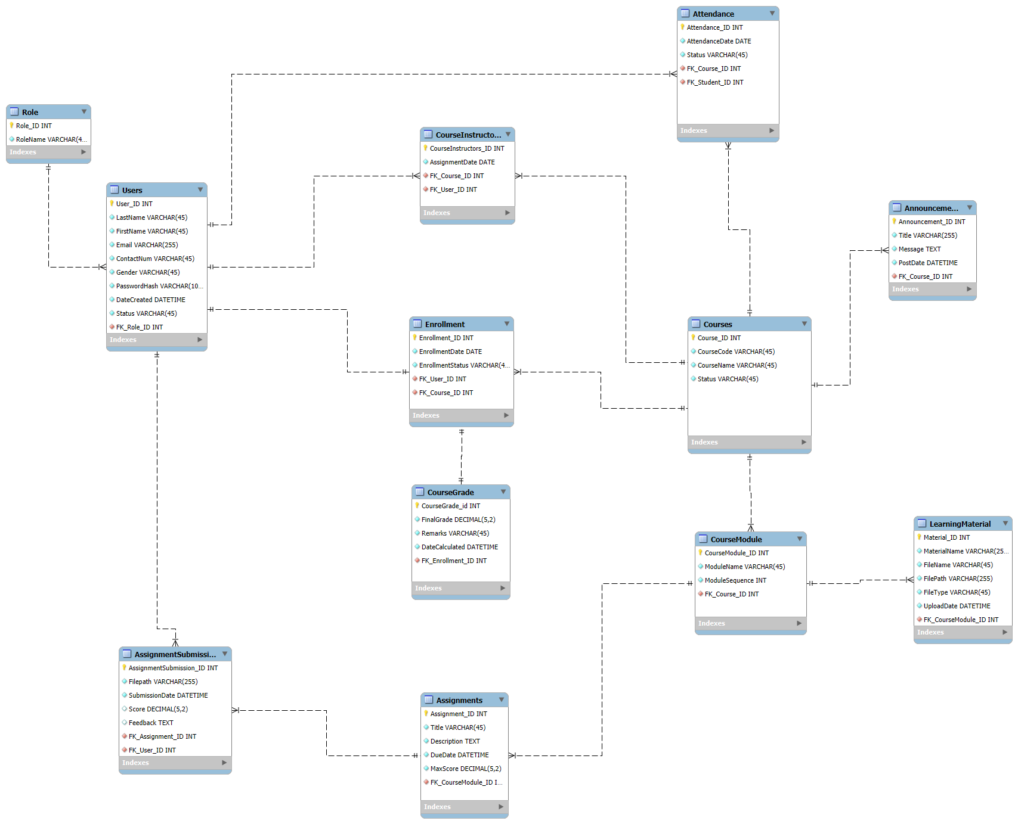

[Section 1: Role, Users, Enrollment, CourseGrade, CourseInstructors]
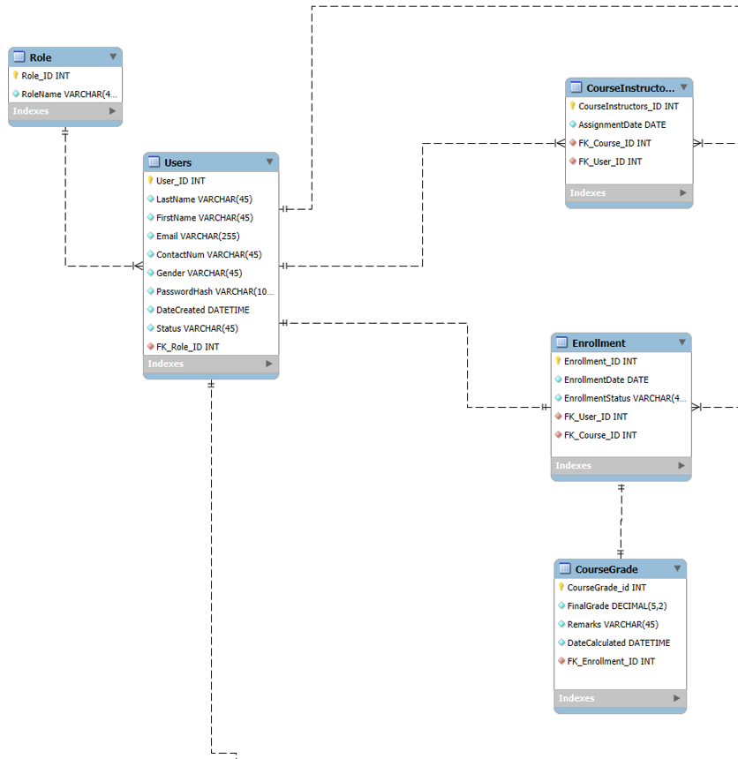

[Section 2: Attendance, Announcements, Courses, CourseModule, LearningMaterials]
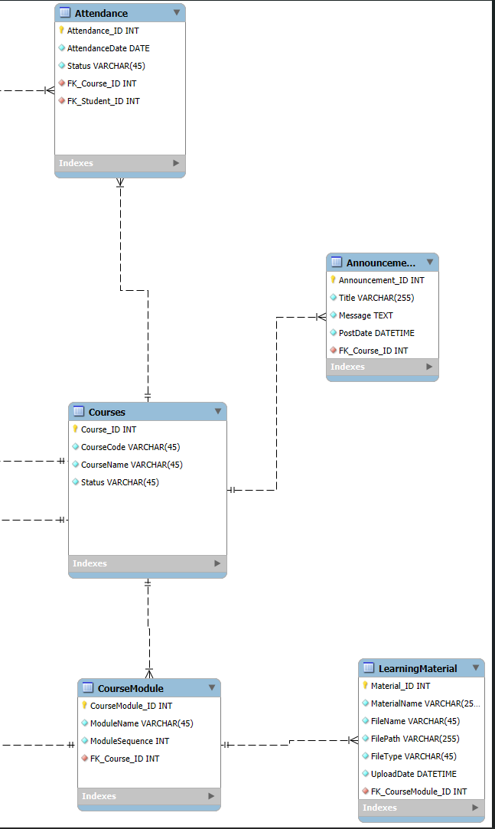
[Section 3: AssignmentSubmissions & Assignments]
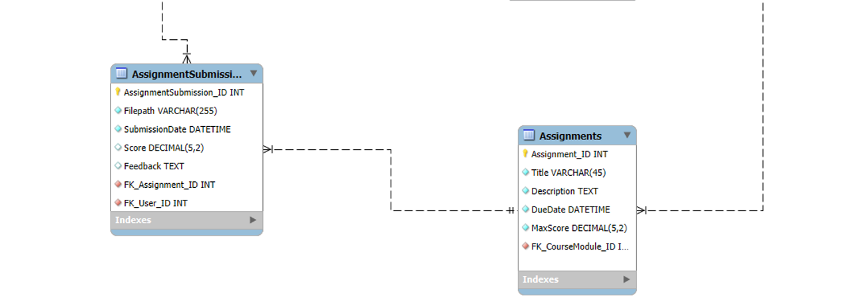

The proposed system utilizes a relational database schema designed to support the core functionalities of an LMS system. At its foundation, the database handles user authentication and role-based access control (RBAC) via Users and Role entities. The core academics center around Courses bridges instructors via Course Instructors and tracks students’ registration through enrollment and Attendance tables. The academic delivery and assessments work Modularly through Course Modules that house the different Learning Materials, Assignments, and Assessments. Finally, transparency and performance tracking are maintained through integrated Announcements and a dedicated Course Grade entity.
- SYSTEM FEATURES
Feature | Description
User Management | - Account creation  - Profile management  - Role-based access control (Teacher, Student, Admin)
Account Management | - Personal Profile management  - records management
Course Management | - Create, update, and delete courses  - Assign instructors to courses  - Course information management  - Course status management
Learning Materials Management | - Upload learning materials  - Organize learning resources  - Update or remove learning resources
Assignment Management | - Create or update assignments  - Set deadlines and submissions  - View submission history

Grade Management | - Encodes student grades  - Update grades  - View grade reports  - Export grades
Attendance Monitoring | - Records student attendance  - Attendance history
Enrollment Management | - Enroll students in the course  - View enrollment records
Announcements | - Posts announcement  - Academic updates and reminders

- Proof of Agreement
(NEXT PAGE)

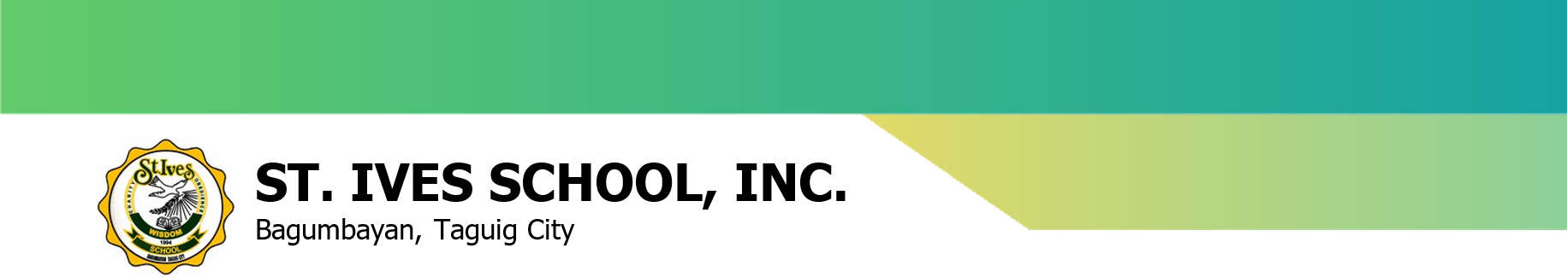

ST. IVES SCHOOL INC.
336 M.L. Quezon St., Bagumbayan, Taguig City
Tel. No.: 89831220 | Facsimile: 88371719

2 June 2026

AALIYAH JANE BARCELITA
EUAN MYKEL F. CRUZ
GIAN ANTONIO DE LUNA
KRYSTEL CASSANDRA DE GUZMAN
MAPÚA University
1191 Pablo Ocampo Sr. Ext, Makati City, Metro Manila

Subject: Acceptance of Proposal for School LMS Project
Dear Mr. Cruz,
Thank you for your letter dated 1 June 2026 regarding your proposal to develop a School Learning Management System (LMS) for St. Ives School as part of your major requirement for Web Systems and Technology 2.
I appreciate you and your team identifying the need for an efficient, web-based system to streamline our daily operations and improve document accessibility for our students. In today's educational landscape, a user-friendly LMS is indeed essential for managing learning modules and records effectively.
On behalf of St. Ives School, I am pleased to formally accept your proposal. We are glad to cooperate with your team and provide the necessary support to ensure the success of this project.
Please coordinate with my office so we can schedule a meeting to discuss your research, the technical requirements, and the timeline for the system's development.
We look forward to a productive collaboration and to seeing the final system you create.

Sincerely yours,

ERICARDO A. CRUZ
School Director
St. Ives School, Inc.

