|  |  |  |  |  |  |
| --- | --- | --- | --- | --- | --- |
| **Statistics** | | | | | |
|  | | b1_entrpy_OG | b1_entrpy_RC | b1_nckmn_OG | b1_nckmn_RC |
| N | Valid | 38333 | 38333 | 38316 | 38316 |
| Missing | 0 | 0 | 17 | 17 |
| Mean | | .389 | .356 | .060 | .0601 |
| Median | | .371 | .340 | -.064 | -.091 |
| Std. Deviation | | .139 | .133 | 3.181 | 3.234 |
| Minimum | | .000 | .000 | -14.039 | -13.910 |
| Maximum | | .997 | .893 | 13.101 | 12.848 |
| Percentiles | 10 | .232 | .206 | -3.607 | -3.619 |
| 25 | .298 | .266 | -1.768 | -1.815 |
| 75 | .466 | .424 | 1.518 | 1.553 |
| 90 | .581 | .535 | 3.619 | 3.684 |

|  |  |  |  |  |  |  |  |  |  |
| --- | --- | --- | --- | --- | --- | --- | --- | --- | --- |
| **Paired Samples Test** | | | | | | | | | |
|  | | Paired Differences | | | | | t | df | Sig. (2-tailed) |
| Mean | Std. Deviation | Std. Error Mean | 95% Confidence Interval of the Difference | |
| Lower | Upper |
| Pair 1 | b1_nckmn_OG - b1_nckmn_RC | .000057 | .24579 | .00125 | -.0024 | .0025 | .045 | 38315 | .964 |

|  |  |
| --- | --- |
|  |  |
|  |  |

|  |  |  |  |  |  |
| --- | --- | --- | --- | --- | --- |
| **Correlations** | | | | | |
|  | | b1_entrpy_OG | b1_nckmn_OG | b1_entrpy_RC | b1_nckmn_RC |
| b1_entrpy_OG | Pearson Correlation | 1 | .675** | .970** | .655** |
| Sig. (2-tailed) |  | .000 | .000 | .000 |
| N | 38333 | 38316 | 38333 | 38316 |
| b1_nckmn_OG | Pearson Correlation | .675** | 1 | .719** | .997** |
| Sig. (2-tailed) | .000 |  | .000 | .000 |
| N | 38316 | 38316 | 38316 | 38316 |
| b1_entrpy_RC | Pearson Correlation | .970** | .719** | 1 | .717** |
| Sig. (2-tailed) | .000 | .000 |  | .000 |
| N | 38333 | 38316 | 38333 | 38316 |
| b1_nckmn_RC | Pearson Correlation | .655** | .997** | .717** | 1 |
| Sig. (2-tailed) | .000 | .000 | .000 |  |
| N | 38316 | 38316 | 38316 | 38316 |
| **. Correlation is significant at the 0.01 level (2-tailed). | | | | | |

Analysis of reliability for the walkability scale scores is 0.997.

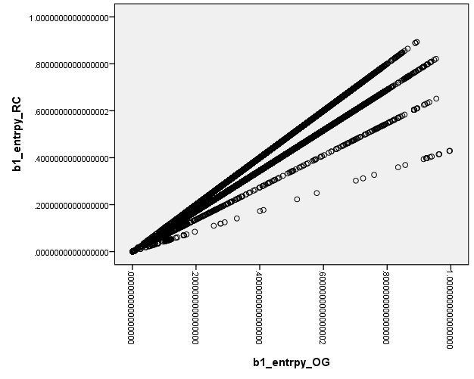

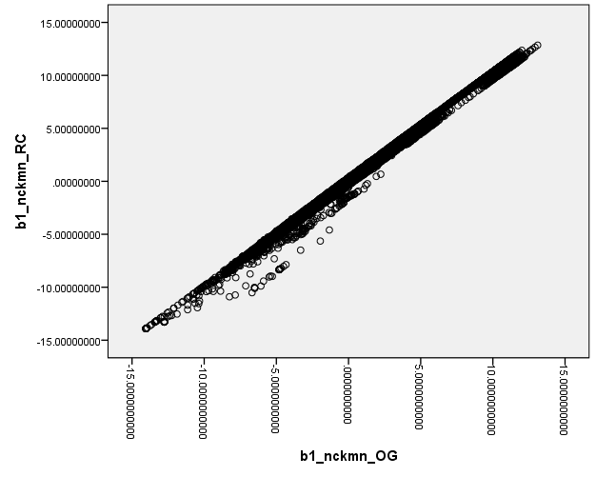

|  |  |
| --- | --- |
| Boro_code =1, Mean N=4.65 (4, 5), R=0.998 | Boro_code =2, Mean N=4.37 (4, 5), R=0.994 |
| Boro_code 3, Mean N = 4.55, R=0.994 | Boro_code 4, Mean N= 4.19, R=0.997 |
| Boro_code=5, Mean N=4, R=0.993 |  |

Difference in quintile categories ---- Walkability_RC category – Walkability_OG category

Median = 0, min =-2 max=1

|  |  |  |  |  |  |
| --- | --- | --- | --- | --- | --- |
| **Difference in Quintile Categories** | | | | | |
|  | | Frequency | Percent | Valid Percent | Cumulative Percent |
| Valid | -2.00 | 3 | .0 | .0 | .0 |
| -1.00 | 1760 | 4.6 | 4.6 | 4.6 |
| .00 | 34787 | 90.7 | 90.8 | 95.4 |
| 1.00 | 1766 | 4.6 | 4.6 | 100.0 |
| Total | 38316 | 100.0 | 100.0 |  |
| Missing | System | 17 | .0 |  |  |
| Total | | 38333 | 100.0 |  |  |