***Objectives***: The New York City Department of Health and Mental Hygiene inspects all restaurants for food safety violations, providing a numeric score that reflect violations , with a higher score being worse. Starting on July 27th 2010 New York City required restaurants to post a letter grade summarizing the results of food safety inspections. We sought to assess the impact of this requirement on subsequent restaurant inspection scores and to investigate how whether these impacts varied across neighborhoods.

**Methods**: Data on all restaurant inspections between January 1, 2009 and July 30, 2013 were downloaded from New York City’s open data portal. The algorithm for calculating inspection grades from inspection scores was applied to all restaurant data prior to July 27th 2010 so that restaurant grades could be calculated across the entire study period. Restaurant addresses listed in the inspection data were geocoded and locations were matched to census-tract level socio demographic data from the US Census bureau.

**Results**: We find that average restaurant inspection scores improved over time, but that most of the increase resulted from B grade restaurants becoming A grade restaurants shortly after grade posting was required. A gap between average scores in for restaurants in wealthier verses less wealthy neighborhoods opened approximately simultaneously with the policy. Neighborhoods with high percentages of foreign-born inhabitants had lower (better) scores throughout the entire period. For a panel of restaurants, a fixed-effects analysis of the average treatment effect for the requirement of posting letter grades for a panel of restaurants gives a mean improvement in inspection scores of 1.6 points (95%CI: 1.9 to 1.3)

**Conclusions**: The requirement that restaurants post letter grades reflecting food safety inspection grades improves restaurant compliance with food safety regulations, but disparities persist across neighborhoods.

Ensuring the safety of the food supply is a core function of the public health system. In July, 2010, New York City (NYC) introduced a new policy that required all restaurants to post, in highly publically visible locations, letter grades summarizing food safety scores. In this paper, we analyze a large longitudinal dataset of restaurant inspections that spans the introduction of the policy. We address two basic questions. First, how did the policy affect the distribution of food safety scores? Second, how did these effects vary across neighborhoods with different demographic and economic characteristics? Our results contribute to a growing literature on the effectiveness of mandatory disclosure policies – a strategy that has gained prominence both in public health and in diverse domains including campaign finance, energy policy, and employment policy – and offers the first evidence of how the effectiveness of disclosure strategies varies across neighborhoods.

New York has one of the oldest and largest restaurant inspection systems in the world. The NYC Department of Health and Mental Hygiene (DOHMH) created the division of food inspection and offensive trades in 1881, and by 1919 it was completing 19,500 inspections annually. In 2012, the DOH carried out x inspections. NYC is not alone in devoting substantial resources to restaurant inspections. In the United States, nearly all food service businesses are covered by a patchwork of state, county and municipal restaurant inspection laws which, though they differ in their particulars, almost all entail regular inspections.1

Despite these efforts, food poisoning remains an important threat to public health. In 2011, according to the CDC, about 48 million Americans became ill, 128,000 were hospitalized, and 3,000 died from food borne diseases.2 In a separate analysis, the CDC concluded that the majority of exposure to food borne pathogens occurs in restaurants.3

*Restaurant inspections and public health*

What do we know about the effectiveness of restaurant inspections as a public health intervention? A priori, the very nature of the scores used to rate restaurant food safety imposes a constraint on their information content, as the overall score conflates the number and the severity of the infractions. Thus, score-based approaches fail to distinguish between numerous small infractions that probably pose limited health risks and one or two large problems that do threaten health. This points to what some critics have flagged as a deeper problem with the letter grade system: the food safety community has so far failed to converge on a consensus metric for food safety.4,5

Assessments of the ability of restaurant inspection data to predict outbreaks has been mixed, with inspections in some jurisdictions showing good predictive ability6 while others show none.7 The best evidence linking publicly posted inspection grades to health outcomes comes from Los Angeles, CA, where city officials instituted a public grade card system in early 1998. In a careful analysis, Jin and Leslie conclude that the policy change resulted in a 20% decrease in hospital admissions from food-related illnesses.8 However, their empirical specification does not allow them to distinguish between improved restaurant hygiene and consumers avoiding low-graded restaurants.

*Letter grades in New York City*

The structure of NYC’s restaurant inspection is simple. An inspector arrives unannounced, and assigns points based on a checklist of violations. The number of points depends on the frequency and extent of the violation – e.g., one tray of chicken wings held below 140 degrees would be scored 7 points, but two trays in that condition would be scored 8 points.9 Under the letter grading system, a restaurant that scores 13 points or fewer earns an A, 14 to 27 gets a B, and 28+ points gets a C. The New York City Board of Health voted the letter grade policy into place on March 16, 2010, and it went into force on July 27 that same year. Inspections, and the associated grade placard postings, began immediately (the first grade was posted on 28 July 2010, in a deli in Queens).10

Methods

To construct the dataset for analysis, publicly-available restaurant inspection data were downloaded for a period bracketing the launch of the inspection grade posting policy. Restaurant addresses listed in the inspection data were geocoded and assigned to Census tracts. The sociodemographic characteristics of the Census tracts were characterized using American Community Survey (ACS) data [which years]. The DOHMH makes available approximately 500,000 rows of recent restaurant inspection data available via the NYC Open Data website (each row describes a violation, so this equates to substantially fewer inspections).12 We downloaded data in three rounds, yielding 209,661 inspections of 29,150 restaurants, stretching from August 2008 through July 2013. We infilled data for months with no inspection using each restaurant’s most recent inspection score, resulting in a dataset of scores (rather than inspections). The resulting dataset captures the prevalence of scores in New York City at any given point in time. Critical for our empirical strategy described below, we found no evidence that the scoring rubric has changed meaningfully over the period for which data were downloaded. This is corroborated by DOHMH documents describing the scoring system,11 and by a recent legal analysis of the grading policy.5

To examine how restaurant inspection scores changed citywide, we carried out four analyses. First, we simply plotted the average score over time. Second, to understand how the overall distribution of scores changed, we examined histograms of scores in the periods before and after the posting policy was put in place. Third, to understand how the distribution of letter grades evolved over the analysis period we assigned all numerical scores to a grade category using DOHMH cut points and plotted the evolution of the grade distribution over time. Finally, we carried out a series of fixed effect linear regressions to generate point estimates of the causal effect of the policy on average scores.

Geolocation of the restaurants allowed for assessments of how neighborhood context affected restaurant response to the policy change. Fundamental Cause Theory predicts that a health intervention based on the provision of information would cause disparities to occur in the outcome. The Census tract of each restaurant was characterized as to racial/ethnic composition; percent foreign born; mean income and percent living below the poverty line. Since many of these measures contain essentially the same information, we focused on the measures: proportion of the residents who were black, proportion of residents who were foreign born, and mean income.

To examine the time trends, we plotted kernel-weighted local polynomial regression lines (Epanechnikov kernel, bandwidth selected using the Rule of Thumb method13) of restaurant inspection scores for restaurants in top and bottom quartiles of each of each Census tract demographic variables of interest. Alternate specifications of the local polynomial regression gave essentially similar results. These plots allow examination of the time path of food safety scores in Census tracts at the high and low end of the distribution of key demographic variables in response to the implementation of the grade posting policy.

We were also interested in the effect of restaurant density on score dynamics. The underlying behavioral postulate is that restaurants located in restaurant-dense settings operate in a more competitive environment and are therefore likely to be more sensitive to the impact of posting a low score. To construct a measure of restaurant density, the density of restaurants per km2 in each census tract (count of restaurants/area of tract) was calculated. We used this density variable to construct plots of restaurant inspection scores in high and low restaurant density tracts as described above.

Finally, to assess the overall effect of the policy on average scores we carried out fixed effect linear regression on a panel of restaurants. If the timing of the policy change is uncorrelated with time-varying unobservables that affect inspection scores, than this specification consistently estimates the average treatment effect.14

Results

In aggregate, the introduction of the grade posting policy appears to have reversed an upward drift in average scores, as shown in Figure 1. Here and in subsequent time series plots, the vertical red bar denotes the announcement of the grade posting policy. Given the undulating shape of the trajectory, we cannot rule out that the timing of the change in slope was coincidental. Figure 2 suggests that most of the transitions post-policy entailed B-grade restaurants improving to A-grade restaurants; the frequency of C grades appears essentially stable over time. This observation suggests an assessment of the distribution of scores rather than grades, which is presented in Figure 3. While the overall distribution of scores shifts to the left indicating improvements in food safety, the striking pattern exhibited in Figure 3 is the increase in density in the neighborhood of the cut point for an A grade. Taken together, Figures 2 and suggest that relatively high-performing restaurants responded to the policy change by improving practices just enough to qualify for an A grade.

Figure 4 shows local polynomial smoothed plots of inspection scores for restaurants in Census tracts in the top and bottom quartiles of neighborhood contexts. Panel A compares the time path of scores in top quartile tracts (high % white) and bottom quartile tracts. While the two diverge before the introduction of the policy, it appears that the slope of the decline in scores in top quartile tracts increases after the policy was implemented. Tracts separated by top and bottom quartiles of poverty (panel B) show a similar pattern, though the divergence is less pronounced. Tracts with high percent foreign-born residents experienced almost no improvement in food safety scores (Panel C), while those with low percent foreign-born exhibit substantial improvements, particularly after the July 2010 policy change. Finally, in Panel D restaurants in Census tracts with a low restaurant density had better inspection scores than restaurants in high density neighborhoods but scores for restaurants in low density neighborhoods did not improve after the grading policy was implemented. However, restaurants in high-restaurant density tracts showed substantial improvements that appear to accelerate after the grade-posting policy came into effect.

To estimate the average treatment effect of the policy change, fixed effect models with restaurant, month, and borough fixed effects were fit. This specification recovers the causal effect of the policy on inspection scores, conditional on the assumption that the policy change is uncorrelated with time-varying unobservables that affect inspection scores. The point estimate for the effect of the letter grade posting policy on restaurant inspection scores is -1.6 (95%CI: -1.9 to -1.3), that is, the average effect of the policy was to improve (lower) scores by 1.6 points. By way of reference, a food safety violation deemed to be a public health hazard (e.g., storing food at an incorrect temperature) triggers a penalty of 7 points, a critical violation (e.g., rodents) carries a 5 point violation, and a general violation (improperly sanitized cooking utensils) adds 2 points to the total score.

Conclusions

Ensuring the safety of the food supply is a core function of the public health. The analyses suggest that requiring restaurants to post letter grades summarizing their food safety compliance scores results in modest but measurable improvements in average scores. However, most of these gains appear to have resulted from B-grade restaurants improving just enough to earn an A grade; the proportion of C-grade restaurants remains approximately stable over the analysis period. It is likely that increased technical support and training or greater sanctions will be required to improve restaurants earning C-grades.

For health interventions that are based purely on the provision of information and that require behavior change, Fundamental Cause Theory predicts that outcomes will improve first for those with greater socio-economic resources. For the grade posting policy to improve food safety practices individual restaurant owners must decide to make changes to their kitchen procedures either prompted by the perception that a poor grade will damage business or by declines in business as customers decide to eat elsewhere. Our analyses provide a novel disaggregation of the restaurant inspection score trajectories by neighborhood characteristics that allow us to test whether these predicted disparities arise. The analyses suggest that indeed the grade posting policy increased disparities in restaurant food safety by neighborhood income and racial composition; larger gains in food safety as measured by inspection scores were observed in neighborhoods that were largely white and in wealthier neighborhoods. Neighborhoods with large foreign-born populations benefited little from the policy. While the data suggest that this policy initiative overall improved compliance with food safety regulations, increases in disparities by neighborhood racial and ethnic composition and socio-economic status are an environmental justice concern. The data suggest that further technical support and training be provided to restaurants in low performing neighborhoods to improve food safety and reduce disparities.

The validation of our prediction based on Fundamental Cause Theory that disparities in inspection scores would arise as the policy was implemented provides further evidence that the letter grade posting policy had causal effects. Likewise the finding that inspection scores improved in neighborhoods with higher densities of restaurants is consistent with the idea that restaurants improved their food safety procedures to gain an edge in areas with higher competition for diners. Both of these interactions between the policy implementation and neighborhood characteristics on restaurant inspection score trajectories provide evidence that the changes in inspection score trajectories are a causal reaction to the policy and do not just reflect a cyclical undulation in the inspection scores.

While this study has notable strengths including, a very large data set of restaurants and consistent data gathering through time, the analyses have weaknesses that need to be highlighted. The first is that the inspection data provide no basis for assessing how this policy change and shifts in food safety inspection scores affect public health, these analyses only show that restaurant food safety hazards as codified by these inspection scores have declined. The second is that Census tracts were used as proxies for neighborhoods and as a convenience framework for describing the socio-demographic context within which restaurants operate. The use of these administrative geometries imposes boundary effects whereby restaurants on either side of a tract boundary may experience more similar socio-demographic contexts than reflected by the differences in their aggregated Census tract characteristics. It is not a priori clear how a restaurant’s neighborhood should be defined and bounded.

DARBY- can you do a para placing this in the larger context of disclosure polices that you allude to in the intro?

In conclusion, the advent of the NYC policy that restaurants display letter grades reflecting their food safety grade appears to have restaurant inspection scores in NYC. However, improvements reflect a decline in B grades and an increase in A grades, the prevalence of C grades has remained static. In addition, the improvements have mainly occurred in wealthier and predominantly white neighborhoods. Additional technical support, targeted training and possibly sanctions may be required to reduce disparities in restaurant inspection scores.

References

1. Filion K, Powell DA. The use of restaurant inspection disclosure systems as a means of communicating food safety information. *J Foodserv*. 2009;20(6):287–297. doi:10.1111/j.1748-0159.2009.00151.x.

2. CDC - 2011 Estimates of Foodborne Illness. Available at: http://www.cdc.gov/foodborneburden/2011-foodborne-estimates.html. Accessed December 6, 2013.

3. Murphree R, Garman K, Phan Q, Everstine K, Gould LH, Jones TF. Characteristics of Foodborne Disease Outbreak Investigations Conducted by Foodborne Diseases Active Surveillance Network (FoodNet) Sites, 2003–2008. *Clin Infect Dis*. 2012;54(suppl 5):S498-S503. doi:10.1093/cid/cis232.

4. Wiant CJ. Scores, Grades, and Communicating About Food Safety. *J Environ Health*. 1999;61(9):37.

5. Ho DE. Fudging the Nudge: Information Disclosure and Restaurant Grading. *Yale LJ*. 2012;122:574–837.

6. Irwin K, Ballard J, Grendon J, Kobayashi J. Results of routine restaurant inspections can predict outbreaks of foodborne illness: the Seattle-King County experience. *Am J Public Health*. 1989;79(5):586-590.

7. Cruz MA, Katz DJ, Suarez JA. An assessment of the ability of routine restaurant inspections to predict food-borne outbreaks in Miami-Dade County, Florida. *Am J Public Health*. 2001;91(5):821-823.

8. Jin GZ, Leslie P. The Effect of Information on Product Quality: Evidence from Restaurant Hygiene Grade Cards. *Q J Econ*. 2003;118(2):409-451. doi:10.1162/003355303321675428.

9. NYC DOHMH - Restaurant Inspections. Available at: http://www.nyc.gov/html/doh/html/environmental/food-service-inspection.shtml. Accessed December 6, 2013.

10. Collins G. “A” Grades Have Gone to Almost Half the Restaurants With Full Inspections. *New York Times*. http://dinersjournal.blogs.nytimes.com/2010/08/26/a-grades-have-gone-to-almost-half-the-restaurants-with-full-inspections/. Published August 26, 2010. Accessed December 6, 2013.

11. Letter grading: frequently asked questions. Available at: http://www.nyc.gov/html/doh/downloads/pdf/rii/rii-nyc-rules.pdf. Accessed December 6, 2013.

12. Restaurant Inspection Results. *NYC Open Data*. Available at: https://nycopendata.socrata.com/Health/Restaurant-Inspection-Results/4vkw-7nck. Accessed December 9, 2013.

13. Fan J, Gijbels I. *Local Polynomial Modelling and Its Applications: Monographs on Statistics and Applied Probability 66*. CRC Press; 1996.

14. Wooldridge JM. *Econometric Analysis of Cross Section and Panel Data*. Cambridge, MA: MIT Press; 2002.



Figure : score over time

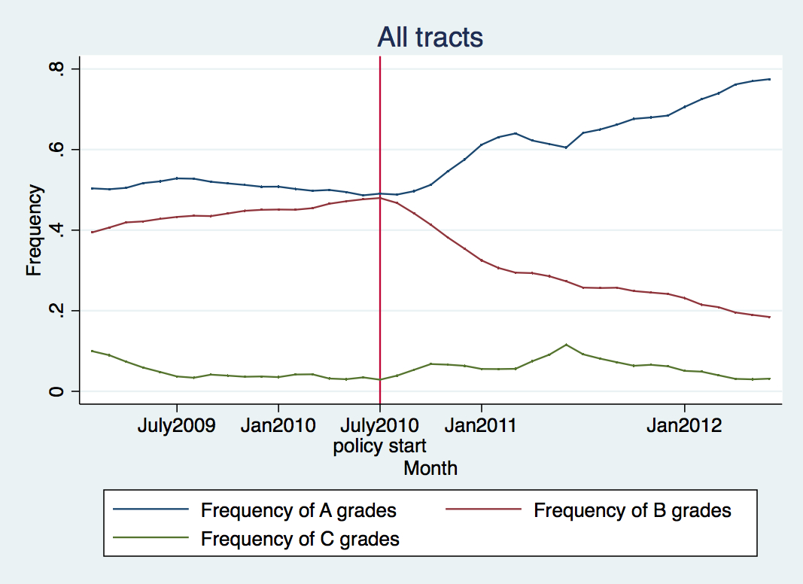

Figure : frequency of letter grades over time; note that grades before July 2010 were imputed from inspection scores.



Figure : distribution of scores before and after policy change

