Research Letter: ~650 words (aiming for <700 words)

**Quantifying Global Positioning System Error in Urban Spaces**

**Introduction**

Global Positioning System (GPS) monitoring of study subjects holds promise for studying physical activity and mobility.1 However, physical impediments in the path between a subject’s GPS device and GPS satellites, such as high building bulk and dense tree canopy, may interfere with GPS accuracy.2 Urban design and tree canopy cover vary by spatial context, so GPS error due to these built environment factors may hinder GPS use for understanding context-driven variation in physical activity. To date, however, the magnitude of error due to interference has not been empirically quantified in the scientific literature. This research letter presents a comparison of GPS accuracy under a variety of building bulk and tree canopy conditions.

**Methods**

First, we explored the impact of building bulk density, a measure of urban street canyoning. Using building bulk information from tax assessor records,3 we chose ten straight walks approximately 400 meters long adjacent to census blocks in the highest quartile of building bulk density, and ten adjacent to census blocks in the lowest quartile. High bulk density walks were in Midtown and Downtown Manhattan, where street-width-to-building height ratios range around 1:5, among the highest in the United States but less than in informal construction in the developing world. Census blocks in the lowest quartile were in industrial sections of Northern Manhattan and the Bronx, with width:height ratios around 3:1. During the summer of 2014, one research assistant carrying two Globalsat DG-100 GPS Data Logger devices performed each walk twice, resulting in eighty recorded trips.

Next, we explored the impact of tree canopy cover. Using tree canopy data gathered by LiDAR scan,4 we selected ten straight walks adjacent to census blocks in the highest quartile of tree canopy cover in New York City and ten adjacent to blocks in the lowest quartile. To minimize transportation logistics, we preferred blocks proximal to the Columbia University Medical Center, where the research team was based. Two research assistants performed each walk carrying two DG-100 devices during fall 2014. Due to battery failure (?), one GPS device failed to record any data for the walks, resulting in sixty recorded trips.

We used ArcGIS version XX to select blocks and to sum distances between consecutive GPS waypoints to compute the GPS-measured distance. We divided this distance by the straight line path of the structured walk to compute GPS overestimation. We used R for Windows version 2.15.3 for statistical analyses.

**Results**

Visual inspection of GPS-recorded points revealed that spatial scatter of GPS waypoints was greater perpendicular to the axis of the street than along the axis of travel (Figure 1). Lateral scatter in the GPS waypoints caused overestimates of distances traveled (median: 35% overestimate, range: 8% underestimate to 513% overestimate). Overestimates were correlated within walks (ICC(2,1)=0.60, p<0.01 for bulk density walks, ICC(2,1)=0.84,P<0.01 for tree canopy walks).

Overestimates were modestly, but not statistically significantly, higher on walks selected for high versus low tree canopy cover (43% vs 27% median overestimate; p=0.15, Table 1). Overestimates were substantially higher on street segments selected for high versus low building bulk density (97% vs 14% median overestimate, Wilcoxon rank-sum p<0.01).

**Discussion**

GPS scatter was much greater in deeper street canyons. In particular, GPS-measured walking distances in deeply canyoned streets were nearly double the true distance on average. Overestimates were not statistically significantly greater on streets with higher tree canopy. Future research should investigate the use of device-embedded spatial correction algorithms such as shadow matching2 and wi-fi assisted GPS5 as well as post-hoc spatial correction such as snapping GPS points to street grids to minimize observed error.

**Figure 1. GPS points (dots) and structured walk plan (line) for low (left panel) and high (right panel) building bulk density walks** – Work with Danny to get better imagery here

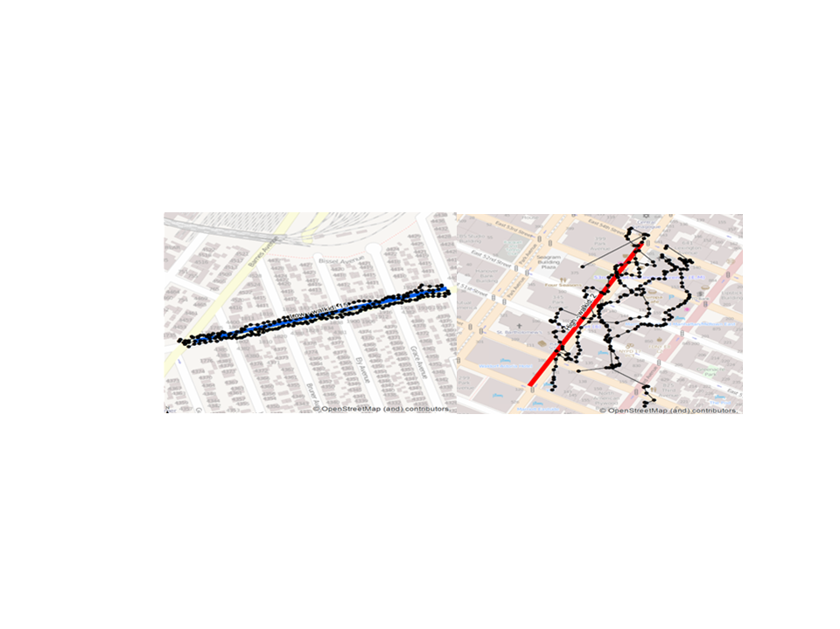

**Table 1. True and GPS-measured distances of structured walks in New York City**

|  |  |  |  |  |  |
| --- | --- | --- | --- | --- | --- |
| Category | Number of Recorded Walks | True Distance, (meters)  Median (IQR) | GPS-Measured Distance (meters) Median (IQR) | Overestimate Median (IQR) | ICC |
| All | 140 | 389 (371 – 422) | 556 (459 – 786) | 1.41 (1.18 – 1.95) |  |
| High tree canopy | 30 | 391 (375 – 430) | 559 (459 – 944) | 1.43 (1.19 – 2.13) | 0.90 |
| Low tree canopy | 30 | 420 (377 – 449) | 524 (491 – 565) | 1.27 (1.20 – 1.47) | 0.10 |
| High bulk density | 40 | 393 (386 – 408) | 786 (660 – 1030) | 1.97 (1.70 – 2.49) | 0.45 |
| Low bulk density | 40 | 374 (354 – 392) | 432 (383 – 533) | 1.14 (1.07 – 1.37) | 0.18 |

References

1. Krenn PJ, Titze S, Oja P, Jones A, Ogilvie D. Use of global positioning systems to study physical activity and the environment: a systematic review. American journal of preventive medicine 2011;41(5):508-515.

2. Groves PD. Shadow matching: A new GNSS positioning technique for urban canyons. Journal of Navigation 2011;64(03):417-430.

3. Purciel M, Neckerman KM, Lovasi GS, Quinn JW, Weiss C, Bader MD, et al. Creating and validating GIS measures of urban design for health research. Journal of environmental psychology 2009;29(4):457-466.

4. MacFaden SW, O’Neil-Dunne JP, Royar AR, Lu JW, Rundle AG. High-resolution tree canopy mapping for New York City using LIDAR and object-based image analysis. Journal of Applied Remote Sensing 2012;6(1):063567-1-063567-23.

5. Zandbergen PA. Accuracy of iPhone locations: A comparison of assisted GPS, WiFi and cellular positioning. Transactions in GIS 2009;13(s1):5-25.