# Food Environment, Dietary Intake, and Cardiac Arrest Risk

## SER abstract and tables from Steve Mooney

**Background**

Neighborhood food environments may contribute to sudden cardiac arrest incidence and mortality. The neighborhood environment may limit local access to cardio-protective foods such as fish and nuts, or may facilitate local access to low-cost processed foods, including those containing cardio-harmful *trans*-fats.

**Methods**

We linked residential addresses of subjects from the Cardiac Arrest Blood Study-Repository (CABS-R) to nearby food sources using the National Establishment Time-Series (NETS) longitudinal database of registered businesses. CABS-R is a registry of blood samples and abstracted emergency response records of sudden cardiac arrest cases and population-based controls from King County, WA. We performed three analyses of food sources within a 5km buffer of the home address: 1) in relation to case status for 899 cases and 807 controls, 2) in relation to dietary biomarkers for 1894 cases, and 3) in relation to survival after cardiac arrest for 1808 cases presenting with ventricular fibrillation.

**Results**

Unhealthy food outlet density near the subject’s home was associated with cardiac arrest (OR: 1.79, 95% CI: 1.59, 2.03 per z-score increase). However, healthy food outlet density was similarly associated (OR: 1.75, 95% CI: 1.56, 1.98 per z-score increase). Both fish markets and overall healthy food outlets near the subjects’ home were unassociated with markers indicating fish consumption. Unhealthy food sources near the home were associated with a *lower* proportion of fatty acids that were *trans*-fats (0.034 percent decrease per z-score increase 95% CI: 0.006, 0.062). Survival after cardiac arrest was unassociated with local food environment (OR: 1.03, 95% CI: 0.93, 1.51 per z-score increase in healthy food sources, OR: 1.02, 95% CI: 0.92, 1.14 per z-score increase in unhealthy food sources).

**Conclusions**

We did not find support for the hypothesized effect of the food environment on case status or dietary biomarkers.

**Table 1. Demographic Characteristics of CABS-R subject used in various analyses. Table 1a, below, indicates which CABS variable was used for each row.**

|  |  |  |  |  |  |
| --- | --- | --- | --- | --- | --- |
|  | Controls | Comparable Cases1 | Cases with Biomarker Data2 | Cases with VF3 | All Cases4 |
| *Individual* |  |  |  |  |  |
| First Year Enrolled | 1990 | 1990 | 1990 | 1999 | 1990 |
| Last Year Enrolled | 2006 | 2006 | 2004 | 2010 | 2010 |
| Number of subjects | 807 | 899 | 1894 | 2185 | 3859 |
| Age, mean | 57 | 61 | 67 | 65 | 67 |
| Female, % | 22 | 27 | 24 | 20 | 26 |
| Arrest Witnessed | N/A | 68 | 60 | 75 | 60 |
| Survived 30 days after arrest, % | N/A | 37 | 17 | 32 | 20 |
| Neighborhood Identified, % | 92 | 78 | 81 | 79 | 83 |
| *Home Census Tract* |  |  |  |  |  |
| Per-capita Income, $ | 31,268 | 28,296 | 29,864 | 28,522 | 28,393 |
| Healthy Food Outlets, median | 1 | 1 | 1 | 1 | 1 |
| Fish Markets, median | 0 | 0 | 0 | 0 | 0 |
| Unhealthy Food Outlets, median | 2 | 4 | 3 | 4 | 4 |
| 5 km buffer from Home Census Tract Centroid |  |  |  |  |  |
| Healthy Food Outlets, median | 18 | 26 | 26 | 26 | 26 |
| Fish Markets, median | 1 | 2 | 2 | 1 | 2 |
| Unhealthy Food Outlets, median | 62 | 98 | 93 | 99 | 103 |

1 Age 80 or younger (EventAge), with no history of clinically diagnosed heart disease (Z_CHARS_CADPRIOR is 0 or DPCase is 0), cardiac arrest incident at or prior to 2006 (EventYear)

2 EventID found in 2014Apr30_CABSR_Biomarkers.csv

3 Subset of all subjects with ZRhythm == ’VF’

4 Subset of all subjects with DPCase == 1

**Table 1a. CABS Variables used to compute row values in Table 1 (NOT INTENDED FOR PUBLIC VIEW)**

|  |  |
| --- | --- |
|  | Relevant Variable (s) |
| *Individual* |  |
| First Year Enrolled | EventYear |
| Last Year Enrolled | EventYear |
| Number of subjects | EventID defining unique subject |
| Age, mean | ZEventAge (where ZEventAge < 120) |
| Female, % | ZGender |
| Arrest Witnessed | ZWitness (where ‘Y’ indicates witnessed) |
| Survived 30 days after arrest, % | EMS_outcome (where 1 indicates survived) |
| Neighborhood Identified, % | TRACT00L (where non-null indicates identified) |
| *Home Census Tract* |  |
| Per-capita Income, $ | pcincome |
| Healthy Food Outlets, median | tn_MOD_col_h |
| Fish Markets, median | tn_FSH_OV_col_h_for_event_year |
| Unhealthy Food Outlets, median | tn_UHY_col_h |
| 5 km buffer from Home Census Tract Centroid |  |
| Healthy Food Outlets, median | bn_MOD_col_h |
| Fish Markets, median | bn_FSH_OV_col_h_for_event_year |
| Unhealthy Food Outlets, median | bn_UHY_col_h |

**Table 2. Neighborhood environments as related to case status, stratified by SES for 807 controls and 899 cases considered ‘comparable’ in Table 1 (Columns 1 and 2). All analyses z-transform count of institutions and control for age, year of event, and gender.**

**Financial institutions are included here as a positive control – financial institutions may be a marker of neighborhood SES but should not be causally related to cardiac arrest, though of course they may be correlated with truly causal factors – we might consider moving financial institutions to supplementary material to minimize reader confusion.**

**Similarly, we may want to pick either 5km buffers (my preference) or census tracts to report in the main paper and leave the other to the supplement**

|  |  |  |  |
| --- | --- | --- | --- |
| Exposure | Odds Ratio per z-score  increase in exposure | 95% Confidence Interval | |
| Healthy Food Sources in 5km Buffer1 | 1.75 | 1.56 | 1.98 |
| Lowest Income Quartile | 2.33 | 1.73 | 3.25 |
| Highest Income Quartile | 1.37 | 1.10 | 1.71 |
|  |  |  |  |
| Unhealthy Food Sources in 5km Buffer2 | 1.79 | 1.59 | 2.03 |
| Lowest Income Quartile | 2.32 | 1.70 | 3.32 |
| Highest Income Quartile | 1.44 | 1.16 | 1.81 |
|  |  |  |  |
| Financial Institutions in 5km Buffer3 | 1.68 | 1.50 | 1.90 |
| Lowest Income Quartile | 2.34 | 1.70 | 3.46 |
| Highest Income Quartile | 1.39 | 1.12 | 1.73 |
|  |  |  |  |
| Healthy Food Sources in Home Census Tract1 | 1.24 | 1.10 | 1.40 |
| Lowest Income Quartile | 1.39 | 1.09 | 1.79 |
| Highest Income Quartile | 1.33 | 1.06 | 1.74 |
|  |  |  |  |
| Unhealthy Food Sources in Home Census Tract2 | 2.01 | 1.68 | 2.42 |
| Lowest Income Quartile | 1.93 | 1.43 | 2.68 |
| Highest Income Quartile | 1.47 | 1.14 | 2.02 |
|  |  |  |  |
| Financial Institutions in Home Census Tract3 | 1.36 | 1.17 | 1.63 |
| Lowest Income Quartile | 1.30 | 1.01 | 1.72 |
| Highest Income Quartile | 1.41 | 1.10 | 2.01 |

1Supermarkets, Produce Markets, Natural Food Stores, Nut Stores, and Fish Markets

2Fast Food Stores, Pizza Restaurants, Bakeries, Convenience Stores, and Meat Markets

3Banks and Credit Unions

**Table 3. Neighborhood environments as related to dietary biomarker, for 1613 cases for whom we had both biomarker and neighborhood data available (a subset of Table 1, Column 3). All analyses z-transform count of institutions and control for age, year of event, and gender.**

**Financial institutions are again included here as a positive control, and again we might consider moving them to supplementary material.**

|  |  |  |  |  |  |  |  |  |  |
| --- | --- | --- | --- | --- | --- | --- | --- | --- | --- |
|  | Trans Fats | | | EPA | | | DHA | | |
| Exposure | **Increase1** | **95% CI** | | **Increase1** | **95% CI** | | **Increase1** | **95% CI** | |
| Healthy Food Sources in 5km Buffer1 | -0.02 | -0.05 | 0.01 | 0.00 | -0.01 | 0.01 | 0.00 | -0.05 | 0.05 |
| Lowest Income Quartile | 0.02 | -0.04 | 0.08 | 0.00 | -0.02 | 0.02 | 0.10 | 0.01 | 0.19 |
| Highest Income Quartile | -0.09 | -0.14 | -0.03 | 0.01 | -0.02 | 0.03 | -0.02 | -0.12 | 0.09 |
|  |  |  |  |  |  |  |  |  |  |
| Unhealthy Food Sources in 5km Buffer1 | -0.03 | -0.06 | -0.01 | 0.00 | -0.01 | 0.01 | -0.01 | -0.06 | 0.04 |
| Lowest Income Quartile | 0.01 | -0.05 | 0.07 | 0.00 | -0.02 | 0.02 | 0.10 | 0.01 | 0.19 |
| Highest Income Quartile | -0.09 | -0.14 | -0.04 | 0.01 | -0.02 | 0.03 | -0.03 | -0.13 | 0.08 |
|  |  |  |  |  |  |  |  |  |  |
| Financial Institutions in 5km Buffer3 | -0.04 | -0.07 | -0.01 | 0.00 | -0.01 | 0.01 | -0.01 | -0.06 | 0.04 |
| Lowest Income Quartile | 0.01 | -0.05 | 0.07 | 0.00 | -0.01 | 0.02 | 0.11 | 0.02 | 0.20 |
| Highest Income Quartile | -0.08 | -0.13 | -0.03 | 0.00 | -0.02 | 0.03 | -0.05 | -0.15 | 0.06 |
|  |  |  |  |  |  |  |  |  |  |
| Fish Markets in 5km Buffer1 | -0.04 | -0.07 | -0.01 | 0.01 | -0.01 | 0.02 | 0.00 | -0.05 | 0.05 |
| Lowest Income Quartile | 0.00 | -0.06 | 0.05 | 0.01 | 0.00 | 0.03 | 0.14 | 0.05 | 0.22 |
| Highest Income Quartile | -0.08 | -0.13 | -0.03 | 0.00 | -0.02 | 0.02 | -0.04 | -0.15 | 0.06 |

1Increase interpretable as the average % increase in all fatty acids that were this type of fatty acid per Z-score increase in listed business type

2Supermarkets, Produce Markets, Natural Food Stores, Nut Stores, and Fish Markets

3Fast Food Stores, Pizza Restaurants, Bakeries, Convenience Stores, and Meat Markets

4Banks and Credit Unions

**Table 4. Neighborhood environments as related to survival after cardiac arrest, stratified by SES, for 2185 cases presenting with ventricular fibrillation (Column 4 in Table 1). All analyses z-transform count of institutions and control for age, year of event, and gender.**

**Financial institutions are again included here as a positive control, and again we might consider moving them to supplementary material. Similarly, we likely ought to pick 5km buffers or tracts and relegate the other to the appendix**

|  |  |  |  |
| --- | --- | --- | --- |
| Exposure | Odds Ratio relating odds of survival per z-score increase in exposure | 95% Confidence Interval | |
| Healthy Food Sources in 5km Buffer1 | 1.03 | 0.93 | 1.15 |
| Lowest Income Quartile | 1.14 | 0.93 | 1.40 |
| Highest Income Quartile | 0.95 | 0.75 | 1.19 |
|  |  |  |  |
| Unhealthy Food Sources in 5km Buffer2 | 1.03 | 0.92 | 1.14 |
| Lowest Income Quartile | 1.12 | 0.91 | 1.38 |
| Highest Income Quartile | 0.98 | 0.78 | 1.22 |
|  |  |  |  |
| Financial Institutions in 5km Buffer3 | 1.06 | 0.95 | 1.18 |
| Lowest Income Quartile | 1.17 | 0.95 | 1.44 |
| Highest Income Quartile | 1.03 | 0.81 | 1.30 |
|  |  |  |  |
| Healthy Food Sources in Home Census Tract1 | 0.94 | 0.84 | 1.04 |
| Lowest Income Quartile | 1.00 | 0.80 | 1.22 |
| Highest Income Quartile | 0.88 | 0.67 | 1.11 |
|  |  |  |  |
| Unhealthy Food Sources in Home Census Tract2 | 0.98 | 0.88 | 1.09 |
| Lowest Income Quartile | 0.96 | 0.77 | 1.18 |
| Highest Income Quartile | 0.96 | 0.75 | 1.19 |
|  |  |  |  |
| Financial Institutions in Home Census Tract3 | 0.92 | 0.80 | 1.03 |
| Lowest Income Quartile | 0.78 | 0.60 | 0.99 |
| Highest Income Quartile | 0.95 | 0.72 | 1.19 |

1Supermarkets, Produce Markets, Natural Food Stores, Nut Stores, and Fish Markets

2Fast Food Stores, Pizza Restaurants, Bakeries, Convenience Stores, and Meat Markets

3Banks and Credit Unions

**Figure 1. Scatterplot of count of healthy and unhealthy food outlets within a 5km buffer for controls and comparable cases (r=0.97)**

**We probably ought to present this on a per-tract rather than per-person basis – I suspect the result will be very similar, but it makes more sense**

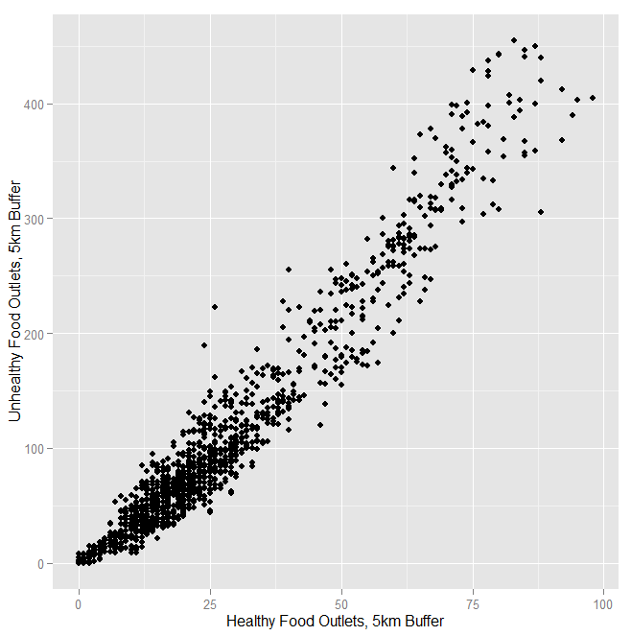

**Figure 2. Jittered scatterplot of count of healthy and unhealthy food outlets within home census tract for controls and comparable cases (FOR SUPPLEMENTARY MATERIAL)**

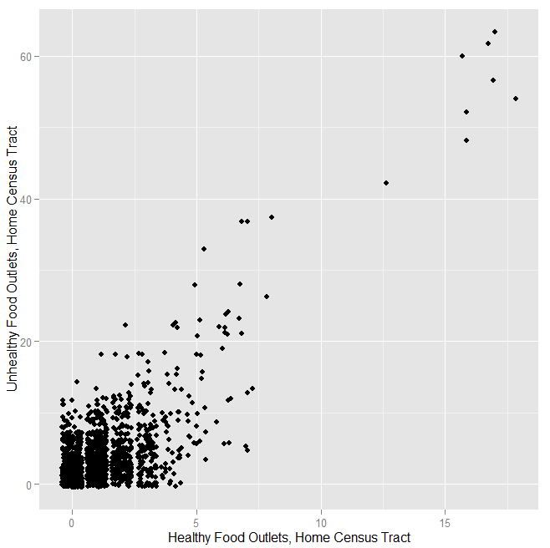

**Figure 3. Kernel Density Plot of counts of various types of business establishments within 5km buffer of centroid of home census tracts, stratified by case/control status, using comparable cases and controls as defined in Table 1.**

**I think this is better suited for the supplement, but we may want to pick one or two for a figure 2 for the main paper**

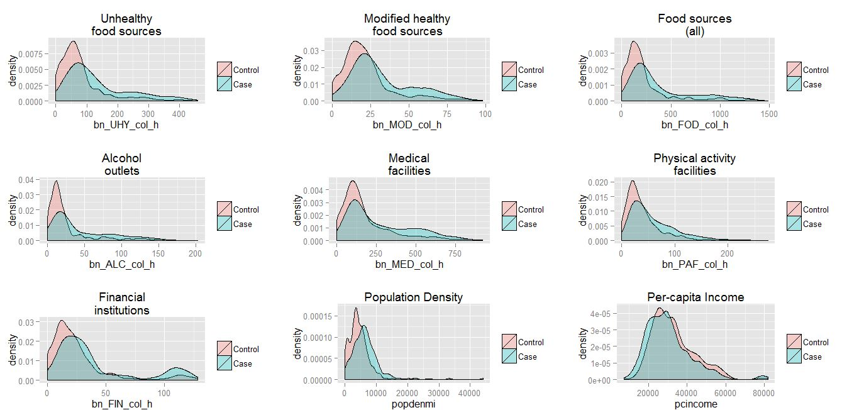

**Figure 4. Kernel Density Plot of counts of various types of business establishments within 5km buffer of centroid of home census tracts, stratified by survival after cardiac arrest, among 1613 cases presenting with ventricular fibrillation**

**Similar to Figure 3 above, I think this is better suited for the supplement, but we may want to pick one or two for a figure 2 for the main paper**

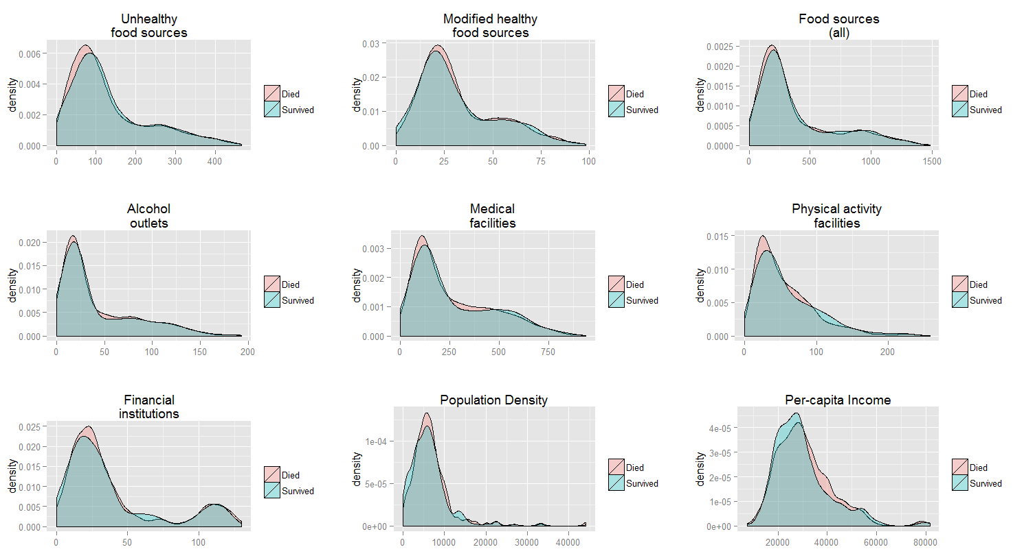

**Figure 5: Correlation of tract per-capita income to Parcel Improved Value for parcel closest to subject reported home address, 3320 subjects for whom data were available. FOR SUPPLEMENTARY MATERIAL (?)**

