**Aim 2b Tables**

**Table 1. Selected Characteristics of NYCNAMES-II Study Population and the subset who completed three waves of data collection (Repeated from aim 2a)**

|  |  |  |
| --- | --- | --- |
|  | Study Population  (N=3,497) | Completed Three Waves  (N=2,023) |
| Characteristic | **%** | **%** |
| Age |  |  |
| 65-68 | 33 | 34 |
| 69-71 | 21 | 21 |
| 72-75 | 46 | 45 |
| Sex |  |  |
| Female | 60 | 61 |
| Male | 40 | 39 |
| Race/Ethnicity |  |  |
| Non-Hispanic White | 52 | 55 |
| Non-Hispanic Black | 31 | 30 |
| Hispanic | 11 | 9 |
| Other | 7 | 6 |
| Educational Attainment |  |  |
| Less than High School | 19 | 16 |
| Completed High School | 27 | 26 |
| Some College | 18 | 17 |
| Completed College | 36 | 41 |
| Household Income |  |  |
| Less than $20,000 | 36 | 33 |
| $20,000-40,000 | 25 | 24 |
| $40,000-80,000 | 21 | 22 |
| More than $80,000 | 18 | 21 |

**Table 2. Frequencies of Activity Participation across all 3 waves of data collection**

|  |  |  |  |  |  |
| --- | --- | --- | --- | --- | --- |
| Activity | Wave 1 | Wave 2 | Wave 3 | Examples |  |
| Ever-Sports | 55.2 | 54.8 | 55.2 | Golf, dancing, basketball, hiking, jogging |  |
| Often-Sports | 27.9 | 26.6 | 25.3 | Sports for more than 30 minutes a day |  |
| Ever-Exercises | 37.6 | 36.8 | 38.4 | Calisthenics, sit-ups, weight lifting |  |
| Often-Exercises | 5.9 | 5.2 | 5.5 | Exercises for more than 30 minutes a day |  |
| Ever-Walking | 91.5 | 90.6 | 90.2 |  |  |
| Often-Walking | 52.6 | 50.0 | 50.0 | Walking for more than 30 minutes a day |  |
| Caring for Others | 31.1 | 30.4 | 31.2 | Caring for a person who requires assistance with daily living tasks (e.g. showering) |  |
| Outdoor Gardening | 21.1 | 18.7 | 20.5 | Planting plants, pruning, weeding |  |
| Heavy Housework | 10.7 | 9.8 | 10.5 | Vacuuming, sweeping, moving furniture |  |
| Home Repairs | 54.5 | 54.3 | 53.0 | Painting, plumbing, carpentry |  |
| Light Housework | 92.0 | 92.1 | 92.2 | Washing dishes, ironing, laundry |  |
| Lawn Work or Yard Care | 17.5 | 16.4 | 16.7 | Shoveling snow, lawn mowing |  |

**Table 3 Item response probabilities by latent class**

|  |  |  |  |  |  |  |  |
| --- | --- | --- | --- | --- | --- | --- | --- |
| Activity | Sports without  Heavy Housework | Walker | Gardener/ Athlete | Sports and Housework | Least Active | Gardener | Housework Only |
| Ever-Sports | 100% | 33% | 100% | 100% | 13% | 35% | 28% |
| Often-Sports | 73% | 0% | 77% | 64% | 1% | 0% | 0% |
| Ever-Exercises | 70% | 25% | 65% | 55% | 21% | 22% | 22% |
| Often-Exercises | 15% | 1% | 17% | 6% | 2% | 3% | 2% |
| Ever-Walking | 98% | 100% | 99% | 99% | 36% | 96% | 95% |
| Often-Walking | 73% | 40% | 73% | 78% | 0% | 45% | 47% |
| Caring for Others | 17% | 19% | 44% | 43% | 13% | 38% | 36% |
| Outdoor Gardening | 6% | 2% | 85% | 4% | 1% | 77% | 3% |
| Heavy Housework | 16% | 8% | 77% | 84% | 10% | 75% | 83% |
| Home Repairs | 2% | 3% | 33% | 11% | 2% | 25% | 6% |
| Light Housework | 85% | 90% | 96% | 99% | 68% | 96% | 100% |
| Lawn Work or Yard Care | 2% | 1% | 75% | 3% | 0% | 66% | 2% |
| Proportion of Cohort |  |  |  |  |  |  |  |
| Wave 1 | 11% | 16% | 12% | 16% | 11% | 11% | 24% |
| Wave 2 | 12% | 16% | 10% | 16% | 11% | 12% | 24% |
| Wave 3 | 10% | 16% | 10% | 17% | 12% | 12% | 23% |

**Table 4. Probability of Transitioning Between Classes Across Waves**

|  |  |  |  |  |  |  |  |  |
| --- | --- | --- | --- | --- | --- | --- | --- | --- |
|  | Wave 2 | | | | | | | |
| Wave 1 |  | **Sports w/o**  **Heavy Housework** | **Walker** | **Gardener/Athlete** | **Sports and Housework** | **Least Active** | **Gardener** | **Housework Only** |
| **Sports w/o Heavy Housework** | 69% | 16% | 1% | 6% | 3% | 2% | 4% |
| **Walker** | 14% | 75% | 0% | 0% | 4% | 1% | 5% |
| **Gardener/Athlete** | 6% | 0% | 65% | 5% | 0% | 22% | 2% |
| **Sports and Housework** | 3% | 2% | 2% | 70% | 0% | 0% | 23% |
| **Least Active** | 1% | 7% | 0% | 0% | 79% | 1% | 11% |
| **Gardener** | 4% | 5% | 12% | 0% | 2% | 72% | 4% |
| **Housework Only** | 1% | 0% | 2% | 14% | 5% | 4% | 74% |
|  | **Wave 3** | | | | | | | |
| Wave 2 | **Sports w/o Heavy Housework** | 66% | 14% | 8% | 0% | 4% | 3% | 5% |
| **Walker** | 11% | 75% | 0% | 0% | 7% | 1% | 6% |
| **Gardener/Athlete** | 5% | 0% | 70% | 4% | 1% | 18% | 2% |
| **Sports and Housework** | 0% | 4% | 0% | 79% | 0% | 0% | 17% |
| **Least Active** | 1% | 11% | 0% | 0% | 83% | 2% | 3% |
| **Gardener** | 2% | 0% | 18% | 2% | 2% | 71% | 4% |
| **Housework Only** | 0% | 5% | 0% | 14% | 4% | 5% | 72% |

**Same data as Table 4: Wave 1, presented as a figure**

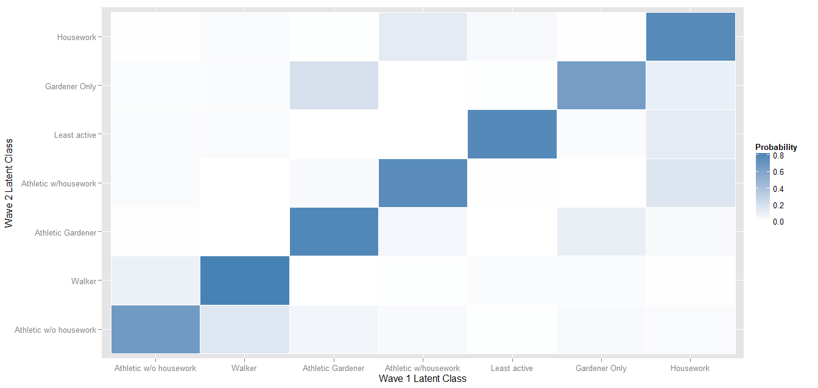

Another figure I’m thinking about, though I don’t love it: classes in terms of adding categories of activities:

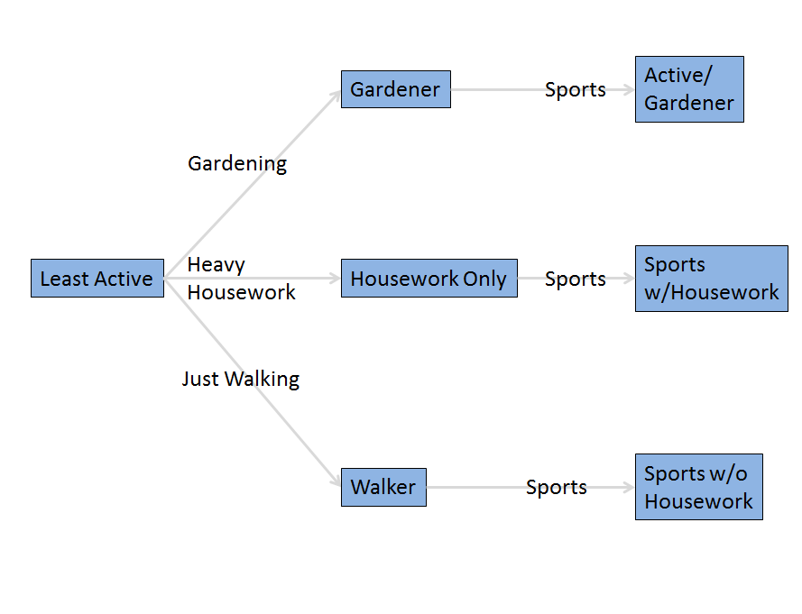

To do: Predictors of class membership (in any wave)

Disorder varies between latent classes cross-sectionally:

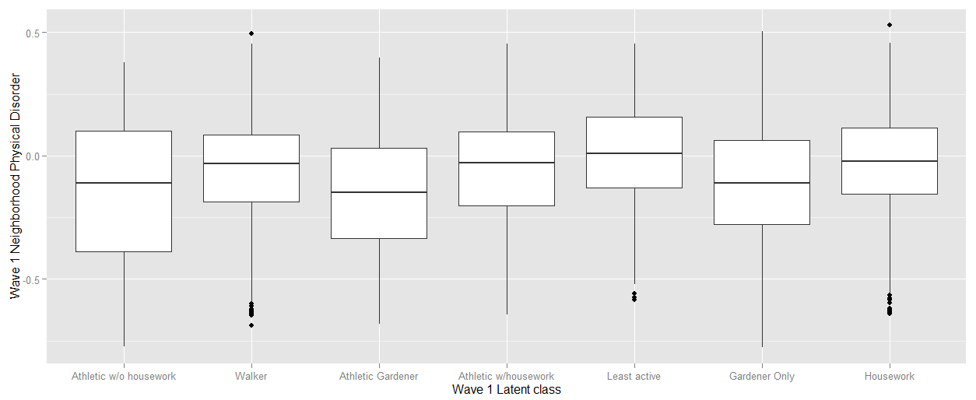

As does self-reported health, gender, borough, and probably a lot of other demographic characteristics. But we explored a lot of that already in the NYCNAMES-LCA paper. So it’s the transitions that are interesting…

**Predictors of transition between classes**

I haven’t found much that predicts transition between latent class, except for increase in # of health conditions, which may be co-occurring due to other change.

One exception: W1 Latent class as predictor of # of newly diagnosed health conditions b/t W1 and W3 was stronger than W1 PASE: R-squared of .05 for latent class, 0.02 for PASE (both significantly different from zero, not sure how to test vs. each other – use AICs or something?).

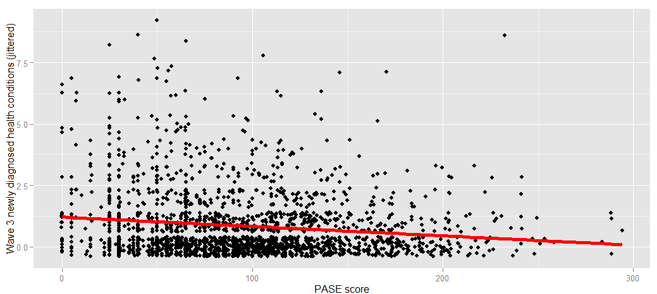

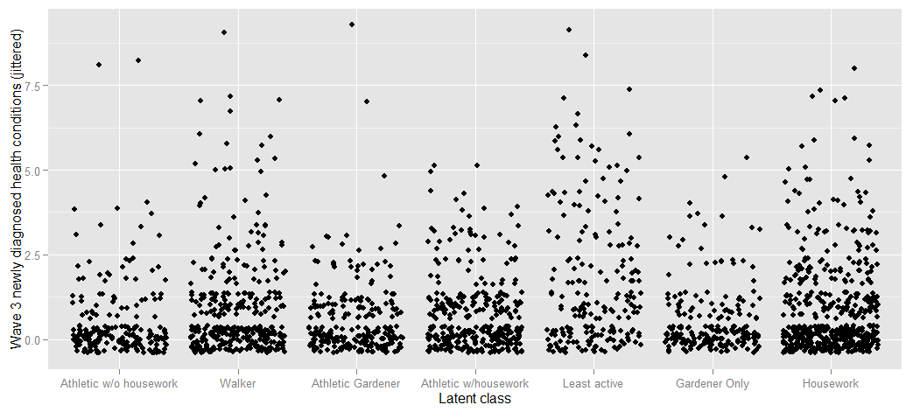

**Appendix Table 1. Latent Transition Model Fit Statistics**

|  |  |  |  |
| --- | --- | --- | --- |
| Number of latent classes | AIC | BIC | G2 |
| 3 | 33251.45 | 33532.07 | 33151.45 |
| 4 | 32139.65 | 32560.58 | 31989.65 |
| 5 | 30722.59 | 31306.27 | 30514.59 |
| 6 | 30299.69 | 31068.58 | 30025.69 |
| 7 | 29844.51 | 30821.06 | 29496.51 |
| 8 | 29727.84 | 30934.49 | 29297.84 |