**ThermoPic – A Tool for Predicting and Visualizing the Seasonal Availability of Thermal Habitat in Lakes**

Charles K. Minns1, Simon Fung2, Brian Shuter1,2, and Nigel Lester1,2

1. Ecology and Evolutionary Biology, University of Toronto

2. Aquatic Research and Monitoring Section, Science and Research Branch, Ontario Ministry of Natural Resources and Forestry, Peterborough, Ontario

Document: Revised project completion report from a Climate Change project funded in 2014-2015

Version: 2018.01.19 (v3b)

Project Title: Expanding the seasonal temperature profile model to report thermal habitat in Broad-scale Monitoring reports

Project Code: MNR-CC-14-15-10

Project Lead: Nigel Lester

Collaborators: Simon Fung, Charles K. Minns and Brian Shuter

Original Report Title: Calibration of a seasonal temperature profile model (STM) for estimating thermal habitat in lakes

**Table of Contents**

1. Measuring Thermal Habitat in Lakes

2. Summary of Results

2.1 Estimating STM Parameters from BsM Point-in-Time Data

2.2 Estimating STM Parameters from Time Series Profile Data

2.3 Estimating Missing Lake Parameters from BsM Data

2.4 Predicting Thermal Habitat Space

3. Conclusions and Recommendations

4. References

5. Acknowledgments

6. Tables

7. Figures

Appendix A. Technical Details

A1. Estimating STM Parameters from BsM Point-in-Time Data

A2. Estimating STM Parameters from Time Series Profile Data

A3. Estimating Missing Lake Parameters from BsM Data

A4. Predicting Thermal Habitat Space

A5. Comparison of STM Parameters Using Old and New Models

Appendix B. Data Archive

B1. BsM Cycle 1

B2. Non-BsM Data

Appendix C. Guide to ThermoPic Software

C1. File Organization

C2. R Programs

C3. Data Input

C4. Data Output

C5. Data Dictionary

**1. Measuring Thermal Habitat in Lakes**

Thermal habitat is a key driver of fisheries productivity in lakes with different fishes having different thermal requirements. For example, the continuous availability of cold water during summer strongly influences the success of Lake Trout populations; on the other hand, the lack of warm water in the summer limits the ability of Smallmouth Bass (and other warm water fish) to inhabit lakes. Thermal habitat in lakes is shaped by the interaction of a number of climate-, landscape- and lake-related parameters: mean monthly air temperatures strongly influences surface warming/cooling; the concentration of dissolved organic carbon influences the water colour and thereby modifies the penetration of light and the depth at which stratification occurs; and the area and maximum depth of a lake which bound the stratification depth).

The Inland Lakes Broad-scale Monitoring (BsM) program for Ontario (Sandstrom et al. 2013) includes a number of measurements intended to provide indicators of thermal habitat alongside other ecosystem components. The principal source of thermal habitat information is the single depth-interval profile taken of temperature and oxygen during the only visit to the lake during summer to sample the fish communities. The initial framework for BsM reporting provides a series of habitat statistics based on the models of Shuter et al (1983); the statistics include the duration of the ice-free season, maximum summer surface temperatures, daily surface temperature during the ice-free season, thermocline depth, and the volume of the hypolimnetic space below the thermocline. Recently, new models have been published for ice-on/off dates (Shuter et al 2013) and for seasonal temperature profiles in stratified lakes (Seasonal temperature-profile model or STM; Minns et al 2013). These models have been used to generate regional projections under climate change for Ontario’s inland lakes (Ice-cover Minns et al 2014; open water temperature regimes and suitable thermal space for fishes based on the STM Minns et al 2015).

The main purpose of this project was to examine the opportunities to update, expand and further standardize the array of lacustrine habitat metrics available for BsM assessment reports. The BsM program sampled 721 lakes province-wide during its first cycle, 336 of which are in the Great Lakes Basin. In this report, we demonstrate how further development of a seasonal temperature model enables characterization of fish thermal habitat in lakes, and, thus, provides a foundation for modeling climate change impacts. This challenge is described through the graphs displayed in Figures 1 and 2. Figure 1a illustrates how the temperature profile of a lake varies seasonally. The profile is isothermal in the early spring (Day < 125) and late fall (Day = 320); surface temperature increases from ice-out to midsummer (days = 125, 150, 175, 200); then surface temperature decreases (days 220, 250, 285). In this example of a deep lake, thermal stratification occurs during the summer so that temperature at the lake bottom is cold throughout the year. In shallow lakes, thermal stratification does not occur and thus suitable habitat for cold water fish does not exist during the summer. The STM does not address the period when the lake is ice-covered.

Modeling the availability of water at different temperatures requires a model of the sort shown in Figure 1b (from Minns et al. 2013). The triangle (and diagonal lines within) describe temperature through time at different depths. The bottom of the triangle is the deepwater (hypolimnion) temperature (TN). The ascending and descending sides of the triangle show changing surface temperature, reaching its maximum (TX) at midsummer. The diagonal lines show changes in temperature at different depths (e.g. 5, 10, 15 m). Significant dates include the onset of stratification (JS), the midsummer peak (JM) and the end of stratification (JE). Our ability to predict water temperature in lakes depends on our ability to predict the five anchor points shown in Figure 1b, as well as three other parameters: maximum thermocline depth (ZM), the day after onset when thermocline depth reaches one-half its maximum (ZJ), and the steepness of the temperature transition from epilimnion to the hypolimnion (SP). In this paper, we expand on earlier work (Minns et al. 2013) showing how these anchor points can be predicted from easily measure lake variables (e.g. air temperature, lake depth and area, latitude, etc.,).

The fish habitat outcome of this modeling is demonstrated in Figure 2, as a ThermoPic. It portrays the seasonal availability of different water temperatures, measured as percentage of lake volume. Thermal habitat is colour coded with cold water (8-12 oC, blue) shown at the bottom and warm water (24-28 oC, red) shown at the top. This thermal habitat picture (i.e., ThermoPic) can be generated for any lake given the input parameters we describe in this paper. ThermoPics show the seasonal variation in the portion of a lake’s space having temperatures spanning the thermal niche of various fish guilds. ThermoPics offer a convenient means of contrasting habitat available in different lakes or in the same lake at different points in time. We expect ThermoPics will be very useful for portraying impacts of climate change. In this report, we demonstrate their utility by contrasting the availability of thermal habitat in lakes within the Great Lakes Basin using lake data collected by the BsM program. In addition, we provide the software tools that will generate a seasonal temperature profile and the implied ThermoPic for any lake where the input variables are available. We illustrate the application of these tools by showing how they may be used to characterize fish habitat in lakes of the Great Lakes Basin.

There were four main components to the project. In the **first**, we examined the utility of the BsM single-day temperature profile data for developing a seasonal temperature model (STM). Although each lake was sampled only once within a five-year period (2008-2012), the pooled data from many lakes offered an opportunity to explore which STM parameters could be predicted from a multi-lake point in time dataset. In addition, a physics-based approach was applied to determine basic profile characteristics, in particular the presence-absence of stable thermal stratification. The **second** component used seasonal temperature profile data collected from Ontario lakes to predict STM parameters. These data were available from 60 Ontario lakes studied by the University of Toronto and others, and 25 lakes studied by MNRF in the Northwest region where time series temperature monitoring was implemented in 2008. The **third** component used available BsM data in regression models to fill gaps in lake specific input parameters for predicting STM parameters:Some missing values were observed in the BsM dataset for shoreline length (Shoreline\_km, km), Secchi depth (m), and DOC (Dissolved Organic Carbon mg/l). The **fourth** component of this project centred on the development of a computer program to generate thermal habitat statistics and create ThermoPics (e.g., Figure 2). This software is documented in Appendix C (Guide to ThermoPic Software). We illustrate application of the STM model and supporting software by generating habitat statistics and ThermoPics for BsM lakes in the Great Lakes basin. Results are summarized in this report by contrasting thermal habitat of lakes in the five drainage areas of the Great Lakes basin. Results for all BsM lakes and a complete archive of ThermoPics are included as supplementary material (see Appendix B).

Results from these four components are summarized in the main report; technical details are given in Appendix A. An additional component of the work examined how new models developed here differ from old models used to predict thermal properties of lakes. That work is described at the end of Appendix A. The comparison includes prediction of (1) number of ice-free days, (2) maximum surface temperature, and (3) thermocline depth. This comparison is especially useful because current BsM reporting (e.g. Cycle 1 Lake Synopses) is based on old models.

**2. Summary of Results**

**2.1 Estimating STM Parameters from BsM Point-in-Time Data**

Single day temperature profiles from 660 BsM lakes sampled during 2008-2012 were analyzed. The analyses of Lake Number (an indicator of stratification strength) showed that presence/absence of stratification was correctly predicted in 89% of BsM lakes by a simple function of lake area, maximum depth and dissolved organic carbon (DOC) concentration. In addition, the analyses of the singleton summertime BsM temperature profiles provided information about four of the STM input parameters (TX , TN, ZM, SP).

Regression showed that surface temperature varied with day of year, DOC, elevation above sea level and mean summer air temperature (Jun-Aug). Given a fixed estimate of the midsummer peak date (JM) for all lakes, the day of year components of the regression equation can be used to adjust the observed surface temperature and provide an estimate of maximum surface temperature (TX). In stratified lakes, the bottom temperature provides an estimate of TN; regression analysis showed this parameter is predictable from lake area, maximum depth and Secchi depth (i.e., an indicator of vertical light penetration in lakes). The analyses of point estimates of thermocline depth showed that it increases during summer in most lakes and hence is largely predictable from day of year, lake area and mean summer air temperature (Jun-Aug). The steepness of stratification (SP) typically has a value in the 4 to 6 range and is weakly predictable from lake area, maximum depth, and mean summer air temperature combined with thermocline depth and the day of year that it was observed.

These regression results, obtained using the BsM point-in-time profiles, are quite similar to the results obtained with time series datasets as described in the following section. These results indicate that cumulatively the analysis and modelling of BsM profiles will provide a steadily improving picture of overall lake conditions across the province. With further analyses, the impacts of climate warming will become increasingly evident with details on the interregional variation in the rates of warming.

**2.2 Estimating STM Parameters from Time Series Profile Data**

Good fits to the seasonal temperature model were obtained for 152 of 170 lake-year time-series temperature profile datasets (where each R2 > 0.9). Four STM parameters (TX, TN, ZM and JE) were well predicted by regression models with varying mixtures of lake and climate variables as inputs. Predicting the onset of stratification (JS) was poor because many of the time series did not begin until well after the onset of stratification; however, existing empirical models of onset date can be used to provide estimates for the STM application. The steepness of stratification (SP) was poorly predicted but generally varies over a small range (3 to 6) with the result that little error is introduced into simulated temperature profiles. The estimates of the time from onset to the achievement of one-half maximum thermocline depth (ZJ) were bimodal with numerous zero values (indicating no change in thermocline depth during stratification) and many relatively high values with a wide range. These results require further investigation as they are not consistent within lakes across years; variation in winds seasonally from year to year may be a factor producing the bimodal results. The default approach with thermocline depth is to assume ZJ is zero whereby ZTH = ZM.

Regression results for all STM parameters and input variables are shown in Appendix A (Tables A2). Input variables include lake location (latitude/longitude), surface area, shoreline length, elevation, maximum depth, mean depth, Secchi depth, DOC, date of ice cover break up, mean air temperature (for various portions of the year), and mean August precipitation. Date of ice-cover break up can be estimated from a subset of these input variables, but also requires the angular elevation of the noon sun during the spring (Shuter et al. 2013, see Table A7).

**2.3 Estimating Missing Lake Parameters from BsM Data**

There were some instances of missing values for a few of the lake parameters (Shoreline length, Secchi depth, and DOC) which go into equations to predict lake-specific STM parameters. To address this the BsM dataset was analyzed using least-square regression to develop predictive equations. The results obtained meant that thermal space estimates could be developed for all BsM survey lakes. Details of the regression models are shown in Appendix A.

**2.4 Predicting Thermal Habitat Space**

A computer program was developed which takes STM parameter estimates for a single lake in a particular year and predicts temperature profiles from the isothermal condition at 4°C in the spring until a return to that isothermal condition in the fall. The thermally-suitable volumes and areas within the lake are computed over five preferred temperatures ranges which cover the majority of species preferences for Ontario’s freshwater fishes: 8-12, 12-16, 16-20, 20-24, and 24-28 °C. Daily estimates of thermal space are then summarized into a range of habitat metrics. While the STM model is set up for stratified lakes, a modified version for un-stratified lakes assumes that whole lake temperatures follow surface values between the 4°C isothermal boundaries. The un-stratified version recognizes that the seasonal availability of some preferred temperature ranges may be discontinuous and tracks the two seasons separately. In addition to computing the habitat statistics, the user has the option of generating a ThermoPic graph showing the seasonal availability of suitable thermal volume with markers to indicate the time of ice break-up, freeze-up, and the 4°C isothermal dates. This software is documented in Appendix C (Guide to ThermoPic Software).

The rest of this section demonstrates how the products developed here can be applied to describe fish habitat in the Great Lakes Basin. For the 336 BsM lakes sampled in the Great Lakes Basin (Figure 3), we computed STM parameters using formulae shown in Table A2. Figure 4 shows how thermal characteristics of lakes vary within and among the five drainage areas (Superior, Huron, Ontario, Upper St. Lawrence and Erie). Maximum surface temperature generally increases with air temperature (Figure 4a), but is heavily influenced by lake area (Figure 4b) - smaller lakes attaining a higher maximum temperature. Ice-free duration also increases with air temperature, but the effect of lake size is less clear (Figure 4c, d). Table 2 summarizes these traits, as well as thermocline depth, by drainage area, showing that lakes in the Superior drainage typically have a shorter ice-free period, a lower maximum surface temperature.

Implications of variation in the STM parameters are illustrated in Figures 5, 6 and 7. ThermoPics (Figure 5) contrast the thermal conditions of lakes in the cold northwest (i.e., Superior) to lakes in a warmer area (i.e., Upper St. Lawrence). Metrics displayed in these ThermoPics were used to calculate annual indices of the availability of thermal habitat for cold, cool and warmwater fish species. Figure 6 shows how an index of warmwater habitat varies within and among lakes of the drainage areas (see figure caption for details). Figure 7 illustrates how this habitat index influences fish communities in lakes. The y-axis in each graph is the proportion (by weight) of warmwater fish in the lake, based on whole lake sampling by the large mesh BsM gillnets. The logistic curve illustrates how this measure of community composition increases with the relative volume of warmwater habitat.

**3. Conclusions and Recommendations**

The analyses of the BsM temperature profiles and the time-series temperature datasets have yielded very encouraging results. The accumulation of temperature profile data through the BsM program will provide a steadily improving picture of overall lake conditions across the province. This picture can be further improved by collecting seasonal time series data from a subset of lakes, an exercise that the Northwest Region initiated in 2008. This improved understanding of how water temperature in lakes relates to air temperature is fundamentally important for predicting impacts of climate change. Our results demonstrated that model-based estimates of the thermal habitat in lakes of the Great Lakes Basin correlated well with the fish community composition. This validation supports application of the model for exploring the fish community response to projected changes in air temperature.

**3.1 Recommendations for BsM Reporting:**

1. Habitat statistics reported in the BsM lake synopses can be improved by using newer predictive equations which take more factors into account.
2. Modify the format of BsM lake synopses to incorporate thermal habitat measures generated by the ThermoPic software. For example, one could include the ThermoPic graph for each lake, as well as thermal habitat suitability scores for coldwater, coolwater and warmwater fish (as demonstrated in Figure 6). The material needed to update BsM lake synopses is included in Appendix B of this report. It includes a ThermoPic for each Cycle 1 BsM lake (n=721), as well as STM parameters and thermal habitat measures.

**3.2 Recommendations for Field Sampling of Lake Temperatures:**

1. Supplement the spring water quality survey of BsM lakes with limited *in situ* temperature measurements at the 0.5 and 10 m depths (or bottom if the lake is shallower). These measurements would enhance efforts to estimate STM parameters.
2. Do seasonal temperature monitoring in a subset of BsM lakes in each Fisheries Management Zone to enhance the regional characterization of seasonal temperature regimes. We recommend a minimum of one lake in each lake size stratum (50-500, 500-1500, 1500-5000, > 5000 ha). This enhancement to the BsM program could be initiated in 2015, because the required equipment has already been purchased by the Aquatic Research and Monitoring Section.
3. For lakes where seasonal temperature monitoring is done, temperature logger strings should be installed within 15 days after ice break up. The current protocol is often failing to capture the early portion of the stratification period. The lack of data in the spring is causing the model to fit an earlier date for the onset of stratification (JS) than expected.

**3.3 Potential Further Development Work**

1. Use the BsM data to explore further the use of thermal habitat space indices for explaining among-lake variation in the composition of fish communities.
2. Build on the STM temperature analysis framework to predict seasonal variation in oxygen concentration at depth. This would expand the framework so that it predicts the availability of habitat meeting both temperature and oxygen requirements. This expansion is important for predicting effects of climate change. Longer periods of stratification (resulting from a warmer climate) increase oxygen depletion in the hypolimnion and thus reduce the supply of suitable thermal-oxygen habitat for coldwater fish.
3. Elaborate the framework to project future thermal space metrics of any Ontario lakes under climate change building on the regional prototype (Minns et al 2015).

**4. References**

Coker, G.A., C.B. Portt, and C.K. Minns. 2001. Morphological and Ecological Characteristics of Canadian Freshwater Fishes. Can. MS. Rpt. Fish. Aquat. Sci. 2554: iv+89 p.

Lester, N. P., A. J. Dextrase, R. S. Kushneriuk, M. R. Rawson and P. A. Ryan. 2004. Light and temperature: key factors affecting walleye abundance and production. Transactions of the American Fisheries Society 133: 588-605.

Mackenzie-Grieve, J.L., and J.R. Post. 2006. Projected impacts of climate warming on production of lake trout (*Salvelinus namaycush*) in southern Yukon lakes. Can. J. Fish. Aquat. Sci. **63**(4): 788–797.

Minns, C.K. and B.J. Shuter. 2013. A semi-mechanistic seasonal temperature-profile model (STM) for the period of stratification in dimictic lakes. Can. J. Fish. Aquat. Sci. 70(2): 169-181.

Minns, C.K., B.J. Shuter and S. Fung. 2014. Regional Projections of Climate Change Effects on Ice Cover and Open-Water Duration for Ontario Lakes Using Updated Ice-Date Models. Ontario Ministry of Natural Resources, Climate Change Research Report 40:52p.

Minns, C.K., B.J. Shuter and S. Fung. 2015. Regional Projections of Climate Change Effects on Thermal Habitat Space for Fishes in Stratified Ontario Lakes. Ontario Ministry of Natural Resources, Climate Change Research Report 41:32p.

R Core Team (2014). R: A language and environment for statistical computing. R Foundation for Statistical Computing, Vienna, Austria. URL http://www.R-project.org/.

Read J.S., D.P. Hamilton, I.D. Jones, K. Muraoka, L.A. Winslow, R. Kroiss, C.H. Wu and E. Gaiser. 2011. Derivation of lake mixing and stratification indices from high-resolution lake buoy data. Env. Modelling & Software 26: 1325-1336.

Sandstrom, S, M. Rawson and N. Lester. 2013. Manual of Instructions for Broad-scale Fish Community Monitoring; using North American (NA1) and Ontario Small Mesh (ON2) Gillnets. Ontario Ministry of Natural Resources. Peterborough, Ontario. Version 2013.2 35 p. +appendices.

Shuter, B.J., C.K. Minns and S.R. Fung. 2013. Empirical models for forecasting changes in the phenology of ice cover for Canadian lakes. Can. J. Fish. Aquat. Sci. 70(7): 982-991.

Shuter, B.J., D.A. Schlesinger and A.P. Zimmerman. 1983. Empirical predictors of annual surface water temperature cycles in North American lakes. Can. J. Fish. Aquat. Sci. **40**(10): 1838–1845.

Sprugel, D.G. 1983. Correcting for bias in log-transformed allometric equations. Ecology **64**: 209-201.

Winslow, L., J. Read, R. Woolway, J. Brentrup, T. Leach and J. Zwart . 2014. Package ‘rLakeAnalyzer’ for the analysis of lake physics. Version 1.4 2014-07-07. [<http://cran.r-project.org/web/packages/rLakeAnalyzer/index.html> accessed 2015-01

**5. Acknowledgments**

This research was supported through a research grant from the MNRF Climate Change fund (MNR CC-14-15-10).We thank the many people from the Ontario Ministry of Natural Resources and Forestry and from the University of Toronto who have contributed to the collection of water temperature data in Ontario lakes and made data available for this research. In particular, we acknowledge Mark Sobchuk for initiating a water temperature monitoring program in northwest Ontario and Pete Addison for his management of that data.

**6. Tables**

Table 1. List of parameters needed to describe the Seasonal Temperature Model (STM). When these parameters are known or predicted from lake variables, then it is possible to calculate the seasonal availability of thermal habitat.

Table 2. Projected mean thermal attributes (with coefficient of variation) of inland lakes summarized by Great Lakes basin and lake size class: 1 = 50 ha, 2 = 50-500 ha, 3 = 500-1500 ha, 4 = 1500-5000 ha, 5 = >5000 ha. Projections are generated using decadal climate averages from 2001 to 2010.

Table 1. List of parameters needed to describe the Seasonal Temperature Model (STM). When these parameters are known or predicted from lake variables, then it is possible to calculate the seasonal availability of thermal habitat.

|  |  |
| --- | --- |
| **Label** | **Description** |
| **JS** | Start of lake stratification (Julian day) |
| **JM** | Day of peak water surface temperature (Julian day) |
| **JE** | End of lake stratification (Julian day) |
| **TX** | Maximum surface water temperature (°C) |
| **TN** | Hypolimnion water temperature (°C) |
| **ZTH** | Midsummer depth of thermocline (m) [= *f*(JS, JM, ZM, & ZJ)] |
| **ZM** | Maximum depth of thermocline (m) |
| **ZJ** | Number of days from the start of stratification to when the thermocline reaches half its maximum depth |
| **SP** | Steepness coefficient describing the change of temperature with depth |

Table 2. Projected mean thermal attributes (with coefficient of variation) of inland lakes summarized by Great Lakes basin and lake size class: 1 = 50 ha, 2 = 50-500 ha, 3 = 500-1500 ha, 4 = 1500-5000 ha, 5 = >5000 ha. Projections are generated using decadal climate averages from 2001 to 2010.

|  |  |  |  |  |  |
| --- | --- | --- | --- | --- | --- |
| Basin | Lake Size  Class | Number of  BsM lakes | Maximum Surface Water  Temperature (TX, °C) | Number of  Ice Free  Days | Midsummer  Thermocline  Depth  (ZTH, m) |
| Superior | 1 | 14 | 24.0 (0.03) | 220 (0.04) | 5.2 (0.05) |
|  | 2 | 58 | 23.9 (0.03) | 219 (0.06) | 6.4 (0.11) |
|  | 3 | 23 | 23.1 (0.03) | 212 (0.05) | 8.0 (0.07) |
|  | 4 | 16 | 22.8 (0.02) | 212 (0.04) | 9.7 (0.08) |
|  | 5 | 5 | 21.7 (0.03) | 216 (0.08) | 10.7 (0.06) |
| Huron | 1 | 11 | 25.4 (0.02) | 229 (0.03) | 5.4 (0.05) |
|  | 2 | 72 | 25.3 (0.02) | 235 (0.04) | 6.8 (0.10) |
|  | 3 | 32 | 25.0 (0.02) | 240 (0.04) | 8.8 (0.07) |
|  | 4 | 18 | 24.3 (0.02) | 242 (0.05) | 10.4 (0.11) |
|  | 5 | 10 | 23.0 (0.04) | 247 (0.05) | 12.4 (0.15) |
| Ontario | 1 | 5 | 26.0 (0.02) | 241 (0.01) | 5.4 (0.06) |
|  | 2 | 17 | 26.1 (0.01) | 244 (0.01) | 6.9 (0.11) |
|  | 3 | 11 | 25.5 (0.02) | 246 (0.02) | 8.8 (0.06) |
|  | 4 | 4 | 25.1 (0.01) | 243 (0.01) | 10.1 (0.09) |
|  | 5 | 3 | 24.5 (0.02) | 244 (0.01) | 11.3 (0.09) |
| Upper St. Lawrence | 1 | 4 | 25.2 (0.02) | 222 (0.05) | 5.2 (0.09) |
|  | 2 | 23 | 25.7 (0.03) | 236 (0.05) | 7.0 (0.11) |
|  | 3 | 19 | 25.2 (0.04) | 238 (0.06) | 8.9 (0.07) |
|  | 4 | 26 | 24.5 (0.03) | 240 (0.05) | 10.1 (0.08) |
|  | 5 | 1 | 23.0 (NA) | 221 (NA) | 10.7 (NA) |
| Erie | 2 | 1 | 27.4 (NA) | 254 (NA) | 7.3 (NA) |
|  | 3 | 2 | 26.6 (0.01) | 253 (0.02) | 7.9 (0.05) |

**7. Figures**

Figure 1. Seasonal temperature cycle in a lake. Temperature profiles in a lake for different days of the year (a), illustrating warming of surface waters during the summer and creation of a thermocline. Depiction of seasonal temperature model (b) showing some key parameters. See Table 1 and text for explanation.

Figure 2. Example of a ThermoPic describing the seasonal availability of thermal habitat in a lake. Thermal habitat (expressed as percentage of lake volume) is plotted against day of year for five 4 °C temperature intervals: 8-12, 12-16, 16-20, 20-24, 24-28. Vertical lines are projected ice break-up date (BU), freeze-up (FU) date and the 4 oC isothermal dates in spring and fall.

Figure 3. Map of Ontario showing spatial variation in air temperature (measured as annual degree days above 5 oC) in 2010 and the location of lakes sampled by the BsM program during cycle 1 (2008-2012; lakes in the Great Lakes Basin as black dots and the rest as white dots). The map shows the major drainage boundaries of the Great Lakes (Superior, Huron, Ontario, Upper St. Lawrence, Erie).

Figure 4. Example of lake parameters generated by the STM model, organized by drainage area. In all graphs, the x-axis is an index of air temperature (Degree-days above 5oC).

Figure 5. ThermoPics of two lakes from the Superior drainage and two lakes from the Upper St. Lawrence (USL) drainage. Lakes on the left are un-stratified; lakes on the right are stratified. The pictures portray the increased availability of warm water in lakes from the USL drainage (bottom graphs). See Figure 2 for details about ThermoPic graphs.

Figure 6. Example of how data shown in ThermoPics can be used to develop thermal habitat indices for lakes. Each point is an estimate for a single lake, plotted against Growing Degree Days above 5°C for 2001-2010The Relative Warmwater Index is the weighted sum of thermal habitat volume suitable for warmwater fish relative to the sum of those scores for all thermal guilds (Cold, Cool and Warmwater fish).

Figure 7. Demonstration of how the Relative Warmwater Index predicts relative biomass of warmwater fish in lakes. The y-axis is the proportion (by weight) of warmwater fish caught in the large mesh BsM gillnets. Warmwater fish are species which have a thermal preference of greater than 25oC (based on Coker et al. 2000). The relationship is described by the logistic equation: **.**

Figure 1. Seasonal temperature cycle in a lake. Temperature profiles in a lake for different days of the year (a), illustrating warming of surface waters during the summer and creation of a thermocline. Depiction of seasonal temperature model (b) showing some key parameters. See text for explanation.

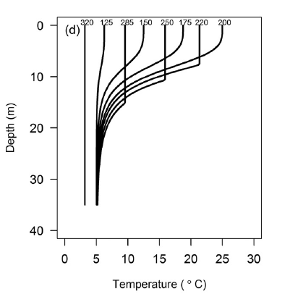

320 125 285 150 250 175 220 200

Day of Year

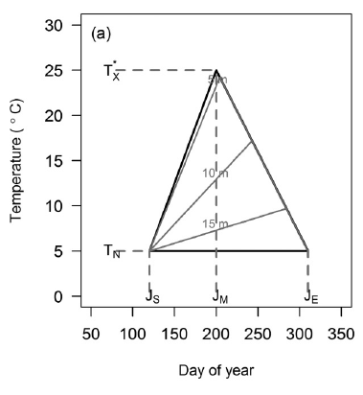

Figure 2. Example of a ThermoPic describing the seasonal availability of thermal habitat in a lake. Thermal habitat (expressed as percentage of lake volume) is plotted against day of year for five 4 °C temperature intervals: 8-12, 12-16, 16-20, 20-24, 24-28. Vertical lines are projected ice break-up date (BU), freeze-up (FU) date and the 4 oC isothermal dates in spring and fall.

C:\R_Data2\ThermPic_Shawenegog L. Y-P_2001-2010_20161005.tiff

24 - 28 C

4oC JM 4oC

8 – 12 C

12 – 16 C

16 – 20 C

20 – 25 C

Percentage of Lake Volume

BU JM FU

Day of year

Figure 3. Map of Ontario showing spatial variation in air temperature (measured as annual degree days above 5 oC) in 2010 and the location of lakes sampled by the BsM program during cycle 1 (2008-2012; lakes in the Great Lakes Basin as black dots and the rest as white dots). The map shows the major drainage boundaries of the Great Lakes (Superior, Huron, Ontario, Upper St. Lawrence, Erie).

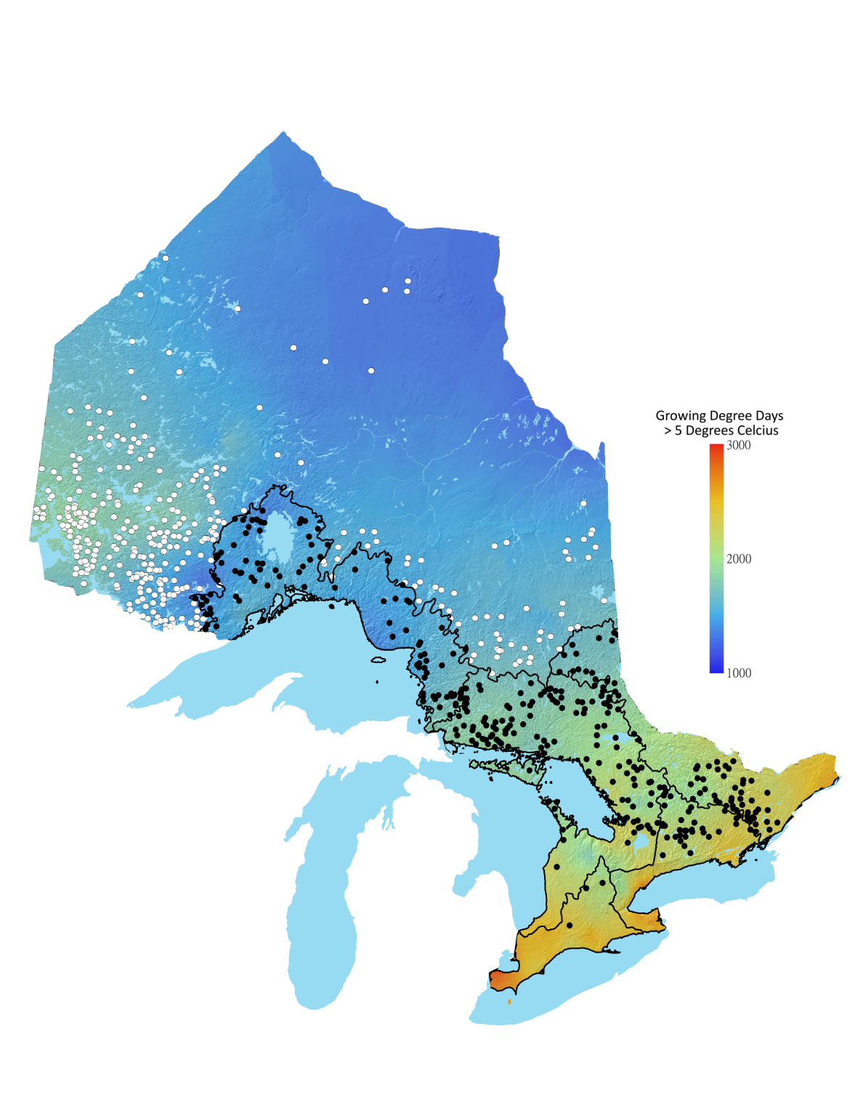

Figure 4. Example of lake parameters generated by the STM model, organized by drainage area. In all graphs, the x-axis is an index of air temperature for years 2001 - 2010 (Degree-days above 5oC).

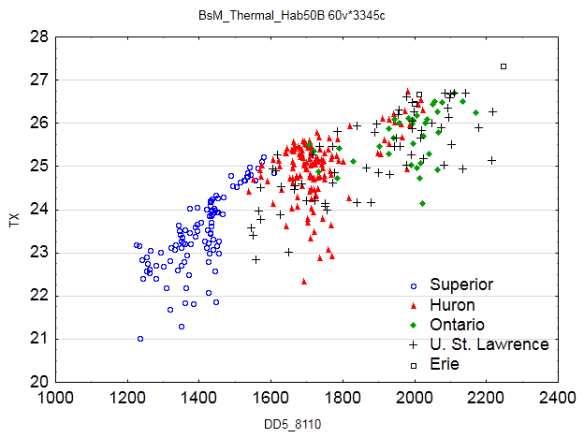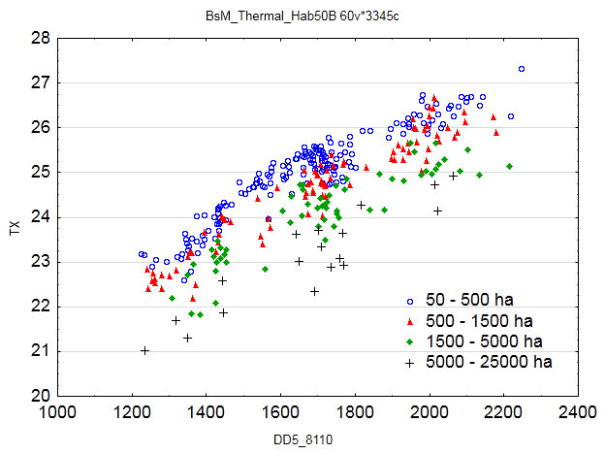

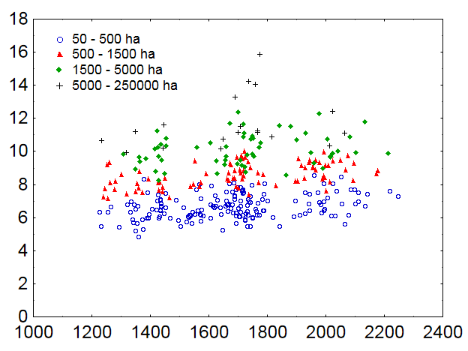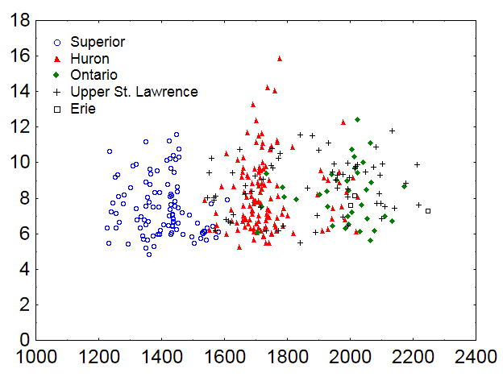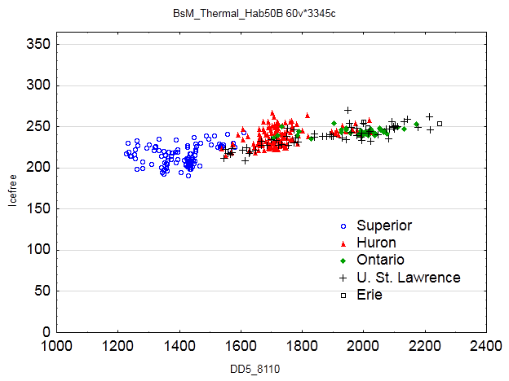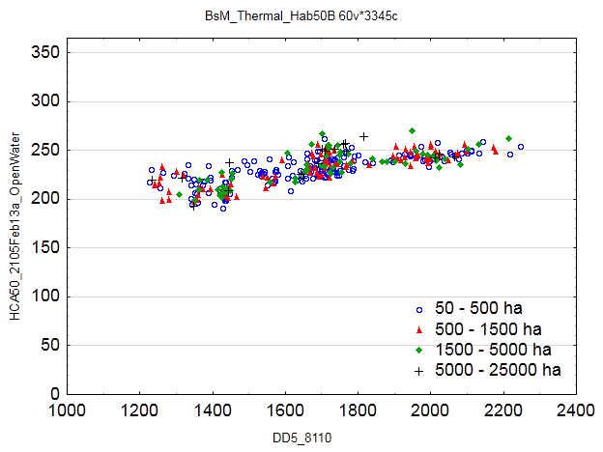6.6

Ice-free duration (days)

Degree Days above 5 oC

Midsummer

Thermocline Depth (m)

Maximum Surface

Temperature (oC)

Figure 5. ThermoPics of two lakes from the Superior drainage and two lakes from the Upper St. Lawrence (USL) drainage. Lakes on the left are un-stratified; lakes on the right are stratified. The pictures portray the increased availability of warm water in lakes from the USL drainage (bottom graphs). See Figure 2 for details about ThermoPic graphs.

.

Superior – Obonga

Superior – Gennis

C:\R_Data2\ThermPic_Gennis L. Y-P_2001-2010_20161005.tiff

****

USL – Christie

USL – Dalhousie

Day of year

Percentage of Lake Volume

Figure 6. Example of how data shown in ThermoPics can be used to develop thermal habitat indices for lakes. Each point is an estimate for a single lake, plotted against Growing Degree Days above 5°C for 2001-2010. Relative Warmwater Index is the weighted sum of thermal habitat volume suitable for warmwater fish relative to the sum of those scores for all thermal guilds (Cold-, Cool- and Warm-water fish). Weights applied when calculating indices for each thermal guild were as follows:

|  |  |  |  |  |  |
| --- | --- | --- | --- | --- | --- |
|  | **Temperature (°C)** | | | | |
| **Thermal Guild** | **8-12** | **12-16** | **16-20** | **20-24** | **24-28** |
| **Cold** | 3 | 2 | 1 | 0 | 0 |
| **Cool** | 0 | 1 | 2 | 2 | 1 |
| **Warm** | 0 | 0 | 1 | 2 | 3 |

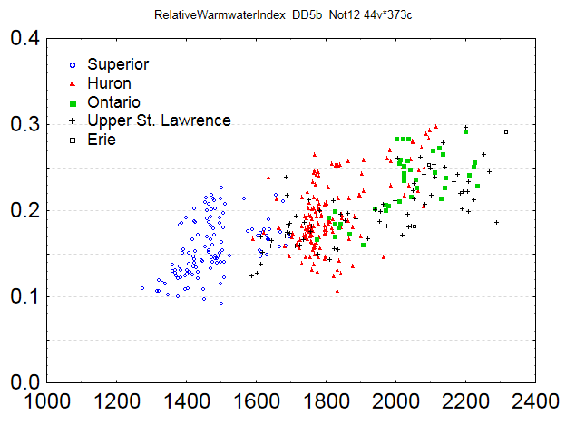

Relative Warmwater Index

Degree Days above 5 oC

Figure 7. Demonstration of how the Relative Warmwater Index predicts relative biomass of warmwater fish in lakes. The y-axis is the proportion (by weight) of warmwater fish caught in the large mesh BsM gillnets. Warmwater fish are species which have a thermal preference of greater than 25oC (based on Coker et al. 2000). The relationship is described by the logistic equation: **.**



Proportion Warmwater Fish

Relative Warmwater Index

U. St. Lawrence

/Erie

Ontario

Huron

Superior

**Appendix A. Technical Details**

**Table of Contents**

A1. Estimating STM Parameters from BsM Point-in-Time Data

A2. Estimating STM Parameters from Time Series Profile Data

A3. Estimating Missing Lake Parameters from BsM Data

A4. Predicting Thermal Habitat Space

A5. Comparison of STM Parameters Using Old and New Models

Table A1 provides a list of all parameters and inputs used in these analyses.

**A1. Estimating STM Parameters from BsM Point-in-Time Data**

Single day temperature profiles from 660 BsM lakes sampled during 2008-2012 were analyzed. First, the stratification status was assessed using the rLakeAnalyzer package (Winslow et al. 2014) to determine Schmidt Stability and Lake Number (cf Read et al 2011) and sort lake-year datasets into stratified and un-stratified. Lake Numbers are computed using a temperature-depth profile and the hypsometric curve for the lake; values greater than 1 are taken to indicate the presence of stable stratification. The likelihood of stratification is determined by lake area, maximum depth, and DOC concentration. Second, a single profile model (Mackenzie-Grieve and Post 2006, MGP), the precursor of the STM model, was fitted. During stratification, the MGP model provides estimates or indicators of four parameters in the STM model: TX, TN, SP and ZTH, which is a function of JM, ZM and ZJ. Sample estimates of those four parameters were pooled along with measures of lake size and water quality to examine the predictability of those parameters. Plots of parameter estimates against variables showing the strongest effect indicate the predictability of patterns (Figure A1).

The preliminary regression models developed were as follows with the significant input variables indicated. In all lakes:

* Stratification: A logistic regression correctly classifies stratification status in 88.7% of cases (ln Area, ln Maximum depth, DOC)
* Surface water temperature: R2 = 0.444 (Day of year, Area, DOC, Elevation, TJJA); Observed surface temperatures can be adjusted to midsummer (JM = 209.7) estimates of TX.

In stratified lakes (Lake Number > 1):

* Hypolimnetic water temperature (TN): R2 = 0.370 (Area, Max depth, Secchi)
* Midsummer thermocline depth (ZTH): R2 = 0.493 (Day of year, Area, TJJA)
* Steepness of stratification (SP): R2=0.225 (ZTH, Day of year, Area, Max depth, Tjja, ZTH) Values typically in 4-6 range.

Climate (mean summer air temperature) affects three of the five thermal characteristics.

**A2. Estimating STM Parameters from Time Series Data**

Seasonal time series of temperature profiles were available for 170 lake-years where temperature logger strings were deployed. The data were supplied by:

* the MNRF northwest region where 25 lakes were monitored from 2008-2013;
* the University of Toronto Lake Ecosystem Working Group which monitored 42 lakes during 1978-1981;
* the University of Toronto NSERC life history project which monitored 18 lakes during 2001-2002

Fitting the Seasonal Temperature Model (STM) to the whole-season dataset showed a good fit for most of the lake-year combinations. Out of 170 samples, 152 had an R-square value above 0.9. Ten samples from 2009 were discarded because their STM fits were very different from the others; the climate during 2009 was noticeably different from the other years with much cooler July and August air temperatures and a warmer September temperature. Two more samples were discarded due to being strong outliers, leaving 140 samples to be used for the subsequent analyses. Statistical analyses of the STM parameters were performed using Statistix 9.0 and the R Project for Statistical Computing. These STM parameter estimates were then modelled by best-fit regressions using lake size and water quality metrics along with a range of climate measures. The regression results for each STM parameter except for ZTH, ZM and ZJ (see Table A2) indicate many inputs variables in common:

* Maximum surface temperature (Tx): Adj R2 = 0.56 (Air temperature, Elevation, Lake area).
* Hypolimnetic temperature (TN): Adj R2 = 0.44 (Air temperature, Area, Mean depth, Maximum depth).
* Onset of stratification (JS): Results are poor as lack of spring data leads to severe under-prediction compared to empirical models of Cahill *et al*. (2005) and Demers and Kalff (1993) which over-predict; Empirical models can be adjusted to estimate JS relative to first detectable stratification which occurs typically 25-30 days later).
* Day of peak surface temperature (JM): Adj R2 = 0.27 (Air temperature, Longitude); JM does not vary much (i.e., typically occurs 15 to 20 days after midsummer).
* End of stratification (JE ): Adj R2= 0.63 (Air temperature, Latitude, Area, Mean and Maximum Depth); typically inversely correlated with TN.
* Midsummer thermocline depth (ZTH): A function of ZM,ZJ and JM. If ZJ = 0 then ZTH = ZM (no change during stratification). If ZJ > 0 then ZTH is computed for midsummer (JM) with ZJ being the number of days for thermocline depth to reach half ZM starting from 0 at JS (the onset date of stratification). Lake area and depth are the main determinants of thermocline depth with increasing air temperature making it shallower and greater Secchi depths making it deeper: Adj R2= 0.64 (Air temperature, Latitude, Area, Mean and Maximum Depth, Secchi).
* Maximum thermocline depth (ZM): Adj R2= 0.502 (Air temperatures, Area, Mean and Maximum Depth, Secchi).Days after onset when thermocline reaches one-half its maximum depth (ZJ ): Values tend to be bimodal and most are zero or less than 25; requires further modelling. Steepness of stratification (SP): Adj R2= 0.134 (Air temperature, JM, Latitude, Longitude); steepness does not vary much beyond values of 4 to 6.

Preliminary application of a model of mid-summer thermocline depth (ZTH) based on the seasonal time-series data produced unusually high values in some instances and the lack of climatic input variables in a linear model of ZTH was a concern. Further regression modelling was undertaken using the STM parameter estimates as well as estimates of ZTH derived from mid-lake temperature profiles collected during the first 5 years of the BsM program. Fits of the temperature profile model of Mackenzie-Grieve and Post (2006), a component of the STM model, yielded estimates of ZTH. Only BsM lakes determined to be stratified (Lake Number > 1) were included for modelling purposes. In addition, the earlier model of Shuter et al (1983) was re-examined. With the Time Series- and BsM-based models, three issues were considered: (i) Should geographic coordinates be included as potential predictor variables? ii) Does natural logarithm-transformation (ln) of the y-variable, ZTH, yield improved results? And iii) Does adding lake shoreline length (km) improve the models? The adjusted-R2 value was higher when geographic coordinates were included for both datasets. The BsM model included day of year and (day of year)2 as the collection of those data spanned several months over the summer and preliminary analysis showed that ZTH generally increased over the summer period. The adjusted-R2 values were always higher when the ln-transform was applied to ZTH. Ln-transform of lake shoreline improved the BsM model but not the Time Series model.. Adding lake shoreline displaced lake depth although Secchi depth acts as a partial proxy for depth. The information statistic AICc was used to find the best fit model in each case with the proviso that a simpler model was preferred if the ∆-AICc value compared to the best fit was less than 2.0.

Highly significant models were obtained with both the Time Series and BsM datasets (Table A3) with the standard deviations of the regressions being comparable to that obtained by Shuter et al (1983). To compare the performance of all three models, the regression models with the application of a bias correction for the loge-transformation (Sprugel 1983) were applied to the BsM lake data which represents the broad range of lake conditions found across Ontario. As might be expected the BsM model shows a good relationship with observed values (Figure A2) although it likely under-predicts in very large, deep lakes. This outcome is preferable to over-prediction in smaller lakes. The model based on the Time Series dataset often predicts much higher values. The Shuter model tends to predict slightly higher values particularly when observed ZTH values are lower but overall produces results similar to the BsM model. The BsM dataset (460 lakes) was much larger than the other datasets (132 for TimeSeries, 73 for Shuter). Since the primary application of a ZTH model is for predicting seasonal ThermoPics for Ontario lakes, the BsM model (shown in Table A2) was the preferred choice given the wide coverage of Ontario lakes in the input dataset.

**A3. Estimating Missing Lake Parameter Values from BsM Data**

There were missing values for shoreline length (29 cases), Secchi depth (2 cases), and DOC (26 cases) in the BsM dataset. To address this problem multiple linear regression models were developed based on other available lake variables. The results are shown in Table A4. Shoreline length (km) was well-predicted (R2 = 0.909) by a combination of lake area, mean depth, and maximum depth. When DOC is available, Secchi depth (m) is well-predicted (R2 = 0.580) by DOC, DOC2, and mean depth. When DOC is not available, Secchi depth is less well-predicted (R2 = 0.382) by lake area and mean depth plus latitude and latitude2. In a few instance, DOC was missing when Secchi depth was available. A model using the inverse of Secchi and Secchi2 along with mean depth provided a good fit (R2 = 0.523). To apply the models where the Y variable was loge-transformed a bias correction based on the standard deviation of the regression was applied (Sprugel 1983).

**A4. Predicting Thermal Habitat Space**

An R program (R Core Team 2014) has been developed to take STM parameter estimates (Table A2) stored in an MS Excel spreadsheet and compute the seasonal availability of thermal habitat space in five 4oC temperature intervals from 8 to 28 oC, covering ranges that broadly match the thermal guild to which all fish can be assigned based on their optimal growth temperatures. Both stratified and un-stratified lakes can be presented with only the surface temperature pattern used in un-stratified lakes. Numerical space indices, both volumetric and areal, can be computed for any lake (Table A5) which can be stored in a spreadsheet for subsequent use. Graphics illustrating the seasonal availability of thermal space can be produced (Figure A3) which can be output as compressed tiff file.

The R program for calculating the STM parameters uses an Excel spreadsheet containing the following lake parameters: Latitude, Longitude, lake surface area (km2), shoreline length (km), lake mean depth (m), lake maximum depth (m), lake elevation (m), Secchi depth (m) and DOC. Missing values of shoreline length, Secchi, and DOC were estimated using BsM-based regression models.. In addition, the program requires another Excel spreadsheet containing the annual and monthly mean air temperature and the annual and monthly total precipitation. The climate data can be obtained from the Historic Climate Analysis Tool (HCAT) for each of the lake locations. Climate calculations require data from the preceding year in addition to the year of interest. A minimum of five consecutive years of climate observation data is also required for the climate parameter calculations. The model can also be used to make predictions based on observed climate normals (for 10 or 30 year intervals) or on projected future climate norms derived from global climate models with given greenhouse gas emissions scenarios; when this form of climate data is used, the normals “year” is assumed to wrap-around for the purposes of estimating climate values in the previous or next normal “year”.

**A5. Comparison of STM Parameters Using Old and New Models**

The BsM Lake Synopses report predicted values of several thermal variables: (1) Ice free duration, (2) Maximum water surface temperature, and (3) Thermocline depth. Historically, these variables have been predicted based on empirical formulae developed by Shuter et al. 1983. This study developed new models for predicting these variables. Table A6 compares the new and old formulae used to predict each variable. Table A7 shows formulae for estimating ice break-up (BU) and freeze-up (FU) which are needed to calculate ice-free duration. Climate inputs based on a 10-year averaged norm from 2001 to 2010 were used to estimate these parameters.

Figures A4, A5 and A6 demonstrate differences in the predicted values for BsM lakes in the Great Lakes Basin that were sampled during Cycle 1. The **relative difference** metric is the absolute difference between the two values divided by the average of the BsM values. Values closer to 0 indicate greater similarity. To compare the projections of the two models, climate data from the year of sampling were used as inputs for both models. Lake morphometric data was obtained from the BsM database.

The new methods for estimating existing thermal parameters provide improvements over the older methods as additional factors affecting the predictions are included. Estimation of ice-free days uses separate models to predict the end of break-up and the completion of ice-cover, from which the difference is calculated. The STM-based model provides an improved method for estimating maximum summer surface temperature and the results from the singleton profiles can be used to further refine those estimates. Thermocline depth estimates can be improved using the STM-based model. In addition, a date-standardized estimate can be developed.

**Table A1**. Key to STM parameters and input variables used in the regression analyses.

| **Set** | **Label** | **Description** |
| --- | --- | --- |
| STM parameters | JS | Start of lake stratification (Julian day) |
|  | JM | Day of peak water surface temperature (Julian day) |
|  | JE | End of lake stratification (Julian day) |
|  | TX | Maximum surface water temperature (°C) |
|  | TN | Hypolimnetic water temperature (°C) |
|  | ZTH | Midsummer depth of thermocline (m) |
|  | ZM | Maximum depth of thermocline (m) |
|  | ZJ | Days from the start of stratification to when the thermocline is maximum  reaches half its maximum depth |
|  | SP | Steepness coefficient describing the change of temperature with depth |
| STM inputs | Area | Lake surface area (km2) |
|  | Depth\_Mn | Mean lake depth (m) |
|  | Depmax | Maximum lake depth (m) |
|  | DOC | Dissolved organic carbon (mg/L) |
|  | Elevation | Lake elevation (m) |
|  | IceBU | Ice cover break up date (Julian day) |
|  | Latitude | Latitude (decimal degrees) |
|  | Longitude | Longitude (decimal degrees) |
|  | PAug | Mean August precipitation (mm) |
|  | Secchi | Secchi depth (m) |
|  | Shoreline | Shoreline length (km) |
|  | TAnn | Mean annual air temperature (°C) |
|  | TMar | Mean March air temperature (°C) |
|  | TMay | Mean May air temperature (°C) |
|  | TJun | Mean June air temperature (°C) |
|  | TJul | Mean July air temperature (°C) |
|  | TAug | Mean August air temperature (°C) |
|  | TSep | Mean September air temperature (°C) |
|  | TJJA | Mean air temperature for June, July and August (°C) |
|  | TSON | Mean air temperature for September, October and November (°C) |

**Table A2**. Regression equations for predicting STM parameters. See Table A1 for key to input variables. Equation for JS is a combination of the empirical equations from Demer and Kalff (1993) and Cahill *et al.* (2005) with a detection delay adjustment. For smaller lakes (surface area < 8 km2), we used an average of the two equations. For lakes larger than 8 km2, we used only the Demer and Kalff equation. All equations, except for ZTH, were derived from analyses of the time-series dataset; the ZTH model was derived from the BsM dataset (See Table A3 for ZTH model based on Time Series data) The final term in the ZTH model (0.0300566) is a correction for back-transformation from a logarithmic model, Correction term = SD2/2 where SD (Standard Deviation of regression) = 0.24518 (see Table A3).

|  |  |  |
| --- | --- | --- |
| **Parameter** | **Regression Equations** | **Adj. R2** |
| TX | 4.81017 - 0.09763\*(ln(Area))2 + 1.0569\*ln(Elevation) + 0.25207\*TAnn + 0.55343\*TJul  + 0.14833\*TAug | 0.563 |
| TN | 11.9389 + 0.4687\*ln(Area) + 0.8784\*ln(Depth\_Mn) - 2.0357\*ln(Depth\_Max) - 0.20951\*Secchi + 0.09426\* TMar | 0.442 |
| JS (Area >= 8 km2) | 160 + 5.14\*TAnn + 2.49\*ln(Area/Depth\_Mn) - 27 | - |
| JS (Area <8 km2) | (160 + 5.14\*TAnn + 2.49\*ln(Area/Depth\_Mn))/2 +  (91.24 - 5.87\*TMay  - 3.35\*DOC + Area + IceBU)/2 - 27 | - |
| JM | 153.592 - 0.93198\*Longitude + 3.27394\*TMay  - 4.86477\*TJul + 2.83079\*TSep | 0.272 |
| JE | 219.445 + 9.2161\*ln(Elevation) + 10.6803\*ln(Depth\_Mn) + 2.43965\*Secchi + 2.28842\*TAug - 3.97789\*TJJA + 5.90576\*TSON | 0.630 |
| ZTH | exp (1.68062 + 0.22536\*ln(Area) - 0.11761\*ln(Shoreline) + 0.04326\*TJJA + 0.01575\*Lat + 0.02193\*Secchi - 0.01663\*JM + 0.00005158\*JM2 + 0.0300566 ) | 0.536 |
| ZM | Assumed to equal ZTH | - |
| ZJ | Assumed to be 0 | - |
| SP | -15.7148 + 0.30155\*Latitude + 0.13118\*Longitude - 0.15883\*TJun + 0.50025\*TJul + 0.010718\*PAug + 0.04379\*JM | 0.134 |

**Table A3**. Linear regressions models of thermocline depth transformed to natural logs (ln ZTH).

|  |  |  |  |
| --- | --- | --- | --- |
|  | **Data Source** | | |
| **Parameter** | **Time Series** | **BsM**  **Point-in-Time** | **Shuter et al. 1983** |
| Intercept | 0.58166 | 1.68062 | 1.6837 |
| ln Area (km2) | 0.25457 | 0.22536 | 0.109 |
| ln Depth\_Mn (m) | 0.65011 | - | 0.213 |
| ln Depth\_Max (m) | -0.39163 | - | - |
| ln Shoreline (km) | - | -0.11761 | - |
| TAnn (°C, annual) | 0.05814 | - | -0.0263 |
| TJJA (°C, summer) | -0.11474 | 0.04326 | - |
| Latitude (degrees) | 0.09604 | 0.01575 | - |
| Longitude (degrees) | 0.02032 | - | - |
| Secchi (m) | 0.03772 | 0.02193 | - |
| Day of year | - | -0.01663 | - |
| (Day of year)2 | - | 0.00005158 | - |
| **Statistics** |  |  |  |
| Number of lakes | 132 | 460 | 73 |
| Adj. R2 | 0.630 | 0.536 | 0.748 |
| S.D. of regression | 0.189 | 0.24518 | 0.250 |

**Table A4**. Regression models for predicting missing BsM variables which are required to predict STM model parameters. All analyses based on the BsM dataset. Note. The Thermopic R code documents alternative formulae based on analysis of Ontario’s Aquatic Habitat Inventory which is a much larger sample size.

|  |  |  |  |  |
| --- | --- | --- | --- | --- |
|  | **Modelled Y** | | | |
|  | **ln Shoreline**  **(km)** | **ln Secchi**  **(m)** | **ln Secchi**  **(m)** | **DOC**  **(mg/L)** |
| **Parameter** |  | [With DOC] | [Without DOC] | [With Secchi] |
| Intercept | 1.39494 | 2.19226 | 0.277336 | 2.7215 |
| ln Area (km2) | 0.69596 | - | -0.08618 | - |
| ln Depth\_Mn (m) | -0.68779 | - | 0.11680 | - |
| ln Depth\_Max (m) | 0.65994 | + 0.179978 | 0.36719 | - 0.0734 |
| ln Secchi (m) | - | - | - | -0.1276 |
| Secchi (m) | - | - | - | -0.1469 |
| ln DOC (mg/l) | - | - 0.720734 | - | - |
| **Statistics** |  |  |  |  |
| Number of Lakes | 721 | 695 | 717 | 695 |
| Adj. R2 | 0.9107 | 0.6033 | 0.3675 | 0.6244 |
| S.D. of regression | 0.3772 | 0.3617 | 0.4582 | 0.3070 |

**Table A5**. Predicted thermal habitat volume statistics based on STM parameter estimates for the two lakes shown in Figure A3. Annual volume is a weighted sum (% of lake volume when present times proportion of year present). Thermal habitat can also be reported as % of lake area.

|  |  |  |  |  |  |  |  |  |  |
| --- | --- | --- | --- | --- | --- | --- | --- | --- | --- |
| Lake type | Temp.  Interval  (oC) | #  Seasons | Spring start  day | Spring end  day | Fall  start  day | Fall  end  day | Prop.  of year  present | Volume when present  (%) | Annual  volume  (%) |
| Stratified | 24-28 | - | - | - | - | - | - | - | - |
|  | 20-24 | 1 | 189 | - | - | 231 | 0.118 | 36.9 | 4.4 |
|  | 16-20 | 1 | 168 | - | - | 260 | 0.255 | 28.2 | 7.2 |
|  | 12-16 | 1 | 147 | - | - | 289 | 0.392 | 23.9 | 9.4 |
|  | 8-12 | 1 | 126 | - | - | 318 | 0.529 | 30.6 | 16.2 |
| Un-Stratified | 24-28 | - | - | - | - | - | - | - | - |
|  | 20-24 | 1 | 189 | - | - | 231 | 0.118 | 100 | 11.8 |
|  | 16-20 | 2 | 168 | 188 | 232 | 260 | 0.137 | 100 | 13.7 |
|  | 12-16 | 2 | 147 | 167 | 261 | 289 | 0.137 | 100 | 13.7 |
|  | 8-12 | 2 | 126 | 146 | 290 | 318 | 0.140 | 100 | 14.0 |
|  |  |  |  |  |  |  |  |  |  |

**Table A6**. Comparison of new and old formulae for calculating some thermal metrics. The old model equation for ice free duration used Fetch (not lake area as shown here). We used an empirical formula (Lester et al. 2004) to estimate Fetch from lake area: Fetch (km) = 1.83 \* Area0.494 when Area is measured in km2.

|  |  |  |  |
| --- | --- | --- | --- |
| **Parameter** | **Old model reference**  **(Shuter et al. 1983)** | **Old model equation** | **New model**  **(this paper)** |
| Ice Free Duration | Table 2, eq. 4 | exp (5.129  + 0.0615 \* Tann  + 0.0318 \* ln(1.83\*Area0.494)  + 0.009 ) | IceFU - IceBU  Equations for freeze up and break up (IceFU and IceBU) are shown in Table A7. |
| Maximum Surface Water Temperature (TX) | Table 4, eq. 8 | exp (2.999  + 0.0385 \* Tann  - 0.0015 \* Tann^2  - 0.0310 \* ln(1.83\*Area0.494)  + 0.0065) | 4.81017  - 0.51763 \* ln(Area)^2  + 2.43370 \* ln(Elevation)  + 0.25207 \* TAnn  + 0.55343 \* TJul  + 0.14833 \* TAug |
| Thermocline Depth (ZTH) | Table 5, eq. 14 | exp (1.55  - 0.0263 \* Tann  + 0.2200 \* ln(1.83\*Area0.494)  + 0.2130 \* ln(Depth\_Mn)  + 0.022) | exp (1.68062  + 0.22536 \* ln(Area)  - 0.11761 \* ln(Shoreline)  + 0.04326 \* TJJA  + 0.01575 \* Latitude  + 0.02193 \* Secchi  - 0.01663 \* JM  + 0.00005158 \* JM2  + 0.0300566) |

**Table A7**. Equations for predicting ice Break Up and Break Up dates (from Shuter *et al*. 2013). Units for IceBU and IceFU are Julian days since the start of the year of ice breakup. Consequently, IceFU > 365 if Freeze Up occurs after December.

|  |  |
| --- | --- |
|  | |
| **Break Up (IceBU)**  **=** 481 + 0.73048\*JSpr0  - 0.73048\*JAut0 - 3.008\*AngSpr0 + 0.0009417\*Area + 0.73145\*Longitude + 0.01477\*Elevation  **Freeze Up (IceFU)**  **=** 58.0924 + 7.2925\*Depth\_Mn0.5 + 0.8303\*JAut0  + 0.9435\*TAut0 | |
| **Variables** | **Description** |
|  |  |
| Area | Lake surface area (km2) |
| Depth\_Mn | Mean lake depth (m) |
| Elev | Lake elevation (m) |
| JAut0 | Autumn date when 30-day smoothed air temperature dropped to 0°C (Julian day) |
| J0Spr | Spring date when 30-day smoothed air temperature rose to 0°C (Julian day) |
| Longitude | Longitude (decimal degrees) |
| AngSpr0 | Angular elevation (degrees) of the sun above the horizon at noon on JSpr0 |
| TAut0 | Mean air temperature (°C) for the 3-month Autumn period when the central month contains JAut0 |
|  |  |

**Figure A1**. Plots of results obtained with analysis of the singleton BsM temperature profiles: A) Presence (solid circles)/absence(open circles) of thermal stratification based on Lake Number versus Ln lake area (ha) and Ln maximum depth (m); B) Surface temperature (TX estimate, C) – black dotted line indicates overall day of year pattern fitted to a sine curve); C) Bottom temperature (TN, C) vs. Ln lake maximum depth (m); D) Thermocline depth (ZTH, m) vs. day of year; and E) Steepness of stratification (SP, no units) vs. estimated thermocline depth (m). [Colours indicate lake size classes: 5-50 (red), 50-500 (orange), 500-1500 (green), 1500-5000(blue) and 5000-250000(purple) ha.

**Figure A2**. Comparison of three models for predicting thermocline depth (ZTH). Predicted thermocline depth is plotted against observed thermocline depth in BsM lakes. Dashed black line shows the 1:1 relationship. Labels refer to the source of data that was used to develop the model. See Table A3 for regression models. Back-transformation of the ln ZTH models used a correction based on SD regression of the logarithmic model.

x Time Series

o BsM

+ Shuter

**Figure A3**. Predicted seasonal thermal volume space for five 4 °C temperature intervals in a typical Ontario lake: Un-stratified lake (left panel) and stratified lake (right panel). Vertical lines are projected ice break-up date (BU), freeze-up (FU) dates and the 4 oC isothermal dates in spring and fall.

Percentage of Lake Volume

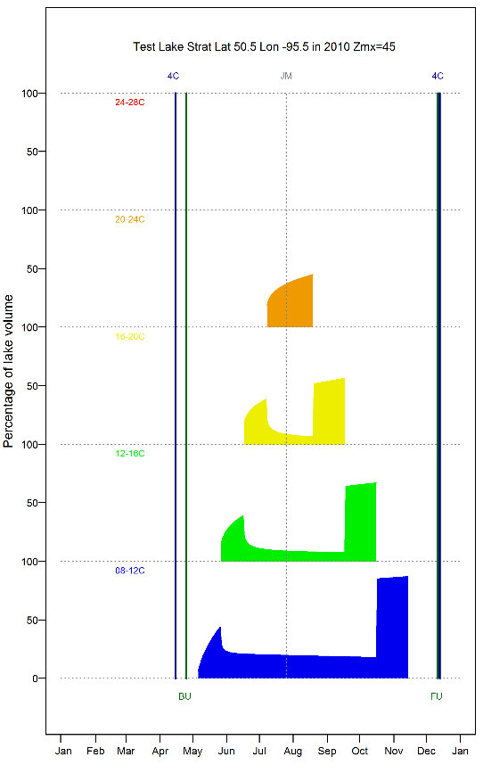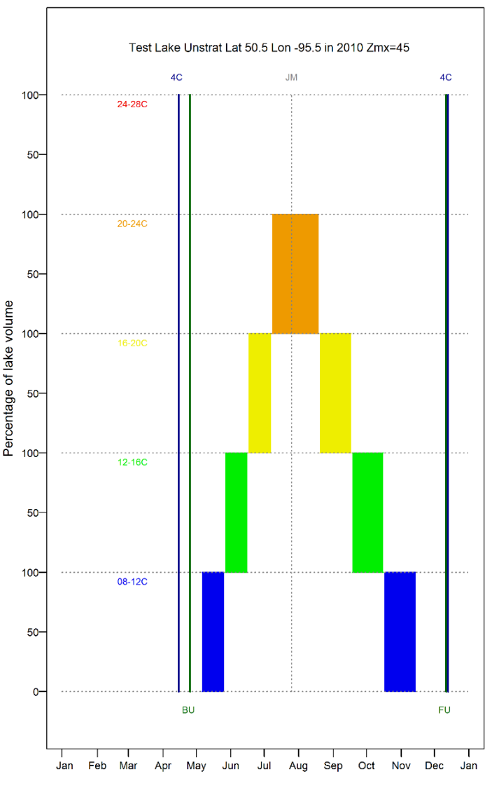

Day of year

Day of year

8 – 12 C

12 – 16 C

16 – 20 C

20 – 24 C

24 - 28 C

Un-stratified Lake

Stratified Lake

8 – 12 C

12 – 16 C

16 – 20 C

20 – 24 C

24 - 28 C

4oC BU FU

4oC BU FU

Percentage of Lake Volume

**Figure A4**. Ice Free Days. The mean relative difference in ice free duration between the new and the old model (i.e. Shuter et al. 1983) is about zero. For lakes with low mean annual air temperature (Tann < 4°C), the new model predicts a longer ice free season (up to 20% longer where Tann = 0°C). For lakes with high annual temperature (Tann > 4°C), the new model predicts a shorter ice free season (up to 20% shorter at Tann = 8°C). The new ice break-up (BU) model takes account of the interaction of solar elevation and timing of spring zero air temperature; the new freeze-up (FU) model takes account of the lag effect of lake depth on fall cooling. See Tables A6 and A7 for model details.

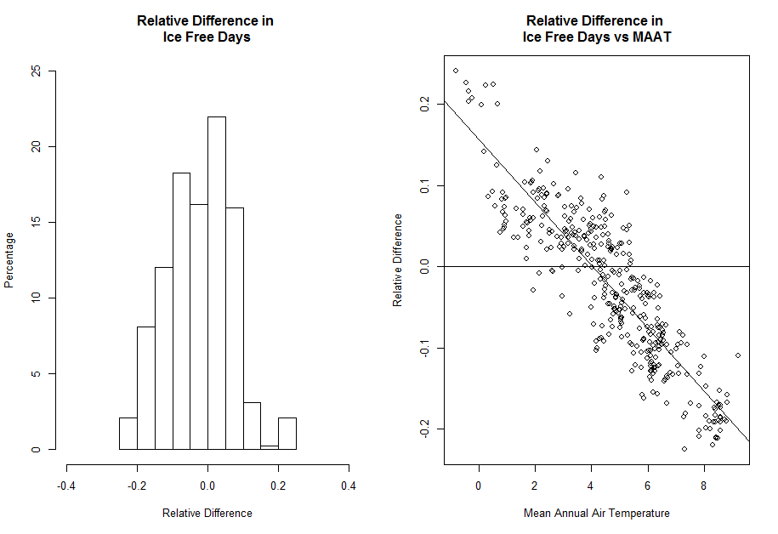

**Mean annual air temperature (°C)**

**Percentage of lakes**

**Relative Difference**

**Relative Difference**

**Figure A5**. Maximum Surface Water Temperature (Tx). The prediction of maximum surface water temperature from the new model is on average about 10% higher compared to the old model (i.e., Shuter et al 1983). This difference is partially explained by the inclusion of elevation as a variable in the new model. Also, the two models had slightly different definition of maximum surface water temperature. The new model used data which were able to capture the exact day where the water temperature was its highest whereas the old model used data which were collected from biweekly sampling. See Table A6 for model details.

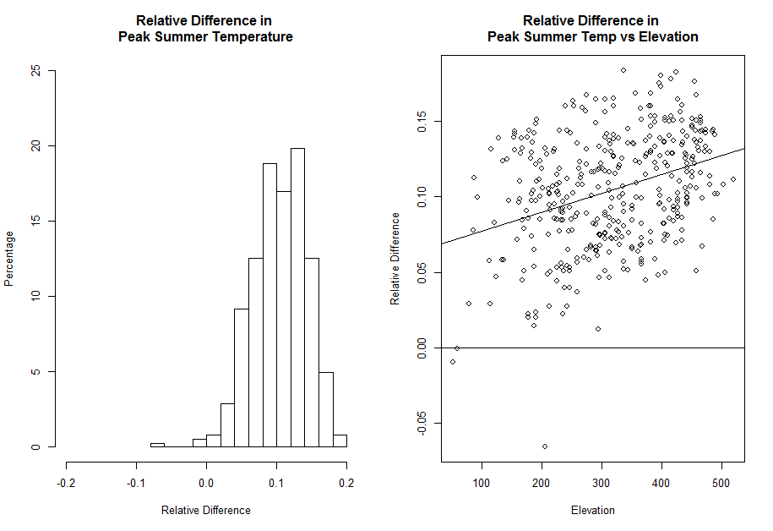

**Relative Difference**

**Percentage of lakes**

**Elevation above sea level (m)**

**Relative Difference**

**Figure A6**. Midsummer Thermocline (ZTH). The predicted midsummer thermocline depth is on average about 12% less than the predicted thermocline depth using the old model (Shuter et al. 1983). Inclusion of Secchi depth has some effect on the new model predictions. The old model relied heavily on end of summer estimates of thermocline depth whereas new analysis of the BsM profile data shows that thermocline depths generally increase over the summer. Hence midsummer values are smaller.

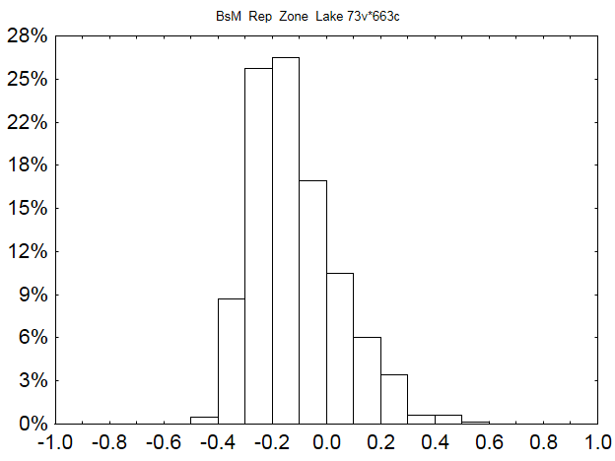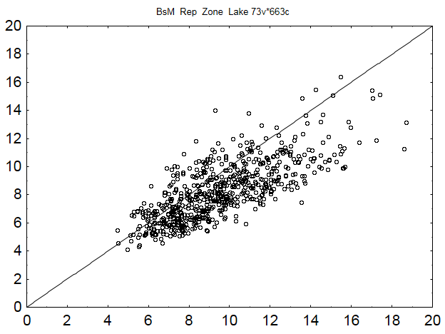

**Appendix B. Data Archive**

**Percentage of lakes**

**Predicted Thermocline (Old)**

**Predicted Thermocline (New)**

**Relative Difference**

**Table of Contents**

B1. BsM\_Cycle1

B2. Other Data

Data used in the report are archived in the folder “R\_ThermoPic\Archive”. This archive includes ThermoPic results for BsM Cycle 1 data (721 lakes).

**B1. BsM Cycle1**

Data related to cycle 1 of BsM are stored in 2 folders

* **BsM\_Cycle1\_DataSource**
  + BsM data used in developing the STM model and in creating data inputs for TheroPic software
  + Includes:
    - Climate\_Annual.xlsx
    - Climate\_Norms\_2001-2010.xlsx
    - HCAT\_Output\_BsM\_temp (Access database file)
    - HCAT\_Output\_BsM\_precip (Access database file)
    - Temperature Profiles.xlsx (for BsM Cycle 1)
* **BsM\_Cycle1\_ThermalSpace**
  + Complete input and output data from the analysis of BsM1 data
  + 4D ThermoPics are stored in the sub-folder (ThermoPics) of DataOut
  + Folder = DataIn
    - Data\_Dictionary
    - 0\_User\_Options
    - 1\_Lake
    - 2\_Climate
  + Folder = DataOut
    - tmp\_ClimMetrics
    - tmp\_IceClimMetrics
    - 3\_Model\_Inputs
    - 4\_STM\_Parameters
    - 5\_ThermoSpace4D
  + Folder = DataOut\Thermopics
    - contains Thermopic plots for 4 oC intervals (one file per lake).

**B2. Other Data**

Non-BsM data that were used to develop the seasonal temperature model (STM)

* **TimeSeries\_NW\_Lakes**

The Ontario Northwest (NW) lakes temperature profile time series.

* + NW\_DailyTempData.xlsx – raw data
  + NW\_Lake STM Fitting Analysis.xlsx
  + NW\_Lakes\_STM Paramaters\_Time Series.xlsx (original name = TS1)
* **LEWG and NSERC Inshore-Offshore**

The LEWG and NSERC Inshore-Offshore seasonal temperature profile datasets, developed by EEB at University of Toronto and supplied by Ken Minns.

* NSERC\_INOFF20012002FileCatalog.xlsx
* NSERC\_INOFFDatasets.xlsx
* Lake\_STM\_ParameterInput.xlsx

**Appendix C. Guide to ThermPic Software (also available as a separate document –ThermoPic\_Guide.pdf)**

**Table of Contents**

C1. Introduction

C2. File Organization

C3. Operation

C4. Data Input

C5. Data Output

C6. Data Dictionary

**C1. Introduction**

A ThermoPic is a picture of thermal habitat in a lake. Given that the seasonal temperature cycle is known or can be predicted (Figure 1), one can calculate for each day of the year how much habitat exists within specified bands of temperature (e.g., 8-12 °C, 12-16 °C, 16-20 °C, etc.). A ThermoPic can then be produced by plotting % volume (or area) of habitat versus day of year (Figure 2). Because fish species differ in terms their preferred temperatures, this plot is a very useful summary of the thermal habitat available for different species.

The ThermoPic software serves three purposes. First, it predicts the seasonal temperature cycle in lakes based on easily measured variables (i.e., lake morphometry and climate). Second, it calculates and reports thermal habitat statistics. Third, it generates a ThermoPic plot. The model used to predict temperature is referred to as the Seasonal Temperature Model (STM). It was created by Minns et al. (2016) based on data from lakes in the province of Ontario (Canada). The STM is based on seven parameters (see Figure 3), each of which can be predicted given the following lake data inputs: location (latitude, longitude, elevation), morphometry (surface area, shoreline length, maximum depth and mean depth), water chemistry (Secchi, DOC), air temperature cycle (monthly means), and precipitation in August. Formulae used to calculate the STM parameters are given in this Guide, including formulae for dealing with missing data (i.e., Secchi, DOC, Shoreline).

**Figure C1**. Seasonal temperature cycle in a lake.



320 125 285 150 250 175 220 200

Day of Year

**Figure C2.** Example of a ThermoPic

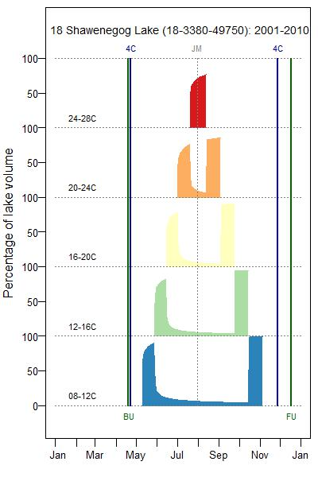

**Figure C3.** The Seasonal Temperature Model (STM) parameters.



**C2. File Organization**

ThermoPic software runs in the R environment, uses CSV files for data input and output, and produces JPEG or TIFF files of ThermoPic plots. The package consists of:

* two R programs (P1\_Model, P2\_Report)
* a data dictionary (ThermoPic\_Dictionary.xlsx)
* 3 CSV data input files (0\_User\_Options, 1\_Lake, 2\_Climate)
* 3 CSV output files (3\_Model\_Inputs, 4\_STM\_Parameters, 5\_Thermal Space4D)
* multiple JPEG files (one for each ThermoPic created)

Program and data files are stored in a main folder (R\_ThermoPic) and two sub-Folders (DataIn, DataOut), as illustrated below. ThermoPic plots are stored as JPEG or TIFF files in a sub-folder of DataOut.

The main folder also includes supplementary information:

* ThermoPic\_TechReport (report by Minns et al. that developed the Seasonal Temperature Model and demonstrates the application of ThermoPics)
* ThermoPic\_Guide.pdf (copy of this document, which is Appendix C in ThermoPiv\_TechREport.pdf)

Figure 4. File organization of ThermoPic software.

**C:\R\_ThermoPic**

- ThermoPic\_P1\_Model.R

- ThermoPic\_P2\_Report.R

- ThermoPic\_Dictionary,xlsx

- ThermoPic\_Guide.pdf

- ThermoPic\_TechReport.pdf

**..\DataIn**

- 0\_User\_Options.csv

- 1\_Lake.csv

- 2\_Climate.csv

**..\DataOut**

- 3\_Model\_Inputs.csv

- 4\_STM\_Parameters.csv

- 5\_ThermalSpace4D.csv

**..\ThermoPics**

- TP4\_Lake1.JPEG

- TP4\_Lake2.JPEG

- ...

**C3. Running the R Programs**

Install ThermoPic by creating a main folder (such as C:\R\_ThermoPic) containing the two R programs shown in Figure 1, as well as the ThermoPic\_Dictionary and sample data file (ThermoPic\_Data). If the main folder is not “C:\R\_ThermoPic”, change the first line of code in each R program to match the name of your main folder.

Create the sub-folder structure shown in Figure 1 and copy the 3 data files to the sub-folder “..\DataIn”:

* 0\_User\_Options.csv
* 1\_Lake.csv
* 2\_Climate.csv

Alternatively, if you have other data files in the correct format, copy your data to “..\DataIn”.

Set up the R environment so that the following libraries can be accessed:

* Chron
* Plyr
* XLConnect
* rLakeAnalyzer
* rootSolve
* RColorBrewer

Then run the following 2 programs (P1 and P2) in sequence. Results will be stored in sub-folders DataOut and DataOut\ThermoPics. After running the two programs, it is best to copy your results and delete the files in these folders.

**ThermoPic\_P1\_Model**

This programcalculates parameters that define the Seasonal Temperature Model (STM) using input from “Lake\_Climate\_Data.xlsx”. Parameters are generated for each combination of Lake x Period identified in the climate data file (2\_Climate.csv).. The results are stored as csv files in the DataOut folder. These files include:

* 0\_User\_Options.csv (a copy of the input file)
* 3\_Model\_Inputs.csv
* 4\_STM\_Parameters.csv

In addition, two temporary files are created and stored in the DataOut folder:

* tmp\_ClimMetrics.csv
* tmp\_IceClimMetrics.csv

The file of primary interest is “4\_STM\_Parameters” – it contains parameters for each lake x climate scenario which is used to report estimate of thermal habitat.

Typically, the code is used to generate a temperature model for a single Period of climatic conditions (e.g. years 2001-2010). But the code can be used to explore how a change in climate affects water temperature in each lake: if the input file includes climate data for several periods (e.g. 1970-1980, 2001-2010), then results are generated for each period.

**ThermoPic \_P2\_Report**

This program should be executed after running P1\_Model. P2\_Report uses outputs from P1\_Model to calculate thermal habitat (volume and area) for 5 temperature bands at intervals of 4 °C (8-12, 12-16, 16-20, 20-24, and 24-28). Results are produced for each “Lake x Period” listed in the input file. These results are stored in the file “5\_ThermalSpace\_4D.csv”. In addition, a plot of thermal habitat volume (ThermoPic4D) is produced for each “Lake x Period” listed in the input file. Each plot is stored as a JPEG (or TIFF) file in the ‘DataOut\ThermoPics’ folder. Production of these plots can be controlled by editing the “0\_User\_Options” file that is stored in the DataIn folder.

**C4. Data Input**

***0\_User\_Options.csv***

This file allows users to modify several options when reporting thermal space (i.e., when running **P2\_Report**). The “Default” column lists default conditions. Edit the “User” column to assign different options.

|  |  |  |
| --- | --- | --- |
| **Option\_Name** | **Default** | **User** |
| TP\_Plots | Yes | Yes |
| TP\_Interval | 4 | 4 |
| TP\_Format | JPEG | JPEG |
| TP\_Folder | DataOut/ThermoPics | DataOut/ThermoPics |
| Nlakes\_test | 0 | 0 |

**TP\_Plots** (Yes or No) indicates whether ThermoPic plots will be produced when running P2\_Report. Production of plots for individual lakes can also be controlled by editing the ‘4\_STM\_Parameters’file in DataOut (after running P2\_Model). By default, “Do\_ThermoPic = TRUE” for all records in ‘4\_STM\_Parameters’. Setting “Do\_ThermoPic” = FALSE will prevent plot production for that case.

**TP\_Interval** specifies the temperature interval used when calculating thermal space. The Default value is 4 oC, which reports results for the following temperature ranges: 8-12, 12-16, 16-20, 20-24, 24-30. Acceptable values of TP\_Interval are 1, 2, 3 and 4. ThermoPic plotting works best when TP\_Interval = 3 or 4, because the plot routine has been designed to show the first 6 temperature bands, starting from 8 °C When TP\_Interval = 1 or 2, the maximum temperatures shown are 14 and 20, respectively. These plots are not very useful and can be suppressed by setting TP\_plots = “No”. The setting of “TP\_plots” has no effect on the production of the report file (e.g. 5\_ThermalSpace\_xD.csv). The program will always produce a report with thermal habitat statistics. The default TP\_Interval (4 oC) produces a file whose name ends with the suffix “4D”. If other intervals are chosen, this suffix changes accordingly (e.g., “3D” implies a 3 degree temperature interval).

**TP\_Format** specifies the file type for ThermoPic graphs. Acceptable values are ‘JPEG’ or ‘TIFF’.

**TP\_Folder** specifies the sub-folder where ThermPic graphs will be stored.

**Nlakes\_test** allows users to test the **P2\_Report** code by processing a small number of lakes, before running the program on all lakes. If **Nlakes\_test** = 0, all lakes in the ‘**1\_Lake.csv’** will be processed. Otherwise, the value of **Nlakes\_test** specifies how many lakes will be processed.

***1\_Lake.csv***

This file is a list of lakes for which STM parameters will be generated. The data include a unique lake identifier (Wby\_Lid) and other variables describing its location, morphometry and water chemistry. Variables used in code calculations include: Latitude, Longitude, Area\_ha, Shoreline , Depth\_Max, Depth\_Mn, Elevation, Secchi and DOC. Missing values are acceptable for Shoreline, Secchi and DOC (see below). Other variables (FMZ, Group) are included for convenience – so they can later be used for organizing the results. These variables can be left empty, but they must not be removed. The column order must not be changed.

**Variable List:**

|  |  |  |  |
| --- | --- | --- | --- |
| **Variable** | **Description** | **Units** | **Order** |
| FMZ | Fishery Management Zone (optional) |  | 1 |
| Group | User-defined (optional) |  | 2 |
| Wby\_Lid | Waterbody Location ID (Unique identifier) |  | 3 |
| Lake\_Name | Lake name |  | 4 |
| Latitude | Laltitude of lake centroid | degrees | 5 |
| Longitude | Longitude of lake centroid | degrees | 6 |
| Elevation | Elevation above seas level | m | 7 |
| Area\_ha | Lake area | hectares | 8 |
| Shoreline | Shoreline perimeter | km | 10 |
| Depth\_Max | Maximum lake depth | m | 11 |
| Depth\_Mn | Mean lake depth | m | 12 |
| Secchi | Secchi depth | m | 13 |
| DOC | Dissolved organic carbon concentration | mg/l | 14 |

**Example:**

|  |  |  |  |  |  |  |  |  |  |  |  |  |
| --- | --- | --- | --- | --- | --- | --- | --- | --- | --- | --- | --- | --- |
| **FMZ** | **Group** | **Wby\_Lid** | **Lake\_Name** | **Latitude** | **Longitude** | **Elevation** | **Area\_ha** | **Shoreline** | **Depth\_Max** | **Depth\_Mn** | **Secchi** | **DOC** |
| 5 | 0 | South Scot Lake | 15-3523-55336 | 49.94 | -95.06 | 343 | 397 | 4.4 | 10.0 | 3.5 | 1.45 | 12.4 |
| 5 | 0 | Whitefish Lake | 15-3532-55170 | 49.79 | -95.04 | 366 | 216 | 3.4 | 20.1 | 7.0 | 2.50 | 6.8 |

**Estimating missing values for lakes (based on BsM lakes)**

eShoreline = exp(1.39494 + 0.69596\*ln(Area) – 0.68779\*ln(Depth\_Mn) + 0.65994\*ln(Depth\_Max) + (0.3772^2)/2)

eSecchi (with DOC) = exp(2.19226 + 0.179978\*ln(Depth\_Max) - 0.720734\*ln(DOC) + (0.3617^2)/2)

eSecchi (without DOC) = exp(0.277336 – 0.08618\*ln(Area) + 0.11680\*ln(Depth\_Mn) + 0.36719\*ln(Depth\_Max) + (0.4582^2)/2)

eDOC = exp(2.7215 – 0.0734\*ln(Depth\_Max) - 0.1276\*ln(Secchi) – 0.1469\*Secchi + (0.3070^2)/2)

***2\_Climate.csv***

This file describes the climate conditions that apply to each lake for a specified period (or several periods). Records are uniquely identified by the combination of *Wby\_Lid* x *Period*. *Period* is typically a block of years for which temperature and precipitation norms have been calculated. For example, *Period* = 2001-2010 identifies a recent decadal norm. Climate data for multiple Periods in a lake may be supplied, in which case STM parameters will be produced for each *Lake x Period* combination. Data are required for all temperature variables and the single precipitation variable. The column order must not be changed.

**Variable List:**

|  |  |  |  |
| --- | --- | --- | --- |
| **Variable** | **Description** | **Units** | **Order** |
| Wby\_Lid | Waterbody Location ID (Unique identifier) |  | 1 |
| Period | Period for which climate norms are given |  | 2 |
| Tjan | Mean air temperature in January for specified Period | °C | 3 |
| Tfeb | Mean air temperature in February for specified Period | °C | 4 |
| Tmar | Mean air temperature in March for specified Period | °C | 5 |
| Tapr | Mean air temperature in April for specified Period | °C | 6 |
| Tmay | Mean air temperature in May for specified Period | °C | 7 |
| Tjun | Mean air temperature in June for specified Period | °C | 8 |
| Tjul | Mean air temperature in July for specified Period | °C | 9 |
| Taug | Mean air temperature in August for specified Period | °C | 10 |
| Tsep | Mean air temperature in September for specified Period | °C | 11 |
| Toct | Mean air temperature in October for specified Period | °C | 12 |
| Tnov | Mean air temperature in November for specified Period | °C | 13 |
| Tdec | Mean air temperature in December for specified Period | °C | 14 |
| Tann | Mean annual air temperature for specified Period | °C | 15 |
| Paug | Mean daily precipitation in August for specified Period | mm | 16 |

**Example:**

|  |  |  |  |  |  |  |  |  |  |  |  |  |  |  |  |
| --- | --- | --- | --- | --- | --- | --- | --- | --- | --- | --- | --- | --- | --- | --- | --- |
| **Wby\_Lid** | **Period** | **Tjan** | **Tfeb** | **Tmar** | **Tapr** | **Tmay** | **Tjun** | **Tjul** | **Taug** | **Tsep** | **Toct** | **Tnov** | **Tdec** | **Tann** | **Paug** |
| 15-3523-55336 | 2001-2010 | -15.2 | -13.8 | -5.7 | 4.1 | 10.0 | 16.3 | 19.4 | 18.1 | 13.4 | 5.0 | -2.8 | -12.2 | 3.2 | 88.7 |
| 15-3532-55170 | 2001-2010 | -15.2 | -13.7 | -5.7 | 4.2 | 10.1 | 16.3 | 19.5 | 18.1 | 13.4 | 5.1 | -2.7 | -12.2 | 3.2 | 88.8 |

**C5. Data Outputs**

**P1\_Model Outputs**

Results from running P1\_Model are stored in several files. Ignore the files with a ‘tmp’ prefix (used mainly for debugging). Results of primary interest are stored in 2 datasheets (***3\_Model\_Inputs***, ***4\_STM\_Parameters).***

***3\_Model\_Inputs,csv***

This file contains the input variables needed to calculate the STM parameters. They include lake measurements, as well as climate and ice variables.

***4\_STM\_Parameters.csv***

This file contains estimates of the STM parameters which are used to predict temperature at depth throughout the icefree season. These estimates are needed to calculate seasonal thermal habitat. Editing of the columns ‘Do\_Space’ and ‘Do\_ThermoPic’ may be done to control output from P2\_ThermoPic.

**Variable List:**

|  |  |  |
| --- | --- | --- |
| **Variable** | **Description** | **Units** |
| Wby\_Lid | Waterbody Location ID (Unique identifier) |  |
| Lake\_Name | Lake name |  |
| (Other Lake vars) | FMZ, Group, Latitude, Longitude, Elevation, Area\_ha, Shoreline, Depth\_max, Depth\_Mn, Secchi, DOC |  |
| Period | Period for which climate norms are given |  |
| TX | STM parameter - maximum surface temperature (i.e., on day JM) | °C |
| TN | STM parameter - hypolimnetic temperature at onset of stratification (i.e., JS) | °C |
| JS | STM parameter - day of onset of stratification | Julian |
| JM | STM parameter - day of peak surface temperature | Julian |
| JE | STM parameter - day of end of stratification | Julian |
| ZTH | STM parameter - thermocline depth on JM (If ZJ=0, ZTH=ZM) | m |
| ZM | STM parameter - maximum thermocline depth | m |
| ZJ | STM parameter - number of days after JS when ZTH reaches ZM/2 | days |
| SP | STM parameter - steepness of temperature transition from epi- to hypo-limnion |  |
| IceBU | Ice breakup completion date (Ice free date measured relative to start of year when freeze occurred) | Julian |
| IceFU | Ice freeze up completion date (date of first complete ice cover) | Julian |
| Icefree | Duration of icefree (open water) period | days |
| DataGood | If TRUE then all required STM parameters have assigned values |  |
| LakeNumber | Computed Lake Number based on STM parameters on JM |  |
| Stratified | If TRUE then lake is thermally stratified (based on LakeNumber >= 1) | logical |
| Do\_Space | If TRUE then calculate themal habitat space (volume and area) | logical |
| Do\_ThermoPic | If TRUE then produce ThermoPic plot | logical |

**Example of 4\_STM\_Parameters**

|  |  |  |  |  |  |  |  |  |  |  |  |  |  |  |
| --- | --- | --- | --- | --- | --- | --- | --- | --- | --- | --- | --- | --- | --- | --- |
| **Wby\_Lid** | **Lake\_Name** | **Period** | **TX** | **TN** | **JS** | **JM** | **JE** | **ZTH** | **ZM** | **ZJ** | **SP** | **IceBU** | **IceFU** | **Icefree** |
| 15-3523-55336 | South Scot Lake | 2001-2010 | 25.0 | 8.2 | 121 | 218 | 291 | 9.7 | 9.7 | 0.0 | 4.5 | 124 | 325 | 201 |
| 15-3532-55170 | Whitefish Lake | 2001-2010 | 25.3 | 6.9 | 125 | 218 | 302 | 8.9 | 8.9 | 0.0 | 4.5 | 124 | 331 | 207 |

|  |  |  |  |  |  |
| --- | --- | --- | --- | --- | --- |
| (Continued) | **DataGood** | **LakeNumber** | **Stratified** | **Do\_Space** | **Do\_ThermoPic** |
| … | True |  | False | True | True |
| … | True | 12.8 | True | True | True |

**STM Equations:**

|  |  |
| --- | --- |
| **Parameter** | **Regression Equations** |
| TX | 4.81017 - 0.09763\*(ln(Area))2 + 1.0569\*ln(Elevation) + 0.25207\*TAnn + 0.55343\*TJul  + 0.14833\*TAug |
| TN | 11.9389 + 0.4687\*ln(Area) + 0.8784\*ln(Depth\_Mn) - 2.0357\*ln(Depth\_Max) - 0.20951\*Secchi + 0.09426\* TMar |
| JS  (Area >= 8 km2) | 160 + 5.14\*TAnn + 2.49\*ln(Area/Depth\_Mn) - 27 |
| JS  (Area <8 km2) | (160 + 5.14\*TAnn + 2.49\*ln(Area/Depth\_Mn))/2 + (91.24 - 5.87\*TMay  - 3.35\*DOC + Area + IceBU)/2 - 27 |
| JM | 153.592 - 0.93198\*Longitude + 3.27394\*TMay  - 4.86477\*TJul + 2.83079\*TSep |
| JE | 219.445 + 9.2161\*ln(Elevation) + 10.6803\*ln(Depth\_Mn) + 2.43965\*Secchi + 2.28842\*TAug - 3.97789\*TJJA + 5.90576\*TSON |
| ZTH | exp (1.68062 + 0.22536\*ln(Area) - 0.11761\*ln(Shoreline) + 0.04326\*TJJA + 0.01575\*Lat + 0.02193\*Secchi - 0.01663\*JM + 0.00005158\*JM2 + 0.0300566 ) |
| ZM | Assumed to equal ZTH |
| ZJ | Assumed to be 0 |
| SP | -15.7148 + 0.30155\*Latitude + 0.13118\*Longitude - 0.15883\*TJun + 0.50025\*TJul + 0.010718\*PAug + 0.04379\*JM |

**P2\_Report Outputs**

The primary output from P2\_Report is stored in one file (e.g., ***5\_ThermalSpace4D)***. In addition, this module may generate a ThermoPic graph for each Lake x Climate scenario. ThermoPics are stored in a sub-folder of DataOut, whose name is specified in ***0\_User\_Options.csv*** (default = ThermoPics).

***5\_ThermalSpace4D***

This file contains estimates of thermal space (volume and area) for various temperature ranges (specified by TRange). By default, thermal space is estimated for a 4 oC temperature interval and the output file is labeled with the suffix ‘4D’. If P2\_Report is run for other TP\_Intervals (e.g. 2 or 3), additional files will exist, labeled as ***5\_ThermalSpace****X****D*** where X equals the temperature interval.

**Variable List:**

|  |  |  |
| --- | --- | --- |
| **Variable** | **Description** | **Units** |
| Wby\_Lid | Waterbody Location ID (Unique identifier based on Zone Northing Easting) |  |
| Lake\_Name | Lake name |  |
| Lake vars | FMZ, Area\_ha, Depth\_Max, Depth\_Mn |  |
| Period | Period for which climate norms are given |  |
| Stratified | If TRUE then lake is thermally stratified (based on LakeNumber >= 1) | logical |
| TRange | Temperature range for estimation of thermal area and volume |  |
| PD\_year | Proportion of days in year when TRange is present |  |
| PD\_icefree | Proportion of days in icefree season when TRange is present |  |
| TSeasons | Number of seasons when TRange is present 0, 1 or 2 |  |
| Jstart\_Spr | Start date of Spring presence of TRange | Julian |
| Jend\_Spr | End date of Spring presence of TRange (if TSeasons = 2) | Julian |
| Jstart\_Aut | Start date of Autumn presence of TRange (if TSeasons = 2) | Julian |
| Jend\_Aut | End date of Autumn presence of TRange | Julian |
| PV\_JM | Proportion of lake volume where TRange exists on day JM (i.e., midsummer peak) | % |
| PV\_mean | Mean proportion of lake volume where TRange exists for days when TRange is present | % |
| PV\_sd | Standard deviation of PV when TRange is present | % |
| PV\_max | Maximum value of PV when TRange is present | % |
| PV\_min | Minimum value of PV when TRange is present | % |
| PV\_year | Proportion of lake volume where TRange exists for entire year (= PD\_year\*PV\_mean) | % |
| PA\_JM | Proportion of lake area where TRange exists on day JM (i.e., midsummer peak) | % |
| PA\_mean | Mean proportion of lake area where TRange exists for days when TRange is present | % |
| PA\_sd | Standard deviation of PA when TRange is present | % |
| PA\_max | Maximum value of PA when TRange is present | % |
| PA\_min | Minimum value of PA when TRange is present | % |
| PA\_year | Proportion of year-area integral when TRange is present (= PD\_year\*PA\_mean) | % |

**Example of 5\_ThermalSpace4D**

|  |  |  |  |  |  |  |  |  |  |  |  |
| --- | --- | --- | --- | --- | --- | --- | --- | --- | --- | --- | --- |
| **Wby\_Lid** | **Lake\_Name** | **Stratified** | **Period** | **TRange** | **PD\_year** | **PD\_icefree** | **TSeasons** | **Jstart\_Spr** | **Jend\_Spr** | **Jstart\_Aut** | **Jend\_Aut** |
| 15-3523-55336 | South Scot Lake | False | 2001-2010 | T0812 | 0.11 | 0.58 | 2 | 121 | 143 | 275 | 291 |
| 15-3523-55336 | South Scot Lake | False | 2001-2010 | T1216 | 0.11 | 0.58 | 2 | 144 | 166 | 258 | 274 |
| 15-3523-55336 | South Scot Lake | False | 2001-2010 | T1620 | 0.11 | 0.56 | 2 | 167 | 189 | 240 | 257 |
| 15-3523-55336 | South Scot Lake | False | 2001-2010 | T2024 | 0.11 | 0.58 | 2 | 190 | 212 | 223 | 239 |
| 15-3523-55336 | South Scot Lake | False | 2001-2010 | T2428 | 0.03 | 1.00 | 1 | 213 |  |  | 222 |
| 15-3532-55170 | Whitefish Lake | True | 2001-2010 | T0812 | 0.45 | 1.00 | 1 | 132 |  |  | 296 |
| 15-3532-55170 | Whitefish Lake | True | 2001-2010 | T1216 | 0.35 | 1.00 | 1 | 152 |  |  | 278 |
| 15-3532-55170 | Whitefish Lake | True | 2001-2010 | T1620 | 0.24 | 1.00 | 1 | 172 |  |  | 260 |
| 15-3532-55170 | Whitefish Lake | True | 2001-2010 | T2024 | 0.14 | 1.00 | 1 | 192 |  |  | 242 |
| 15-3532-55170 | Whitefish Lake | True | 2001-2010 | T2428 | 0.04 | 1.00 | 1 | 212 |  |  | 224 |

|  |  |  |  |  |  |  |  |  |  |  |  |  |
| --- | --- | --- | --- | --- | --- | --- | --- | --- | --- | --- | --- | --- |
| (Continued) | **PV\_JM** | **PV\_mean** | **PV\_sd** | **PV\_min** | **PV\_max** | **PV\_year** | **PA\_JM** | **PA\_mean** | **PA\_sd** | **PA\_min** | **PA\_max** | **PA\_year** |
| … |  | 100.0 | 0.0 | 100.0 | 100.0 | 11.0 |  | 100.0 | 0.0 | 100.0 | 100.0 | 11.0 |
| … |  | 100.0 | 0.0 | 100.0 | 100.0 | 11.0 |  | 100.0 | 0.0 | 100.0 | 100.0 | 11.0 |
| … |  | 100.0 | 0.0 | 100.0 | 100.0 | 11.2 |  | 100.0 | 0.0 | 100.0 | 100.0 | 11.2 |
| … |  | 100.0 | 0.0 | 100.0 | 100.0 | 11.0 |  | 100.0 | 0.0 | 100.0 | 100.0 | 11.0 |
| … | 100.0 | 100.0 | 0.0 | 100.0 | 100.0 | 2.7 | 100.0 | 100.0 | 0.0 | 100.0 | 100.0 | 2.7 |
| … | 9.5 | 30.3 | 34.4 | 5.7 | 100.0 | 13.7 | 18.3 | 34.9 | 28.5 | 14.4 | 99.4 | 15.8 |
| … | 8.3 | 31.6 | 33.6 | 6.0 | 94.3 | 11.0 | 10.6 | 29.2 | 27.3 | 8.9 | 84.5 | 10.2 |
| … | 9.2 | 38.5 | 32.7 | 6.6 | 87.2 | 9.4 | 10.0 | 32.5 | 25.7 | 7.8 | 73.9 | 7.9 |
| … | 16.9 | 55.6 | 23.5 | 12.4 | 78.7 | 7.8 | 15.8 | 43.9 | 17.9 | 12.1 | 63.5 | 6.2 |
| … | 55.4 | 52.1 | 10.8 | 23.0 | 61.9 | 1.9 | 40.9 | 38.4 | 8.6 | 15.7 | 46.7 | 1.4 |

***ThermoPic Files***

ThermoPic plots are stored in a sub-folder of DataOut (as specified in ***0\_User\_Options.csv***).

The file name identifies the Lake x Climate scenario, as well as the temperature interval – as illustrated in the following example.

File name = TP4\_18\_Sand Lake\_ 18-3998-49356\_P1961-1990.JPEG

TP4 ThermoPic for a 4oC temperature interval

18 FMZ of the lake

Sand Lake Name of lake

18-3998-49356 Wby\_Lid (unique identifier of the lake)

P1961-1990 Label identifying period for which climate data were supplied

JPEG file type (could also be TIFF).

By default, a TP4 file will be produced for each Lake x Climate scenario indicated by the input files (1\_Lake and 2\_Climate). Editing the ***0\_User\_Options*** file allows one to generate ThermoPics for other temperature intervals. For example, after producing the default TP4 plots, one could re-run P2\_Report for a TP\_Interval = 3. In that case, a similar set of plots would be produced, but with a prefix = TP3.

**C6. Data Dictionary**

The data dictionary (***ThermoPic\_Dictionary.csv***) is stored in the main folder R\_ThermoPic. This file is reproduced below. It describes all variables, identifies their units, and indicates their presence in the various input files (1\_Lake, 2\_Climate) and output files (3\_Model\_Inputs, 4\_STM\_Parameters, 5\_ThermalSpace). Numbers show the order of variables in each file. If blank, the variable does not exist in the file.

|  |  |  |  |  |  |  |  |
| --- | --- | --- | --- | --- | --- | --- | --- |
| **Variable** | **Description** | **Units** | **1\_Lake** | **2\_Climate** | **3\_Model\_Inputs** | **4\_STM\_Parameters** | **5\_ThermalSpace** |
| FMZ | Fishery Management Zone (optional data) |  | 1 |  |  | 1 | 1 |
| Group | User-defined (optional data) |  | 2 |  |  | 2 |  |
| Wby\_Lid | Waterbody Location ID (Unique identifier) |  | 3 | 1 | 1 | 3 | 2 |
| Lake\_Name | Lake name |  | 4 |  |  | 4 | 3 |
| Latitude | Laltitude of lake centroid | degrees | 5 |  |  | 5 |  |
| Longitude | Longitude of lake centroid | degree | 6 |  |  | 6 |  |
| Elevation | Elevation above sea level | m | 7 |  |  | 7 |  |
| Area\_ha | Lake area | hectare | 8 |  |  | 8 | 4 |
| Shoreline | Shoreline perimeter | km | 10 |  |  | 10 | 5 |
| Depth\_Max | Maximum lake depth | m | 11 |  |  | 11 | 6 |
| Depth\_Mn | Mean lake depth | m | 12 |  |  | 12 |  |
| Secchi | Secchi depth | m | 13 |  |  | 13 |  |
| DOC | Dissolved organic carbon concentration | mg/l | 14 |  |  | 14 |  |
| Period | Period for which climate norms are given |  |  | 2 | 2 |  | 8 |
| Tjan | Mean air temperature in January | °C |  | 3 |  |  |  |
| Tfeb | Mean air temperature in February | °C |  | 4 |  |  |  |
| Tmar | Mean air temperature in March | °C |  | 5 | 3 |  |  |
| Tapr | Mean air temperature in April | °C |  | 6 |  |  |  |
| Tmay | Mean air temperature in May | °C |  | 7 | 4 |  |  |
| Tjun | Mean air temperature in June | °C |  | 8 | 5 |  |  |
| Tjul | Mean air temperature in July | °C |  | 9 | 6 |  |  |
| Taug | Mean air temperature in August | °C |  | 10 | 7 |  |  |
| Tsep | Mean air temperature in September | °C |  | 11 | 8 |  |  |
| Toct | Mean air temperature in October | °C |  | 12 |  |  |  |
| Tnov | Mean air temperature in November | °C |  | 13 |  |  |  |
| Tdec | Mean air temperature in December | °C |  | 14 |  |  |  |
| Tann | Mean annual air temperature | °C |  | 15 |  |  |  |
| Paug | Mean daily precipitation in August | mm |  | 16 | 9 |  |  |
| Tjja | Mean air temperature in June, July and August | °C |  |  | 10 |  |  |
| Tson | Mean air temperature in September, October and November | °C |  |  | 11 |  |  |
| J\_Spr0 | Spring date when 30-day smoothed air temperature rose to 0°C | Julian |  |  | 12 |  |  |
| J\_Aut0 | Autumn date when 30-day smoothed air temperature dropped to 0°C | Julian |  |  | 13 |  |  |
| T\_Aut0 | Mean air temperature for the 3-month period when the central month contains J\_Aut0 | °C |  |  | 14 |  |  |
| Ang\_Spr0 | Angular elevation of the sun above the horizon at noon on J\_Spr0 | degrees |  |  | 15 |  |  |
| TX | STM parameter - maximum surface temperature (i.e., on day JM) | °C |  |  |  | 15 |  |
| TN | STM parameter - hypolimnetic temperature at onset of stratification (i.e., JS) | °C |  |  |  | 16 |  |
| JS | STM parameter - day of onset of stratification | Julian |  |  |  | 17 |  |
| JM | STM parameter - day of peak surface temperature | Julian |  |  |  | 18 |  |
| JE | STM parameter - day of end of stratification | Julian |  |  |  | 19 |  |
| ZTH | STM parameter - thermocline depth on JM (If ZJ=0, ZTH=ZM) | m |  |  |  | 20 |  |
| ZM | STM parameter - maximum thermocline depth | m |  |  |  | 21 |  |
| ZJ | STM parameter - number of days after JS when ZTH reaches ZM/2 | days |  |  |  | 22 |  |
| SP | STM parameter - steepness of temperature transition from epi- to hypo-limnion |  |  |  |  | 23 |  |
| IceBU | Ice break up completion date (Ice free date measured relative to start of year when freeze occurred) | Julian |  |  | 16 | 24 |  |
| IceFU | Ice freeze up completion date (date of first complete ice cover) | Julian |  |  |  | 25 |  |
| Icefree | Duration of icefree (open water) period | days |  |  |  | 26 |  |
| DataGood | If TRUE then all required parameters have assigned values and thermopic stats computed |  |  |  |  | 27 |  |
| LakeNumber | Computed Lake Number based on STM parameters on JM |  |  |  |  | 28 |  |
| Stratified | If TRUE then lake is thermally stratified (based on LakeNumber >= 1) | logical |  |  |  | 29 | 7 |
| Do\_Space | If TRUE then calculate themal habitat space (volume and area) | logical |  |  |  | 30 |  |
| Do\_ThermoPic | If TRUE then produce ThermoPic plot | logical |  |  |  | 31 |  |
| Stratified | If TRUE then lake is thermally stratified (based on LakeNumber >= 1) | logical |  |  |  |  | 9 |
| TRange | Temperature range for estimation of thermal area and volume |  |  |  |  |  | 10 |
| PD\_year | Proportion of days in year when TRange is present |  |  |  |  |  | 11 |
| TSeasons | Number of seasons when TRange is present 0, 1 or 2 |  |  |  |  |  | 12 |
| PD\_season1 | For unstratified lakes (i.e., TSeasons=2), proportion of days when TRange is present in the Spring season relative to Spring and Fall; for stratified lakes (i.e., TSeasons=1), PD\_season1 = 1.0 |  |  |  |  |  | 13 |
| Jstart\_Spr | Start date of Spring presence of TRange | Julian |  |  |  |  | 14 |
| Jend\_Spr | End date of Spring presence of TRange (if TSeasons = 2) | Julian |  |  |  |  | 15 |
| Jstart\_Aut | Start date of Autumn presence of TRange (if TSeasons = 2) | Julian |  |  |  |  | 16 |
| Jend\_Aut | End date of Autumn presence of TRange | Julian |  |  |  |  | 17 |
| PV\_JM | Percent of lake volume where TRange exists on day JM (i.e., midsummer peak) | % |  |  |  |  | 18 |
| PV\_mean | Mean percent of lake volume where TRange exists for days when TRange is present | % |  |  |  |  | 19 |
| PV\_sd | Standard deviation of PV when TRange is present | % |  |  |  |  | 20 |
| PV\_max | Maximum value of PV when TRange is present | % |  |  |  |  | 21 |
| PV\_min | Minimum value of PV when TRange is present | % |  |  |  |  | 22 |
| PV\_year | Percent of lake volume where TRange exists for entire year (= PD\_year\*PV\_mean) | % |  |  |  |  | 23 |
| PA\_JM | Percent of lake area where TRange exists on day JM (i.e., midsummer peak) | % |  |  |  |  | 24 |
| PA\_mean | Mean percent of lake area where TRange exists for days when TRange is present | % |  |  |  |  | 25 |
| PA\_sd | Standard deviation of PA when TRange is present | % |  |  |  |  | 26 |
| PA\_max | Maximum value of PA when TRange is present | % |  |  |  |  | 27 |
| PA\_min | Minimum value of PA when TRange is present | % |  |  |  |  | 28 |
| PA\_year | Percent of year-area integral when TRange is present (= PD\_year\*PA\_mean) | % |  |  |  |  | 29 |