Booking a Table on the Little Lemon Website

Problem Statement
The website Little Lemon currently provides the user the capability to order food online.
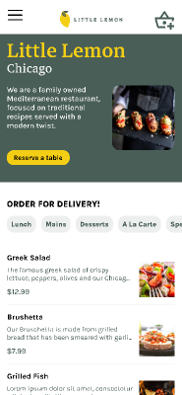
We will add the UX UI for reserving a table (see ‘Reserve a table’) image above. We will design the reserve-a-table feature. The new feature should allow an online user the capability to:
- Reserve a table for a specific day and time (using e-mail address)
- Check on current table reservation status (using e-mail address)
- Update a table reservation (using e-mail address)
- Cancel a table reservation (using e-mail address)
Note: the above design assumes there will only ever be one table reservation per e-mail address

Persona
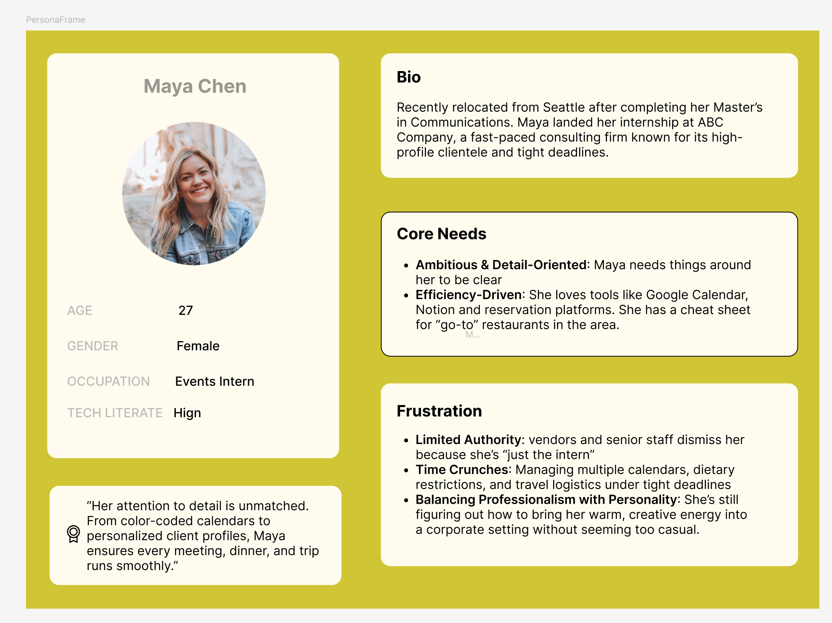

Journey map
This will be a future-state journey map to present how customers will reserve a table. The journey map should present the following scenarios, keeping in mind that it will be for our persona, Maya Chen.

Review Goals
TBD.

Touchpoints
We want to examine the journey map for the user creating a table reservation. The key points being that a table can be reserved for 1-30 customers, between the hours of 12 a.m. – 9 p.m. (We are assuming the restaurant hours are between 11 a.m. – 11 p.m.) The user shall enter the following information to reserve a table:
- E-mail address (used as the key of the reservation.)
- Date
- Time
- Total number of guests
Other possible journey maps:
- Cancel a table reservation
- Modify a table reservation
  - Change time
  - Change day
  - Change number of customers

Wireframes

Prototype

