How to Start a React Vite Project
  - A Step-by-Step Guide for Modern Front-end Development

Introduction
In the rapidly evolving world of front-end development, building fast, scalable, and maintainable applications is essential. React, a popular JavaScript library for constructing user interfaces, combined with Vite, an ultra-fast build tool, offers developers an efficient and enjoyable experience. This guide will walk you through starting a new React project using Vite, from installation to running your first application.

Prerequisites
Before you begin, ensure you have the following:
- Node.js installed (version 14.18+, 16+ recommended)
- npm or yarn as your package manager
- A terminal or command prompt
- Basic knowledge of JavaScript and React helps, but is not strictly necessary

Step 1: Install Node.js and npm
If you haven’t already installed Node.js, download it from the official website [URL] and follow the installation instructions for your operating system. Once installed, verify the installation:
- Check Node.js: node --version
- Check npm: npm --version
Yarn is an alternative package manager, and you can install it globally if you prefer:
npm install --global yarn

Step 2: Create a New Vite Project
Vite offers a streamlined way to bootstrap a React project. In your terminal, navigate to the directory where you want your project to live and run:
npm create vite@latest
You will be prompted for:
- Project name: Type your desired folder/project name (e.g., my-react-app).
- Framework: Select React by using the arrow keys and pressing Enter.
- Variant: Select JavaScript or TypeScript depending on your preference.
Alternatively, you can use Yarn:
yarn create vite
If you want to skip the prompts, you can run:
npm create vite@latest my-react-app -- --template react

Step 3: Install Dependencies
After the project has been scaffolded, move into your new project’s directory:
cd my-react-app
Then, install the dependencies:
npm install
or, if using Yarn:
yarn

Step 4: Start the Development Server
To spin up your development environment, simply run:
npm run dev
or
yarn dev
You should see output in the terminal that tells you the local server’s address, typically [URL]/. Open this URL in your browser to see your running React application.
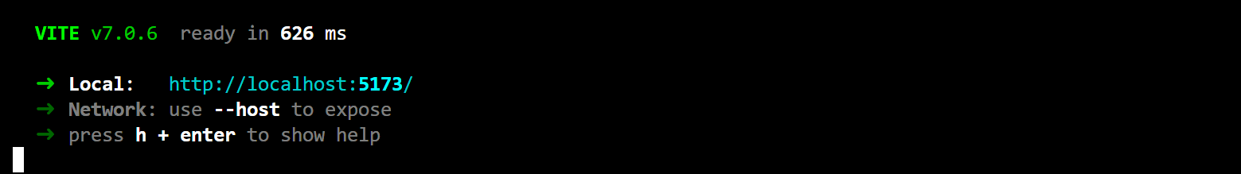

Step 5: Explore the Project Structure
Vite creates a simple project scaffold to get you started quickly. The main files and folders are:
- src/ — Your React components and main application code live here
- index.html — The base HTML file
- vite.config.js or vite.config.ts — Vite configuration file
- package.json — Project metadata and scripts
The default src/App.jsx or src/App.tsx contains a simple example component, which you can edit to start building your own app.

Step 6: Recommended Next Steps
Now that your project runs successfully, consider the following enhancements:
- Add React Router for client-side navigation: npm install react-router-dom
- Styling: Add your favorite styling solution (CSS Modules, Tailwind, styled-components, etc.)
- State Management: Explore options like Redux, Zustand, or React Context API as your app grows
- TypeScript: If you started with JavaScript, consider migrating to TypeScript for type safety
- Testing: Set up testing libraries like Jest and React Testing Library

Troubleshooting Common Issues
- Port Conflicts: If port 5173 is in use, Vite will prompt you to use another. You can also specify a port: npm run dev -- --port=3000
- Node Version: Make sure your Node.js version is compatible. Check node --version
- Dependency Errors: Delete node_modules and package-lock.json or yarn.lock, then run npm install or yarn again.

Going Further
Vite provides an incredibly fast hot module replacement (HMR) experience. As you save your files, changes will reflect instantly in your browser. For production, run:
npm run build
This will produce an optimized, minified bundle in the dist/ folder. To preview the production build locally, use:
npm run preview

Additional Resources
- Vite Documentation: [URL]
- React Documentation: [URL]
- Awesome Vite: [URL]

Conclusion
Starting a React project with Vite is a straightforward process that sets you up for fast development and optimal performance. With your environment ready, you can focus on building rich, interactive user interfaces, knowing your tooling will keep up with your creativity. Explore plugins, experiment with modern JavaScript features, and enjoy a developer experience designed for speed and simplicity.

