Abuse (Video game)
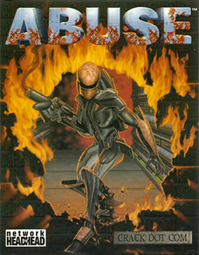

Purpose
These notes (in progress) detail how someone can install, play the 1996 video game Abuse. I will also examine how to build the game from source code.
Note: Much of the material presented come from various sources on the Internet. I listed in the Appendix – References to all the sources.

What is Abuse?
Abuse is a run and gun video game developed by Crack dot Com and published by Electronic Arts in North America and Origin Systems in Europe. It was released on February 29, 1996 for MS-DOS. A Mac OS port of the game was published by Bungie and released on March 5, 1997. The game's source code, along with some of the shareware content, has been in the public domain since the late 1990s and has been ported to Linux and many other platforms.
The company Crack dot Com

Plot
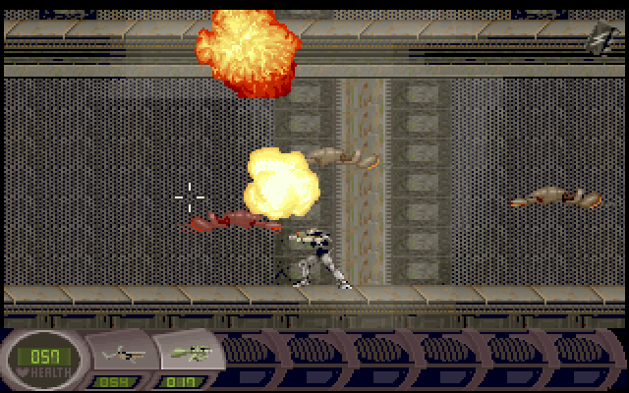
The protagonist of the game, Nick Vrenna, has been unjustly incarcerated in a prison where the staff are performing unethical medical experiments upon the inmates. A prison riot occurs and an experiment goes horribly wrong. The people inside the prison - except for Nick, who seems to be immune - are infected with a substance called Abuse that transforms them into monsters. With the water supply in danger of being infected, Nick arms himself and fights through the horde to prevent this, and then escapes from the prison complex.

Appendix – References
- Wikipedia - https://en.wikipedia.org/wiki/Abuse_(video_game)
- Abuse, and the unfortunate story of its ambitious developer, Crack dot Com, https://www.youtube.com/watch?v=jA_oLrc33LQ

