Update All Repos Script

Purpose
In the past, I only ran one bat file: update_git.bat to update the one big repo I maintained for 1000-days-of-code. Having split the huge repo into several:
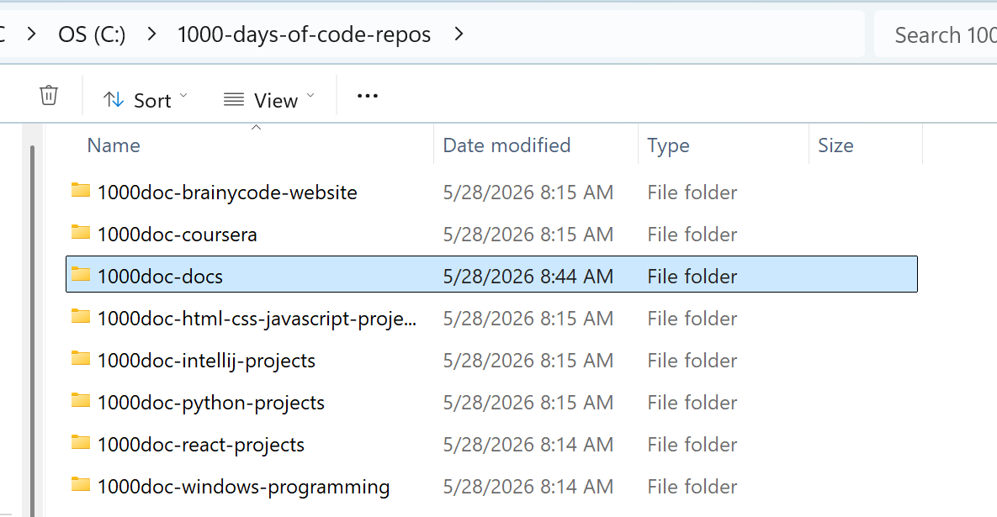
The goal is to have all related work in the same repo rather than one huge repo that was taking longer and longer to update. But, the problem now is that I need to update/improve from one simple script:
@echo off
REM Move to target directory
cd C:\1000-days-of-code
REM Print out status first
git status
REM Wait to continue
pause
REM Add all modified and new files to git
git add .
REM Get commit message
set /p "msg=Commit Message: "
REM Commit
git commit -m %msg%
REM upload to repo
git push

Into one that checks each repo (even the original one) and if there are any changes updates it to github.
This new script will replace update_git.bat above.

What new script should do
For each repo folder:
- cd into the repo
- Run git status --porcelain
- If output is empty → no changes, skip
- If there are changes:
  - show the status
  - ask for a commit message
  - run git add .
  - run git commit -m "<msg>"
  - run git push
- Move on to the next repo

The Script
import os
import subprocess
# List of repo directories (absolute paths recommended)
REPOS = [
r"C:\1000-days-of-code", # original repo
r"C:\1000-days-of-code-repos\1000doc-brainycode-website",
r"C:\1000-days-of-code-repos\1000doc-coursera",
r"C:\1000-days-of-code-repos\1000doc-docs",
r"C:\1000-days-of-code-repos\1000doc-html-css-javascript-projects",
r"C:\1000-days-of-code-repos\1000doc-intellij-projects",
r"C:\1000-days-of-code-repos\1000doc-python-projects",
r"C:\1000-days-of-code-repos\1000doc-react-projects",
r"C:\1000-days-of-code-repos\1000doc-windows-programming",
]
def run(cmd, cwd):
"""Run a shell command inside a specific directory and return output."""
result = subprocess.run(cmd, cwd=cwd, capture_output=True, text=True, shell=True)
return result.stdout.strip()
def update_repo(path):
print(f"\n=== Checking repo: {path} ===")
# Check for changes
status = run("git status --porcelain", path)
if not status:
print("No changes. Skipping.")
return
print("Changes detected:")
print(run("git status", path))
msg = input("Commit message (leave empty to skip): ").strip()
if not msg:
print("Skipping commit for this repo.")
return
# Commit and push
run("git add .", path)
run(f'git commit -m "{msg}"', path)
print(run("git push", path))
print("Updated successfully.")
def main():
for repo in REPOS:
if os.path.isdir(repo):
update_repo(repo)
else:
print(f"Directory not found: {repo}")
if __name__ == "__main__":
main()

How the Script Works
✔ Only commits repos with changes
It uses:
1. git status --porcelain

This returns empty output if nothing changed.
✔ Asks for a commit message only when needed
If you press Enter with no message, it skips that repo.

✔ Works for any number of repos
Just add paths to the REPOS list.

✔ Safe — won’t break anything
It only commits if you explicitly give a message.

How to run it
- Save the script as:
update_all_repos.py

- Run it from anywhere
python update_all_repos.py

- Create a .bat wrapper:
python C:\path\to\update_all_repos.py

Some Notes
QUESTION: Why are the folder names prefixed with r as in r"C:\1000-days-of-code"?
The r makes the string a raw string literal.
A raw string tells Python:
“Interpret backslashes literally, not as escape characters.”
This matters because Windows paths contain lots of backslashes, and Python normally treats backslashes as escape sequences.
⭐ When should you use raw strings for paths?
Use r"..." when:
- the path contains backslashes
- you want to avoid escaping them
- you’re writing Windows paths in Python scripts
You don’t need raw strings for:
- Linux/macOS paths (/home/...)
- Windows paths using forward slashes (C:/1000-days-of-code)
- Paths built with os.path.join()

⭐ Your script will work fine with or without r if you use forward slashes
Python accepts:
1. "C:/1000-days-of-code"

This is perfectly valid on Windows.
But the raw string is still the cleanest and safest.
QUESTION: More information on how subprocess.run works
Let’s walk through each argument in
1. subprocess.run(cmd, cwd=cwd, capture_output=True, text=True, shell=True)

⭐ subprocess.run() — What each argument does
1. cmd
This is the command you want to run, e.g.:
1. "git status"
2. "git add ."
3. "git commit -m 'message'"
It’s passed as a string because we set shell=True.
2. cwd=cwd
This tells Python:
“Run the command inside this directory.”
So if cwd is:
1. C:\python-projects

then the command runs as if you opened a terminal in that folder.
This is how the script jumps between repos.
3. capture_output=True
This tells Python:
“Capture the command’s stdout and stderr instead of printing them.”
So instead of the output going to the console, you get it back as a string:
This is how the script checks whether git status has changes.
4. text=True
This tells Python:
“Return output as text strings, not bytes.”
Without this, you’d get byte strings like:
1. b'On branch main\nnothing to commit\n'

With text=True, you get clean strings:
1. "On branch main\nnothing to commit\n"

Much easier to work with.
5. shell=True
This tells Python:
“Run the command through the system shell.”
On Windows, that means:
- cmd.exe
- or PowerShell, depending on settings
This allows commands like:
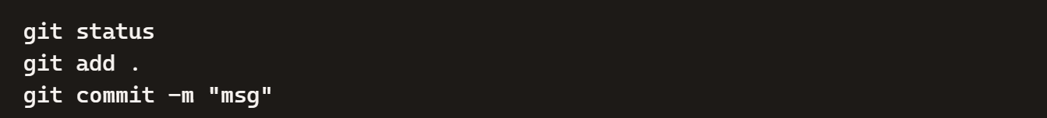
to run exactly as they would in a normal terminal.
Without shell=True, you’d have to pass commands as lists:
1. ["git", "status"]

Using shell=True keeps the script simple and readable.
⭐ Putting it all together
This line:
1. result = subprocess.run(cmd, cwd=cwd, capture_output=True, text=True, shell=True)

means:
- run the command in the given repo folder
- capture the output
- return it as text
- run it through the normal shell
- don’t print anything automatically
And then:
1. return result.stdout.strip()

gives you the clean output.
⭐ Why this design works beautifully for your multi-repo updater
It lets you:
- hop into each repo
- run git commands
- check for changes
- commit only when needed
- push automatically
All without ever leaving Python.
1.

