Idempotency Key Implementation in Java/Spring Boot

I wanted to create this project after reading about the technique used to ensure that clients only send one request (e.g. reserving an Airbnb rental). This ensures that the client is never charged twice in the event of a retry.
1. High-level flow
When a request comes in:
- Client sends header: Idempotency-Key: <uuid>
- Backend checks a database table for that key.
- If key exists → return the stored response.
- If not:
  - Process the request
  - Store the response + status
  - Return the response
This prevents duplicate operations (e.g., double-charging).
QUESTION: What is the common technique used in an application to have clients provide a unique key, generated locally before sending out a request. So, if the client re-tries the same unique key is provided letting the backend know "this is a retry" and it sends back the same response?

Answer:
The technique you’re describing is idempotency keys.

🧩 Concise answer

The common technique is to have the client generate an idempotency key (a unique, client-side UUID) and send it with the request. If the client retries, it sends the same key, and the backend returns the same result instead of performing the operation again.

🧠 How it works
- The client generates a unique key (often a UUID).
- Sends it in a header like: Idempotency-Key: <uuid>
- The server stores:
  - the key
  - the request payload
  - the response it returned
- If the same key arrives again:
  - The server recognizes it as a retry
  - Returns the cached response
  - Prevents duplicate side effects (e.g., double-charging a credit card)

📌 Why it’s used
- Prevents duplicate operations in:
  - Payment APIs (Stripe popularized this pattern)
  - Order creation
  - Resource creation
- Handles:
  - Network retries
  - Client crashes
  - Poor connectivity

🧱 Typical backend behavior
- Check if the idempotency key exists in storage.
- If not:
  - Process the request
  - Store the result under that key
- If yes:
  - Return the stored result

🛠 Common names for this pattern

- Idempotency keys (most widely used term)
- Client-generated request IDs
- Idempotent request pattern
- Deduplication keys (less common)

🧱 2. Create an Idempotency table
1. @Entity
2. @Table(name = "idempotency_keys")
3. public class IdempotencyRecord {
4.
5. @Id
6. private String id; // the idempotency key
7.
8. @Lob
9. private String responseBody;
10.
11. private int statusCode;
12.
13. private Instant createdAt = Instant.now();
14.
15. // getters/setters
16. }
17.

📦 3. Repository
1. public interface IdempotencyRepository extends JpaRepository<IdempotencyRecord, String> {
2. }
3.

🧩 4. Idempotency Service
This service checks, stores, and retrieves cached responses.
1. @Service
2. public class IdempotencyService {
3.
4. private final IdempotencyRepository repo;
5.
6. public IdempotencyService(IdempotencyRepository repo) {
7. this.repo = repo;
8. }
9.
10. public Optional<IdempotencyRecord> getRecord(String key) {
11. return repo.findById(key);
12. }
13.
14. public void saveRecord(String key, int status, String body) {
15. IdempotencyRecord record = new IdempotencyRecord();
16. record.setId(key);
17. record.setStatusCode(status);
18. record.setResponseBody(body);
19. repo.save(record);
20. }
21. }
22.

🧵 5. Idempotency Filter (intercepts requests)
This is the heart of the pattern.
1. @Component
2. public class IdempotencyFilter extends OncePerRequestFilter {
3.
4. private final IdempotencyService idempotencyService;
5.
6. public IdempotencyFilter(IdempotencyService idempotencyService) {
7. this.idempotencyService = idempotencyService;
8. }
9.
10. @Override
11. protected void doFilterInternal(HttpServletRequest request,
12. HttpServletResponse response,
13. FilterChain filterChain)
14. throws ServletException, IOException {
15.
16. String key = request.getHeader("Idempotency-Key");
17.
18. if (key == null) {
19. filterChain.doFilter(request, response);
20. return;
21. }
22.
23. // Check if key already exists
24. Optional<IdempotencyRecord> existing = idempotencyService.getRecord(key);
25.
26. if (existing.isPresent()) {
27. IdempotencyRecord record = existing.get();
28. response.setStatus(record.getStatusCode());
29. response.getWriter().write(record.getResponseBody());
30. return;
31. }
32.
33. // Wrap response to capture output
34. ContentCachingResponseWrapper wrapped = new ContentCachingResponseWrapper(response);
35.
36. filterChain.doFilter(request, wrapped);
37.
38. // Save response
39. String body = new String(wrapped.getContentAsByteArray(), StandardCharsets.UTF_8);
40. idempotencyService.saveRecord(key, wrapped.getStatus(), body);
41.
42. wrapped.copyBodyToResponse();
43. }
44. }
45.

What this filter does:
- Reads the idempotency key
- If key exists → returns cached response
- If not → processes request and stores the response

🧪 6. Example Controller
1. @RestController
2. @RequestMapping("/payments")
3. public class PaymentController {
4.
5. @PostMapping
6. public ResponseEntity<String> createPayment(@RequestBody PaymentRequest req) {
7. // Simulate expensive or side-effect operation
8. return ResponseEntity.ok("Payment created: " + UUID.randomUUID());
9. }
10. }
11.

🧠 7. Notes for production
To make this robust:
- Add TTL (e.g., delete keys older than 24 hours)
- Store request hash to detect conflicting payloads
- Use Redis for high-volume APIs
- Add locking to prevent race conditions

To recreate the idempotency-key example cleanly in IntelliJ using start.spring.io, you only need a small, focused set of Spring Boot components. Let’s keep it tight and aligned with how you’ve been structuring your Spring Boot projects.
✅ Which start.spring.io dependencies you need
For the idempotency example I gave you, you only need four components:
Required
- Spring Web (for controllers, filters, REST endpoints)
- Spring Data JPA (for the IdempotencyRecord entity + repository)
- H2 Database (simple in-memory DB for local development)
- Lombok (optional but recommended) (cuts down boilerplate in entities and services)
Optional but useful
- Validation (if you want to validate incoming requests)
- Spring Boot DevTools (for hot reload)

🏷️ Suggested project metadata
Since you’re building this as a learning project and you’ve been working with layered and hexagonal architectures, here’s a naming convention that fits well:
Group
com.example.idempotency

Why?
- Short
- Clear
- Matches the purpose
- Easy to refactor later if you fold it into a larger architecture

Artifact
idempotency-demo

Name
IdempotencyDemo

Package name
com.example.idempotency

Java version
Use Java 21 (Spring Boot 3+ and 4+ run best on it).

📦 Recommended start.spring.io configuration
Here’s the exact setup you’d pick:
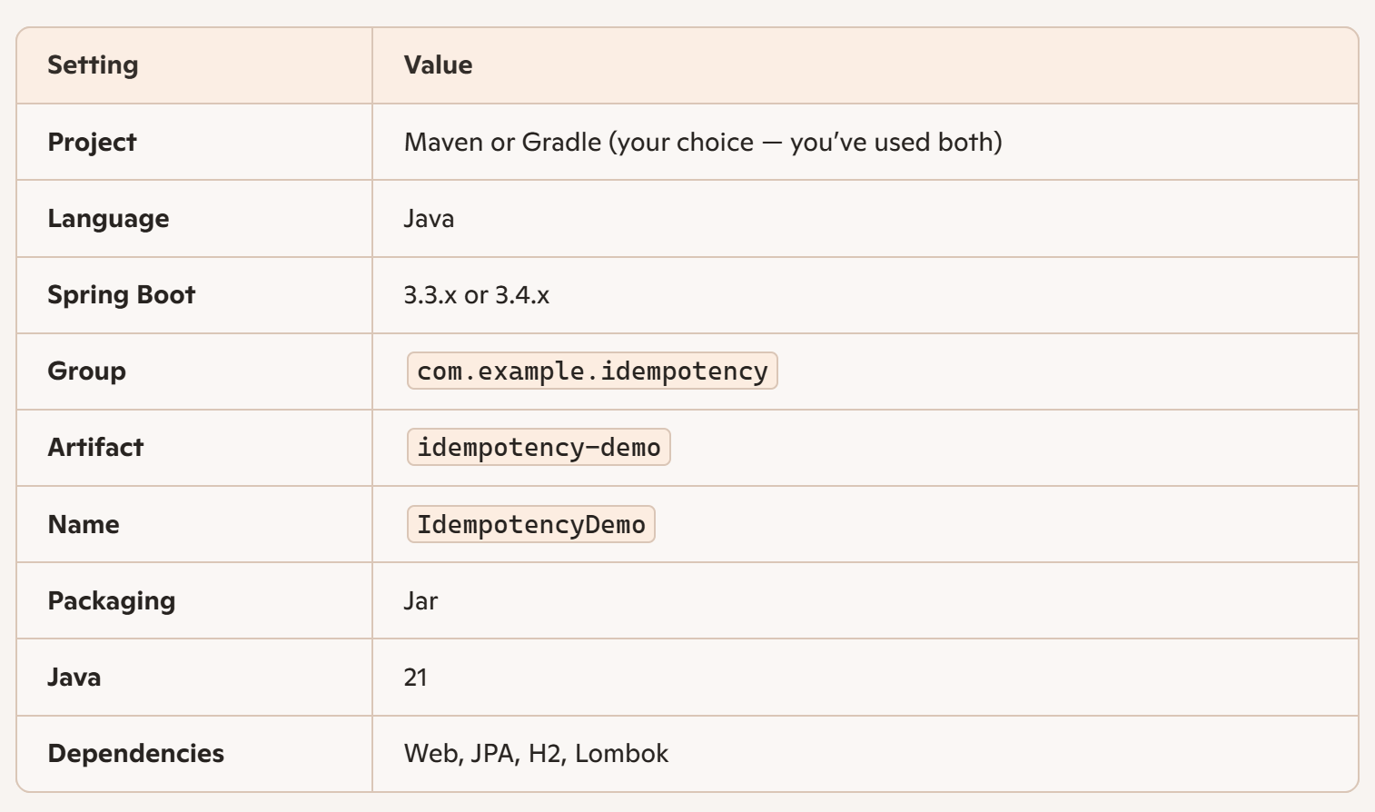
Perfect — let’s build your layered Spring Boot project structure for the idempotency-key example. I’ll give you a clean, conventional layout that matches how Spring Boot apps are typically organized when following a layered architecture (Controller → Service → Repository → Entity).
This will fit naturally into the project you’re creating in IntelliJ with the dependencies we discussed.
✅ Recommended Layered Architecture Structure
Here is the exact folder/package layout you should create under:
src/main/java/com/example/idempotency

1. Controller Layer (Web/API)
Handles HTTP requests and responses.

controller/
PaymentController.java

2. Service Layer (Business Logic)
Contains application logic and orchestrates operations.

service/
PaymentService.java
IdempotencyService.java

3. Repository Layer (Data Access)
Interfaces for persistence.

repository/
PaymentRepository.java (optional, depending on your domain)
IdempotencyRepository.java

4. Entity Layer (JPA Models)
Database entities.

entity/
Payment.java (optional domain example)
IdempotencyRecord.java

5. Filter Layer (Cross-cutting concerns)
Your idempotency filter lives here.

filter/
IdempotencyFilter.java

6. Configuration Layer (Optional)
If you want to register filters manually or add custom beans.

config/
WebConfig.java

7. Application Root
Your Spring Boot main class.

IdempotencyDemoApplication.java
📁 Full Project Structure (copy/paste into IntelliJ)
Code
src/
└── main/
├── java/
│ └── com/example/idempotency/
│ ├── controller/
│ │ └── PaymentController.java
│ ├── service/
│ │ ├── PaymentService.java
│ │ └── IdempotencyService.java
│ ├── repository/
│ │ ├── PaymentRepository.java
│ │ └── IdempotencyRepository.java
│ ├── entity/
│ │ ├── Payment.java
│ │ └── IdempotencyRecord.java
│ ├── filter/
│ │ └── IdempotencyFilter.java
│ ├── config/
│ │ └── WebConfig.java
│ └── IdempotencyDemoApplication.java
└── resources/
├── application.yml
└── data.sql (optional)

🧠 Why this structure works
It follows the classic Spring layered architecture:
- Controller → handles HTTP, maps requests, returns responses
- Service → contains business logic
- Repository → abstracts persistence
- Entity → JPA models
- Filter → cross-cutting concerns like idempotency
- Config → optional but clean for filter registration

This structure is clean, predictable, and easy to extend.
📄 1. IdempotencyDemoApplication.java
File: IdempotencyDemoApplication.java (as generated in IntelliJ)
package com.example.idempotency;
import org.springframework.boot.SpringApplication;
import org.springframework.boot.autoconfigure.SpringBootApplication;
@SpringBootApplication
public class IdempotencyDemoApplication {
public static void main(String[] args) {
SpringApplication.run(IdempotencyDemoApplication.class, args);
}
}

2. entity/IdempotencyRecord.java
package com.example.idempotency.entity;
import jakarta.persistence.Entity;
import jakarta.persistence.Id;
import jakarta.persistence.Lob;
import jakarta.persistence.Table;
import java.time.Instant;
@Entity
@Table(name = "idempotency_keys")
public class IdempotencyRecord {
@Id
private String id;
@Lob
private String responseBody;
private int statusCode;
private Instant createdAt = Instant.now();
public IdempotencyRecord() {}
public IdempotencyRecord(String id, int statusCode, String responseBody) {
this.id = id;
this.statusCode = statusCode;
this.responseBody = responseBody;
}
// getters and setters
public String getId() { return id; }
public void setId(String id) { this.id = id; }
public String getResponseBody() { return responseBody; }
public void setResponseBody(String responseBody) { this.responseBody = responseBody; }
public int getStatusCode() { return statusCode; }
public void setStatusCode(int statusCode) { this.statusCode = statusCode; }
public Instant getCreatedAt() { return createdAt; }
public void setCreatedAt(Instant createdAt) { this.createdAt = createdAt; }
}

📄 3. entity/Payment.java
(Simple example domain object — optional but included)

package com.example.idempotency.entity;
import jakarta.persistence.Entity;
import jakarta.persistence.GeneratedValue;
import jakarta.persistence.Id;
import java.util.UUID;
@Entity
public class Payment {
@Id
@GeneratedValue
private UUID id;
private String description;
public Payment() {}
public Payment(String description) {
this.description = description;
}
public UUID getId() { return id; }
public String getDescription() { return description; }
public void setDescription(String description) { this.description = description; }
}

📄 4. repository/IdempotencyRepository.java

package com.example.idempotency.repository;
import com.example.idempotency.entity.IdempotencyRecord;
import org.springframework.data.jpa.repository.JpaRepository;
public interface IdempotencyRepository extends JpaRepository<IdempotencyRecord, String> {
}

📄 5. repository/PaymentRepository.java
package com.example.idempotency.repository;
import com.example.idempotency.entity.Payment;
import org.springframework.data.jpa.repository.JpaRepository;
import java.util.UUID;
public interface PaymentRepository extends JpaRepository<Payment, UUID> {
}

📄 6. service/IdempotencyService.java
package com.example.idempotency.service;
import com.example.idempotency.entity.IdempotencyRecord;
import com.example.idempotency.repository.IdempotencyRepository;
import org.springframework.stereotype.Service;
import java.util.Optional;
@Service
public class IdempotencyService {
private final IdempotencyRepository repo;
public IdempotencyService(IdempotencyRepository repo) {
this.repo = repo;
}
public Optional<IdempotencyRecord> getRecord(String key) {
return repo.findById(key);
}
public void saveRecord(String key, int status, String body) {
IdempotencyRecord record = new IdempotencyRecord(key, status, body);
repo.save(record);
}
}

📄 7. service/PaymentService.java
package com.example.idempotency.service;
import com.example.idempotency.entity.Payment;
import com.example.idempotency.repository.PaymentRepository;
import org.springframework.stereotype.Service;
@Service
public class PaymentService {
private final PaymentRepository repo;
public PaymentService(PaymentRepository repo) {
this.repo = repo;
}
public Payment createPayment(String description) {
Payment payment = new Payment(description);
return repo.save(payment);
}
}

📄 8. filter/IdempotencyFilter.java

package com.example.idempotency.filter;
import com.example.idempotency.entity.IdempotencyRecord;
import com.example.idempotency.service.IdempotencyService;
import jakarta.servlet.FilterChain;
import jakarta.servlet.ServletException;
import jakarta.servlet.http.HttpServletRequest;
import jakarta.servlet.http.HttpServletResponse;
import org.springframework.stereotype.Component;
import org.springframework.web.filter.OncePerRequestFilter;
import org.springframework.web.util.ContentCachingResponseWrapper;
import java.io.IOException;
import java.nio.charset.StandardCharsets;
import java.util.Optional;
@Component
public class IdempotencyFilter extends OncePerRequestFilter {
private final IdempotencyService idempotencyService;
public IdempotencyFilter(IdempotencyService idempotencyService) {
this.idempotencyService = idempotencyService;
}
@Override
protected void doFilterInternal(HttpServletRequest request,
HttpServletResponse response,
FilterChain filterChain)
throws ServletException, IOException {
String key = request.getHeader("Idempotency-Key");
if (key == null) {
filterChain.doFilter(request, response);
return;
}
Optional<IdempotencyRecord> existing = idempotencyService.getRecord(key);
if (existing.isPresent()) {
IdempotencyRecord record = existing.get();
response.setStatus(record.getStatusCode());
response.getWriter().write(record.getResponseBody());
return;
}
ContentCachingResponseWrapper wrapped = new ContentCachingResponseWrapper(response);
filterChain.doFilter(request, wrapped);
String body = new String(wrapped.getContentAsByteArray(), StandardCharsets.UTF_8);
idempotencyService.saveRecord(key, wrapped.getStatus(), body);
wrapped.copyBodyToResponse();
}
}

📄 9. controller/PaymentController.java
package com.example.idempotency.controller;
import com.example.idempotency.entity.Payment;
import com.example.idempotency.service.PaymentService;
import org.springframework.http.ResponseEntity;
import org.springframework.web.bind.annotation.*;
@RestController
@RequestMapping("/payments")
public class PaymentController {
private final PaymentService service;
public PaymentController(PaymentService service) {
this.service = service;
}
@PostMapping
public ResponseEntity<String> createPayment(@RequestBody String description) {
Payment payment = service.createPayment(description);
return ResponseEntity.ok("Payment created: " + payment.getId());
}
}

📄 10. config/WebConfig.java
(Optional — Spring auto-registers filters, but this is clean)
package com.example.idempotency.config;
import com.example.idempotency.filter.IdempotencyFilter;
import org.springframework.boot.web.servlet.FilterRegistrationBean;
import org.springframework.context.annotation.Bean;
import org.springframework.context.annotation.Configuration;
@Configuration
public class WebConfig {
@Bean
public FilterRegistrationBean<IdempotencyFilter> idempotencyFilter(IdempotencyFilter filter) {
FilterRegistrationBean<IdempotencyFilter> registration = new FilterRegistrationBean<>();
registration.setFilter(filter);
registration.addUrlPatterns("/*");
registration.setOrder(1);
return registration;
}
}

📄 11. resources/application.yml
spring:
datasource:
url: jdbc:h2:mem:idempotencydb
driverClassName: org.h2.Driver
username: sa
password: password
jpa:
hibernate:
ddl-auto: update
show-sql: true
h2:
console:
enabled: true

🎉 Your project is complete
This is a fully working Spring Boot application with:
- Idempotency key support
- JPA persistence
- H2 in-memory DB
- Clean layered architecture
- A working /payments endpoint
You can now run it in IntelliJ and test with:
POST http://localhost:8080/payments
Idempotency-Key: 12345
Body: "Test payment"

Send it twice — you’ll get the same response.

Issues

Failed to start application
Obtained the following error:
2026-05-29T09:13:15.763-04:00 WARN 24864 --- [ main] ConfigServletWebServerApplicationContext : Exception encountered during context initialization - cancelling refresh attempt: org.springframework.beans.factory.support.BeanDefinitionOverrideException: Invalid bean definition with name 'idempotencyFilter' defined in class path resource [com/example/idempotency/config/WebConfig.class]: Cannot register bean definition [Root bean: class=null; scope=; abstract=false; lazyInit=null; autowireMode=3; dependencyCheck=0; autowireCandidate=true; primary=false; fallback=false; factoryBeanName=webConfig; factoryMethodName=idempotencyFilter; initMethodNames=null; destroyMethodNames=[(inferred)]; defined in class path resource [com/example/idempotency/config/WebConfig.class]] for bean 'idempotencyFilter' since there is already [Generic bean: class=com.example.idempotency.filter.IdempotencyFilter; scope=singleton; abstract=false; lazyInit=null; autowireMode=0; dependencyCheck=0; autowireCandidate=true; primary=false; fallback=false; factoryBeanName=null; factoryMethodName=null; initMethodNames=null; destroyMethodNames=null; defined in file [C:\1000-days-of-code-repos\1000doc-intellij-projects\IdempotencyDemo\build\classes\java\main\com\example\idempotency\filter\IdempotencyFilter.class]] bound.

Ahh yes — this one is a classic Spring Boot gotcha, and it’s super easy to fix once you see what’s happening.
You’re getting:
BeanDefinitionOverrideException: Invalid bean definition with name 'idempotencyFilter'

🔍 Why this error happens
You currently have two beans with the same name:
- @Component on IdempotencyFilter → Spring auto-registers it as a bean named "idempotencyFilter"
- @Bean method in WebConfig → You manually register another bean with the same name "idempotencyFilter"
Spring Boot 3+ does NOT allow bean overriding by default, so it throws the exception.

✅ Fix Options (pick ONE)
Option 1 — Remove the @Component annotation (recommended)
If you want to register the filter manually in WebConfig, then your filter should NOT be a component.
Remove this:

And keep WebConfig:
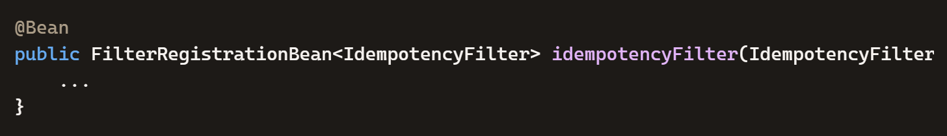
This is the cleanest approach when you want explicit filter ordering.
I TOOK OPTION 1
Option 2 — Delete WebConfig and let Spring auto-register the filter
If you prefer the simpler approach, keep @Component and delete the entire WebConfig class.
Spring Boot will automatically detect and register the filter.
This works because OncePerRequestFilter + @Component is enough for Spring Boot.

Option 3 — Rename the bean in WebConfig
Not recommended, but valid:
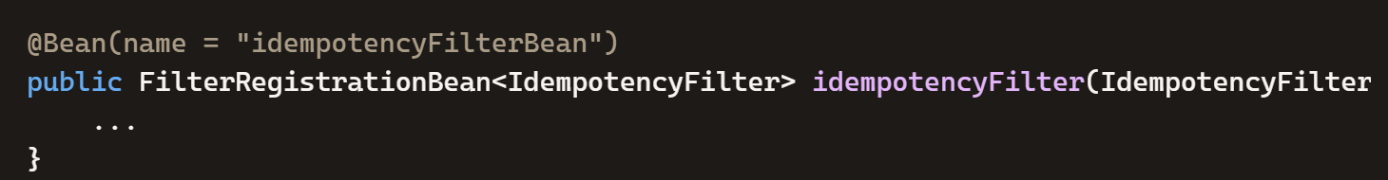

Failed to Start Service – Again!
The new error is:
Error starting Tomcat context. Exception: org.springframework.beans.factory.UnsatisfiedDependencyException. Message: Error creating bean with name 'idempotencyFilter' defined in class path resource [com/example/idempotency/config/WebConfig.class]: Unsatisfied dependency expressed through method 'idempotencyFilter' parameter 0: No qualifying bean of type 'com.example.idempotency.filter.IdempotencyFilter' available: expected at least 1 bean which qualifies as autowire candidate. Dependency annotations: {}

You fixed the first problem exactly right — now you’re just seeing the next expected one, and it has a very simple cause:
✅ Why this new error happens
You removed @Component from IdempotencyFilter (correct), but now Spring has no way to create an instance of that filter unless you explicitly tell it how.
Your WebConfig has:
1. @Bean
2. public FilterRegistrationBean<IdempotencyFilter> idempotencyFilter(IdempotencyFilter filter) {
3.

…but Spring cannot inject IdempotencyFilter filter because no bean of that type exists anymore.
So Spring says:
No qualifying bean of type 'IdempotencyFilter' available

🎯 Two ways to fix it — but only ONE is correct for your setup
Since you chose Option #1, the correct fix is:
✅ Add a @Bean method to create the IdempotencyFilter instance
Your WebConfig should look like this:
package com.example.idempotency.config;
import com.example.idempotency.filter.IdempotencyFilter;
import com.example.idempotency.service.IdempotencyService;
import org.springframework.boot.web.servlet.FilterRegistrationBean;
import org.springframework.context.annotation.Bean;
import org.springframework.context.annotation.Configuration;
@Configuration
public class WebConfig {
@Bean
public IdempotencyFilter idempotencyFilterBean(IdempotencyService service) {
return new IdempotencyFilter(service);
}
@Bean
public FilterRegistrationBean<IdempotencyFilter> idempotencyFilter(IdempotencyFilter filter) {
FilterRegistrationBean<IdempotencyFilter> registration = new FilterRegistrationBean<>();
registration.setFilter(filter);
registration.addUrlPatterns("/*");
registration.setOrder(1);
return registration;
}
}

Why this works
- idempotencyFilterBean() creates the filter
- idempotencyFilter() registers it with Tomcat
Now Spring has exactly one bean of type IdempotencyFilter, and everything wires up cleanly.

🧠 Alternative (if you prefer simpler)
If you want to avoid two beans, you can also combine them:
1. @Bean
2. public FilterRegistrationBean<IdempotencyFilter> idempotencyFilter(IdempotencyService service) {
3. FilterRegistrationBean<IdempotencyFilter> registration = new FilterRegistrationBean<>();
4. registration.setFilter(new IdempotencyFilter(service));
5. registration.addUrlPatterns("/*");
6. registration.setOrder(1);
7. return registration;
8. }
9.
This is totally valid and clean.
🎉 TL;DR Fix
You removed @Component, so now you must manually create the filter bean:
1. @Bean
2. public IdempotencyFilter idempotencyFilterBean(IdempotencyService service) {
3. return new IdempotencyFilter(service);
4. }
5.

JPA Issue
I know see the following error:
Error starting Tomcat context. Exception: org.springframework.beans.factory.UnsatisfiedDependencyException. Message: Error creating bean with name 'idempotencyFilter' defined in class path resource [com/example/idempotency/config/WebConfig.class]: Unsatisfied dependency expressed through method 'idempotencyFilter' parameter 0: Error creating bean with name 'idempotencyFilterBean' defined in class path resource [com/example/idempotency/config/WebConfig.class]: Unsatisfied dependency expressed through method 'idempotencyFilterBean' parameter 0: Error creating bean with name 'idempotencyService' defined in file [C:\1000-days-of-code-repos\1000doc-intellij-projects\IdempotencyDemo\build\classes\java\main\com\example\idempotency\service\IdempotencyService.class]: Unsatisfied dependency expressed through constructor parameter 0: Error creating bean with name 'idempotencyRepository' defined in com.example.idempotency.repository.IdempotencyRepository defined in @EnableJpaRepositories declared on DataJpaRepositoriesRegistrar.EnableJpaRepositoriesConfiguration: Cannot resolve reference to bean 'jpaSharedEM_entityManagerFactory' while setting bean property 'entityManager'

You’re very close — and the error you’re seeing now is not actually about your filter anymore. This new stack trace is a JPA bootstrapping failure, and it happens before Spring even gets to your filter.
Let’s break it down cleanly.
✅ What the error really means
The key part is:
Cannot resolve reference to bean 'jpaSharedEM_entityManagerFactory'

This means:
Spring Boot could not create the JPA EntityManagerFactory.
When that happens, every JPA-dependent bean fails — including:
- IdempotencyRepository
- IdempotencyService
- IdempotencyFilter (because it depends on IdempotencyService)
So the filter is not the root cause — JPA is.
🎯 The REAL root cause is almost always one of these:
1. Missing or incorrect H2 dependency
Make sure your build.gradle or pom.xml includes:

Maven
<dependency>
<groupId>com.h2database</groupId>
<artifactId>h2</artifactId>
<scope>runtime</scope>
</dependency>

Gradle
runtimeOnly 'com.h2database:h2'

2. Wrong datasource URL
Your application.yml should be:
spring:
datasource:
url: jdbc:h2:mem:idempotencydb
driverClassName: org.h2.Driver
username: sa
password: password

jpa:
hibernate:
ddl-auto: update
show-sql: true

h2:
console:
enabled: true

If the URL is wrong (e.g., missing jdbc:h2:), JPA will fail exactly like this.
3. Missing JPA annotations on your entities
Double-check:
IdempotencyRecord.java
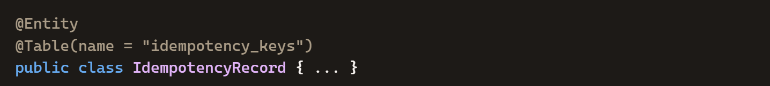
Payment.java
If either entity is missing @Entity, JPA will fail to start.
4. Wrong package structure (MOST COMMON)
Spring Boot scans entities starting from your main class package:
com.example.idempotency

Your entities must be inside that package or a subpackage:
com.example.idempotency.entity

If you accidentally created:
com.example.idempotency.entities

or
com.example.idempotency.model

Spring won’t find them → JPA fails → EntityManagerFactory fails → Repository fails → Service fails → Filter fails.

5. You accidentally created a second @SpringBootApplication
This causes multiple scans and breaks JPA.
Search your project for:
@SpringBootApplication

You should have exactly one.
🧪 Let’s confirm the fix step-by-step
Here’s what I want you to check in order:
Step 1 — Confirm H2 is in your dependencies
If not, add it.
Step 2 — Confirm your application.yml matches mine exactly
Step 3 — Confirm your entities are in:
Code
src/main/java/com/example/idempotency/entity/
Step 4 — Confirm both entities have @Entity
Step 5 — Clean and rebuild
In IntelliJ:
Build → Rebuild Project

Or via terminal:
Maven
mvn clean package

Gradle

./gradlew clean build

Fixed build.grade:
plugins {
id 'java'
id 'org.springframework.boot' version '4.0.6'
id 'io.spring.dependency-management' version '1.1.7'
}
group = 'com.example.idempotency'
version = '0.0.1-SNAPSHOT'
description = 'IdempotencyDemo'
java {
toolchain {
languageVersion = JavaLanguageVersion.of(21)
}
}
repositories {
mavenCentral()
}
dependencies {
implementation 'org.springframework.boot:spring-boot-starter-web'
implementation 'org.springframework.boot:spring-boot-starter-data-jpa'
runtimeOnly 'com.h2database:h2'
compileOnly 'org.projectlombok:lombok'
annotationProcessor 'org.projectlombok:lombok'
testImplementation 'org.springframework.boot:spring-boot-starter-test'
}
tasks.named('test') {
useJUnitPlatform()
}

I did:
- clean
- build
Got an error:
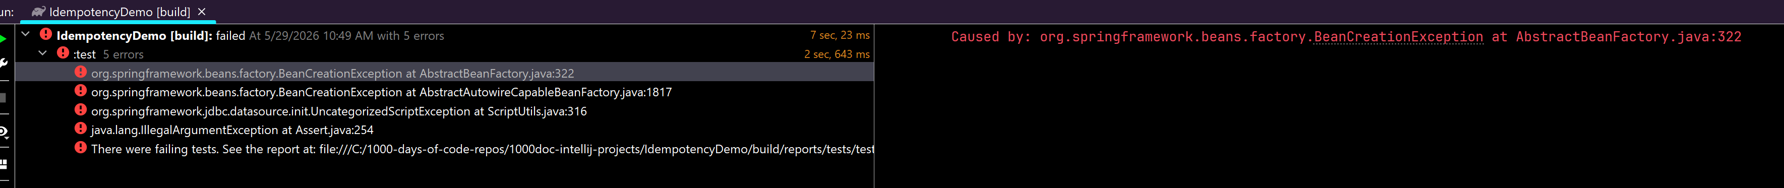
The problem was because I had an empty data.sql file in resources folder!!!
- Removed file
bootRun vs. running from application:
Now that you're ready to actually run the app, here’s the clean way to think about bootRun vs running the main application class:
🚀 Short answer
Use bootRun when you want the full Spring Boot dev experience. Use “Run Application” when you just want to start the app quickly from IntelliJ.
Both work — they just behave a little differently.
🧭 When to use ./gradlew bootRun
Use this when you want:
- Automatic classpath setup from Gradle
- To ensure the app runs exactly as Gradle builds it
- To avoid IntelliJ accidentally using cached/outdated compiled classes
- To run with Gradle-managed profiles or environment variables
- To match how the app will run in CI/CD or production-like environments
This is the most “official” way to run a Spring Boot app during development.
🖥️ When to use IntelliJ “Run Application”
Use this when you want:
- Fast startup
- Debugging with breakpoints
- Quick iteration while coding
- No need to rebuild the whole Gradle project
IntelliJ compiles and runs the app using its own build system, which is usually fine for local development.
🧠 My recommendation for you right now
Since you just fixed a build issue and want to be sure everything is clean and consistent:
👉 Run ./gradlew bootRun once to confirm the app starts correctly. After that, feel free to use IntelliJ’s green “Run” arrow for convenience.

- Executed Gradle Tasks -> application -> bootRun
10:56:53 AM: Executing 'bootRun'…

> Task :compileJava UP-TO-DATE
> Task :processResources UP-TO-DATE
> Task :classes UP-TO-DATE
> Task :resolveMainClassName UP-TO-DATE

> Task :bootRun

. ____ _ __ _ _
/\\ / ___'_ __ _ _(_)_ __ __ _ \ \ \ \
( ( )\___ | '_ | '_| | '_ \/ _` | \ \ \ \
\\/ ___)| |_)| | | | | || (_| | ) ) ) )
' |____| .__|_| |_|_| |_\__, | / / / /
=========|_|==============|___/=/_/_/_/

:: Spring Boot :: (v4.0.6)

2026-05-29T10:56:55.144-04:00 INFO 40896 --- [ main] c.e.i.IdempotencyDemoApplication : Starting IdempotencyDemoApplication using Java 21.0.5 with PID 40896 (C:\1000-days-of-code-repos\1000doc-intellij-projects\IdempotencyDemo\build\classes\java\main started by lorra in C:\1000-days-of-code-repos\1000doc-intellij-projects\IdempotencyDemo)
2026-05-29T10:56:55.147-04:00 INFO 40896 --- [ main] c.e.i.IdempotencyDemoApplication : No active profile set, falling back to 1 default profile: "default"
2026-05-29T10:56:55.521-04:00 INFO 40896 --- [ main] .s.d.r.c.RepositoryConfigurationDelegate : Bootstrapping Spring Data JPA repositories in DEFAULT mode.
2026-05-29T10:56:55.559-04:00 INFO 40896 --- [ main] .s.d.r.c.RepositoryConfigurationDelegate : Finished Spring Data repository scanning in 31 ms. Found 2 JPA repository interfaces.
2026-05-29T10:56:55.870-04:00 INFO 40896 --- [ main] o.s.boot.tomcat.TomcatWebServer : Tomcat initialized with port 8080 (http)
2026-05-29T10:56:55.879-04:00 INFO 40896 --- [ main] o.apache.catalina.core.StandardService : Starting service [Tomcat]
2026-05-29T10:56:55.879-04:00 INFO 40896 --- [ main] o.apache.catalina.core.StandardEngine : Starting Servlet engine: [Apache Tomcat/11.0.21]
2026-05-29T10:56:55.919-04:00 INFO 40896 --- [ main] b.w.c.s.WebApplicationContextInitializer : Root WebApplicationContext: initialization completed in 744 ms
2026-05-29T10:56:56.002-04:00 INFO 40896 --- [ main] org.hibernate.orm.jpa : HHH008540: Processing PersistenceUnitInfo [name: default]
2026-05-29T10:56:56.037-04:00 INFO 40896 --- [ main] org.hibernate.orm.core : HHH000001: Hibernate ORM core version 7.2.12.Final
2026-05-29T10:56:56.371-04:00 INFO 40896 --- [ main] o.s.o.j.p.SpringPersistenceUnitInfo : No LoadTimeWeaver setup: ignoring JPA class transformer
2026-05-29T10:56:56.398-04:00 INFO 40896 --- [ main] com.zaxxer.hikari.HikariDataSource : HikariPool-1 - Starting...
2026-05-29T10:56:56.516-04:00 INFO 40896 --- [ main] com.zaxxer.hikari.pool.HikariPool : HikariPool-1 - Added connection conn0: url=jdbc:h2:mem:idempotencydb user=SA
2026-05-29T10:56:56.517-04:00 INFO 40896 --- [ main] com.zaxxer.hikari.HikariDataSource : HikariPool-1 - Start completed.
2026-05-29T10:56:56.559-04:00 INFO 40896 --- [ main] org.hibernate.orm.connections.pooling : HHH10001005: Database info:
Database JDBC URL [jdbc:h2:mem:idempotencydb]
Database driver: H2 JDBC Driver
Database dialect: H2Dialect
Database version: 2.4.240
Default catalog/schema: IDEMPOTENCYDB/PUBLIC
Autocommit mode: undefined/unknown
Isolation level: READ_COMMITTED [default READ_COMMITTED]
JDBC fetch size: 100
Pool: DataSourceConnectionProvider
Minimum pool size: undefined/unknown
Maximum pool size: undefined/unknown
2026-05-29T10:56:57.123-04:00 INFO 40896 --- [ main] org.hibernate.orm.core : HHH000489: No JTA platform available (set 'hibernate.transaction.jta.platform' to enable JTA platform integration)
Hibernate: create table idempotency_keys (id varchar(255) not null, created_at timestamp(6) with time zone, response_body clob, status_code integer not null, primary key (id))
Hibernate: create table payment (id uuid not null, description varchar(255), primary key (id))
2026-05-29T10:56:57.166-04:00 INFO 40896 --- [ main] j.LocalContainerEntityManagerFactoryBean : Initialized JPA EntityManagerFactory for persistence unit 'default'
2026-05-29T10:56:57.204-04:00 INFO 40896 --- [ main] o.s.d.j.r.query.QueryEnhancerFactories : Hibernate is in classpath; If applicable, HQL parser will be used.
2026-05-29T10:56:57.315-04:00 WARN 40896 --- [ main] JpaBaseConfiguration$JpaWebConfiguration : spring.jpa.open-in-view is enabled by default. Therefore, database queries may be performed during view rendering. Explicitly configure spring.jpa.open-in-view to disable this warning
2026-05-29T10:56:57.522-04:00 INFO 40896 --- [ main] o.s.boot.tomcat.TomcatWebServer : Tomcat started on port 8080 (http) with context path '/'
2026-05-29T10:56:57.525-04:00 INFO 40896 --- [ main] c.e.i.IdempotencyDemoApplication : Started IdempotencyDemoApplication in 2.7 seconds (process running for 2.963)

Testing from Postman
with your controller mapped at:
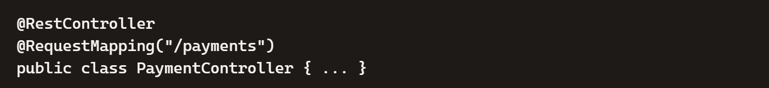
your API base path is:
And the typical REST patterns become:
- POST /payments
- GET /payments/{id}
- GET /payments
- DELETE /payments/{id}
- PUT /payments/{id} (if you support updates)
Let me give you a clean, ready-to-import Postman collection specifically for /payments, plus example requests you can fire off immediately.
📦 Postman Collection for /payments
Copy this JSON into a file named PaymentsAPI.postman_collection.json and import it into Postman.
{
"info": {
"name": "Payments API",
"_postman_id": "a1b2c3d4-5678-90ab-cdef-1234567890ab",
"description": "Collection for testing Spring Boot Payments API with Idempotency-Key support",
"schema": "https://schema.getpostman.com/json/collection/v2.1.0/collection.json"
},
"item": [
{
"name": "Create Payment",
"request": {
"method": "POST",
"header": [
{ "key": "Idempotency-Key", "value": "{{$guid}}" },
{ "key": "Content-Type", "value": "application/json" }
],
"body": {
"mode": "raw",
"raw": "{\n \"amount\": 100.00,\n \"currency\": \"USD\",\n \"description\": \"Test payment\"\n}"
},
"url": {
"raw": "http://localhost:8080/payments",
"protocol": "http",
"host": ["localhost"],
"port": "8080",
"path": ["payments"]
}
}
},
{
"name": "Get Payment by ID",
"request": {
"method": "GET",
"header": [],
"url": {
"raw": "http://localhost:8080/payments/1",
"protocol": "http",
"host": ["localhost"],
"port": "8080",
"path": ["payments", "1"]
}
}
},
{
"name": "Get All Payments",
"request": {
"method": "GET",
"header": [],
"url": {
"raw": "http://localhost:8080/payments",
"protocol": "http",
"host": ["localhost"],
"port": "8080",
"path": ["payments"]
}
}
},
{
"name": "Delete Payment",
"request": {
"method": "DELETE",
"header": [],
"url": {
"raw": "http://localhost:8080/payments/1",
"protocol": "http",
"host": ["localhost"],
"port": "8080",
"path": ["payments", "1"]
}
}
}
]
}

🧪 Manual Postman Requests
1. Create a payment
POST http://localhost:8080/payments

Body → raw → JSON:
{
"amount": 100.00,
"currency": "USD",
"description": "Test payment"
}
2. Get a payment by ID
GET http://localhost:8080/payments/1

3. Get all payments
GET http://localhost:8080/payments

4. Delete a payment
DELETE http://localhost:8080/payments/1

