I Designed Airbnb’s Booking System Live. The Interviewer Stopped Me at Minute 12.

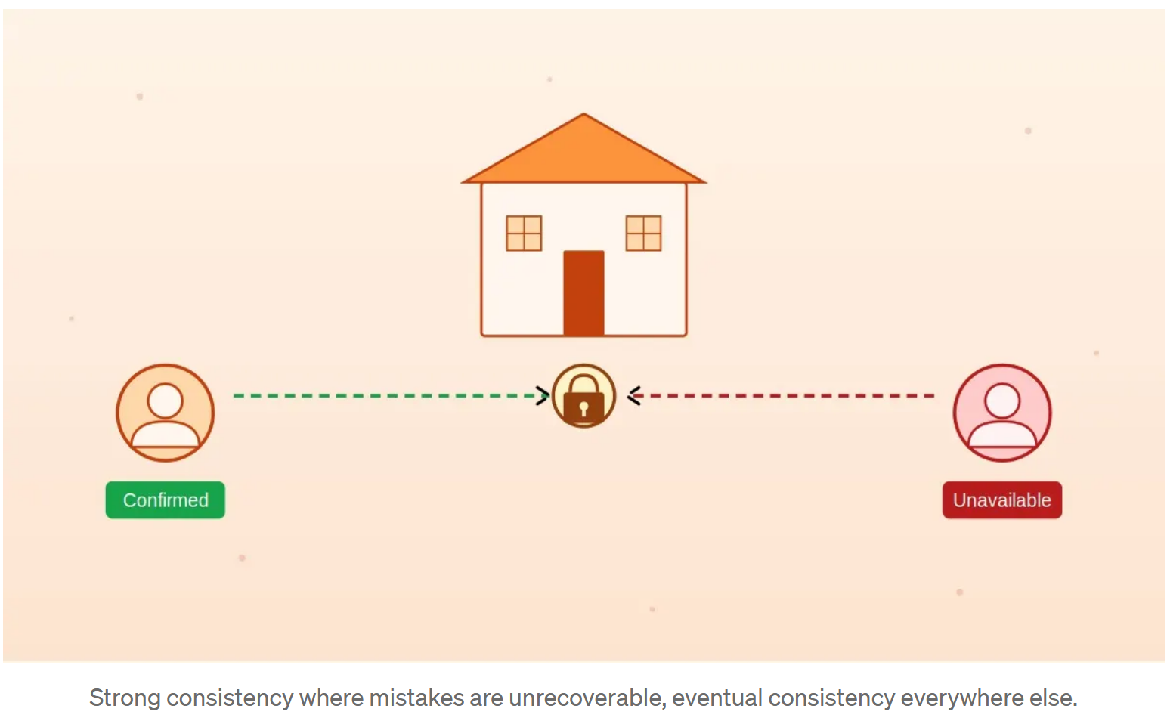
The two guests problem
Two guests. Same listing. Same dates. Their fingers hit the book button at the same instant. One booking succeeds. The other fails cleanly with “no longer available.” The guest sees a clear error, not a charged card and an empty calendar.
That outcome looks simple from the outside. It is not simple. It is the entire booking problem compressed into one moment, and the answer is not what most engineers reach for first.

What most engineers reach for
The first instinct is sound and common. Open a transaction, lock the listing’s calendar row, check whether the requested dates are free, insert a booking row, commit. The database guarantees that two transactions cannot both succeed against the same row. Problem solved.
It works on paper. It works in a single region against a single database. It starts to crack the moment you add the things that real systems have. Network retries from flaky mobile clients. Global users hitting nearest regions. Background jobs writing to the same row. Wait. If the network just dropped between the database commit and the response reaching the client, did the booking happen or not? The client doesn’t know. The user retries. Now you have two bookings for the same dates from the same person, charged twice.
At any meaningful scale, partial failures are not the exception. They are most of what your system handles.
What the system is actually optimizing for
The deeper move is to stop thinking about this as a concurrency problem and start thinking about it as a “safe to retry” problem. The classical concurrency case (two strangers, same dates, same instant) is rare. The retry case (one user, one intent, three network hiccups) happens constantly.
Strong consistency on the booking commit is not optional. A guest who clicks once must produce one booking. A guest who clicks five times because their connection is dying must still produce one booking. The tradeoff you are making is coordination cost against correctness. You can have low latency, global availability, and zero coordination, but not all three. Bookings are the operation where you spend the coordination budget and accept the latency cost. Everything else gets to be cheap.
This is the reframing the interviewer was waiting for. Once it lands, the rest of the design follows.
The architecture
Two patterns carry the load.
The first is idempotency. Every booking request from the client carries a unique key, generated locally before the request goes out. The server stores the outcome of each key. If the same key arrives again because the client retried, the server returns the original result instead of doing the work twice. The user sees “your booking is confirmed” even on the third retry, because the booking already happened on the first attempt. The cost is a small amount of storage and a lookup on every write. The benefit is that you stop apologizing for retries.
QUESTION: What is the common technique used in an application to have clients provide a unique key, generated locally before sending out a request. So, if the client re-tries the same unique key is provided letting the backend know "this is a retry" and it sends back the same response?

Answer:
The technique you’re describing is idempotency keys.
🧩 Concise answer

The common technique is to have the client generate an idempotency key (a unique, client-side UUID) and send it with the request. If the client retries, it sends the same key, and the backend returns the same result instead of performing the operation again.

🧠 How it works
- The client generates a unique key (often a UUID).
- Sends it in a header like: Idempotency-Key: <uuid>
- The server stores:
  - the key
  - the request payload
  - the response it returned
- If the same key arrives again:
  - The server recognizes it as a retry
  - Returns the cached response
  - Prevents duplicate side effects (e.g., double-charging a credit card)

📌 Why it’s used
- Prevents duplicate operations in:
  - Payment APIs (Stripe popularized this pattern)
  - Order creation
  - Resource creation
- Handles:
  - Network retries
  - Client crashes
  - Poor connectivity

🧱 Typical backend behavior
- Check if the idempotency key exists in storage.
- If not:
  - Process the request
  - Store the result under that key
- If yes:
  - Return the stored result

🛠 Common names for this pattern

- Idempotency keys (most widely used term)
- Client-generated request IDs
- Idempotent request pattern
- Deduplication keys (less common)
The second is conflict prevention at the data layer. Most teams at this scale converge on one of two approaches. Either a database constraint that makes overlapping date ranges for the same listing impossible to insert, which Postgres exclusion constraints handle natively, or an inventory reservation pattern where the dates are held with an expiring lease while payment processes, then committed or released. Reservation adds operational weight but handles long running payment flows gracefully when payment providers stall.
Both layers run together. Idempotency stops accidental duplicates. The constraint stops genuine conflicts. Either alone is not enough.
The pattern you’re describing is formally known as the Reservation-Then-Commit Pattern (sometimes called Inventory Reservation, Two-Phase Reservation, or Hold-and-Commit).

It is a distributed-systems pattern used to prevent overselling when multiple customers attempt to buy the same limited inventory at the same time.

🧩 Core Idea (the short version)
You reserve the item first—immediately removing it from the “available” pool—then give the customer a short, expiring lease while they complete payment. After payment:

- Commit → the reservation becomes a permanent sale
- Release/Expire → the reservation is discarded and inventory returns to available

This closes the race window that causes overselling.
This is exactly the pattern described in the AppScale article on preventing overselling under concurrent demand.

🔍 Why the pattern exists
Naive checkout flows do this:
- Read stock
- If stock > 0, start payment
- After payment, decrement stock

Under concurrency, many buyers can read the same “1 item left” and all proceed to payment.

This leads to overselling.

The Reservation-Then-Commit pattern fixes this by moving the decrement to the beginning, not the end.

🏗️ How the Reservation Lifecycle Works
Sources describe a nearly identical three-state model: Available → Reserved → Confirmed (or Released).
1. Reserve (Hold)
- System atomically moves units from available to reserved.
- A TTL (time-to-live) is attached—e.g., 5–15 minutes.
- No other customer can claim these units.

2. Commit
- After payment succeeds, the reservation is confirmed.
- Reserved units become permanently deducted from inventory.

3. Release / Expire
- If payment fails, the user abandons checkout, or TTL expires:
  - Units move back to available.
  - This prevents “ghost reservations” that lock up stock.

🧠 Where this pattern is used

The pattern is standard in any system with scarce inventory:
- Concert tickets, flights, hotels, restaurant tables
- E-commerce carts and checkout flows
- GPU/compute instance reservations
- Parking spots, appointments, etc.

⚙️ Implementation Approaches

Different systems implement the same conceptual pattern:

1. Strong transactional DB reservation
- Use SQL transactions to atomically decrement available stock and create a reservation row.
- Common in monolithic or strongly consistent systems.

2. Redis with TTL (very common)
Redis supports:
- Atomic check-and-reserve using WATCH + MULTI
- TTL-based expiration
- Separate “available” and “reserved” pools

3. Dedicated Reservation Service
A microservice that:
- Owns reservation state
- Emits events (Outbox pattern)
- Integrates with Sagas for payment/order workflows

🧨 Failure Modes the Pattern Prevents
From the AppScale article:
- Overselling (most important)
- Double-booking
- Ghost reservations (if TTL is missing)

🧩 How it fits with Sagas, Idempotency, and Payments
Modern systems combine this pattern with:
- Idempotency keys → prevent duplicate reserve/commit calls
- Sagas → coordinate payment + order + inventory
- Outbox pattern → reliable event publishing

📝 Summary
Name: Reservation-Then-Commit Pattern
Also called: Inventory Reservation, Hold-and-Commit, Two-Phase Reservation
Purpose: Prevent overselling by reserving inventory before payment
Mechanism: Temporary hold with TTL → commit or release
Used in: Ticketing, e-commerce, hotel/flight booking, compute reservations
Backed by: Strong transactional DB, Redis TTL, or a dedicated reservation service

Where it gets genuinely hard
Most engineers reach this point. The next question is where it gets harder.
What about a guest in one region and a guest in another region booking the same listing at the same instant? You cannot lock a row across continents without paying tens of milliseconds of latency on every read, which kills your search experience. The honest answer is partitioning. Every booking write for a given listing routes to a single primary region. That listing’s calendar lives there. Other regions read replicas with eventual consistency for browsing, but bookings always travel back to the primary.
The tradeoff is real and worth saying out loud. A guest geographically far from a listing’s primary region pays a slightly higher booking latency. In exchange, the booking is correct. Hosts care more about correctness than guests care about a small extra delay at checkout.
The mental model
Draw the consistency boundary around what must be globally agreed on. Booking confirmation is inside the boundary. View counts, search availability cache, recommendation signals, wishlist saves, all of these sit outside. For the inside, use a single source of truth, idempotency keys, and a database that enforces the conflict rule. For the outside, use data types that merge concurrent updates without coordination, sometimes called CRDTs (data structures that resolve concurrent writes deterministically without locking). One booking primary per listing. Many eventually consistent caches everywhere else.
The sentence that fits in any system design discussion: strong consistency where mistakes are unrecoverable, eventual consistency everywhere else.
Back to the two guests
The system does not prevent the conflict by being faster than the second guest. It prevents the conflict by deciding, before either request arrives, who has the authority to decide. The primary region for that listing answers. Idempotency keys make the answer survive retries. Constraints make the answer survive the rare genuine race. CRDTs and similar patterns handle everything around the booking that doesn’t need to be globally agreed.
That is the architecture in one sentence, and that is roughly the point in the conversation where the interviewer stopped me. Not because I had finished. Because once you have named the boundary, every other decision is downstream of it. The next interesting question, the one I’d love to hear how you’d answer: what changes if you allow overbooking by design, the way airlines do?
One platform I came across while preparing was PracHub. The technical and behavioral question sets are genuinely good, and worth exploring if you’re in interview prep mode.
If you want pieces like this delivered to your inbox, you can subscribe below. I’m covering more system design patterns like this. Follow along so you don’t miss the next one.
Follow me for more such content.

