Testing Soap Service

🌟 1. Verify the WSDL (the “contract”)
This is the first sanity check.
Open your browser and go to:
http://localhost:8080/ws/greeting.wsdl
If you see XML describing your service, you’re golden. If the WSDL loads, the SOAP service is officially alive.

🌟 2. Test SOAP using Postman (the easiest modern tool)
Step 1 — Create a new POST request
http://localhost:8080/ws
Step 2 — Add headers
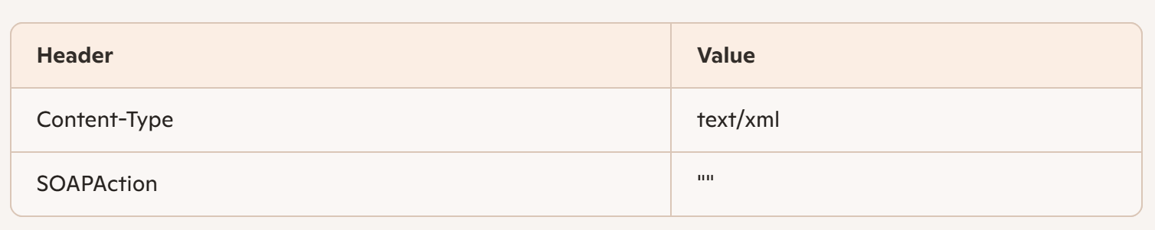

Step 3 — Paste this into the Body (raw → XML)
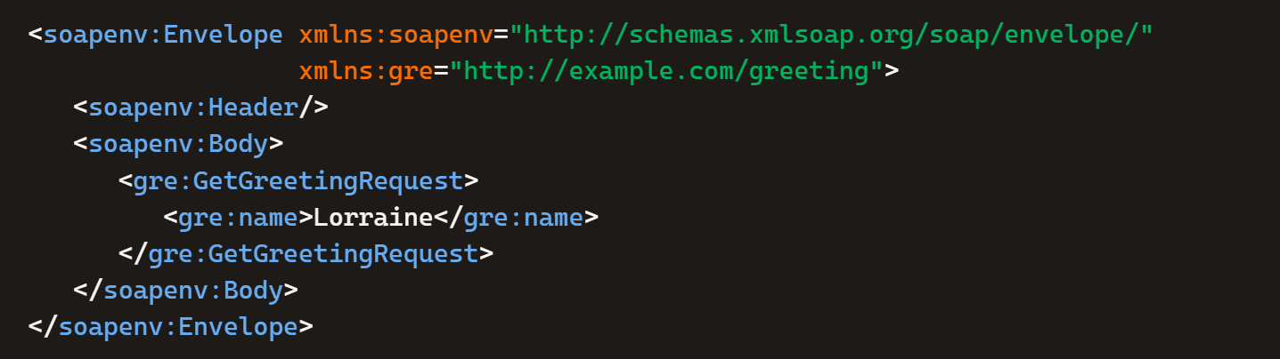
Step 4 — Send
You should get something like:
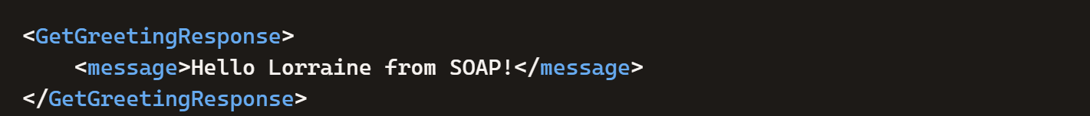
That’s your endpoint working exactly as designed.

🌟 3. Test using SoapUI (classic SOAP tool)
If you prefer the old-school SOAP workflow:
- Open SoapUI
- File → New SOAP Project
- Enter the WSDL URL:

http://localhost:8080/ws/greeting.wsdl

- SoapUI will auto-generate a request template
- Fill in <name> and send
This gives you a full SOAP testing environment.

🌟 4. Test using curl (quick command-line check)
If you want a terminal test:
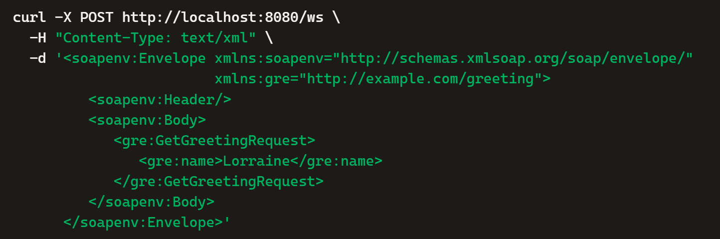

🌟 5. What success looks like
If everything is correct, you’ll see:
- WSDL loads in browser
- SOAP request returns a valid XML response
- No errors in logs
- REST endpoint still works independently
You now have a dual-protocol Spring Boot application — REST + SOAP — which is something many teams struggle to get right.

