The Reservation Then Commit Pattern: Holding Stock, Seats, and Slots Without Overselling Under Concurrent Demand (2026)
URL: https://appscale.blog/en/blog/microservices-pattern-reservation-then-commit-2026?utm_source=copilot.com
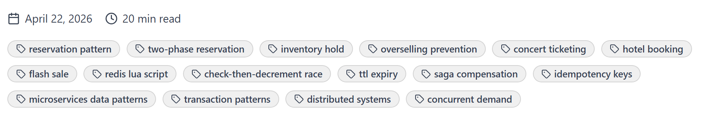
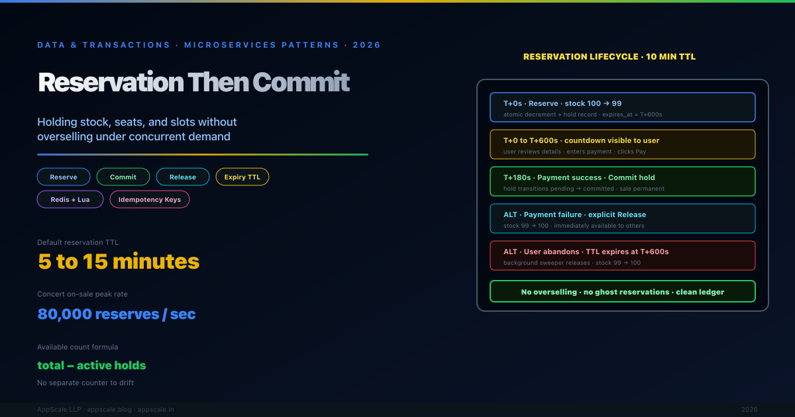
The classic concert-ticketing failure is the same every time: ten thousand users hit "buy" simultaneously for a hundred seats; the system shows them all the seat is available; ninety-nine hundred get an error somewhere in the payment flow because the seat was already sold to one of the others. The naive design — check stock, take payment, decrement stock — has an unbounded race window between the check and the decrement during which any number of other transactions can also see stock as available.
The reservation-then-commit pattern closes that window by introducing an explicit hold step: the seat is reserved (decrementing available stock immediately) before payment begins, and the reservation either commits (becomes a permanent sale) or expires (restoring the stock for someone else) within a bounded time window. The pattern is the standard solution to overselling in any scarce-inventory system: ticketing, hotel rooms, restaurant tables, ride-hail driver matching, retail flash sales, vaccine appointments, GPU instance reservations, parking spots, and any limited-quantity sale.
This article covers the two-phase reservation lifecycle, the role of expiry and time-bounded holds, the implementation patterns (database row locks, Redis with TTL, dedicated reservation services), how the pattern composes with the Saga and Idempotency patterns, the failure modes the pattern prevents (overselling, double-booking, ghost reservations), the failure modes it can introduce (lost capacity from expired holds, race conditions on commit), the configuration values that work in production, and the operational discipline of monitoring reservation lifetimes and expiry rates.

The Failure Mode Reservation Then Commit Prevents
The check-then-decrement race condition. The naive flow is: read available stock, if greater than zero proceed to payment, after payment decrement stock. Between the read and the decrement, any number of other transactions can also read the stock and proceed to payment. With sufficient concurrency, more transactions complete payment than there is stock to fulfil. The system has now sold something it does not have. The customer who paid but did not receive the inventory is owed a refund and an apology; if the inventory in question is a flight seat or concert ticket on a non-rebookable date, the customer is owed substantially more.
The race window scales with payment latency. Even pessimistic locks at the database layer cannot help if the payment provider takes 3 seconds to authorise and the lock cannot be held across that latency. Holding a database row lock open across a network call to a payment provider blocks every other transaction trying to access that row, creates lock-timeout cascades, and is functionally a denial-of-service against your own database. The solution must allow many concurrent purchase attempts to proceed in parallel without blocking each other, while still guaranteeing that only as many succeed as there is stock available.
Optimistic concurrency at the commit moment is too late. An optimistic-locking approach — let everyone proceed, then at commit time check if stock is still available and reject the late ones — is mathematically correct but produces a terrible user experience. Customers complete a 90-second checkout flow including payment, then see "sorry, this is no longer available" at the very end. The conversion impact is severe; the support load is significant; the reputational cost is real. Reservation-then-commit converts this late failure into an early failure: customers find out at second 1 (when they try to add to cart) rather than at second 90 (after they have committed to buying), so they can either choose a different option or abandon without sunk-cost frustration.

What the Pattern Actually Is
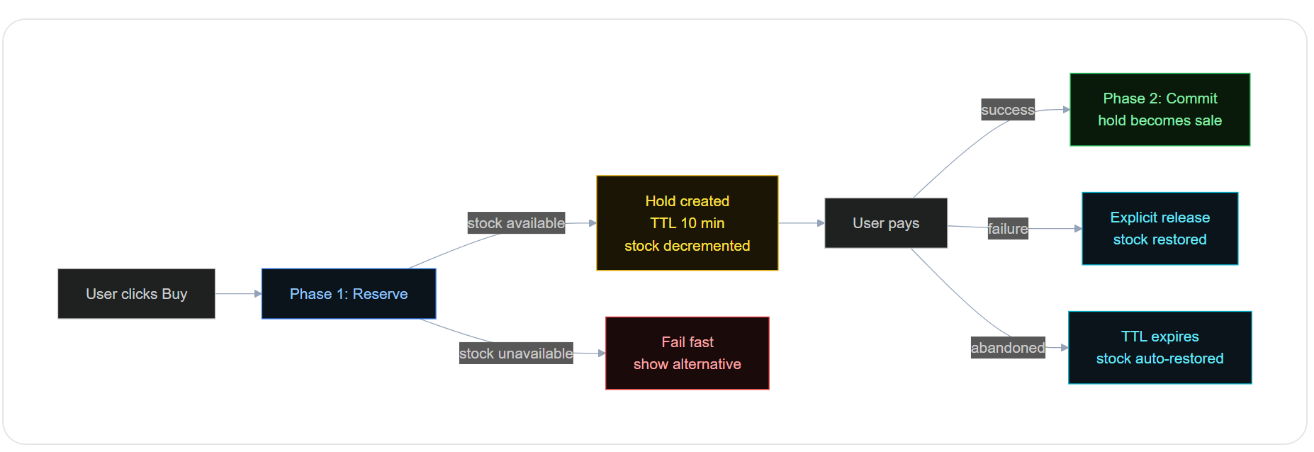
Phase 1: Reserve. The user's intent to purchase triggers an atomic operation that decrements available stock and creates a hold record with an expiry timestamp. The decrement and the hold creation are a single atomic operation (database transaction or Redis Lua script) — no race window. If stock is zero, the reserve fails immediately and the user sees "sold out" before any payment flow begins. If stock is greater than zero, the user receives a reservation token and proceeds to payment. From this moment, the unit of stock is logically "held" — it does not appear as available to any other purchase attempt, but it is also not yet permanently sold.
Phase 2: Commit (or release). When payment succeeds, the application calls commit on the reservation token: the hold record transitions from pending to committed, and the stock decrement is now permanent. When payment fails, the application calls release on the token: the hold record transitions to released, and the stock decrement is reversed (the unit becomes available again immediately). When the user abandons the flow without either completing or cancelling, the hold record's expiry timestamp eventually triggers an automatic release: a background process reverses the decrement and the unit becomes available again. The TTL is the bound on how long the unit is held in limbo.
The hold record is the source of truth, not the original stock count. "Available stock" is computed as "total stock minus active holds" rather than stored as a separate counter. This formulation makes the system correct under any sequence of reserve, commit, release, and expire operations — the available count is always the difference between the canonical totals and the canonical holds, with no separate counter to drift out of sync. Some implementations cache the computed available count for read performance and invalidate the cache on every reserve/release event, but the source of truth remains the holds table.

Implementation Patterns
Database row locks with explicit reservation table. The most common implementation uses a relational database with a reservations table. Each reservation is a row with stock_id, user_id, quantity, status (pending, committed, released, expired), and expires_at columns. The reserve operation runs in a transaction: SELECT the current available count (computed from total minus pending+committed reservations); if greater than the requested quantity, INSERT a new pending reservation. The transaction's serialisable isolation level prevents the race condition. The downside is that the transaction holds locks on the reservations table for its duration, which can be a contention point under very high concurrency. Acceptable for most workloads up to a few thousand reservations per second.
Redis with Lua script for atomic decrement-and-hold. For higher-throughput workloads, Redis is the typical choice. Stock counts live in Redis as integer keys; reservations are tracked in a Redis hash with TTL. A single Lua script executes the check-decrement-hold atomically: KEYS[1] is the stock counter, ARGV[1] is the requested quantity, ARGV[2] is the reservation ID, ARGV[3] is the TTL. The script DECRBY's the stock counter only if it remains non-negative, then HSET's the reservation with the TTL. The whole operation runs as a single Redis command (atomic by Redis semantics), no race window. Throughput is in tens of thousands per second per Redis instance. The downside is that Redis is volatile by default; reservations must be persisted to a durable store as well for audit trail and recovery.
Dedicated reservation service with event sourcing. Large-scale systems (airline reservation systems, major event ticketing platforms) often build a dedicated reservation service backed by an event-sourced ledger. Every reserve, commit, release, and expire is an event in an append-only log; the current state of any inventory unit is computed by replaying the events. This pattern provides perfect audit trail, supports complex business rules (overbooking policies for airlines, group reservations for events), and scales horizontally by partitioning the event stream. The implementation complexity is significant; only justified for systems where the reservation logic is the core product, not a side concern.
Distributed lock with timeout (the anti-pattern). A naive implementation uses a distributed lock (Redis SETNX with TTL, ZooKeeper, etcd) to protect the check-decrement sequence. This works for low concurrency but does not scale: every reserve operation must acquire the lock, including reservations for entirely unrelated stock units. The lock becomes a bottleneck. Use locks for the metadata operations (creating a new product, configuring inventory) but use atomic operations (database serialisable transactions, Redis Lua scripts) for the per-reservation hot path.

The TTL Decision: How Long to Hold a Reservation
Match the TTL to the realistic completion time of the user flow. A standard e-commerce checkout takes 2 to 10 minutes from add-to-cart to order placement; a 10-minute TTL is the typical default. A complex booking flow with seat selection, dietary preferences, and add-on services may need 15 to 30 minutes; an enterprise procurement flow with approvals may need hours or days. Setting the TTL too short causes user frustration ("the seat I just selected disappeared while I was reading the terms"); setting it too long causes lost capacity ("twenty seats are reserved and idle, the event is sold out, but ten will eventually expire").
Different reservation types can have different TTLs. A guest checkout TTL might be 10 minutes; a logged-in returning customer's TTL might be 20 minutes; a corporate buyer making a bulk reservation might have 60 minutes. Personalising the TTL by user segment recovers some of the trade-off — give your most reliable users more time, give your most flaky users a tighter window. Implementation is a small extension to the reserve operation: TTL is computed from user metadata at reservation time and stored on the hold record.
Visible countdowns reduce abandonment. Showing the user "Your seat is reserved for 8:42" creates urgency and reduces the rate at which users walk away mid-flow. The countdown also calibrates user expectations — they understand the reservation is time-bounded and will not be surprised when it expires. The implementation is purely client-side: the server returns the expires_at timestamp; the client renders a countdown. Be careful to handle clock skew gracefully (the client's clock may not match the server's) by always treating the server's expires_at as authoritative on commit attempts.
Extending an active reservation. Long-flow systems may allow the user to extend an active reservation by clicking "I need more time." The extend operation atomically updates the hold record's expires_at to a new timestamp; the stock count is unaffected because the hold is already counted as taken. Limit the number of extensions to prevent indefinite holds; charge for the extension if appropriate (for premium scarce inventory).

Composition with Saga and Idempotency
The Saga pattern uses reservations as its compensable steps. A multi-service checkout saga (reserve inventory, charge payment, allocate shipping, send confirmation) uses the reservation as the inventory step's local transaction. If a later saga step fails, the inventory step's compensation is to release the reservation — a clean reversal because no commit has yet occurred. Without reservations, the inventory step would have to be a permanent decrement, requiring the compensating action to be a full inventory restore (including audit trail of the reversal). Reservations make sagas substantially cleaner because the compensable step is built into the reservation lifecycle. See the Saga Orchestration article for the broader pattern.
Idempotency keys protect the reserve, commit, and release operations. Network errors during reserve, commit, or release can cause the client to retry — and a non-idempotent retry can produce double reservations or commit-on-released holds. Each operation accepts an idempotency key; the server stores the key with the result and returns the same result on retry without re-executing the operation. This is essential for any production reservation system because the reservation-payment-commit flow has multiple network boundaries and any of them can fail in a way that requires retry. See the Idempotency article for the underlying mechanism.
The commit operation is the saga's success signal. The successful payment authorisation triggers the commit on the reservation; the reservation transitions to committed; the saga proceeds to subsequent steps (shipping allocation, notification). If the commit operation itself fails (network error, timeout), the system is in a recoverable state — the payment was successful, the reservation is still pending, the saga can retry the commit. The TTL on the reservation gives the saga a bounded window to complete the commit; if the saga cannot complete in time, the reservation expires, the inventory is released, and the saga's overall outcome must be a refund of the payment. This design captures the intended semantics: the inventory is held until either the saga completes or the saga abandons.

Production Example: A Concert Ticket Sale at On-Sale Moment
A concert ticketing system handles the on-sale moment for a high-demand event: 10,000 tickets, expected concurrent users in the tens of thousands, target sub-2-second add-to-cart time. The architecture uses Redis with Lua scripts for the reserve operation, a Postgres reservations table for durable persistence, and a Kafka event stream for downstream observability. Each ticket is represented as an inventory unit in Redis; the on-sale moment opens the inventory at exactly the published time.
When a user clicks "buy 2 tickets," the application sends a reserve request with the user ID, the requested quantity, and a 10-minute TTL. The Redis Lua script atomically checks the available count (10,000 minus current holds), decrements by 2 if available, creates a hold record with TTL 600 seconds, and returns the reservation token. The same operation is replicated synchronously to a Postgres reservations table for durability. The user is redirected to the payment page; their countdown timer starts at 10:00. If payment completes in under 10 minutes, the application sends a commit request with the reservation token; the hold transitions to committed and the tickets are permanently sold. If the user abandons the flow, the TTL fires after 10 minutes; a background sweeper detects expired pending holds and converts them to released, restoring the inventory.
During the on-sale moment, traffic peaks at 80,000 reserve requests per second. Redis handles the volume comfortably (single instance, 250,000 ops/sec capacity); Postgres handles the persistence (sharded by reservation_id). The system sells out in 47 seconds. After 10 minutes, a small percentage of holds (about 8 per cent) expire because users abandoned mid-flow; that capacity is automatically returned to the inventory pool and immediately picked up by users who had been queued. Total sold tickets: exactly 10,000 — no overselling, no underselling, fully reconciled with the payment provider's settled amounts.

Anti-Patterns That Defeat the Pattern
Holding a database lock across the payment call. Acquiring a row lock at reserve time and releasing it only after payment completes blocks every other transaction trying to access the same inventory; under concurrent load, the database becomes the bottleneck and the system effectively serialises ticket sales. The point of reservations is to avoid holding locks across long latencies — the reservation record is the lock-free representation of "this seat is held." Never combine database row locks with payment-call latency.
No expiry on holds. Reservations without TTL produce permanent inventory ghosts: a user clicks buy, the reservation is created, the user closes the browser tab, the reservation never expires, the inventory is permanently held but never sold. Operations teams discover months later that 30 per cent of the inventory is "reserved" by users who abandoned years ago. Always set a TTL; always have a sweeper that processes expired holds; alert on growing pending reservation backlogs.
Allowing commit on an expired reservation. A user starts the flow at 10:00, the TTL is 10 minutes, the user takes 12 minutes to complete payment. The system has two options: (a) reject the commit because the reservation expired, or (b) allow the commit if stock is still available. Option (a) is correct in terms of the contract but produces user-visible payment-without-inventory failures; option (b) silently creates race conditions because between the expiry and the commit attempt, the same inventory may have been reserved by someone else. The right answer is to attempt the commit but treat it as a re-reservation — atomically check if stock is currently available; if yes, commit; if no, reject and refund the payment. This produces correct semantics without surprising the user.
Computing available count from a separate counter that drifts. A separate "available count" column updated by reserve and release operations is a source of bugs: any operation that fails to update the counter creates drift. The drift is invisible until inventory becomes scarce, at which point the system either oversells (counter is too high) or shows fake sold-out (counter is too low). The fix is to compute available count from the canonical sources (total stock minus active holds) and cache only as an optimisation, not as a source of truth.
No idempotency on reserve, commit, or release. A flaky network between the client and the reservation service produces retries; non-idempotent retries produce duplicate reservations (the user thinks they reserved 2, actually reserved 4) or duplicate commits (the user pays once, but the reservation is committed twice, charging twice through the saga). Always use idempotency keys on every reservation lifecycle operation.

Configuration Values That Work in Production
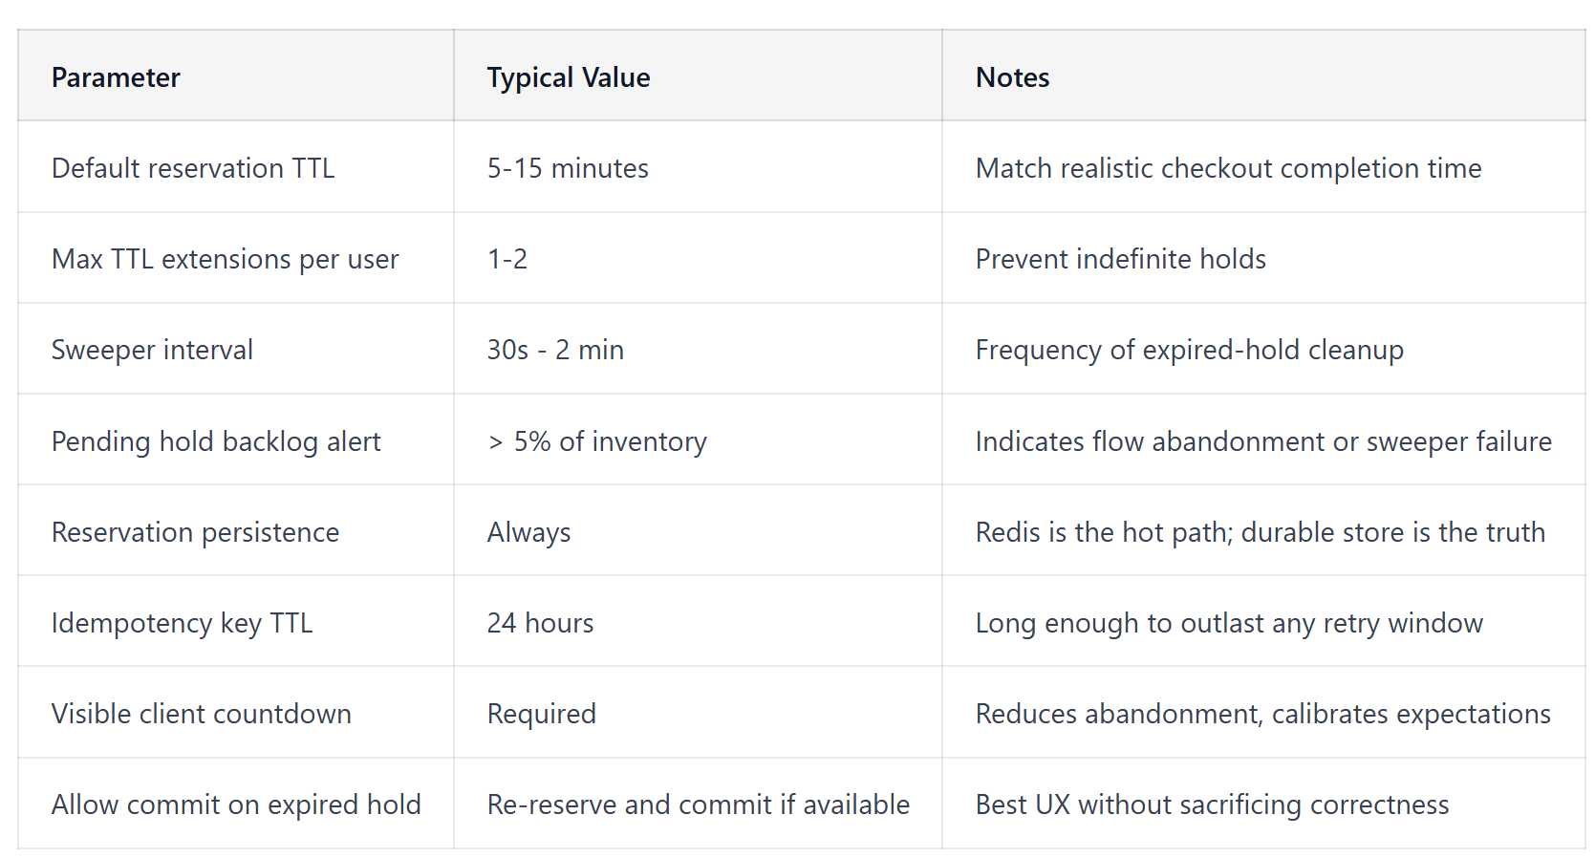

Reference Architecture
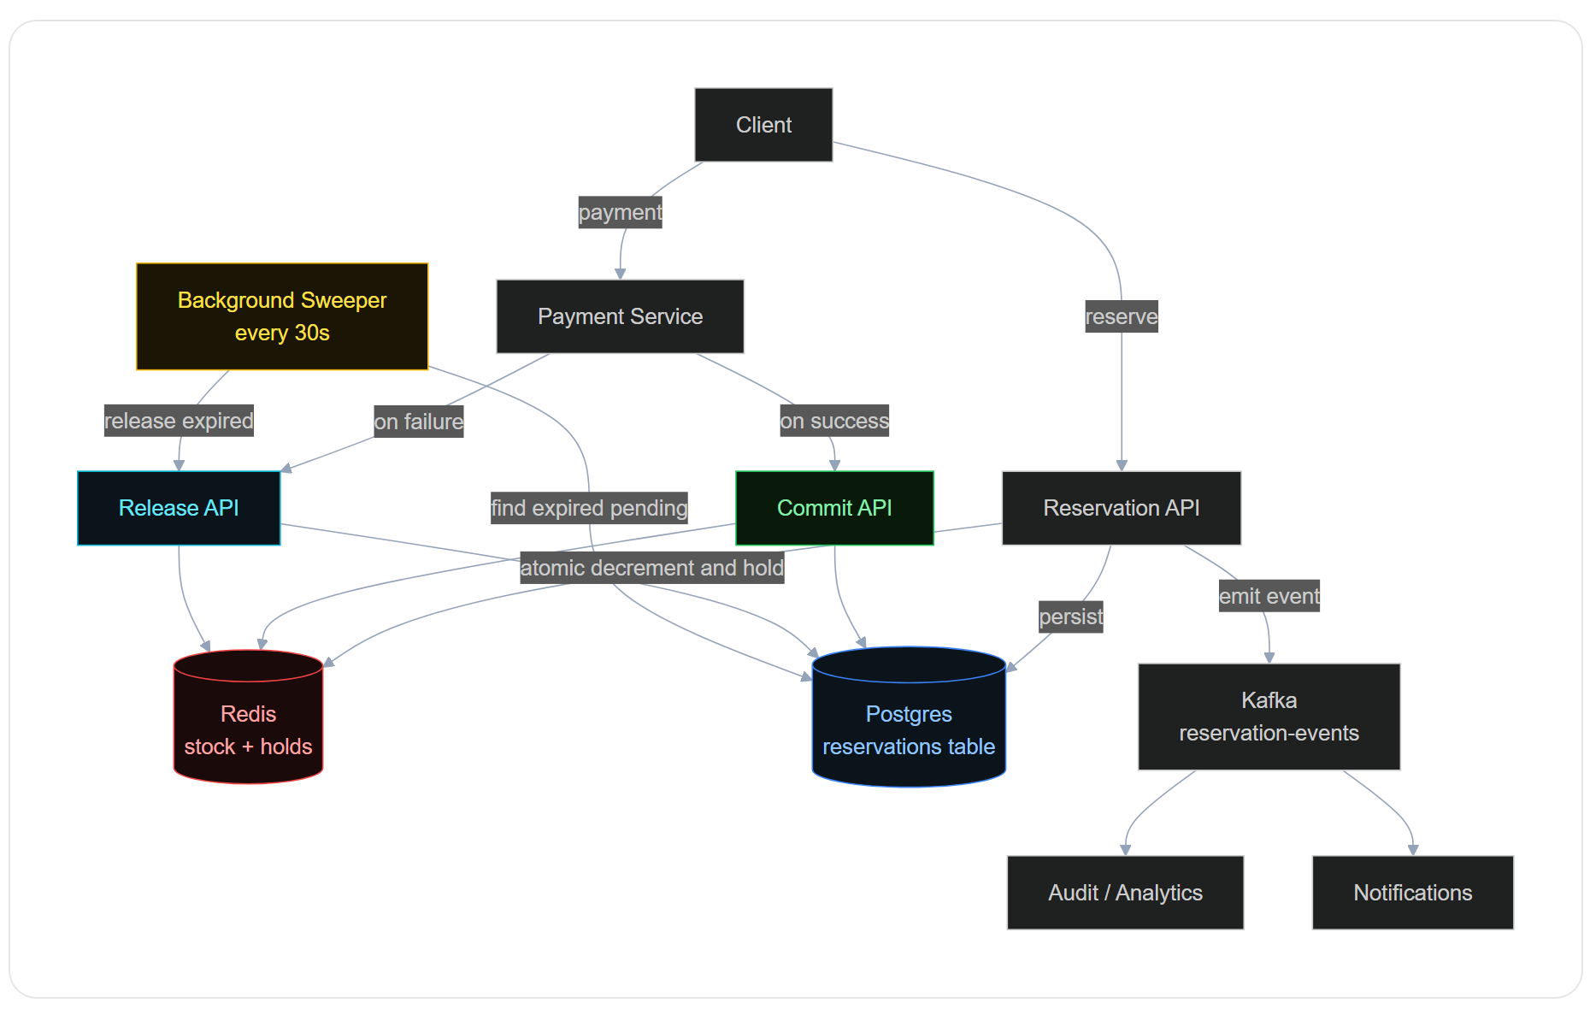

Operational Discipline: Monitoring Reservation Health
Track the four lifecycle rates: reserve, commit, release, expire. The ratio of commits to reserves is the conversion rate of users who reserved through to a completed sale; for healthy systems this is typically 70 to 90 per cent. The expire rate is the percentage of reserves that timed out without resolution; for healthy systems this is below 10 per cent. A sudden spike in expires (say 30 per cent) indicates a flow problem — payment provider is slow, checkout page is broken, the TTL is too short. A sudden drop in commits indicates a different flow problem — payment authorisation is failing, the commit endpoint has a bug. Alert on both ratios with sliding windows of 5 to 15 minutes.
Reservation backlog indicates sweeper or flow health. The count of pending reservations should be roughly proportional to current sales rate — high during on-sale moments, low during quiet periods. A growing backlog of pending reservations during quiet periods indicates either (a) the sweeper is not running and expired holds are accumulating, or (b) users are reserving and not converting at unusual rates. Monitor backlog size and age distribution; alert when the oldest pending reservation exceeds a threshold (typically 2× the configured TTL).
Reconciliation between Redis and durable store. The Redis hot path and the Postgres durable store should agree on the current set of active holds. Periodic reconciliation (hourly or daily) compares the two and alerts on drift. Drift indicates write failures (a reserve persisted to Redis but not Postgres, or vice versa) that need investigation. In normal operation, drift should be zero; even small drift is a warning sign.
Capacity planning for sweeper throughput. The sweeper must process expired holds faster than they accumulate. During peak periods (on-sale moments), the sweeper may need to process thousands of expired holds per minute. Test the sweeper at scale during pre-launch load tests; size the sweeper's batch size and concurrency to meet peak load. A backed-up sweeper produces invisible inventory loss as expired holds remain held instead of being released.

When the Pattern Does Not Apply
Unlimited or near-unlimited inventory. Digital goods (software downloads, streaming subscriptions, generated AI responses) have no scarce inventory; the reservation pattern adds complexity for no benefit. The check-then-decrement race does not exist because the decrement is always safe. Use direct purchase flows.
Flows where commit is instantaneous and synchronous with reserve. If the entire purchase flow (browse, decide, pay) completes in under a second and there is no intermediate user-visible state, the reservation pattern has no value — the race window is too small to matter. Direct atomic decrement is sufficient.
Inventory that cannot tolerate any temporary lock-up. Some real-time matching systems (ride-hail, ad bidding) cannot afford to have inventory held in pending state for any meaningful time — the demand is real-time and any delay loses the opportunity. These systems use ultra-short TTLs (single-digit seconds) or alternative patterns (auction-style allocation, instant matching with optimistic confirmation). The reservation pattern in its standard form does not fit.

Strategic Picture
Overselling is the kind of failure that does not look like a failure during normal operations — every developer test passes, every functional review passes, the system works perfectly until the moment of high concurrency, at which point it sells more than it has and the company is liable for refunds plus reputation damage. The reservation-then-commit pattern eliminates this entire class of failure with a single design choice: introduce an explicit time-bounded hold between intent and commitment. The implementation cost is bounded — a reservations table, a Redis script, a sweeper process, idempotency keys — and the operational discipline is the same as for any production system (monitor lifecycle ratios, reconcile state, alert on anomalies). Every system that sells scarce inventory will eventually face the on-sale-moment failure unless this pattern is in place; the question is only whether the team builds it before that moment or after.
For the broader transaction-coordination pattern that uses reservations as compensable steps, see the Saga Orchestration article; for the retry-safety mechanism that protects every reservation operation, see the Idempotency article; for the broader microservices data and transaction strategy, see the Microservices Patterns master index.

Closing Insight
The reservation-then-commit pattern is one of those rare patterns that is conceptually simple, broadly applicable, and almost universally absent from systems that have not yet faced the on-sale-moment failure. The cost of adding it after a public overselling incident is much higher than the cost of adding it during initial design — not just the engineering cost but the reputational cost, the customer-service cost, the regulatory cost in some industries. The pattern should be the default for any system selling scarce inventory: ticketing, hospitality, retail flash sales, vaccine slots, GPU instances, parking, anything where the supply is bounded and the demand can spike. Build it in from day one; the operational simplicity of having a clean reservation lifecycle is itself worth the upfront investment, even before the first time it saves the company from a public incident.

Frequently Asked Questions

What is the reservation-then-commit pattern?
Reservation-then-commit is a two-phase pattern for selling scarce inventory without overselling under concurrent demand. Phase 1 (Reserve) atomically decrements available stock and creates a time-bounded hold record when the user expresses intent to purchase; Phase 2 (Commit) converts the hold into a permanent sale when payment succeeds, or releases it if payment fails or the TTL expires. The pattern eliminates the check-then-decrement race condition that causes overselling in naive designs by closing the race window — the decrement happens at intent time, not at completion time. It is the standard solution for any scarce-inventory system: ticketing, hotels, restaurants, ride-hail matching, retail flash sales, vaccine appointments, and GPU reservations.

How long should a reservation TTL be?
Match the TTL to the realistic completion time of the user flow. Standard e-commerce checkout takes 2 to 10 minutes from add-to-cart to order placement; a 10-minute TTL is the typical default. Complex booking flows with seat selection and add-on services may need 15 to 30 minutes; enterprise procurement with approvals may need hours or days. Setting the TTL too short causes user frustration ("the seat I selected disappeared while I was reading"); setting it too long causes lost capacity ("twenty seats are reserved and idle, the event is sold out, but ten will eventually expire"). Different user segments can have different TTLs — guest checkout 10 minutes, returning customer 20 minutes, corporate buyer 60 minutes. Always show a visible countdown to the user to reduce abandonment and calibrate expectations.

What are the main implementation patterns for reservations?
Three production patterns. (1) Database row locks with explicit reservation table — most common; uses serialisable transactions on a reservations table; acceptable for up to a few thousand reservations per second. (2) Redis with Lua script for atomic decrement-and-hold — for higher throughput; a single Lua script atomically checks-decrements-creates-hold-with-TTL; tens of thousands per second per Redis instance; must persist to durable store for audit trail. (3) Dedicated reservation service with event sourcing — for very large systems (airline reservations, major ticketing platforms); event-sourced ledger with full audit and complex business rules; high implementation complexity. Avoid the anti-pattern of distributed locks (Redis SETNX, ZooKeeper) for the per-reservation hot path — use locks for metadata operations, atomic operations for reservations.

How does the reservation pattern compose with sagas and idempotency?
The Saga pattern uses reservations as its compensable steps — when a multi-service checkout saga (reserve inventory, charge payment, allocate shipping) fails at a later step, the inventory step's compensation is to release the reservation, which is a clean reversal because no commit has yet occurred. Without reservations, the inventory step would have to be a permanent decrement requiring a full restore as compensation, including audit trail of the reversal. Idempotency keys protect every reservation lifecycle operation (reserve, commit, release) — network errors during these operations cause client retries, and non-idempotent retries produce duplicate reservations or commits-on-released holds. Each operation accepts an idempotency key; the server stores the key with the result and returns the same result on retry without re-executing.

What happens when a user tries to commit after the reservation has expired?
There are two options: (a) reject the commit because the reservation expired (correct in terms of the contract but produces user-visible payment-without-inventory failures), or (b) allow the commit if stock is still available. Option (b) silently creates race conditions because between the expiry and the commit attempt, the same inventory may have been reserved by someone else. The right answer is to attempt the commit but treat it as a re-reservation — atomically check if stock is currently available; if yes, commit and accept; if no, reject and refund the payment. This produces correct semantics (no overselling, no payment without inventory) without surprising the user with arbitrary timing-dependent failures. The implementation is a small extension to the commit endpoint that performs the atomic re-check before committing.

What are the most common reservation anti-patterns?
Holding a database row lock across the payment call: blocks every concurrent transaction on the same inventory; under load the database becomes the bottleneck. The reservation record itself is the lock-free representation of "this seat is held." Never combine row locks with payment-call latency. No expiry on holds: produces permanent inventory ghosts as users abandon flows without releasing; always set a TTL and run a sweeper. Computing available count from a separate counter that drifts: any operation that fails to update the counter creates invisible drift, leading to overselling or fake sold-out states; compute available from canonical sources (total minus active holds), cache only as an optimisation. No idempotency on reserve, commit, or release: flaky networks produce retries that create duplicate reservations or duplicate commits. Allowing commit on an expired hold without re-checking availability: silently creates race conditions and overselling.

Other articles to consider:
[36 Microservices Patterns & Anti-Patterns: The Definitive Architect's Reference (2026)]( https://appscale.blog/en/blog/microservices-patterns-anti-patterns-master-index-2026)
[Saga Orchestration Pattern: Managing Distributed Transactions Without 2PC (2026)
](https://appscale.blog/en/blog/microservices-pattern-saga-orchestration-2026)
[Idempotency in Distributed Systems: Safe Retries, Deduplication, and the Idempotency Key Pattern (2026)
]( https://appscale.blog/en/blog/microservices-pattern-idempotency-distributed-systems-2026)

