Tutorial: Create 2D Game Engine using C++

URL: <https://www.youtube.com/playlist?list=PL-K0viiuJ2RctP5nlJlqmHGeh66-GOZR_>

# Purpose

This is the second half of the notes on the video tutorial. The first Word document was quite large because of the animated gifs I created using the tool ***ScreenToGif***. An animated gif shows up quite well in a Microsoft Word document and it is quite useful in showing off the progress of the work in building the platform game in the tutorial.

# 19. Collision Handling – Part I

# 20. Collision Handling – Part II

# 21. Animation State Machine

# 22. Texture Parser

# 23. Frame Animation

# 24. Enemy Animation

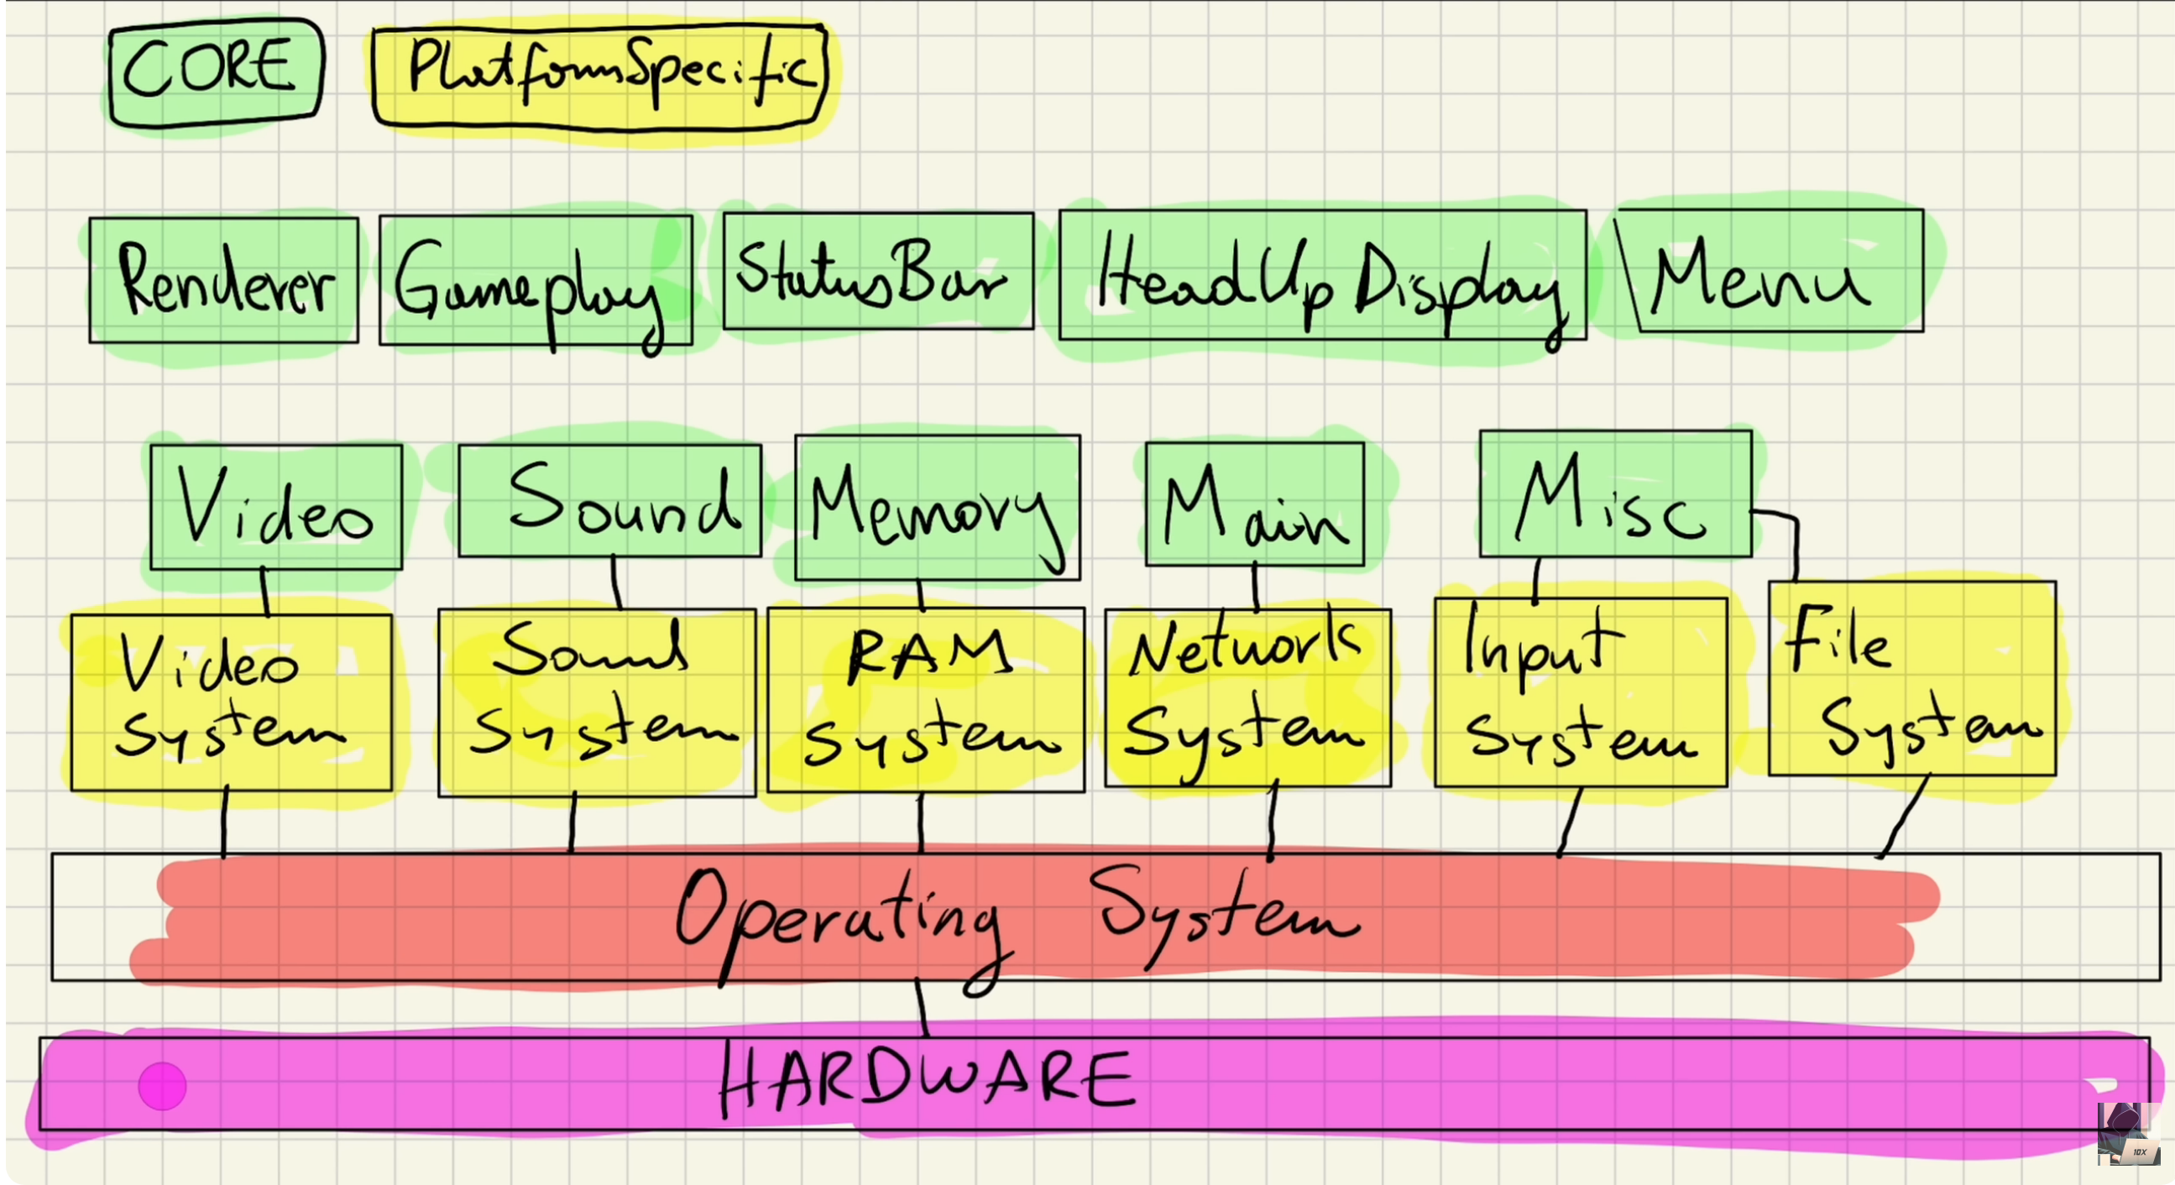

From: <https://www.youtube.com/watch?v=cqL3jvlU61c&ab_channel=Tariq10x>

# Web sites to Learn SDL2

* <https://lazyfoo.net/tutorials/SDL/index.php>
* <https://wiki.libsdl.org/SDL2/FrontPage>
* <https://wiki.libsdl.org/SDL2_image>
* <https://www.ferzkopp.net/wordpress/2016/01/02/sdl_gfx-sdl2_gfx/>
* <https://www.freepik.com/>
* <http://programarcadegames.com/>
* <https://giphy.com/>
* <https://github.com/nsklaus/SoftEngine>
* <https://forum.gdevelop.io/t/solved-how-do-i-slice-a-sprite-sheet/37755>
* <https://box2d.org/>
* <https://www.gameart2d.com/> - Tile sets

**Syntax**

**Function Parameters**

**Returns**

**Remarks**