Android Basics: User Input

URL: <https://www.udacity.com/course/android-basics-user-input--ud836>

About this Course

Learn the basics of Android and Java programming, and take the first step on your journey to becoming an Android developer!

This course is designed for students who are new to programming, and want to learn how to build Android apps. You don’t need any programming experience to take this course. If you’ve been using a smartphone to surf the web and chat with friends, then you’re our perfect target student!

Learning anything new can be tough. We will walk you through the process of making Android apps, but to get the most out of this course, you must bring your enthusiasm for learning, and budget time on your calendar to learn with us.

By the end of this course, you will have learned how to make your app interactive using buttons and changing text. You will have practiced those skills by making a basketball scores app, and you will have built a full coffee-ordering app.

If you’re curious about the road even farther ahead, these are the free courses that make up the Android Basics Nanodegree, in order:

* Android Basics: User Interface (https://www.udacity.com/course/android-basics-user-interface--ud834)
* Android Basics: User Input (<https://www.udacity.com/course/android-basics-user-input--ud836>)
* Android Basics: Multiscreen Apps (https://www.udacity.com/course/android-basics-multiscreen-apps--ud839)
* Android Basics: Networking (https://www.udacity.com/course/android-basics-networking--ud843)
* Android Basics: Data Storage (<https://www.udacity.com/course/android-basics-data-storage--ud845>)

# Lesson 1 – Making an App Interactive: Part 1

Begin making you app interactive!

## 1. Introduction

Welcome back! We’re excited that you want to move onto the next step of learning Android.

By the end of this course, you’ll be able to make an Android app with buttons and text fields that a user can interact with. Together we’ll make the Just Java app, which allows a user to fill out a form to order coffee.

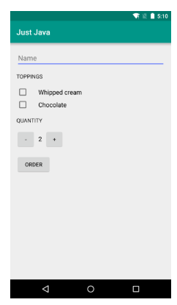

[Just Java App](https://classroom.udacity.com/courses/ud836/lessons/4038208680/concepts/0bd6ff7e-ba88-4dac-8093-a5a6d561efa0)

We picked this project because nearly every popular app involves accepting some type of user input and doing something with that data. For example, in a chat app, you type in a message and it gets sent to a friend. Hence, knowing how to accept user input is a critical milestone on the way to becoming an experienced app developer.

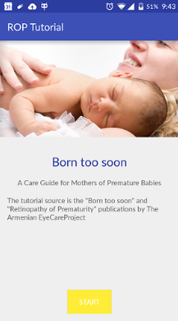

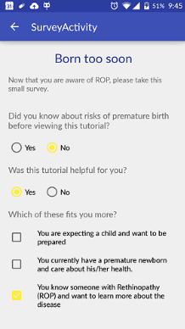

[ROP Tutorial app created by student arpy_vanyan](https://classroom.udacity.com/courses/ud836/lessons/4038208680/concepts/0bd6ff7e-ba88-4dac-8093-a5a6d561efa0)

To build the Just Java app, we’ll introduce you to the basic fundamentals of Java and computer science, as well as how to debug and fix errors in the code. We’ll explore more of what the Android platform offers, by building more complex user interfaces, adding support for another language, and taking advantage of other apps on the device. We have a [vocabulary glossary](https://developers.google.com/android/for-all/vocab-words/?hl=en) that accompanies this course, and if you need help, you can ask questions on the class discussion forum.

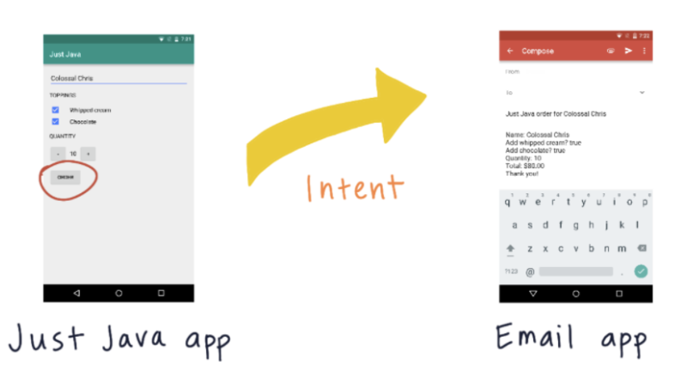

[To build the Just Java app, we’ll introduce you to the basic fundamentals of Java such as Intents.](https://classroom.udacity.com/courses/ud836/lessons/4038208680/concepts/0bd6ff7e-ba88-4dac-8093-a5a6d561efa0)

If you’re just joining us for the first time, note that the content presented here used to be part of a larger course (called Android for Beginners), which got broken up into 2 courses. So this course will contain Lesson 2, Practice Set 2, and Lesson 3. If you aren’t sure how to create user interface layouts in Android with XML, we recommend that you first take the Android Basics: User Interface course and then return here. You should also have [Android Studio](https://developer.android.com/studio/index.html) already on your computer (if not, check out these installation instructions).

As a reminder, this course is intended for people with little to no programming experience. Course topics include variables, data types, methods, classes, and object-oriented programming. If you’re an experienced developer already, consider checking out the [Developing Android Apps course](https://www.udacity.com/course/new-android-fundamentals--ud851).

We’ll be your instructors guiding you through the course, so let’s get started!



## 2. Quiz: Create a new Project

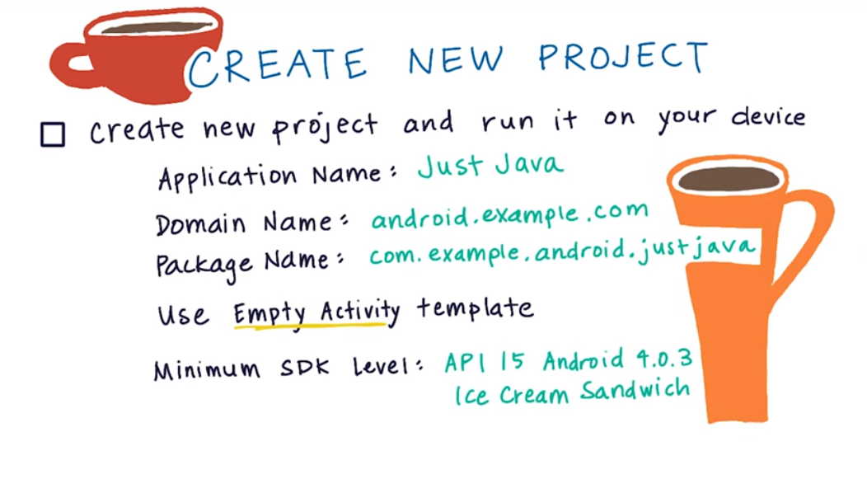

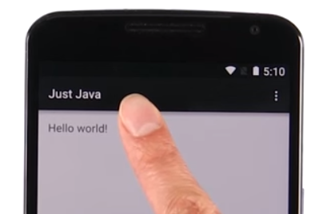

In 2020 the application looks like this:

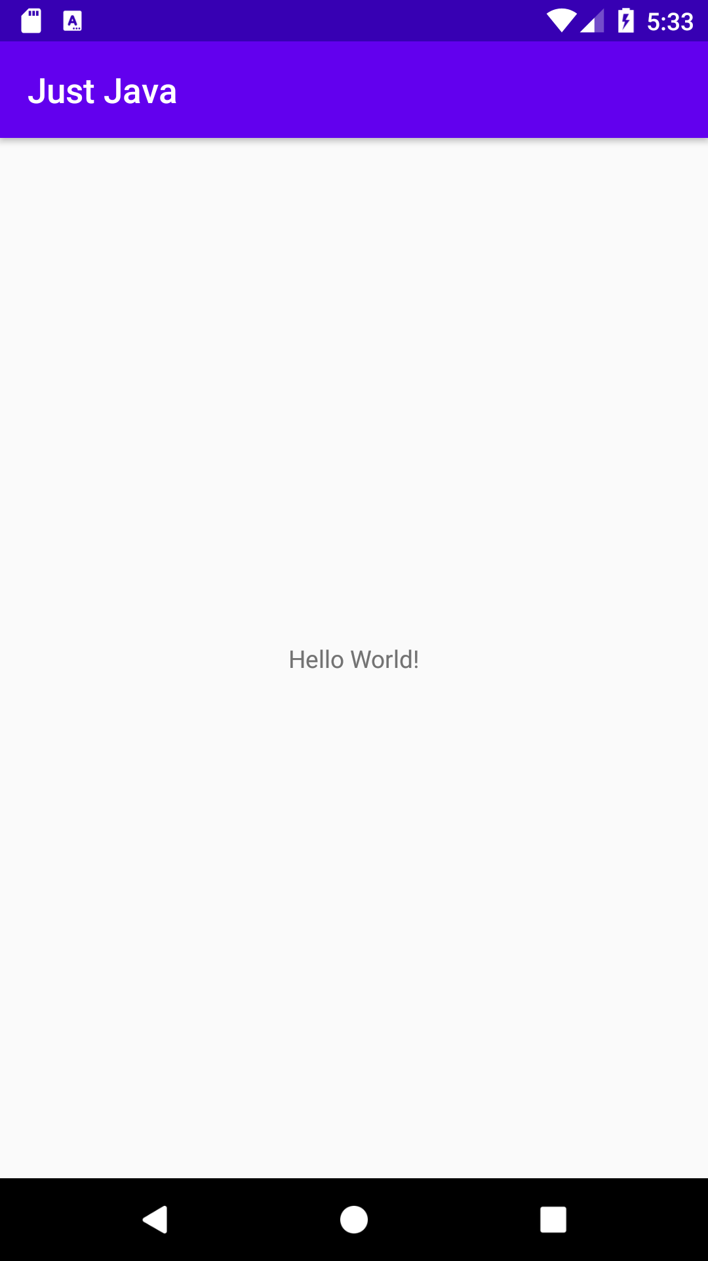

## 3. Quiz: Plan How to Build the Layout

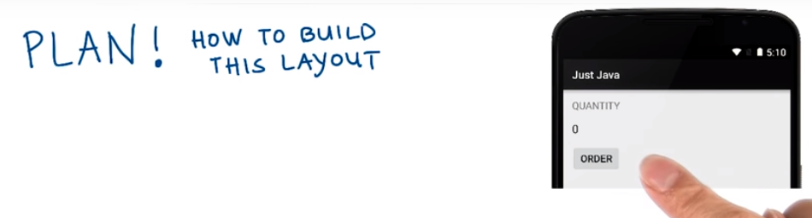

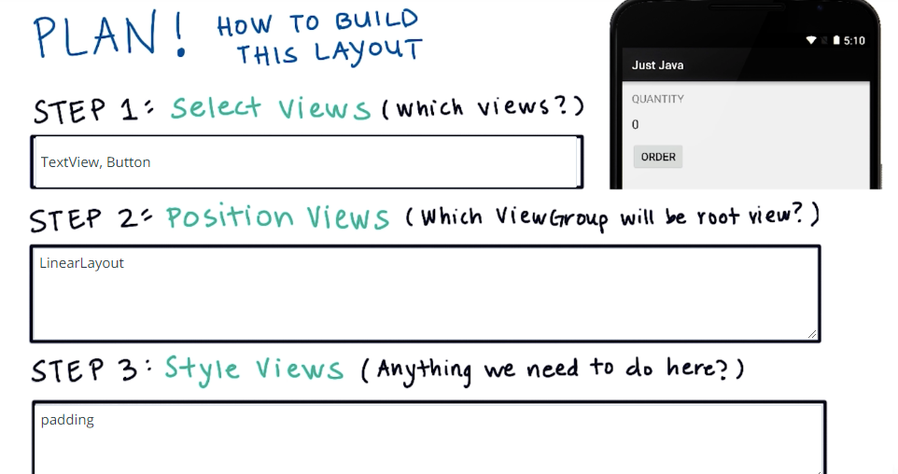

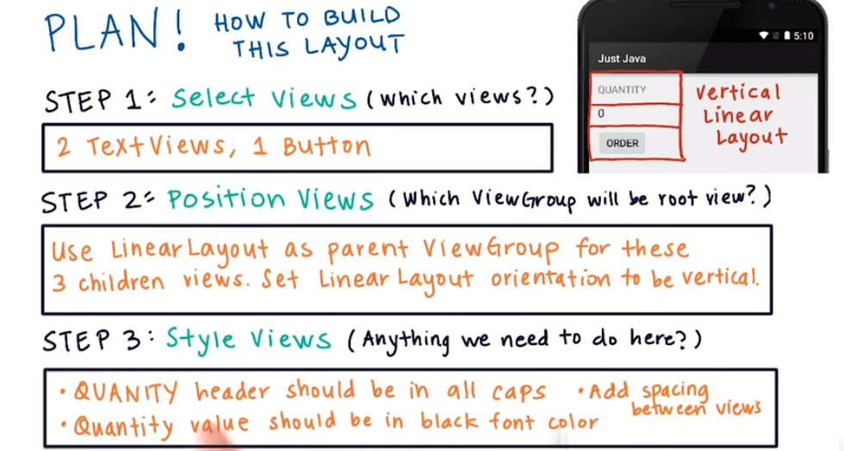

## 4. Quiz: Build Layout

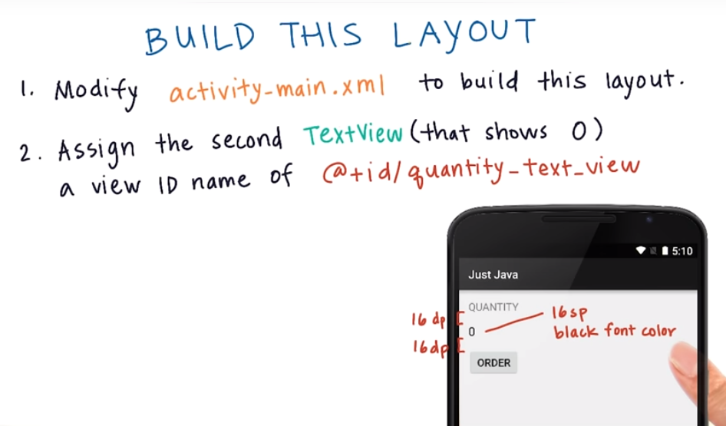

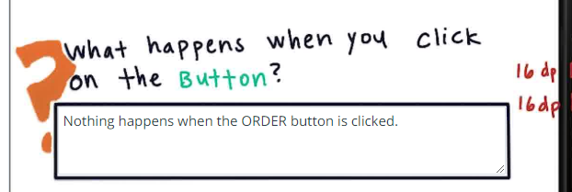

## 5. Quiz: Do Something When the Button is Clicked

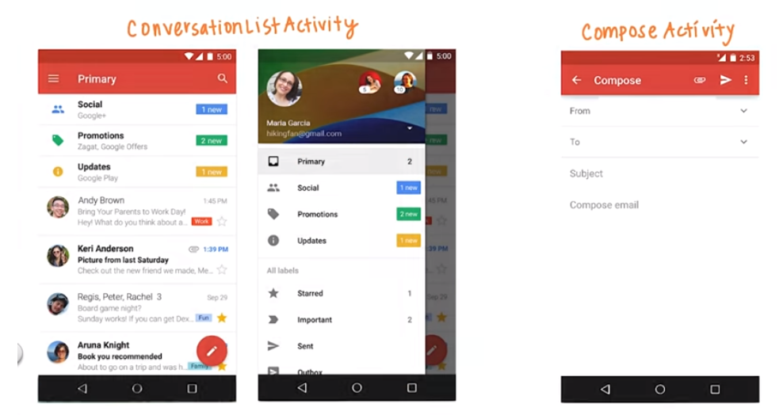

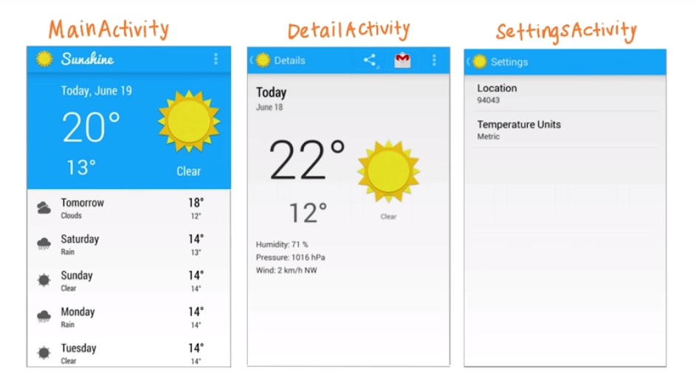

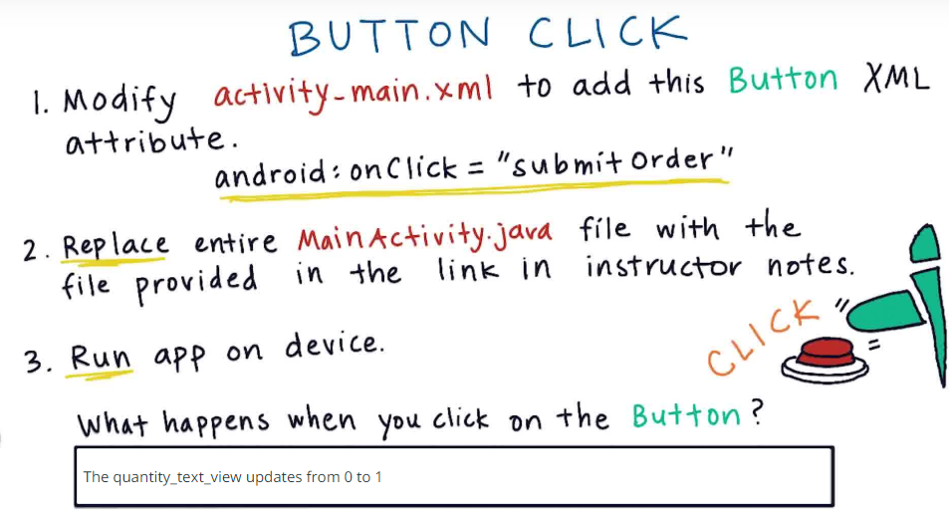

## 6. Quiz: Modifying First Lines of Java . . .

## 7. Quiz: Solving Math Problems

## 8. Quiz: Add TextViews for Price

## 9. Quiz: The Need for Variables

## 10. Quiz: Add your First Variable

## 11. Sometimes things don’t go as . . .

## 12. Quiz: Debugging a Crash

## 13. Chatting with Google’s Alice Yar. . .

## 14. Quiz: Hook Up Two Buttons

## 15. Quiz: Debug Mode in Android

## 16. Quiz: Update Data

## 17. Quiz: Update a Variable in the . . .

## 18. Quiz: Update Quantity Variable

## 19. Quiz: Modify the increment() . . .

## 20. Quiz: Modify the decrement() . . .

## 21. Quiz: Make the Quantity Picke…

## 22. Quiz: Fix the Order Button

## 23. Quiz: Reflection

# Lesson 2 – Making an App Interactive: Part 2

Continue making your app interactive using Java code

# Lesson 3 – Practice Set: Making an App Interactive

Practice building interactivity and build your second projects!

# Project: Score Keeper App

Implement an app to track scores between two teams playing a game.

# Lesson 5 – Object-Oriented Programming: Part 1

# Lesson 6 – Object-Oriented Programming: Part 2