Task 2: State management using Redux
- You have the basic layout in the CartSlice.jsx file.
- Define Reducer Functions
- Now implement the reducer property of the slice for adding, removing, and updating the number of items in the cart.
- These reducer functions will be called when user wants to add or remove the quantity of plants within the cartItems component.
- The addItem() reducer adds a new plant item to the items array which you initialized in the previous step.
- The addItem() function should get called when the user selects an Add to cart on the plant listing page. Subsequently, the handleAddToCart() gets called which has the plant type as a parameter.
- The handleAddToCart() function will then dispatch the plant details to the addItem() reducer function in CartSlice.jsx.
addItem: (state, action) => {
const { name, image, cost } = action.payload; // Destructure product details from the action payload
// Check if the item already exists in the cart by comparing names
const existingItem = state.items.find(item => item.name === name);
if (existingItem) {
// If item already exists in the cart, increase its quantity
existingItem.quantity++;
} else {
// If item does not exist, add it to the cart with quantity 1
state.items.push({ name, image, cost, quantity: 1 });
}
},
- Now you need to complete code for the removeItem() and updateQuantity() reducers.
- removeItem(): This reducer removes an item from the cart based on its name and gets called when the user wants to remove products from the cart.

state.items = state.items.filter(item => item.name !== action.payload);

- updateQuantity(): To create this function, start by extracting the item's name and amount from the action.payload. Then, look for the item in the state.items array that matches the extracted name. If the item is found, update its quantity to the new amount provided in the payload. This ensures the item's quantity is correctly updated based on the action.
const { name, quantity } = action.payload; // Destructure the product name and new quantity from the action payload
// Find the item in the cart that matches the given name
const itemToUpdate = state.items.find(item => item.name === name);
if (itemToUpdate) {
itemToUpdate.quantity = quantity; // If the item is found, update its quantity to the new value
}
- Handle Actions
- Export the action creators, addItem() to use in ProductList.jsx, removeItem(), and updateQuantity(), to use in the CartItem.jsx.
- Also export the reducer as the default to use in store.js.
- Make sure you save these changes by pushing your code to your GitHub repository.

Task 3: CartItems component
Next, you will complete the development of the CartItem.jsxcomponent which displays the items held in the shopping cart. This component has a number of functionalities that you find in a typical shopping cart:
- Calculate the total for all items in the cart.
- Calculate the subtotal for each plant type in the cart.
- Continue shopping
- Increment and decrement the number of each plant type in the cart
- Remove (delete) a plant type from the cart altogether.
You will dispatch the increment, decrement, and update quantity details from a Redux file.
When you are done, the cart page should look similar to the following:
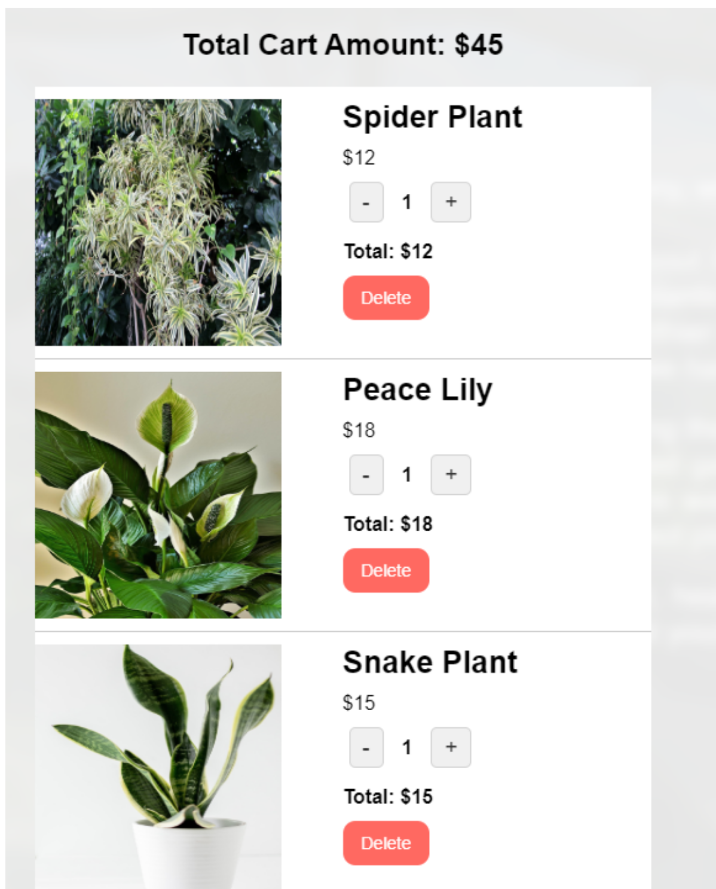
- Cost of all items in cart
- In the calculateTotalAmount() you need a function to calculate the cost of all of the items in the cart. There are a number of ways you can calculate this.
Sample algorithm description for calculating the total cost
- Initialize a variable total to hold the cumulative sum.
- Iterate over the cart array using cart.forEach().
- For each item, extract its quantity and cost.
- Convert the cost string (e.g., "$10.00") to a number using parseFloat(item.cost.substring(1)), then multiply it by the quantity.
- Add the resulting value to total.
- After processing all items, return the final total sum.

- Continue shopping
- Users should be able to return to the plant listing page to continue shopping while on the shopping cart page. So, in the handleContinueShopping() function, call the onContinueShopping(e) function passed from the parent component.
- Checkout
- In this project, you are not required to provide the handleCheckoutShopping() function, but you may wish to for further exploration and practice. For now, just add in the following code to alert the user this function will get added at a later date.
const handleCheckoutShopping = (e) => {
alert('Functionality to be added for future reference');
};
- Increment and decrement
- For the handleIncrement() and handleDecrement() functions, you need to dispatch the updateQuantity() reducer in the CartSlice.jsx file. In the function argument, either add one to the item.quantity value or subtract one, respectively.
- Also, for the handleDecrement() you will need an if-else to handle the case. -- If the item's quantity is greater than 1, dispatch updateQuantity to decrease the quantity by 1. -- Else if the quantity would drop to 0, dispatch the removeItem action to remove the plant type from the cart.
Click here to see hints:
- Dispatch the updateQuantity action (from your Redux slice) to increase or decrease the item's quantity by 1.
- Use the name parameter of the item to identify which item's quantity needs to be updated.
- Example code:
dispatch(updateQuantity({ name: item.name, quantity: item.quantity + 1 }));

- Remove plant from the cart
- For the handleRemove() function you need to dispatch the removeItem action to delete the item from the cart.
- Item subtotal
- Calculate the total cost for an item by multiplying its quantity with its unit price in the calculateTotalCost() function.
- Extract the numeric value from the item's cost string using parseFloat(item.cost.substring(1)) before performing the multiplication.
Note: Ensure that these event handlers update the UI in real time. When the user changes the number of a plant type, the following should update accordingly: • The individual plant quantity. • The item's subtotal. • The overall total cost. • The the total number of items in the cart icon. • After a user clicks the "Add to Cart" button for a plant item, the button should become disabled and grayed out, and its label should update to "Added to Cart" to indicate that the item has already been added.

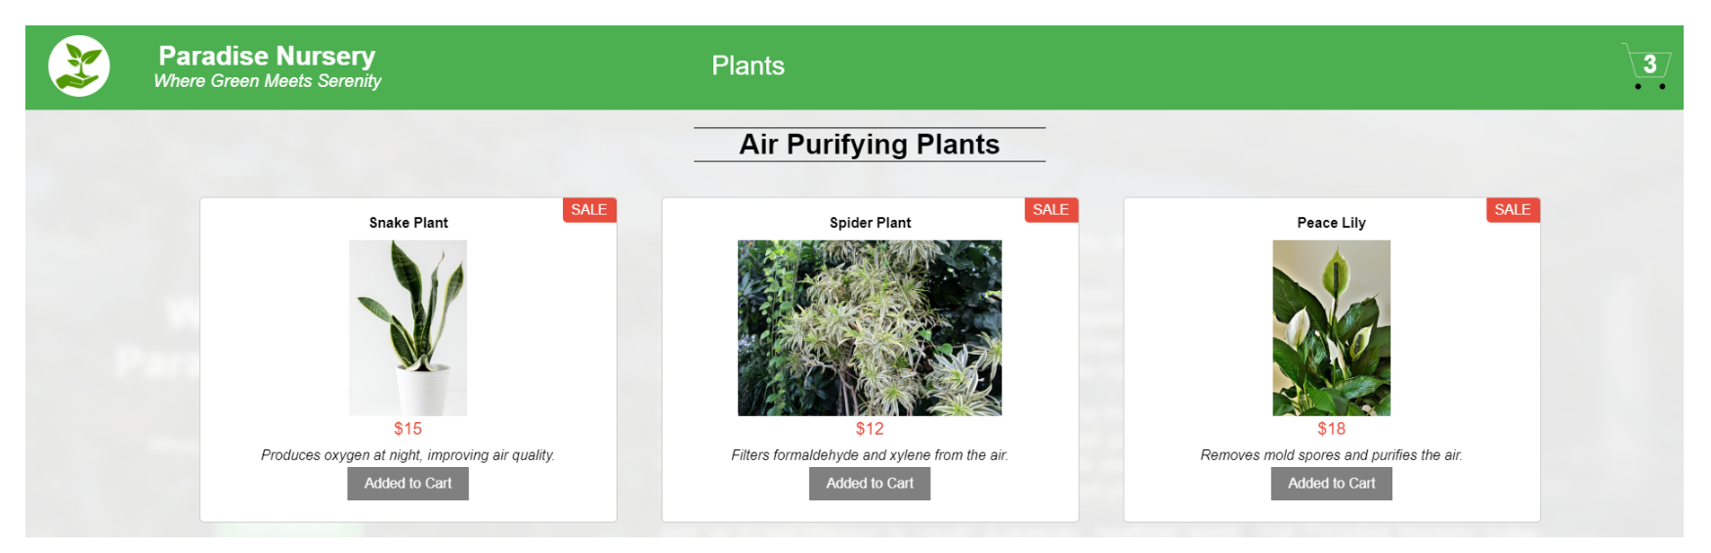
- Make sure that you save these changes by pushing your code to your GitHub repository.

Task 4: Integrate Redux functionality in your components
- ProductList Component
- Initialize the cart state within the Redux store to keep track of cart items.

Click here to see hints
dispatch(addItem(product));

- Use the addItem action to add selected products to the cart.
- Access the Redux store to retrieve and display the total quantity of items currently in the cart.

Click here to see hints
const calculateTotalQuantity = () => { return CartItems ? CartItems.reduce((total, item) => total + item.quantity, 0) : 0; };

- CartItem Component
- Use the updateQuantity action to change how many items are in the cart.
- Use the addItem action to add a new product to the cart.
- Use the removeItem action to delete an item completely from the cart.

Click here to see hints
dispatch(removeItem(item.name));

Note: Make sure that you save these changes by pushing your code to your GitHub repository

Task 5: Import details to store.js
- Importing Necessary Functions and Files:
  - The configureStore() function from the @reduxjs/toolkit package is imported to set up the Redux store.
  - The cartReducer from the CartSlice.jsx file which is imported, manages the state slice related to the shopping cart.

import { configureStore } from '@reduxjs/toolkit';
import cartReducer from './CartSlice';
- Configuring the Store:
  - The configureStore() function is used to setup the Redux store.
  - Inside the configuration object passed to configureStore(), the reducer key specifies the reducer functions. In this case, the cartReducer is assigned to manage the cart slice of the state.
// Create a Redux store using configureStore from Redux Toolkit
const store = configureStore({
// Define the root reducer object
reducer: {
// 'cart' is the name of the slice in the store, and it's managed by cartReducer
cart: cartReducer,
},
});

export default store; // Export the store for use in the app (e.g., in <Provider store={store}>)
- Exporting the Store:
  - The configured Redux store is exported using export default store;, so it can be used throughout the application to manage state.
export default store;

Note: - This store.js code is pre-configured in the repository and ready for use. - Make sure that you save these changes by pushing your code to your GitHub repository

Task 6: Set up the global store
- Navigate to the main.jsx file in the src folder.
- The Provider component from the react-redux library is already imported. This component enables all components in the application to access the Redux store.
import { Provider } from 'react-redux';
- The Redux store is imported from the store.js file. This store holds the application's state, using the reducer defined in the CartSlice.jsx file.
import store from './store.js';
- The App component is wrapped with the Provider component, with the Redux store passed as a prop. This allows all components in the app to access and interact with the global state managed by Redux.
<Provider store={store}>
<App />
</Provider>
- Deploying Your Application with GitHub Pages
To deploy your react application in GitHub you need to install gh-pages. This allows you to use it as a tool for deploying your project to GitHub Pages. Perform given command in the terminal
npm install gh-pages --save-dev
Add given lines before "build": "vite build" in package.json file.
"predeploy": "npm run build",
"deploy": "gh-pages -d dist",
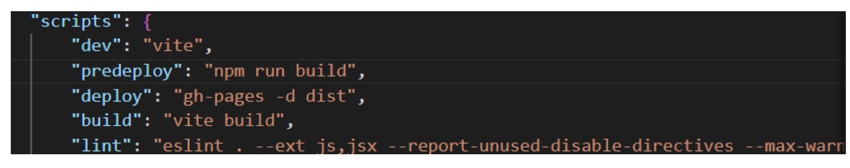
- Then in the vite.config.js file add this line before plugins: [react()]
base: "/YOUR_REPOSITORY_NAME",
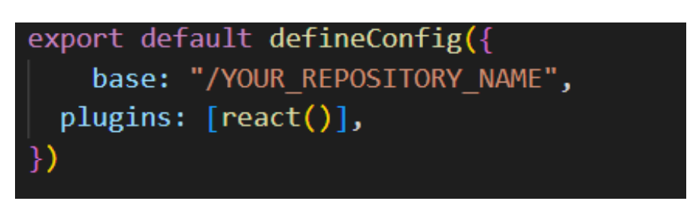
Note: Instead of write your own repository name such as assume if your github repository name is learning_react the it should look like base: "/learning_react"
- Now perform deploy command in the terminal to executes the "deploy" script defined in the package.json file, deploying the project to GitHub Pages using the gh-pages tool.
npm run deploy
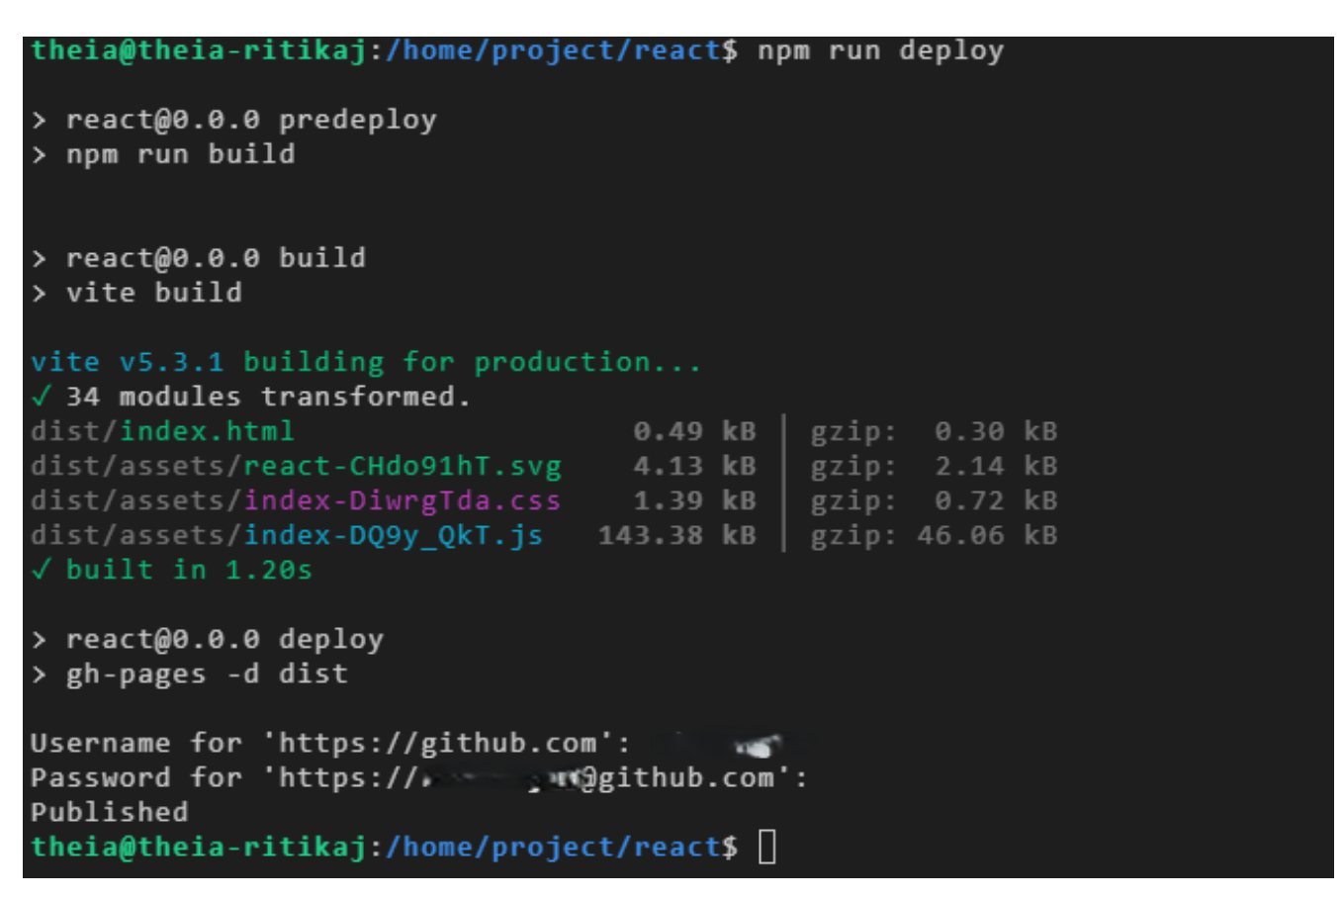
Note: Whenever you make any change to your code you need to save all your files and perform git commands for them.
- Perform git add and git commit commands to update changes in your code. Then perform git push command to update your GitHub repository for proper code management.
- Go to your GitHub repository. Then, navigate to your site's repository that you created.
- Under your repository name, click Settings.
- Navigate to the left hand side navigation bar. In the Code and Automation section of the sidebar, click Pages.
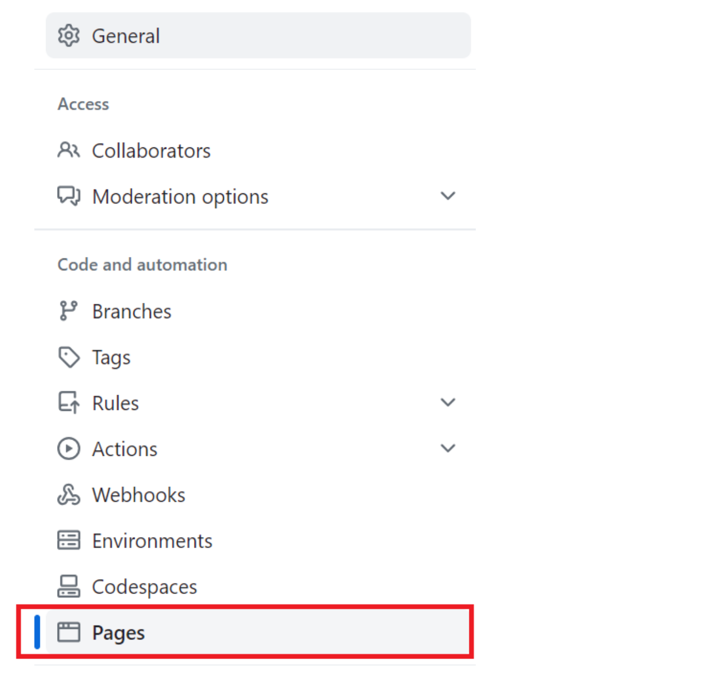
- You will see the page shown below. Click the drop down menu where you see None, then click gh-pages, and then click the Save button.
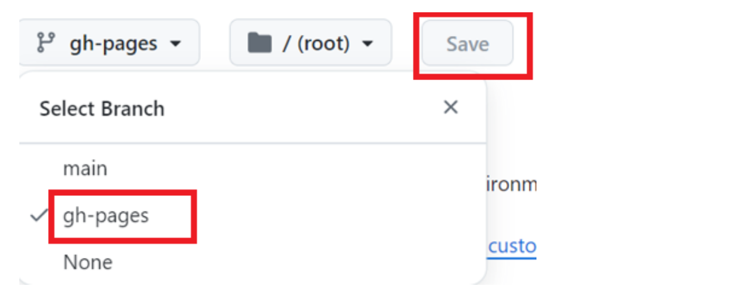
- Refresh your page again, and you will see the link, just as below. Instead of shoppingreact, you will see your github repository name.
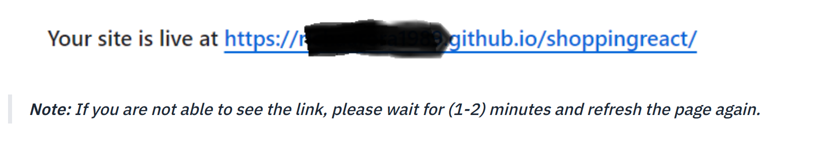
- Click above generated link to see your live website.

Note:
- This code is pre-configured in the repository and ready for use.
- Make sure that you save these changes by pushing your code to your GitHub repository
- After deploying on GitHub Pages, it may take some time for all contents and images to appear properly. Please wait a few extra minutes for the application to load completely.
Project Completion
Congratulations!
You completed this project! Great work.
- If you have not already done so, deploy your application. You can deploy it using GitHub Pages or your own hosting site.
- Ensure you have pushed all the updated files to your github repository
Summary
- You created function React components, composed, and nested them.
- You implemented React Hooks, specifically the useState and useEffect hooks to manage component-level states.
- You integrated Redux within your React application and applied Redux concepts like actions, reducers, and the store.
- You dynamically rendered data fetched from an array of objects onto the UI. You mapped over arrays to generate lists of components.
- You handled user events such as button selection and triggered corresponding actions to add and remove items in the cart.

Checklist for Submission
Follow the checklist below to verify that your project meets all requirements before submission.
Submit your work through either Option 1: AI-Graded Submission and Evaluation or Option 2: Peer-Graded Submission and Evaluation, depending on the submission path you choose for project evaluation.
Checklist for Option 1: AI-Graded Submission and Evaluation
After completing the final project, you should:
- Submit the GitHub URL of the README.md file containing the project name details.
  - Ensure the content includes the repository name e-plantShopping.
- Submit the GitHub URL of the AboutUs.jsx file, which includes details about the company.
- Submit the GitHub URL of the App.css file, which includes the background image for the Paradise Nursery landing page.
- Submit the GitHub URL of the App.jsx file, which includes the Paradise Nursery landing page with the company's welcome message and a "Get Started" button.
- Submit the GitHub URL of the CartSlice.jsx file, which includes the Redux slice for the shopping cart.
  - Ensure it defines Redux functionality to add, remove, and update cart items.
- Submit the GitHub URL of the ProductList.jsx file, which implements the product listing page with the following functionalities:
  - Display at least six unique houseplants per category, each with a thumbnail, name, and price.
  - Group the plants into at least three categories.
  - Include "Add to Cart" buttons that:
    - Add the product to the cart.
    - Disable the button after the item is added.
    - Update the cart.
  - Include a navbar visible on both Product Listing and Cart pages, with links to Home, Plants, and Cart.
  - Display a cart icon showing the total number of items dynamically.
- Submit the GitHub URL of the CartItem.jsx file, which displays the Shopping Cart page with the following functionalities:
  - Show the total cart amount for all plants.
  - Display the total cost per plant in the cart.
  - Each cart item should display the thumbnail, plant name, and unit price.
  - Include buttons to increase or decrease quantity, updating totals correctly.
  - Include a delete button to remove items from the cart.
  - Include a checkout button that displays "Coming Soon" or a similar message.
  - Include a continue shopping button that links back to the Product Listing page.
Before You Submit
- Ensure all files are updated, committed, and pushed to the e-plantShopping repository.
- Each submitted link must be a public GitHub URL pointing directly to the specific file.
- Verify that all functionalities work correctly before final submission.
Checklist for Option 2: Peer Review Evaluation
After completing the final project, you should:
- Submit the URL of your deployed application, hosted on GitHub Pages or another platform.
  - Ensure your app is fully functional and publicly accessible.
- Submit the GitHub URL of your public repository, named e-plantShopping.
  - Ensure all files are committed and pushed before submission.
Project Evaluation Rubric for peer review
GitHub Link:
- Public GitHub repository URL
- Redux-related files and code implemented correctly
By URL of your deployed application: Landing Page
- Background image displayed properly
- Includes a paragraph about the company
- Displays the company name
- Includes a "Get Started" button that links to the product listing page
Product Listing Page
- Displays at least six unique houseplants for sale, each showing a thumbnail, name, and price
- Groups plants into at least three categories
- Includes an "Add to Cart" button for each plant that:
  - Adds the selected plant to the shopping cart
  - Increments the shopping cart icon count
  - Disables the button after the plant is added
Header
- Displays on both the product listing and shopping cart pages
- Includes a shopping cart icon that dynamically displays the total number of items
- Allows navigation between the product listing and shopping cart pages
Shopping Cart Page
- Displays the total number of plants in the cart
- Displays the total cost of all items
- Each plant type displays a thumbnail, name, and unit price
- Includes buttons to increase or decrease the quantity of each plant and update totals accordingly - Includes a delete button to remove items from the cart
- Includes a checkout button displaying "Coming Soon" or a similar message
- Includes a "Continue Shopping" button linking back to the product listing page
Before You Submit
- Confirm that your deployed application link opens correctly.
- Ensure your GitHub repository is public and includes all the latest updates.
Author
Richa Arora

