***INTERNETWORKING ESSENTIALS - CSE307***

***Section – K23UP Submitted by: Nihal Nazeer***

***Registration & Roll Number: 12311441, 58***

***DATE: - 29/04/2025***

***In partial fulfilment for the requirements of the award of the degree of***

***“B. Tech CSE Data Science and Machine Learning”***



***“School of Computer Science and Engineering” Lovely Professional University***

***Phagwara, Punjab***

Project58: You are hired as a network engineer for Alltech Providers, a mid-sized enterprise with a 5-floor office building. Each floor is equipped with a different number of computers, like floor 1 has 936, floor 2 has 4563, floor 3 has 23456, floor 4 has 3462, and floor 5 has 234. Configure the DNS server on floor 1, the Email server should be connected on floor 3, the FTP server should be connected on floor 2, and the DHCP and HTTP servers of the company are on floor 5. The organization requires a well-structured network to ensure efficient communication and scalability. Network Design Requirements: 1. Topology Selection: Design a Star topology for the first 2 floors and a Ring topology for the remaining floors, considering performance and fault tolerance. (Just connect 7 computers on each floor instead of the given requirement, as we are not able to do this in Cisco Packet Tracer.) 2. IP Addressing Scheme: The company has decided to use Class B private IPv4 addresses for the first 3 floors and Class A private for the remaining floors, following a classless addressing scheme that is VLSM. Allocate IP addresses properly for each floor, ensuring uniqueness. 3. Routing Strategy for Inter-Floor Communication & Connectivity: Recommend a routing approach that is Static for inter-floor communication. • Design how the floors will be connected for seamless interdepartment communication. • Suggest the appropriate network devices (e.g., switches, routers, access points) and their placement. • If using dynamic routing, use RIP routing protocol. • If using static routing, define the static routes for efficient data flow. • The minimum number of routers to be used should be 4 and the maximum 5. • Specify the number of default gateways along with IP addresses. • Specify each SUBENTWORK with proper Subnetwork address, host IP range, and broadcast address. Report Writing: Write the project report, which includes all the above things along with the labeled network scenario, and also mention the innovation done by you in the project. Then upload the project on GitHub as well as check the engagement level of the project uploaded on GitHub.

# Full Topology

# 

STAR TOPOLOGY

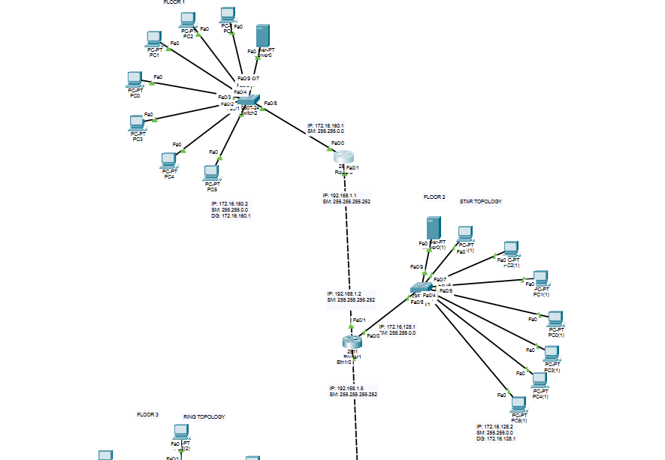

RING TOPOLOGY

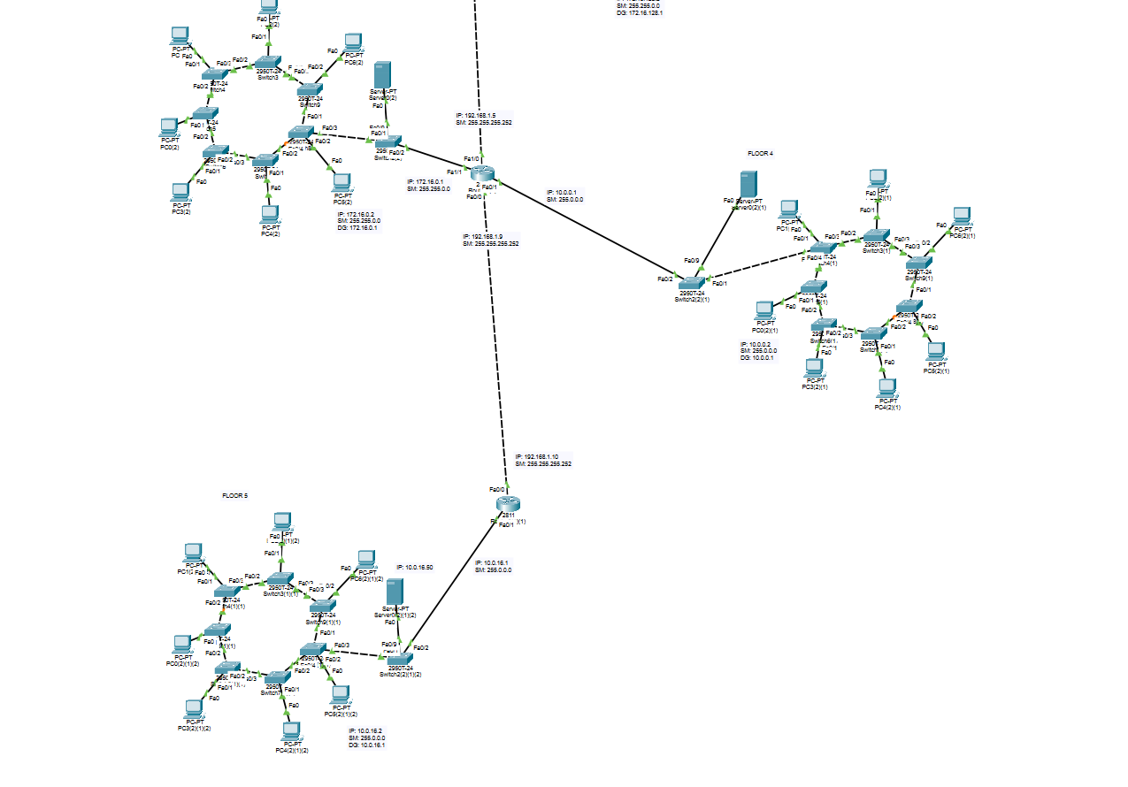

* **Network addresses to each floor: 10 Networks**

|  |  |  |
| --- | --- | --- |
| **S.no.** | **Floors** | **Network Address** |
| 1. | Floor 1 | 172.16.160.0 |
| 2. | Foor 2 | 172.16.128.0 |
| 3. | Router 1 to Router 2 | 192.168.1.0 |
| 4. | Floor 3 | 172.16.0.0 |
| 5. | Floor 4 | 10.0.0.0 |
| 6. | Router 2 to Router 3 | 192.168.1.0 |
| 7. | Floor 5 | 10.0.16.0 |
| 8. | Router 3 to Router 4 | 192.168.1.0 |
|  |  |  |

* + **Number of Floor’s: -** 5 Floors
  + **Type of Networking: -** Static

## Number of Topology’s: - 2

* + **Type of Topology: -** 1st to 2 is STAR **Topology**, 3th floor TO 5th its RING TOPOLOGY
  + **Number of devices connected in each floor: -** 7 Devices connected each floor

### GitHub Link: -

# How you have assigned the IP. Attach snapshot.

# 

# 

1. ***How you have done the routing. Attach snapshot***

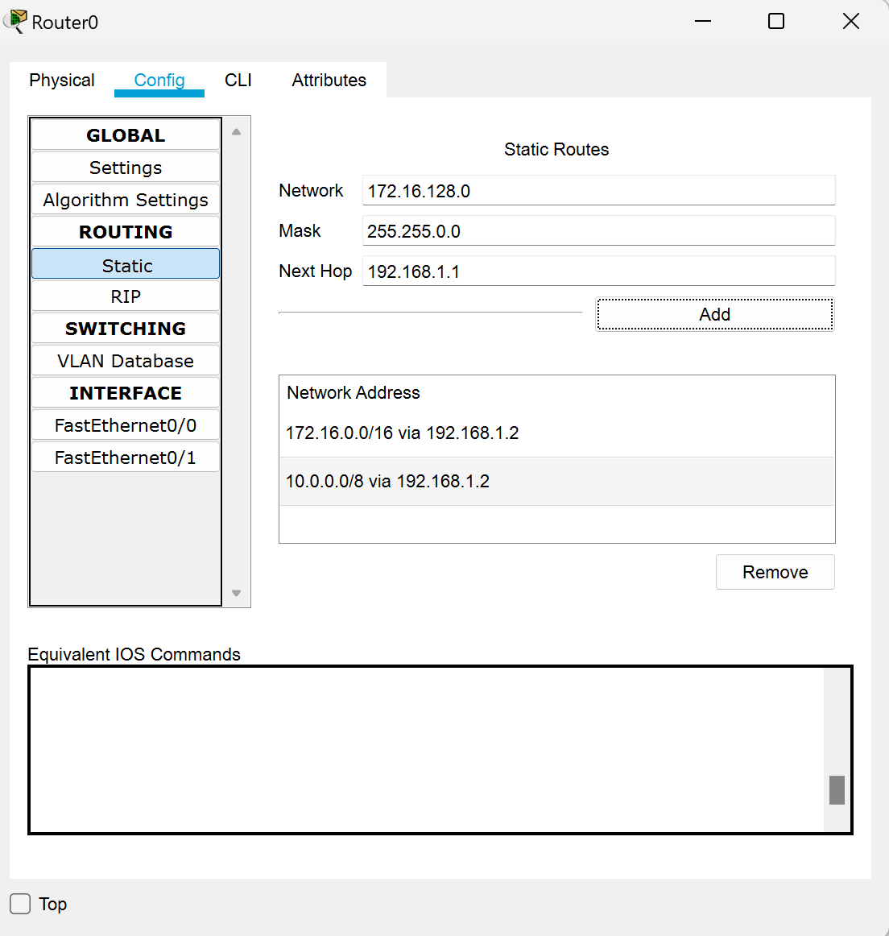

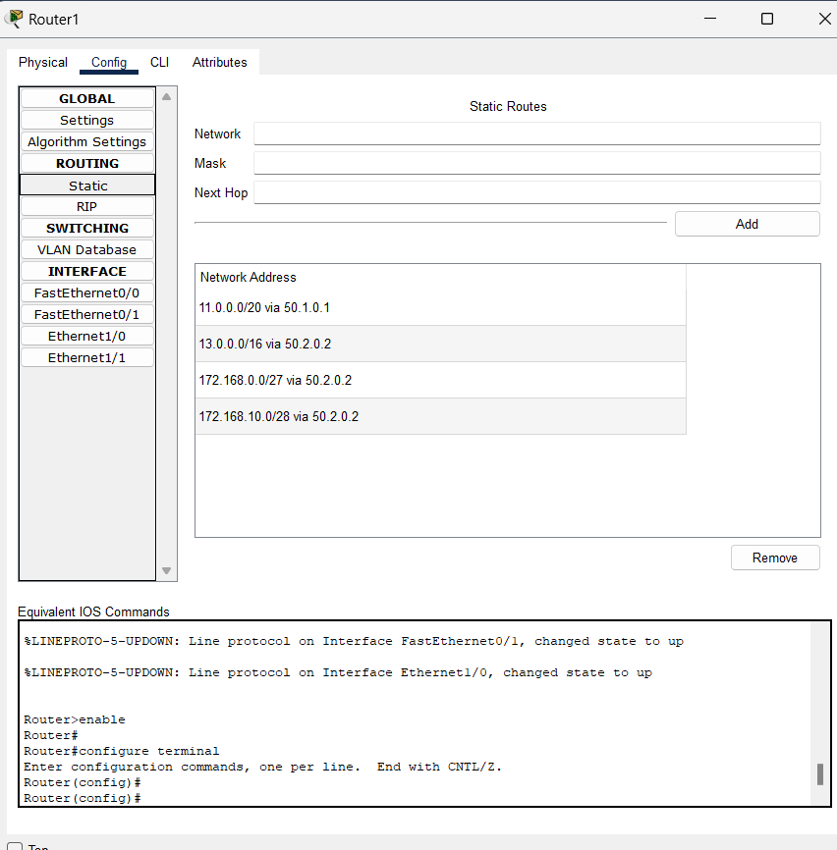

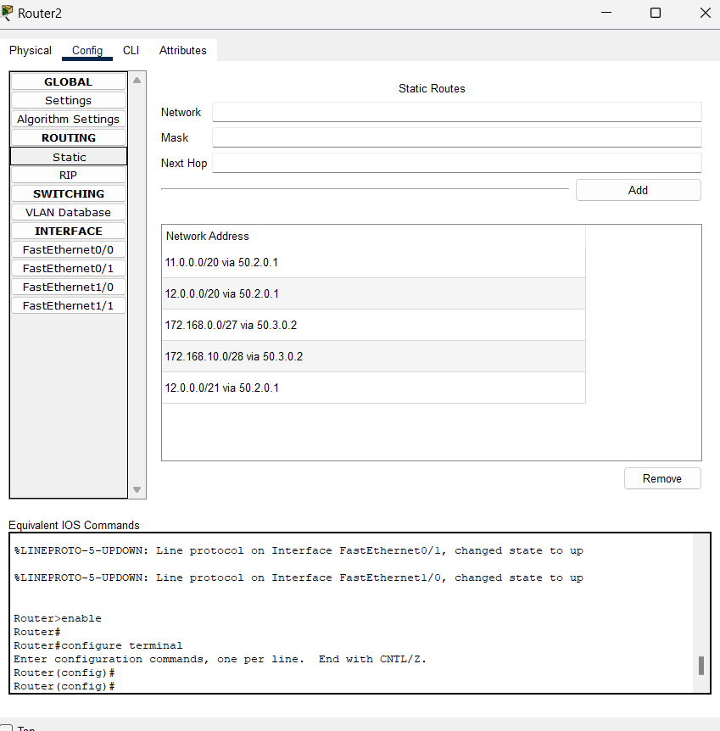

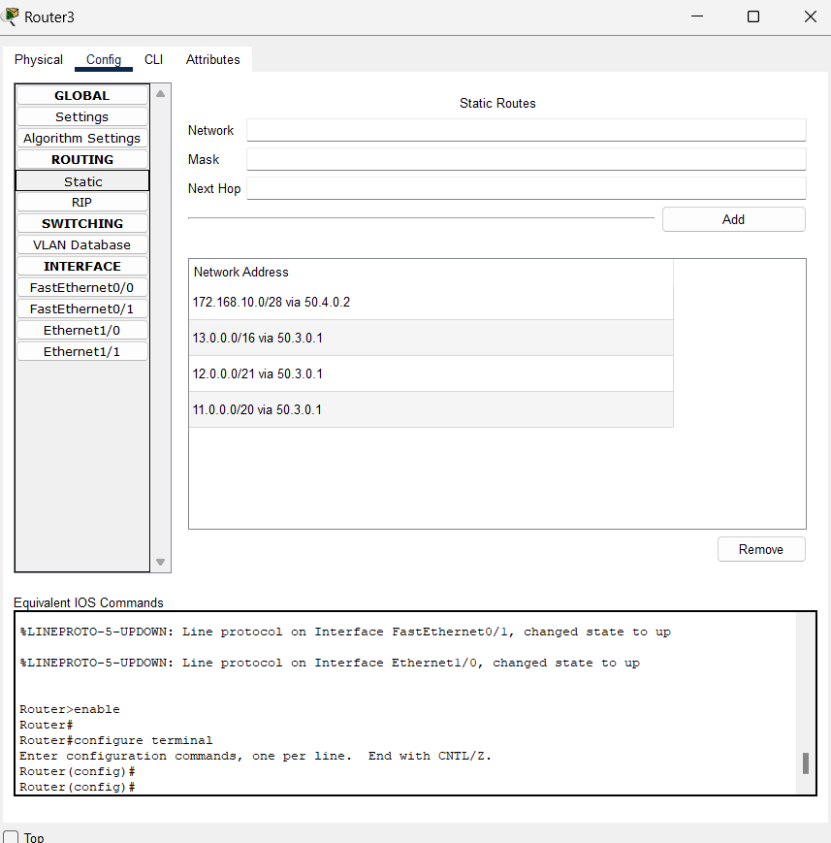

1. **Then show the communication between all pc. Attach snapshot.**

## Email

## 

