Question 2 — Secure Cloud Network for Fintech API
Course: Network and Cloud Essentials — Final Exam Author: Nyi Htut Zaw Date: 28 April 2026

1. Scenario Recap
A fintech startup runs mobile payment APIs in the cloud. Customers use the APIs from iOS / Android apps. Internal staff need admin access. There’s a small on-premises accounting system that pulls transaction summaries every night. Customer data must remain on-premises in Thailand per the PDPA.
The platform must:
- Provide the basic hybrid setup (secure cloud↔on-prem, private DB, public access only to API front end, credential-theft protection).
- Keep the API always available and able to handle ultra-high load on payday.
- Allow internal admins to access the cloud safely.
- Push nightly transaction summaries from cloud to the on-prem accounting system.
- Back up data to cloud + a physical site, with one super-secure copy.
- Detect eavesdropping, SQL injection, and DDoS, and run automated incident response.
The exam tasks:
- Task 1: Design a solution that supports all requirements.
- Task 2: Design how a mobile-app user authenticates once and uses all API endpoints.
- Task 3: Design API-side geo-fraud detection that denies access if the user is not in Thailand or visited specific countries in the last 3 months, using the user’s Google Maps location history.

2. Architecture Diagram
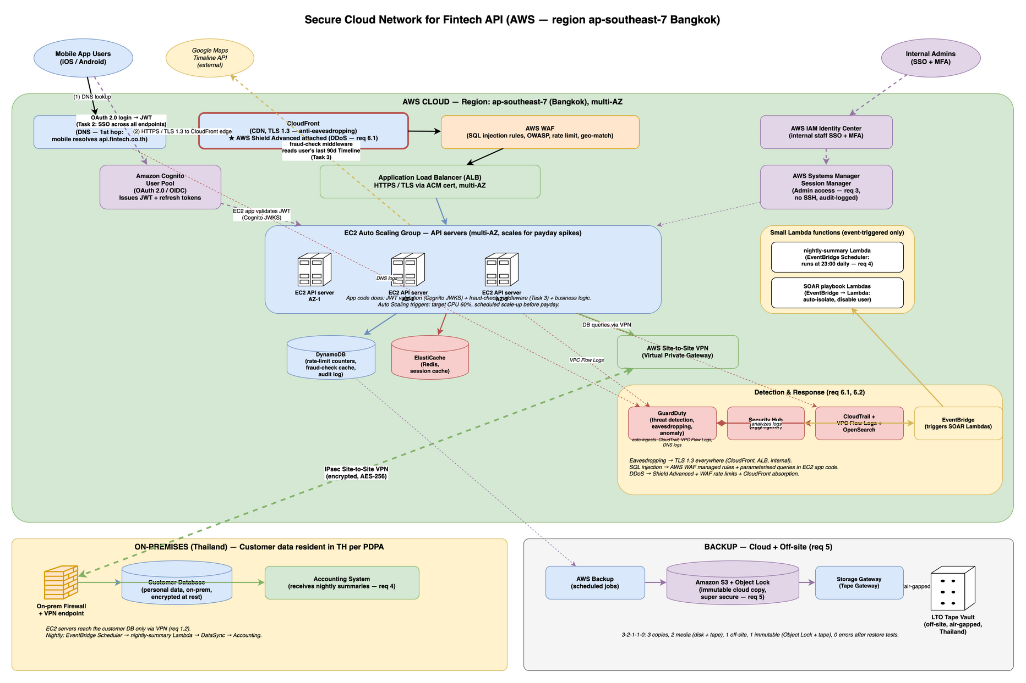
Fintech API Architecture
Three zones: AWS cloud (green, top), on-premises (yellow, bottom-left), and off-site backup (grey, bottom-right). The cloud handles mobile API traffic; customer data stays on-prem; backups go to immutable cloud storage plus tape.

3. How Each Requirement is Met
Secure cloud ↔ on-prem connection (Req 1.1): The solution uses AWS Site-to-Site VPN with encrypted IPsec tunnels between the on-prem firewall and AWS Virtual Private Gateway. This encrypted backbone allows cloud and on-prem systems to communicate securely over the internet.
Private access to the database (Req 1.2): The customer database stays on-prem. Cloud API servers reach it only through the encrypted VPN tunnel — the database never accepts direct internet connections. The “DB queries via VPN” path is the exclusive route.
Public access only to API front end (Req 1.3): Internet traffic reaches only the API endpoints through Route 53 (DNS) → CloudFront (CDN, TLS 1.3) → AWS WAF (SQL injection + OWASP rules) → Application Load Balancer → EC2 API servers. Nothing else is public-facing. The on-prem network does not accept any internet traffic.
Credential-theft protection (Req 1.4): End-users authenticate via Amazon Cognito (OAuth 2.0, MFA-enabled, returns JWT). Internal admins use AWS IAM Identity Center for single sign-on with MFA. Admin access to cloud servers goes through AWS Systems Manager Session Manager — no SSH keys, no inbound port 22, every session audited.
API always available (Req 2.1): The solution uses Route 53 health-checked DNS failover to redirect traffic if the primary stack fails. EC2 Auto Scaling group spans three Availability Zones for redundancy. Multi-AZ databases (DynamoDB, ElastiCache, and on-prem customer DB replication) ensure data survives AZ failures.
Ultra-high payday load (Req 2.2): The EC2 Auto Scaling group uses two scaling strategies: (1) Target tracking keeps average CPU at 60%, adding instances when traffic rises; (2) Scheduled scale-up increases capacity before known payday windows (e.g., end of month) so the system is ready before the spike. This combination handles predictable spikes without cold-start delays.
Admin secure access (Req 3): All internal staff use AWS IAM Identity Center for single sign-on with MFA. Admins access EC2 instances via Session Manager, an audited shell that requires no SSH keys and leaves a full audit trail.
Nightly summary to on-prem accounting (Req 4): EventBridge Scheduler runs a cron rule at 23:00 daily, triggering the nightly-summary Lambda function. This small function reads the day’s transactions from DynamoDB, aggregates them, and pushes the summary file over the VPN to the on-prem accounting system.
Backup to cloud + physical site, one super-secure copy (Req 5): The solution follows the 3-2-1-1-0 rule: production data, cloud snapshots, immutable S3 with Object Lock, and off-site LTO tape. Two of these copies (S3 Object Lock and air-gapped tape) are “super secure” — attackers cannot delete them.
Detect eavesdropping / SQL injection / DDoS (Req 6.1): (a) Eavesdropping: TLS 1.3 everywhere (CloudFront to client, ALB to EC2, EC2 to databases). (b) SQL injection: AWS WAF blocks SQL injection patterns at the edge; all EC2 code uses parameterized queries (defense in depth). (c) DDoS: AWS Shield Advanced protects CloudFront and ALB; CloudFront absorbs volumetric attacks at the edge; WAF rate-limit rules stop application-layer floods.
IR investigation + automated actions (Req 6.2): GuardDuty detects threats, Security Hub aggregates alerts in one dashboard. When a high-severity alert fires, EventBridge triggers SOAR Lambda scripts that automatically isolate affected machines, disable compromised accounts, snapshot disks for forensics, and open tickets.

Compute Architecture Note
The main API tier runs on EC2 Auto Scaling group + ALB for consistency with Q1 and to handle predictable payday spikes via scheduled scaling. Small Lambda functions are used only where they fit best: - Nightly cron job (req 4): runs 1 minute/day, so EC2 would waste resources. - SOAR playbooks (req 6.2): triggered by alerts, short-lived, event-driven — ideal Lambda use cases.
This hybrid approach buys operational simplicity without sacrificing auto-scaling capability.

4. Component-by-Component Justification

4.1 Edge — Route 53, Shield, CloudFront, WAF
- Route 53 does DNS with health-checked failover. If the primary stack is unhealthy, traffic is redirected to a secondary region — the foundation of “always available”. Note: Route 53 is auto-integrated with CloudFront — enabling CloudFront automatically includes Route 53 DNS routing.
- AWS Shield Advanced is enabled because the question explicitly asks for DDoS detection. Shield Standard is free and on by default; Advanced adds 24/7 DDoS response support and cost protection during attacks. For a payments API where downtime = lost transactions, the cost is justified. Note: Shield is auto-integrated with CloudFront — enabling Shield protects all CloudFront distributions automatically.
- CloudFront sits in front of the ALB. It absorbs DDoS at the edge and terminates TLS 1.3 close to the user — the practical answer to the eavesdropping requirement.
- AWS WAF has the AWS-managed SQL-injection rule set, OWASP rules, IP rate limiting, and a geo-match rule that allows only Thai IPs (a coarse fraud filter; Task 3 has a finer-grained version).

4.2 API tier — ALB + EC2 Auto Scaling Group
- Application Load Balancer (ALB) terminates HTTPS, distributes traffic across the EC2 instances, and runs health checks.
- EC2 Auto Scaling group runs the API server code. Configured to span three Availability Zones for HA. Auto-scaling rules:
  - Target tracking: keep average CPU at 60%; ASG adds instances when CPU rises.
  - Scheduled scale-up: before known payday windows (e.g., end-of-month days), scale up in advance so capacity is ready before the spike hits.
- Inside the EC2 application code:
  - JWT validation against Cognito’s published keys (a standard library does this — same idea as JWT validation in any stateless web app).
  - fraud-check middleware (Task 3) — runs before each business endpoint and decides allow/deny.
  - Business logic: payments, user-profile, transactions, etc.
- Trade-off accepted: EC2 ASG takes a few minutes to scale up — slower than Lambda, which scales instantly. For payday spikes the scheduled scale-up handles this; for unexpected spikes, target tracking adds capacity within 2–3 minutes. Acceptable for a fintech API; if it weren’t, we’d pre-warm with higher minimum capacity.

4.3 Cloud-side data
- DynamoDB for short-lived data. Why DynamoDB for each type:
  - Rate-limit counters: Need sub-millisecond reads/writes on every API request. DynamoDB’s single-digit millisecond latency is ideal — strong choice for high-frequency lookups on payday.
  - Fraud-check decision cache: 30-minute TTL per request. DynamoDB TTL feature auto-expires entries — no cleanup code needed. Key-value access pattern fits perfectly.
  - Audit log: High write throughput on payday (millions of requests). DynamoDB on-demand scaling handles spikes without capacity planning; each API call logs a record.
- ElastiCache (Redis) as a hot cache to reduce DynamoDB load on payday spikes (session caching, temporary decision cache).
- Customer PII stays on-prem — the PDPA hard line. All customer data, transaction history, and account info remain in the on-premises database, never copied to cloud.

4.4 Connectivity to on-prem
- AWS Site-to-Site VPN with the Virtual Private Gateway. IPsec/AES-256.
- The on-prem firewall accepts only the VPN tunnel from the AWS public IP, on the specific ports the cloud apps need.
- Trade-off accepted: VPN goes over the internet, so internet outages affect us. AWS Direct Connect is faster and more reliable but costs more and takes weeks to provision. For a startup, VPN is the right starting point.

4.5 Identity (req 1.4 + Task 2)
- End users → Amazon Cognito. OAuth 2.0 / OIDC, MFA available, returns a signed JWT. (Full flow in §5.)
- Admins → AWS IAM Identity Center for SSO with MFA. Once logged in, admins reach EC2 instances through AWS Systems Manager Session Manager — no SSH keys, no inbound port 22, every session audited.

4.6 Nightly summary push (req 4)
This is one of the two places where a small Lambda is the right tool:
- EventBridge Scheduler fires a cron rule at 23:00 Bangkok time daily.
- It triggers the nightly-summary Lambda which reads the day’s transactions, aggregates them, and writes a file to a private S3 bucket.
- AWS DataSync (running in the VPC) pushes the file over the VPN to the on-prem accounting server.
- Why Lambda here? It’s a 1-minute job that runs once a day. Provisioning an EC2 instance for that would waste 23 hours and 59 minutes of every day.

4.7 Backup (req 5)
The solution follows the 3-2-1-1-0 rule: 3 copies of data, 2 media types (disk + tape), 1 off-site copy, 1 offline/immutable copy, 0 errors after restore tests.
Layer 1 — Production: DynamoDB (cloud) and customer database (on-prem) are the live copies.
Layer 2 — Cloud disk backup: AWS Backup creates snapshots of DynamoDB and other AWS resources. These are quick to restore if a resource fails in the same region.
Layer 3 — Cloud immutable backup: Amazon S3 with Object Lock (same as Q1) provides write-once retention. Even an attacker with admin credentials cannot delete the backup until the retention period expires (typically 90 days). This is the “super-secure” copy that survives ransomware attacks on all live cloud systems.
Layer 4 — Off-site air-gapped tape: AWS Storage Gateway writes snapshots to physical LTO tape, which is then rotated weekly to an off-site vault in Thailand. Tape is air-gapped (no network connection) — ransomware cannot reach it. This is the second “super hard to delete” copy, protecting against scenarios where the cloud itself is compromised.

4.8 Detection and IR (req 6.1, 6.2)
- Eavesdropping → TLS 1.3 from mobile app to CloudFront, then TLS internally between AWS services. Certificates from AWS Certificate Manager.
- SQL injection → AWS WAF managed SQL-injection ruleset blocks the obvious patterns at the edge, and all EC2 application code uses parameterised queries (defence in depth: WAF can be bypassed, parameterised queries cannot).
- DDoS → AWS Shield Advanced detects volumetric attacks; CloudFront absorbs them; WAF rate-limit rules stop application-layer floods.
- Investigation → CloudTrail (every API call), VPC Flow Logs (network metadata), GuardDuty (alerts — note: GuardDuty auto-ingests CloudTrail, VPC Flow Logs, and Route 53 DNS logs, no manual wiring needed), Security Hub (one dashboard).
- Automated response → This is the second place where small Lambdas are the right tool. EventBridge → SOAR Lambdas run scripts: block source IP at WAF, disable a Cognito user, snapshot affected EC2 disks, open a ticket. Same pattern as Q1.

5. Task 2 — One Login, All API Endpoints
The requirement is single sign-on for the mobile app: the user authenticates once, then uses every API endpoint without logging in again per endpoint.

Method: OAuth 2.0 + JWT, via Amazon Cognito (validated by the EC2 app)
Mobile app ──(1) login: username + password + MFA──► Amazon Cognito User Pool
◄─(2) returns a signed JWT (access token + refresh token)──
Mobile app ──(3) GET /api/v1/transactions
Authorization: Bearer <JWT>──────► CloudFront → WAF → ALB → EC2
│
(4) EC2 app middleware validates JWT:
─ signature is valid (Cognito JWKS)
─ token not expired
─ token issued by our Cognito pool
│
(5) accept → forward to handler
reject → 401 Unauthorized

Why this works as SSO across endpoints
- One login, many endpoints: every endpoint runs the same JWT validation middleware. The JWT from step 2 works on all of them — that’s the SSO.
- Stateless: the EC2 app validates the JWT signature locally without calling Cognito on every request — scales fine for payday traffic.
- Token lifecycle:
  - Access token: ~15 minutes (short, limits damage if leaked).
  - Refresh token: ~30 days (the mobile app silently swaps it for a new access token).
- Revocation: if a user’s account is compromised, an admin disables them in Cognito → all existing tokens fail validation almost immediately.
- MFA: enforced at the Cognito login step (SMS, TOTP, etc.).

Trade-offs accepted
- JWTs cannot be invalidated mid-life without extra work. I’m relying on the short access-token TTL.
- Cognito has a learning curve; an alternative is Auth0 or Okta as a third-party IDP. I’m picking Cognito because it’s AWS-native and integrates cleanly.

6. Task 3 — Geo-Fraud Detection Using Google Maps Location History
Requirement: deny API access if the user is not currently in Thailand, or if they visited specific blocklisted countries in the last 3 months — using the user’s Google Maps location history.

Method overview
The fraud check runs as middleware in the EC2 application code, just after JWT validation and before the business handler. It allows or denies based on the user’s location.
Mobile app ──► CloudFront → WAF → ALB → EC2 ──(a) validate JWT (Cognito)
──(b) fraud-check middleware
│
│ uses the user's stored Google OAuth token
│ to call:
▼
Google Maps Timeline API
(last 90 days of location history)
│
──(c) allow → run business handler
deny → 403 Forbidden

Step-by-step
- One-time enrollment (during signup):
  - The mobile app shows a Google “sign in” + “share Location History” consent screen.
  - On consent, Google returns an OAuth refresh token. The app sends it to our backend, which stores it encrypted in AWS Secrets Manager, keyed by the user’s Cognito ID.
- On each API request (cached in DynamoDB for ~30 min to avoid Google rate limits):
  - The fraud-check middleware on EC2:
    - Reads the user’s Cognito ID from the JWT.
    - Looks up the encrypted Google token in Secrets Manager.
    - Calls the Google Maps Timeline API for the last 90 days.
    - Runs the rules below.
    - Caches the decision in DynamoDB with a 30-minute TTL.
    - Logs an audit record.
- Decision rules:
  - Rule A — current location must be in Thailand. If not, deny.
  - Rule B — if the user visited any country on the company’s blocklist in the last 3 months, deny.
  - Rule C — if the timeline shows physically impossible movement (Bangkok → New York → Bangkok in 2 hours), the data is fake → deny.
  - Rule D (fallback) — if the user did not consent to share Google data, fall back to: IP geolocation (must be Thai) + device GPS reported by the app. Lower confidence → smaller transaction limits.
- Failure modes:
  - Google API down → cached decisions remain valid for 30 min, then fall back to IP + device GPS.
  - User turns off Location History → treat as “no consent” → fallback rules.

Why this design
- Reuses standard pieces: JWT validation proves who; fraud-check middleware proves where. Both run in the same EC2 process — no extra hop.
- Audit trail: every decision logged.
- Privacy-aware: only the user’s own location history is read; only the OAuth token (not raw history) is stored long-term.

Trade-offs accepted
- Sharing Google Location History is a big ask. Users who opt out get lower transaction limits, not denied service.
- Google may rate-limit. The 30-min cache and the IP fallback handle this.
- The blocklist of countries is a business decision — needs governance.

7. Summary
The fintech API platform sits behind a layered AWS edge (Shield + CloudFront + WAF + ALB) with a multi-AZ EC2 Auto Scaling group serving the actual API requests. Customer data stays on-prem in Thailand for PDPA, reached only over an IPsec VPN. End users authenticate once via Amazon Cognito (OAuth 2.0 + JWT) and the same token is accepted by every endpoint. Geo-fraud rules run as middleware in the EC2 app using the user’s Google Maps location history. Backups follow 3-2-1-1-0 with S3 Object Lock plus off-site tape. Detection and response use GuardDuty + Security Hub + small EventBridge → Lambda scripts for automation. Eavesdropping, SQL injection, and DDoS are addressed in depth at the edge.

References
- AWS — Application Load Balancer overview. https://docs.aws.amazon.com/elasticloadbalancing/latest/application/introduction.html
- AWS — Amazon EC2 Auto Scaling. https://docs.aws.amazon.com/autoscaling/ec2/userguide/what-is-amazon-ec2-auto-scaling.html
- AWS — AWS WAF managed rule groups. https://docs.aws.amazon.com/waf/latest/developerguide/aws-managed-rule-groups.html
- AWS — AWS Shield Advanced. https://docs.aws.amazon.com/waf/latest/developerguide/shield-chapter.html
- AWS — Amazon S3 Object Lock. https://docs.aws.amazon.com/AmazonS3/latest/userguide/object-lock.html
- RFC 6749 — The OAuth 2.0 Authorization Framework.
- RFC 7519 — JSON Web Token (JWT).
- Google Maps Platform — Timeline / Semantic Location History API.
- NIST SP 800-61 Rev. 2 — Computer Security Incident Handling Guide.

