Question 3 — Rapid Development of a Student Submission Platform
Course: Network and Cloud Essentials — Final Exam Author: Nyi Htut Zaw Date: 28 April 2026

1. Scenario Recap
A software team is building a student project submission platform. They want to ship quickly with minimal upfront server hardware and minimal long-term maintenance.
The platform must:
- Provide the basic hybrid baseline (secure cloud↔on-prem connection, private DB access, public access only to the web front end, credential-theft protection).
- Detect virus and malware, and run automated incident response.
- Provide these features:
  - Student / teacher login with different roles and data permissions.
  - File upload with large temporary storage (late submissions allowed for one month).
  - Teacher review dashboard and grading.
  - Student submission view dashboard.
  - Student / teacher chat.
  - Email notifications on submission and grading.
  - Auto virus scan after upload.
  - AI-based plagiarism detection.
  - Student profile and records on-prem; grades updatable via API.
Tasks: - Task 1: Design a solution. Identify which cloud-service category (PaaS, SaaS, FaaS / serverless) is used for which purpose. - Task 2: Design the student / teacher login and role-taking method.
The phrase “minimal server hardware” is the design driver: this answer is serverless-first, leaning heavily on managed AWS services so the team writes business logic, not infrastructure code.

2. Architecture Diagram
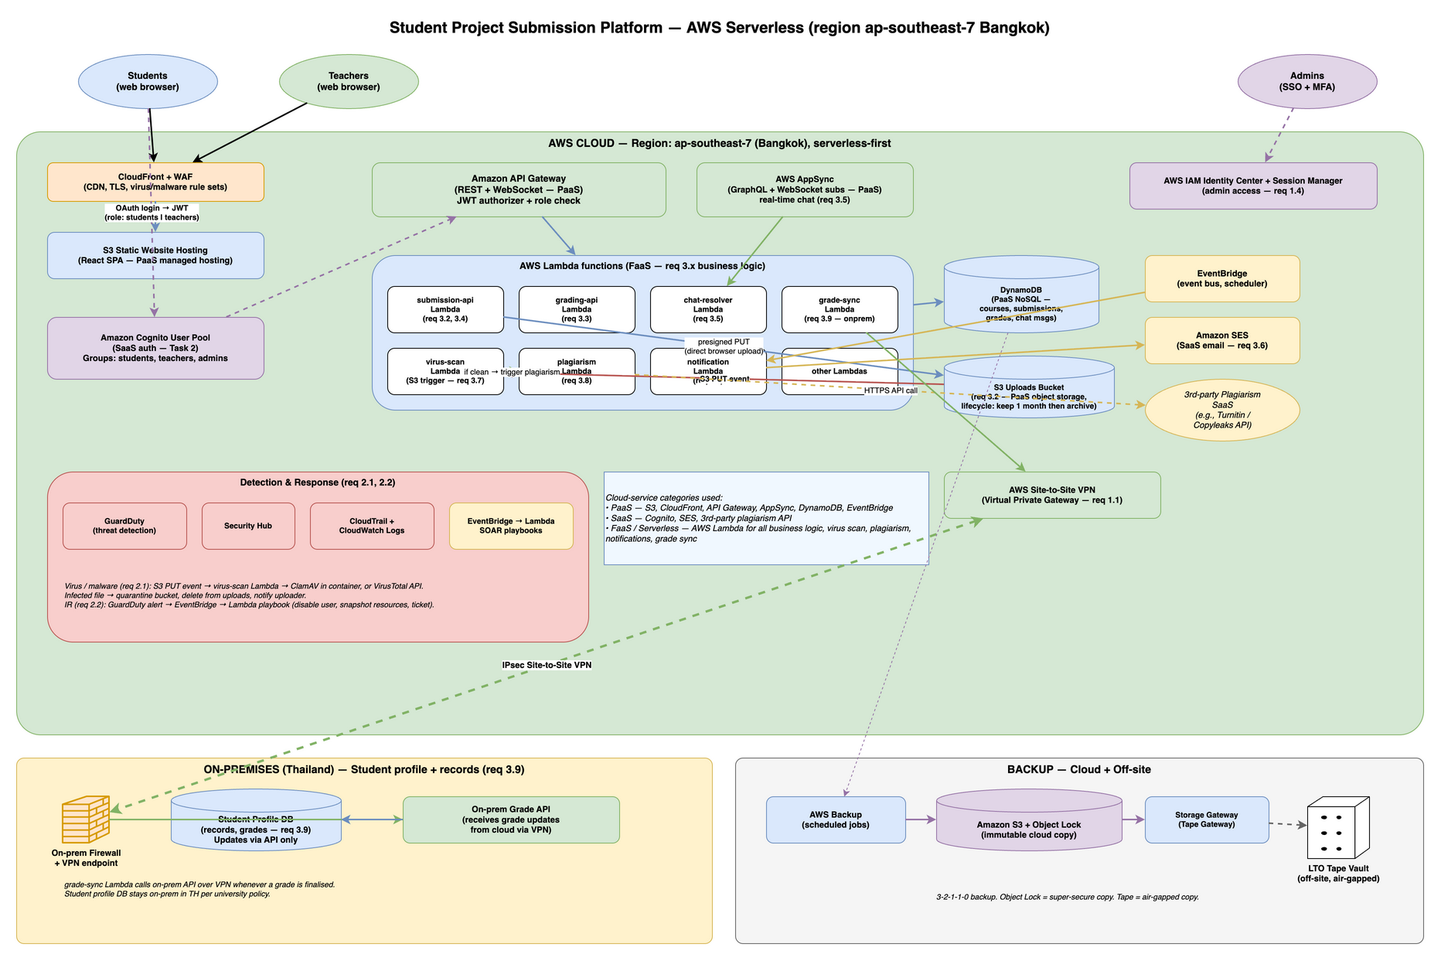
Student Submission Platform
Three zones: AWS cloud (green, top — almost everything lives here), on-premises (yellow, bottom-left — only the student profile DB and grade API), and off-site backup (grey, bottom-right).

3. Cloud-Service Categories — Which Service for What (Task 1)
Task 1 explicitly asks to identify which cloud-service category is used for which purpose. The design uses four categories:

3.1 SaaS — Third-party managed services (we consume them, we don’t run them)
- Amazon Cognito User Pool — handles student and teacher login, MFA, password resets, and group membership. The app never writes auth code; Cognito does it all. Returns a JWT.
- Amazon SES — sends email notifications (submission receipt, grade announcement). The app calls SendEmail with a template; SES handles delivery.
- AWS IAM Identity Center — admin staff login with MFA and single sign-on. Paired with Session Manager for audited shell access (no SSH keys).
- 3rd-party plagiarism API (Turnitin / Copyleaks) — external service called from a Lambda to check submissions against a corpus.
- Amazon GuardDuty — automated threat detection. We don’t operate it; we configure it and read its alerts.
- AWS Backup — managed backup orchestration. We configure it; AWS runs the snapshots.

3.2 PaaS — AWS-managed platforms (AWS runs the infrastructure; we configure and use)
- Amazon S3 — object storage for file uploads and the React frontend bundle. Lifecycle rules auto-delete old submissions (after 60 days) and move to Glacier (after 30 days).
- Amazon CloudFront — CDN for the React frontend; serves TLS 1.3, caches static assets, protects against DDoS.
- Amazon API Gateway — REST API and WebSocket endpoint. Routes requests to Lambdas, enforces authentication, provides rate limiting.
- AWS AppSync — GraphQL API with WebSocket subscriptions for real-time chat. No server to manage; it scales automatically.
- Amazon DynamoDB — NoSQL database for submission metadata, grades, chat messages, plagiarism scores. Scales on demand; no capacity planning.
- Amazon EventBridge — event bus routing. Publish events (file uploaded, graded) and trigger Lambdas asynchronously.
- AWS CloudTrail + CloudWatch Logs — audit trail of every API call and application log.
- AWS Site-to-Site VPN — encrypted tunnel to the on-prem grade API.

3.3 FaaS / Serverless — Lambda for all business logic (we write code; AWS runs it on demand)
Every Lambda function represents a feature:
- submission-api Lambda — handles student API calls: get submissions, upload, check status. Talks to DynamoDB.
- grading-api Lambda — handles teacher API calls: list submissions, submit grades, retrieve rubrics.
- chat-resolver Lambda — AppSync GraphQL resolver. Persists messages to DynamoDB, subscriptions handled by AppSync.
- virus-scan Lambda — triggered by S3 PUT event. Calls VirusTotal or runs ClamAV; moves infected files to quarantine.
- plagiarism Lambda — triggered by EventBridge after virus scan passes. Calls 3rd-party plagiarism API, stores result in DynamoDB.
- notification Lambda — triggered by EventBridge when submission received or graded. Calls SES to email students/teachers.
- grade-sync Lambda — runs on a cron (e.g., once daily) via EventBridge Scheduler. Reads finalised grades from DynamoDB, pushes to the on-prem grade API over the VPN.

3.4 IaaS — deliberately none
There are no EC2 instances, no Kubernetes clusters, no self-managed servers. This is the team’s explicit constraint: “minimal server hardware.” If something ever required a self-hosted component (e.g., a local ClamAV signature cache), I’d run it as ECS Fargate containers (still serverless, no VM management).

Summary: How This Mix Enables Speed
This is the point of the question: by assembling SaaS + PaaS + FaaS services, the team buys most of the platform and writes only the differentiated business logic (the Lambdas). The team never writes auth, email, scanning, plagiarism detection, or infrastructure code — all consumed as APIs or managed services. The remaining work is glue code + React UI — the actual competitive advantage. That’s how a small software team gets a real platform up in weeks instead of quarters.

4. Requirements → Component Mapping
Baseline hybrid requirements (Req 1):
- Secure cloud↔on-prem connection (1.1): AWS Site-to-Site VPN with IPsec/AES-256 encryption.
- Private access to the database (1.2): Student profile database stays on-prem in Thailand. Cloud components access it only via the VPN tunnel to the on-prem grade API; the database never accepts public internet connections.
- Public access only to web front end (1.3): Internet traffic reaches only the React SPA (S3 + CloudFront) and the public API endpoints (API Gateway). Nothing else is exposed. WAF is attached to CloudFront to filter DDoS and injection attacks.
- Credential-theft protection (1.4): Cognito enforces MFA for student and teacher logins. Internal admins use IAM Identity Center + Session Manager — no SSH keys, no inbound port 22, every session audited.
Detection and IR (Req 2):
- Detect virus and malware (2.1): S3 PUT event automatically triggers the virus-scan Lambda, which calls VirusTotal API or runs ClamAV. Infected files are moved to a quarantine folder and the student is notified.
- IR investigation + automated actions (2.2): GuardDuty detects threats; Security Hub aggregates alerts. When a high-severity alert fires, EventBridge triggers SOAR Lambda playbooks that automatically disable a compromised user, snapshot affected resources, and open a ticket.
Platform features (Req 3):
- Student/teacher login + roles (3.1): Amazon Cognito User Pool with three groups: students, teachers, admins. The JWT includes a cognito:groups claim. Every Lambda reads this claim and enforces RBAC (students can only access their own submissions; teachers access their courses).
- Large temp file upload (3.2): S3 bucket with a lifecycle rule: move objects to Glacier after 30 days, delete after 60 days. Supports late submissions.
- Teacher grading dashboard (3.3): React SPA (teacher view) → API Gateway → grading-api Lambda → DynamoDB.
- Student submission view dashboard (3.4): React SPA (student view) → API Gateway → submission-api Lambda → DynamoDB.
- Student/teacher chat (3.5): AWS AppSync GraphQL subscriptions (WebSocket) → chat-resolver Lambda → DynamoDB. Real-time message sync.
- Email notifications (3.6): EventBridge rule triggers notification Lambda when a submission is received or graded. Lambda calls SES to email the affected user.
- Auto virus scan after upload (3.7): S3 PUT event → virus-scan Lambda (automatic, no manual trigger needed).
- AI plagiarism detection (3.8): After virus scan passes, EventBridge publishes an event. plagiarism Lambda is triggered, calls a 3rd-party API (Turnitin / Copyleaks), stores the score in DynamoDB.
- Profile + records on-prem (3.9): Student profile database stays on-prem in Thailand (PDPA compliance). The grade-sync Lambda reads finalised grades from the cloud and writes them to the on-prem grade API over the VPN.

5. End-to-end Flows (the interesting ones)

5.1 Student uploads a project file (req 3.2 + 3.7 + 3.8 + 3.6)
- Student logs in → Cognito → JWT.
- The browser asks the submission-api Lambda for a temporary upload URL.
- The browser uploads the file directly to S3 using that URL. (The Lambda never sees the file itself — saves cost and time.)
- The S3 upload triggers the virus-scan Lambda automatically.
  - Infected → file moved to quarantine/, removed from uploads, student emailed.
  - Clean → an event is published on EventBridge.
- EventBridge fan-out (parallel):
  - plagiarism Lambda → calls the 3rd-party plagiarism API → stores the score in DynamoDB.
  - notification Lambda → sends “your file was received” email via SES.
- The student dashboard reads the submission status from DynamoDB.

5.2 Teacher grades a submission (req 3.3 + 3.6 + 3.9)
- Teacher logs in → Cognito JWT shows the group is teachers.
- Teacher opens the grading dashboard → API Gateway → grading-api Lambda → DynamoDB.
- Teacher submits a grade → Lambda saves it in DynamoDB and publishes a “grade finalised” event.
- EventBridge fan-out:
  - notification Lambda → emails the student via SES.
  - grade-sync Lambda → calls the on-prem grade API over the VPN → records the grade in the on-prem student profile DB.

5.3 Student / teacher chat (req 3.5)
- AWS AppSync exposes a GraphQL subscription endpoint over WebSocket.
- Cognito-authenticated client connects, subscribes to a chat thread, sends/receives messages in real time.
- chat-resolver Lambda persists each message to DynamoDB.

6. Task 2 — Login and Role-Taking Method

Method: Amazon Cognito User Pool + Cognito Groups + JWT role claim + Lambda RBAC
Browser ──(1) login: email + password + MFA──► Amazon Cognito User Pool
◄─(2) returns JWT (id token + access token)─
JWT payload (decoded — illustrative):
{
"sub": "abc-123-uuid",
"email": "alice@uni.edu",
"cognito:groups": ["students"], ← role(s) here
"custom:student_id": "S60012345",
"exp": 1714291200,
...
}
Browser ──(3) GET /grading/dashboard Authorization: Bearer <JWT>──► API Gateway
│
(4) Cognito authorizer validates JWT
│
(5) request reaches `grading-api` Lambda
│
(6) Lambda reads cognito:groups
if "teachers" not in groups → 403
else → proceed

Where roles are assigned
Two simple options:
- By email domain at signup — *@student.uni.edu → added to the students group automatically. *@uni.edu → added to teachers. A small Cognito trigger function does this when a user signs up.
- Manually by admin — an admin tool can flip a user’s group for edge cases (TAs, exchange students).
(Could also let students sign in with their existing university account if the university already has a single sign-on system — Cognito supports this. I’d start with native Cognito for speed, add federation later.)

How role-based access is enforced
Cognito does login; the application checks roles. Two layers:
- Coarse (route level) — different routes for students vs teachers (/student/* vs /teacher/*). The Cognito authorizer rejects calls from the wrong group.
- Fine (record level) — inside each Lambda:
  - A student can only read or write their own submissions.
  - A teacher can read all submissions for courses they teach, and write grades for those.

Why this is a good answer for this course
- Cognito handles login, MFA, and password resets — no auth code to maintain.
- The role is inside the JWT — every Lambda can check it without a DB lookup.
- One mental model — student, teacher, admin — same mechanism, only the group changes.

Trade-offs accepted
- Cognito’s login UI has limited customisation; for a heavily branded login the team would build their own UI on top of Cognito’s API.
- For very fine-grained sharing (like Google Drive permissions), groups alone aren’t enough — I’d store per-record ACLs in DynamoDB. The exam’s requirement is simple role separation, so groups are enough.

7. Detection and IR (req 2)

Virus / malware (req 2.1)
- Every file uploaded to S3 triggers the virus-scan Lambda automatically. Two options for the scanning engine:
  - VirusTotal API (SaaS) — easy, broad coverage, paid per call.
  - ClamAV running inside a Lambda container — free, but signatures need updating daily.
- Infected file → moved to a quarantine/ folder, deleted from uploads, student emailed, ticket created.

Incident response (req 2.2)
- Detection: AWS GuardDuty (threat detection), Security Hub (alert dashboard), CloudTrail (audit), CloudWatch Logs.
- Automated response: EventBridge → Lambda runs scripts that disable a compromised user, snapshot affected resources, and open a ticket.
- Framework: NIST SP 800-61 (same as Q1).

8. Backup (3-2-1-1-0)
The platform follows the same 3-2-1-1-0 rule as Q1 and Q2: 3 copies, 2 media types, 1 off-site, 1 offline/immutable, 0 errors on restore.
Layer 1 — Production: DynamoDB tables (submissions, grades, chat), S3 uploads bucket, and on-prem student profile database are the live copies.
Layer 2 — Cloud disk backup: AWS Backup automatically snapshots DynamoDB and S3. These are quick to restore if a resource fails within the same region.
Layer 3 — Cloud immutable: Amazon S3 with Object Lock provides write-once retention — even an attacker with admin credentials cannot delete backups until retention expires (typically 90 days). This copy survives ransomware attacks on all live systems.
Layer 4 — Off-site air-gapped: AWS Storage Gateway (Tape Gateway) writes snapshots to physical LTO tape, rotated weekly to an off-site vault in Thailand. Tape is air-gapped (no network) — ransomware cannot reach it. This is the second “super-hard to delete” copy.

9. Why this design lets the team ship fast
The exam’s goal for Q3 is to show I understand the value of cloud service categories, not just name them. Here is how each category buys speed:
- SaaS removes whole problem domains. The team will never write an email-sending service, an auth flow, or a virus scanner — three multi-week projects, all consumed as APIs.
- PaaS removes infrastructure work. No Postgres tuning, no load balancer config, no patching. The team configures and uses.
- FaaS removes operations. Lambda runs the code on demand; the team writes business logic and trusts AWS to scale it.
The remaining work is glue code + UI — exactly the differentiated value. That’s how a small software team gets a real platform up in weeks instead of quarters.

10. Summary
A serverless-first AWS architecture: React SPA on S3+CloudFront, public APIs through API Gateway and AppSync, all business logic in Lambda, persistent metadata in DynamoDB, file uploads in S3 with a 30-day lifecycle. Cognito User Pool with student / teacher / admin groups handles auth and roles; API Gateway and Lambdas enforce RBAC using the cognito:groups claim in the JWT. Virus scan runs on S3 PUT; plagiarism check follows via EventBridge to a 3rd-party SaaS. Email notifications via SES. Student profile DB and grade API stay on-prem; the cloud grade-sync Lambda updates grades over a Site-to-Site VPN. Backups follow 3-2-1-1-0 with S3 Object Lock plus off-site tape. Detection and response use GuardDuty + Security Hub + EventBridge → Lambda. The result: minimal upfront hardware, the team ships fast, AWS runs the boring parts.

References
- AWS — Amazon Cognito User Pool groups. https://docs.aws.amazon.com/cognito/latest/developerguide/cognito-user-pools-user-groups.html
- AWS — AWS AppSync real-time GraphQL subscriptions. https://docs.aws.amazon.com/appsync/latest/devguide/real-time-data.html
- AWS — Amazon S3 lifecycle configuration. https://docs.aws.amazon.com/AmazonS3/latest/userguide/object-lifecycle-mgmt.html
- AWS — S3 event notifications to Lambda. https://docs.aws.amazon.com/AmazonS3/latest/userguide/NotificationHowTo.html
- AWS — Amazon SES Developer Guide. https://docs.aws.amazon.com/ses/latest/dg/Welcome.html
- NIST — Definition of cloud computing (SP 800-145) — IaaS / PaaS / SaaS / FaaS taxonomy.
- RFC 7519 — JSON Web Token (JWT).
- VirusTotal — Public API documentation. https://docs.virustotal.com/
- Turnitin / Copyleaks API documentation (3rd-party plagiarism detection).

