Question 4 — Troubleshooting Cloud Services
Course: Network and Cloud Essentials — Final Exam Author: Nyi Htut Zaw Date: 28 April 2026

1. Scenario Recap
The university student-portal platform cannot be deployed because the cloud apps cannot reach the on-prem database. The development team needs to find the root cause and fix it.
The exam tasks:
- Task 1: Design a method to determine the cause. Which devices, modules, networks, services, and software should be investigated, and how?
- Task 2: List possible problems. Pick one and design a fix.

2. Diagram
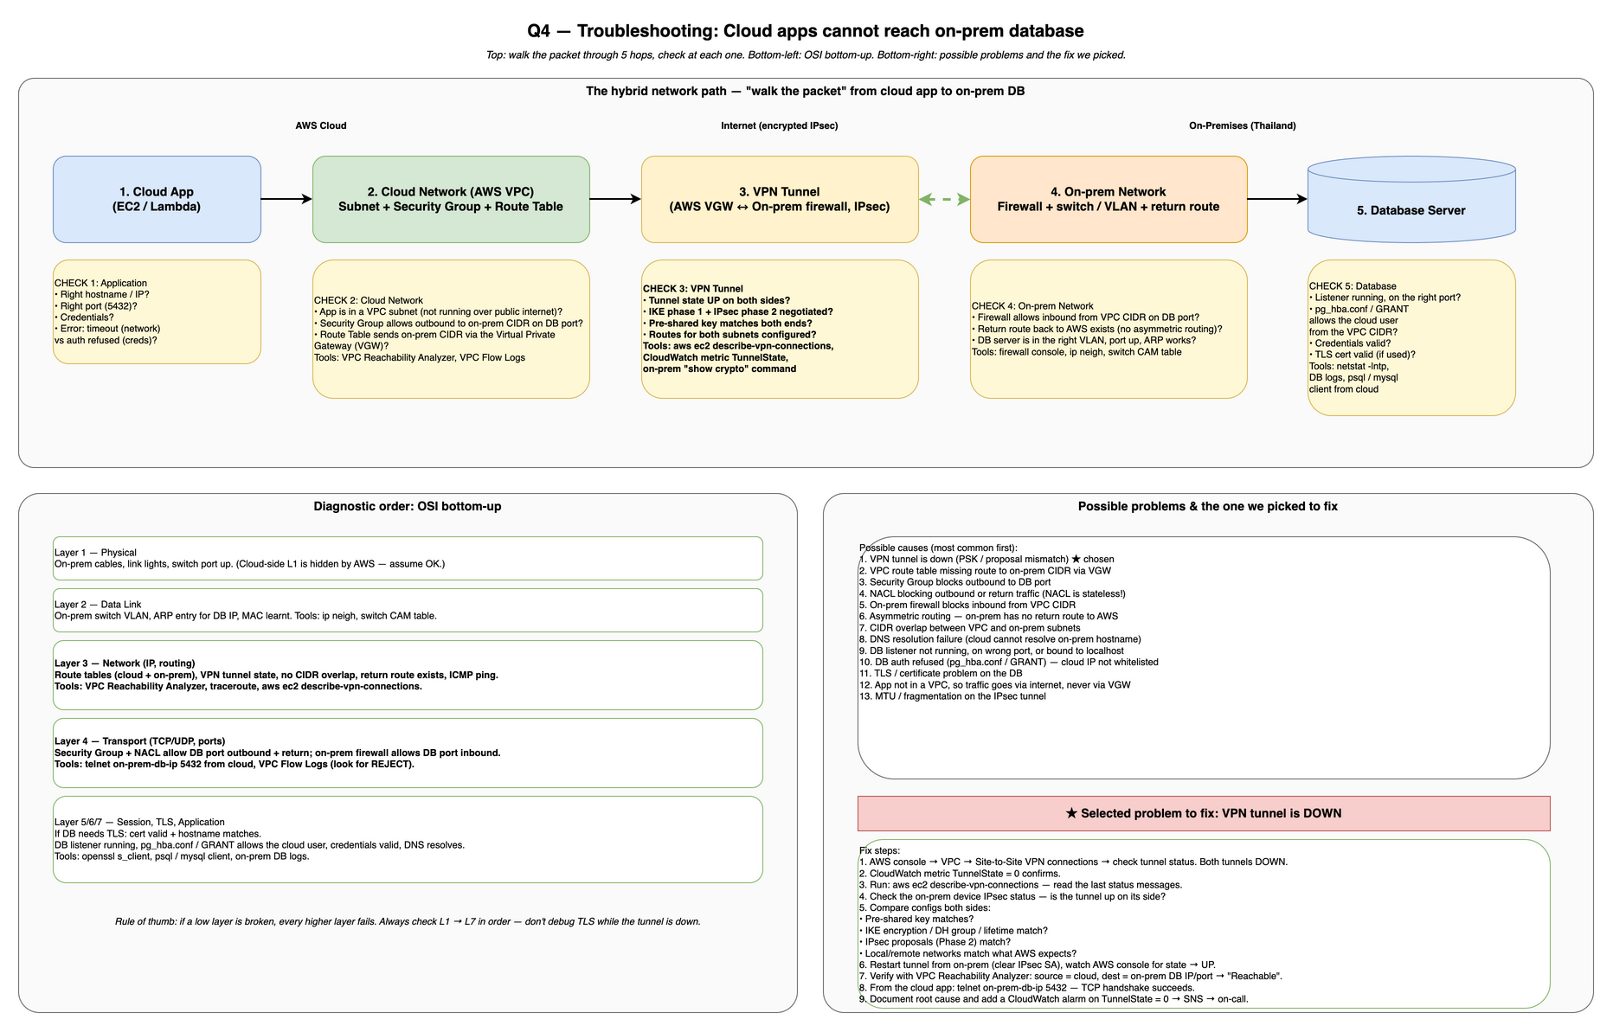
Cloud-to-Onprem DB Troubleshooting
The diagram has three regions:
- Top half — the normal hybrid path with a Check N callout at every hop.
- Bottom-left — OSI bottom-up diagnostic order with the tools to use at each layer.
- Bottom-right — the list of possible causes plus the one we picked to fix.

3. Task 1 — Diagnostic Method: “Walk the Packet” + OSI Bottom-Up
Two complementary approaches, used together:
- Walk the packet from source (cloud app) to destination (on-prem DB). At each hop, ask: can the packet still get through here?
- OSI bottom-up within each hop: physical → data link → network → transport → application. If a low layer is broken, every higher layer fails — so don’t waste time debugging TLS while the tunnel is down.
This combined approach is what the course’s troubleshooting cheat sheet teaches, applied to a hybrid AWS scenario.

3.1 The five hops along the path
Hop 1: Cloud app (EC2 / Lambda). Check that the app is connecting to the right hostname, right port, right credentials, and with a sensible timeout. How: read the connection string in the app code or config; check application logs (is the error “timeout” — a network problem — or “auth refused” — a credential problem?).
Hop 2: Cloud network (VPC subnet + Security Group + Route Table). Check that the app is in a VPC subnet (not public internet–bound), the Security Group allows outbound traffic to the on-prem CIDR on the DB port, and the route table is configured to send on-prem CIDR traffic via the Virtual Private Gateway (VGW). How: VPC console to verify the app’s ENI is in the right subnet, SG rules; VPC Reachability Analyzer to test subnet-to-destination; VPC Flow Logs to check for REJECT packets.
Hop 3: VPN tunnel (AWS VGW ↔ on-prem firewall, IPsec). Check that the tunnel state is UP on both sides, IKE phase 1 + IPsec phase 2 are negotiated, the pre-shared key matches, and both sides have routes for the other’s subnets. How: aws ec2 describe-vpn-connections to poll AWS tunnel state; CloudWatch metric TunnelState should be 1 (UP); on-prem router/firewall console show crypto isakmp sa (Cisco) to verify both phases are established.
Hop 4: On-prem network (firewall + switch / VLAN + return route). Check that the on-prem firewall allows inbound from the VPC CIDR on the DB port, a return route to AWS exists (no asymmetric routing), and the DB server is in the right VLAN with the port up. How: firewall console ACL rules; on-prem routing table to verify return route to AWS CIDR exists; switch CAM table to verify DB server MAC is learnt on the right VLAN port.
Hop 5: DB server. Check that the listener is running on the right port, pg_hba.conf (PostgreSQL) / GRANT (MySQL) allows the cloud user’s IP from the VPC CIDR, credentials are valid, and TLS cert (if required) is valid. How: netstat -lntp on the DB server to verify listener; DB server logs; psql / mysql client from the cloud to test authentication; openssl s_client to check TLS cert validity.

3.2 OSI bottom-up checklist
L1 — Physical. Check cables, link lights, and on-prem switch ports. Cloud-side L1 is managed by AWS so assume it’s OK. Tools: eyeballs and switch console.
L2 — Data Link. On-prem: check the switch VLAN is correct, ARP has an entry for the DB IP, and the DB’s MAC is learnt by the switch. Tools: switch CAM table, arp -a command.
L3 — Network. Check route tables (both cloud and on-prem), VPN tunnel is UP, no CIDR overlap between VPC and on-prem, return route from on-prem to AWS exists, ICMP ping works. Tools: VPC Reachability Analyzer, traceroute, aws ec2 describe-vpn-connections.
L4 — Transport. Check Security Group + NACL allow outbound to the DB port and return traffic (NACLs are stateless, easy to miss the return rule), on-prem firewall allows inbound from the VPC CIDR, TCP handshake completes. Tools: telnet on-prem-db-ip 5432 from cloud to test TCP handshake; VPC Flow Logs to find REJECT packets.
L5/L6 — Session / Presentation (TLS). If the DB requires TLS: check the certificate is valid, trusted, and the hostname matches; SNI is sent. Tools: openssl s_client -connect db:5432.
L7 — Application. Check the DB listener is running on the right port, pg_hba.conf (PostgreSQL) / GRANT (MySQL) permits the cloud user from the VPC CIDR, credentials are valid, DNS resolves the hostname. Tools: psql / mysql client from cloud; on-prem DB logs.

3.3 Devices, modules, networks, services, software (the question’s list)
The question explicitly asks me to enumerate which of each to investigate:
- Devices: cloud Lambda/EC2 instance, VPC route table, Virtual Private Gateway, on-prem firewall, on-prem router, on-prem switch, DB server.
- Modules: IPsec tunnel (IKE phase 1, IPsec phase 2), BGP/static routing module on the VGW, on-prem VPN endpoint module.
- Networks: AWS VPC CIDR, on-prem subnet CIDR, internet path between VGW public IP and on-prem public IP.
- Services: VPC Reachability Analyzer, CloudWatch (TunnelState metric, Lambda logs), CloudTrail, VPC Flow Logs, DNS (Route 53 Resolver / on-prem DNS).
- Software: ping, traceroute, telnet, nc, openssl s_client, dig, psql/mysql client, AWS CLI (aws ec2 describe-vpn-connections).

3.4 The first three commands I’d actually run
A senior engineer doesn’t read the full checklist top to bottom every time. The fastest first three checks:
- aws ec2 describe-vpn-connections — is the tunnel even up? Solves ~50% of these incidents in ten seconds.
- VPC Reachability Analyzer with source = the Lambda’s ENI and destination = on-prem DB IP/port — AWS will tell you exactly which hop is blocking.
- telnet on-prem-db-ip 5432 from a cloud test instance — if TCP handshake succeeds, it’s an app-layer problem (creds, GRANT). If it fails, it’s a network-layer problem.
These three pin down the layer in < 5 minutes.

4. Task 2 — Possible Problems
Common causes, listed roughly most-likely-first:
- VPN tunnel is down (PSK or IPsec proposal mismatch) — L3. The tunnel state shows DOWN; pre-shared key or IKE/IPsec parameters don’t match between AWS and on-prem.
- Route table missing route to on-prem CIDR via VGW — L3. The VPC route table has no entry for the on-prem CIDR pointing to the Virtual Private Gateway.
- Security Group blocks outbound to DB port — L4. The EC2 / Lambda’s SG has no outbound rule permitting the on-prem DB CIDR on the DB port.
- NACL blocks outbound or return traffic — L4. NACLs are stateless, so both outbound and return traffic rules must be present. Easy to add outbound 5432 but forget the return rule.
- On-prem firewall blocks inbound from VPC CIDR — L4. The on-prem firewall ACL doesn’t allow inbound from the VPC CIDR on the DB port.
- Asymmetric routing — L3. Packets from cloud to on-prem get through, but return traffic takes a different path (e.g., via a different router) that doesn’t arrive back.
- CIDR overlap between VPC and on-prem subnets — L3. The VPC CIDR accidentally overlaps with the on-prem CIDR; routing becomes ambiguous.
- DNS resolution failure — L7. The cloud Lambda cannot resolve the on-prem DB hostname because the VPC Resolver Endpoint is not configured to forward queries to on-prem DNS.
- DB listener not running, on wrong port, or bound to localhost only — L7. The database server is not listening, or is listening on a different port than the app expects, or is bound to 127.0.0.1 (won’t accept remote connections).
- DB auth refused — L7. The cloud user’s IP address is not in pg_hba.conf (PostgreSQL) or does not have a GRANT (MySQL), or the credentials are wrong.
- TLS / certificate problem — L5/L6. The DB’s TLS certificate is invalid, expired, untrusted, or the hostname doesn’t match.
- Lambda not configured to run in a VPC — L3. The Lambda is running without an ENI in the VPC, so its outbound traffic goes via the public internet (NAT Gateway), never through the VPN tunnel.
- MTU / fragmentation problem on the IPsec tunnel — L3. The tunnel MTU is too small; packets are fragmented, causing performance issues or silent drops.

5. Selected Problem and Fix: VPN Tunnel Is Down
I picked #1 — VPN tunnel is down because it is the single most common cause of “cloud cannot reach on-prem”, and because it lets me show the full diagnostic + fix loop end-to-end.

5.1 How we know it’s this problem
- AWS console → VPC → Site-to-Site VPN Connections → both tunnels show status DOWN.
- CloudWatch metric TunnelState = 0 for the connection — confirms.
- aws ec2 describe-vpn-connections --vpn-connection-id vpn-xxx — last status message says e.g. “No proposal chosen” or “Phase 2 IPsec SA is not established”.
- From the on-prem router: show crypto isakmp sa (Cisco) or equivalent — the SA is in MM_NO_STATE or absent.
- VPC Reachability Analyzer with source = Lambda ENI, destination = on-prem DB port → reports “Not reachable: VGW route exists, but no active VPN tunnel”.

5.2 Fix steps
The fix is to align the IPsec configuration on both sides until the tunnels come up.
- Pull the AWS-side config for the VPN connection (AWS console → “Download Configuration” gives a vendor-specific config file).
- Compare line-by-line with the on-prem router/firewall configuration. Common mismatches:
  - Pre-shared key — typo or copy-paste error.
  - IKE phase 1 proposal — encryption (AES-256), DH group (14/19), lifetime — all must match.
  - IPsec phase 2 proposal — same idea.
  - Local / remote networks — AWS expects to see exactly the VPC CIDR as the remote network from on-prem’s perspective, and the on-prem CIDR as the remote from AWS’s.
  - Dead Peer Detection (DPD) parameters.
- Update whichever side is wrong, then on the on-prem device clear the existing IPsec SAs and let the tunnel re-establish (clear crypto isakmp on Cisco IOS, equivalent elsewhere).
- Watch AWS console — tunnel state should transition from DOWN → UP within 30–90 seconds.
- Verify with Reachability Analyzer: source = Lambda ENI, destination = on-prem DB IP/port → expect “Reachable”.
- Verify from the cloud app: telnet on-prem-db-ip 5432 from a cloud test EC2 / Lambda — TCP handshake succeeds.
- Try the actual DB connection from the application — if the network now passes but auth fails, jump to the L7 checks (problem #10 above).
- Add a CloudWatch alarm on TunnelState = 0 → SNS → on-call channel, so next time we know within minutes instead of after a deploy fails.

5.3 Why it failed in the first place (likely root cause)
The most common reason a tunnel was up and then is suddenly down: someone on the on-prem side changed the firewall config (e.g., added a new IPsec policy, changed the lifetime), or AWS rotated the tunnel endpoint and the on-prem side wasn’t updated. The audit trail (CloudTrail on the AWS side, change log on the on-prem side) usually points at the change.

6. Summary
A “cloud apps cannot reach the on-prem DB” problem is solved by walking the packet from the cloud Lambda/EC2 through the eight hops (subnet, SG, NACL, route table, VGW, internet, on-prem FW, switch, DB) and applying OSI bottom-up reasoning at each one. Three commands — aws ec2 describe-vpn-connections, VPC Reachability Analyzer, and telnet from a cloud instance to the DB port — pin down the failing layer in minutes. The most common cause is a VPN tunnel that is down because of a mismatched IPsec configuration; the fix is to align both sides’ pre-shared key, IKE/IPsec proposals, and local/remote networks, then add a CloudWatch alarm so the next failure surfaces before a deploy does.

References
- AWS — VPC Reachability Analyzer. https://docs.aws.amazon.com/vpc/latest/reachability/what-is-reachability-analyzer.html
- AWS — Site-to-Site VPN troubleshooting. https://docs.aws.amazon.com/vpn/latest/s2svpn/Troubleshooting.html
- AWS — VPC Flow Logs. https://docs.aws.amazon.com/vpc/latest/userguide/flow-logs.html
- AWS — CloudWatch metrics for VPN. https://docs.aws.amazon.com/vpn/latest/s2svpn/monitoring-cloudwatch-vpn.html
- ISO/IEC 7498-1 — OSI reference model.
- Course cheat sheet — OSI bottom-up troubleshooting (lecture material).

