# [https://avatars2.githubusercontent.com/u/4156894?v=3&s=100](http://www.calstatela.edu/centers/hipic) CIS5200 Term Project Tutorial

#### Authors:  ZHICHENG YU, LOUIS TAN, NEVIN YILMAZ(Term paper group four)

#### Instructor: [Jongwook Woo](https://www.linkedin.com/in/jongwook-woo-7081a85)

#### Date:12/16/2018

**Lab Tutorial**

ZHICHENG YU ([zyu4@calstatela.edu](mailto:zyu4@calstatela.edu))

Louis Tan ([ltan3@calstatela.edu](mailto:ltan3@calstatela.edu))

Nevin Yilmaz ([nyilmaz@calstatela.edu](mailto:nyilmaz@calstatela.edu) )

12/6/2018

**NYC Parking Tickets Data Analysis using Hive**

**Objectives**

This tutorial is using NYC Parking Tickets dataset from Kaggle.com. You will experience using Hadoop Ambari UI to run HIVEQL and learn data analysis on HIVEQL.

We will begin with downloading the dataset including five csv files, and then pick one file to implement a few HIVE operations, such as:

* Create table Schema
* Select specific columns from table
* Sort the data
* Filter and Group the data

**PRE-REQUISITES**

* Available Ambari UI Hadoop platform
* Tableau or Excel to visualize data

**Platform Spec**

* **IBM Server**
* **16GB RAM**
* **Node: 3**
* **HDFS Version: 2.7.3**
* **Hive Version 1.2.1000**
* **CPU: V4 2.2GHZ**

**OUTLINE**

* What is HIVEQL?
* Step 1: Download the Data
* Step2: Upload the data files
* Step3: Create Hive table to query those parking tickets
* Step4: Create Hive queries to analyze the data
* Step5: Use Tableau or Excel to visualize the data

**PART A: HIVEQL In Hadoop Ambari UI**

Step 1: Download the data to local and upload it to the server

1.Download the parking tickets data using the fi

<https://www.kaggle.com/new-york-city/nyc-parking-tickets>?

2.Unzip the file

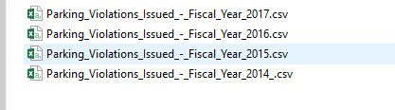

3. UPLOAD THE DATA FILES, open Ambari UI

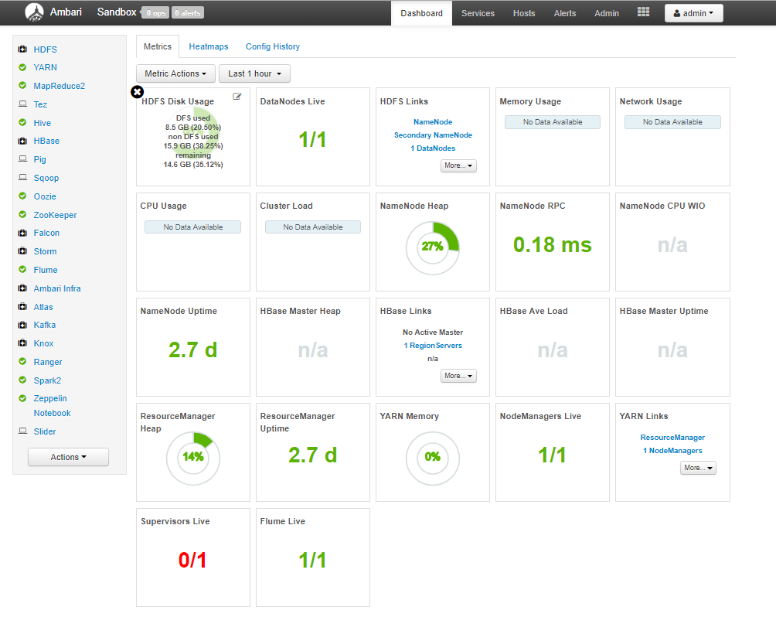

4.Open file view on the right corner of the window

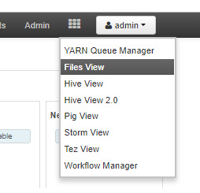

5.Then open path ‘/user/username/’ and Create folder ‘Data’

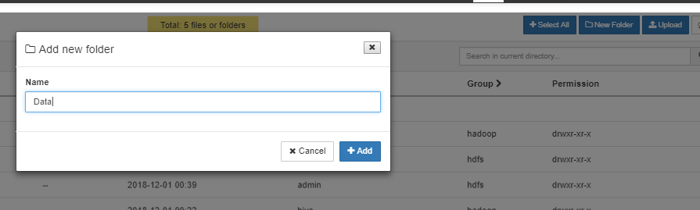

6.Open folder Data and upload dataset csv

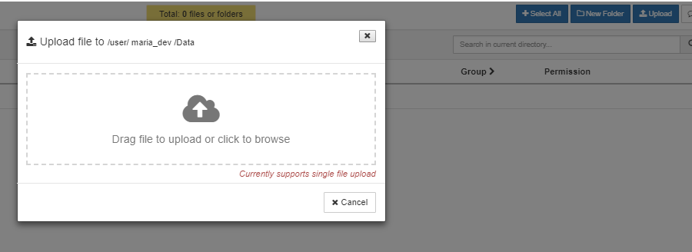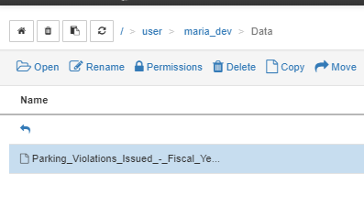

6.Create folder tmp under the path ‘/user/username/’ and change its permission to full access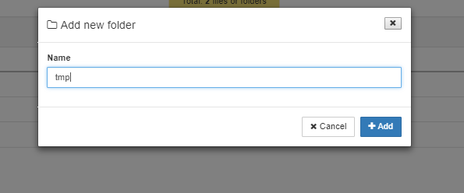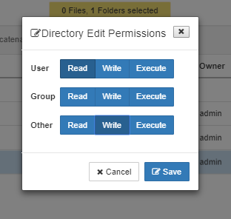

Step 2: Creating Hive table to Query Parking Tickets Data

1.To perform Hive statement, firstly open the HiveView2.0 in Ambari.

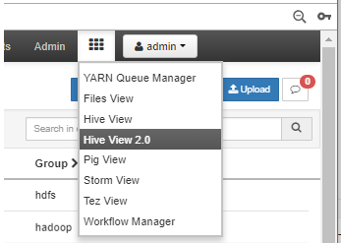

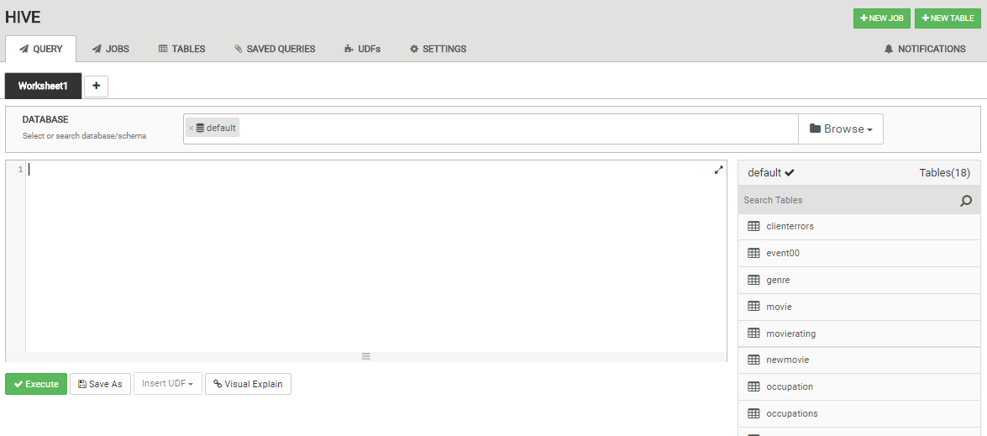

2.Create your own database statement, please replace username with your new user name. Copy and paste the code into HiveView2.0

CREATE database IF NOT EXISTS username

3.Then use select database statement.

USE username

4.To use following code creating external table, which can store the original dataset. Please replace username.

CREATE EXTERNAL TABLE IF NOT EXISTS parking_2014 (

Summons_Number int,

Plate_ID string,

Registration_State string,

Plate_Type string,

Issue_Date string,

Violation_Code int,

Vehicle_Body_Type string,

Vehicle_Make string,

Issuing_Agency char(255),

Street_Code1 int,

Street_Code2 int,

Street_Code3 int,

Vehicle_Expiration_Date int,

Violation_Location int,

Violation_Precinct int,

Issuer_Precinct int,

Issuer_Code int,

Issuer_Command int,

Issuer_Squad int,

Violation_Time string,

Time_First_Observed string,

Violation_County string,

Violation_In_Front_Of_Or_Opposite char(255),

House_Number string,

Street_Name string,

Intersecting_Street string,

Date_First_Observed int,

Law_Section int,

Sub_Division string,

Violation_Legal_Code string,

Days_Parking_In_Effect string,

From_Hours_In_Effect string,

To_Hours_In_Effect string,

Vehicle_Color string,

Unregistered_Vehicle int,

Vehicle_Year int,

Meter_Number char(255),

Feet_From_Curb int,

Violation_Post_Code string,

Violation_Description string,

No_Standing_or_Stopping_Violation string,

Hydrant_Violation string,

Double_Parking_Violation string,

Latitude string,

Longitude string,

Community_Board string,

Community_Council string,

Census_Tract string,

BIN string,

BBL string,

NTA string)

ROW FORMAT DELIMITED FIELDS TERMINATED BY ','

STORED AS TEXTFILE LOCATION '/user/ username /tmp/data/'

5.Then load data into table

LOAD DATA INPATH '/user/username/data/ Parking_Violations_Issued_-_Fiscal_Year_2014_.csv' OVERWRITE INTO TABLE parking_2014;

Step 3: Creating Hive Queries to Analyze Data

1.Copy and paste the following Hive code to HiveView2.0.

CREATE TABLE IF NOT EXISTS SimpleTickets

ROW FORMAT DELIMITED FIELDS TERMINATED BY ','

STORED AS TEXTFILE LOCATION '/user/ username /tmp/SimpleTickets'

AS

SELECT Registration_State,

Issue_Date,

Plate_Type,

Vehicle_Body_Type,

Vehicle_Make,

Vehicle_Expiration_Date,

Violation_Time,

Violation_County,

Vehicle_Color,

Vehicle_Year

FROM parking_2014;

2.Create ticketsbyID table to query data

CREATE TABLE IF NOT EXISTS ticketsbyID

ROW FORMAT DELIMITED FIELDS TERMINATED BY ','

STORED AS TEXTFILE LOCATION '/user/ username /tmp/ticketsbyID'

AS

SELECT Registration_State ,Plate_ID,Plate_Type, COUNT(*) as Total

FROM SimpleTickets

GROUP BY Registration_State ,Plate_ID,Plate_Type

ORDER BY Total DESC;

3.Create ticketsbyState to query data

CREATE TABLE IF NOT EXISTS ticketsbyState

ROW FORMAT DELIMITED FIELDS TERMINATED BY ','

STORED AS TEXTFILE LOCATION '/user/ username /tmp/ticketsbyState'

AS

SELECT Registration_State, COUNT(*)/9100279 * 100 AS Per

FROM SimpleTickets

GROUP BY Registration_State

ORDER BY Per DESC;

4.Create table ticketsbyIssueDate to query data

CREATE TABLE IF NOT EXISTS ticketsbymonth

ROW FORMAT DELIMITED FIELDS TERMINATED BY ','

STORED AS TEXTFILE LOCATION '/user/ username /tmp/ticketsbymonth'

AS

SELECT split(Issue_Date ,'[\/]')[0] AS month, COUNT(*) as Total

FROM SimpleTickets

GROUP BY month

ORDER BY Total DESC;

5.Create table ticketsbymonth to query data

CREATE TABLE IF NOT EXISTS ticketsbymonth

ROW FORMAT DELIMITED FIELDS TERMINATED BY ','

STORED AS TEXTFILE LOCATION '/user/username/ticketsbymonth'

AS

SELECT month, SUM(Total) as Total

FROM ticketsbyIssueDate

GROUP BY month

ORDER BY Total DESC;

6.Create table ticketsbylocation

CREATE TABLE IF NOT EXISTS ticketsbylocation

ROW FORMAT DELIMITED FIELDS TERMINATED BY ','

STORED AS TEXTFILE LOCATION '/user/ username /tmp/ticketsbylocation'

AS

SELECT House_Number,

Street_Name,

Intersecting_Street, COUNT(*) as Total

FROM parking 2014

GROUP BY House_Number,

Street_Name,

Intersecting_Street

ORDER BY Total DESC;

Step 4: Loading Data into Excel and Visualization

1.Open Ambari into File view under path ‘/user/username/tmp/ticketsbyID/’

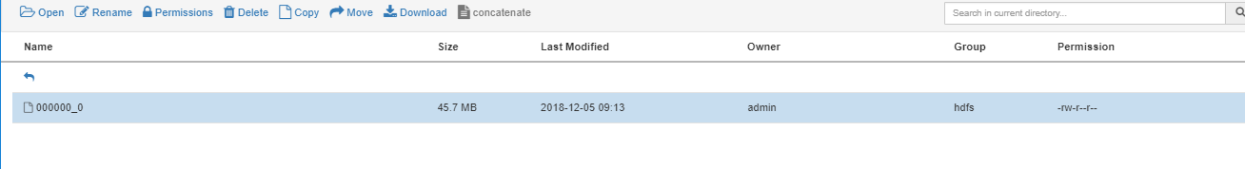Then select file 000000_0 and click download button on top.

Open File in Microsoft EXCEL

.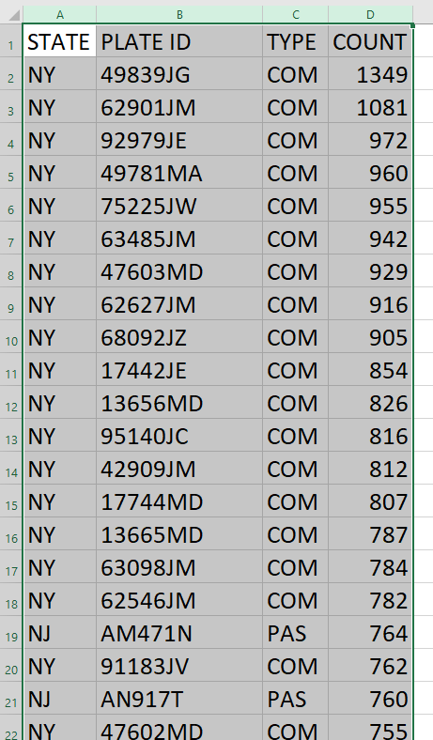

2.Open Ambari into File view under path ‘/user/username/tmp/ticketsbyState/’

Then select file 000000_0 and click download button on top.



Open File in Microsoft EXCEL.

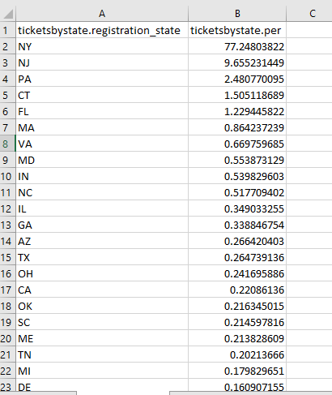

3.Open Ambari into File view under path ‘/user/username/tmp/ticketsbymonth/’



Then select file 000000_0 and click download button on top.

Open File in Microsoft EXCEL.

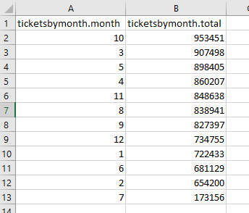

4.Open Ambari into File view under path ‘/user/username/tmp/ticketsbylocation/’



Then select file 000000_0 and click download button on top.

Open File in Microsoft EXCEL.

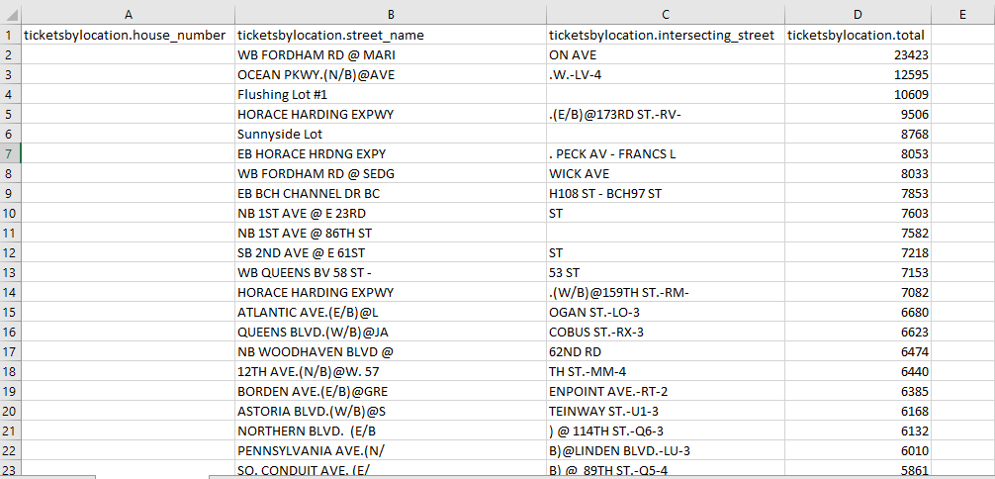

5.Open EXCEL 3D maps and select column street_name as loation

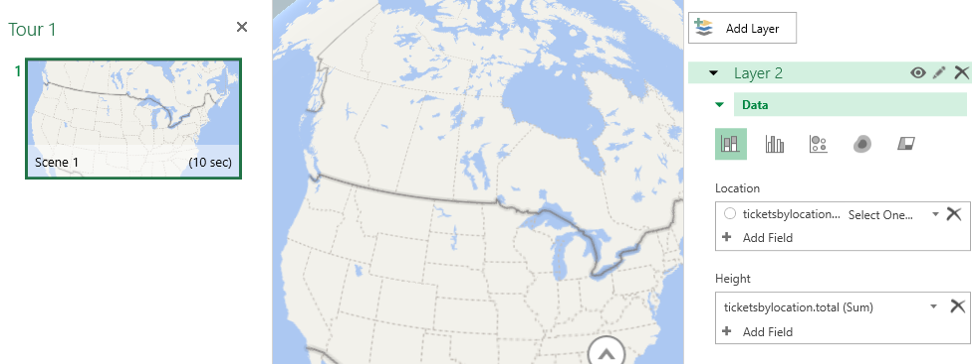

Select total as height

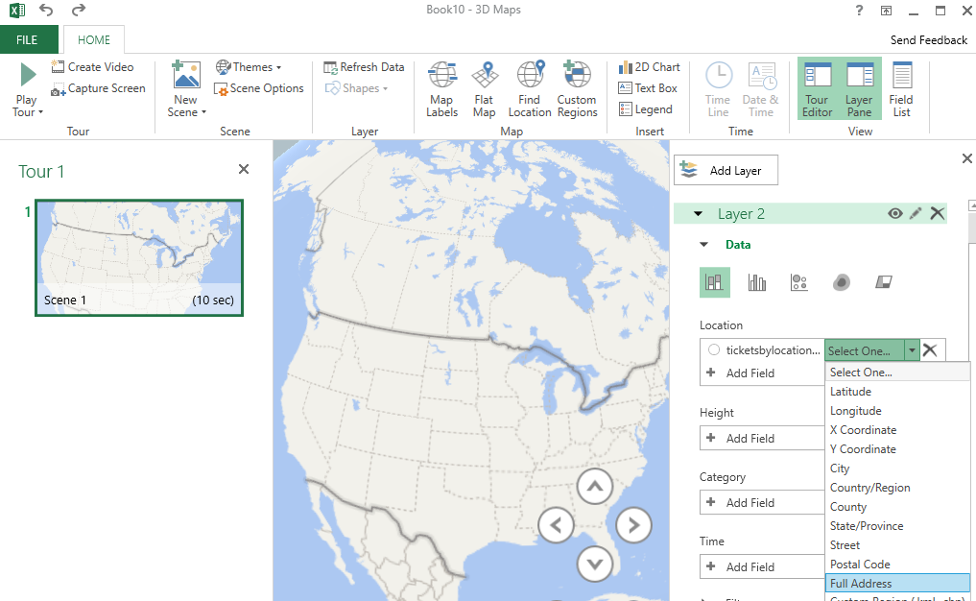

You will see the 3D map with column as following

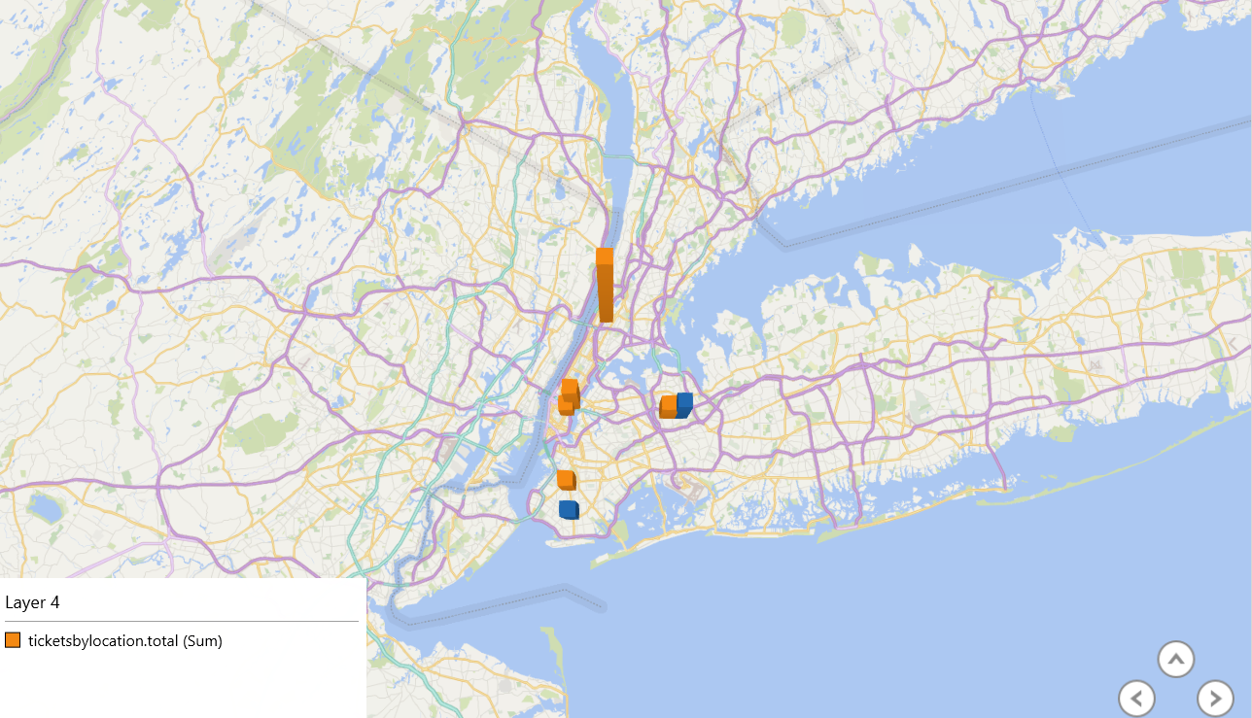

**PART B: Oracle Server**

Step 1: Loading Data into Oracle Server:

Putty and Psftp download link:

<https://www.chiark.greenend.org.uk/~sgtatham/putty/latest.html>

1.Open Putty to connect to oracle server

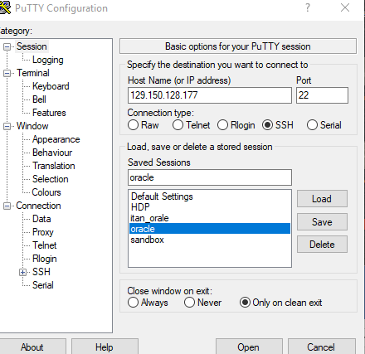

2.Use your own username and password to login

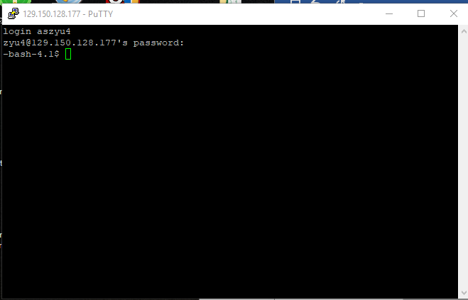

3.Then open SFTP, and use the same username and password as putty to login.

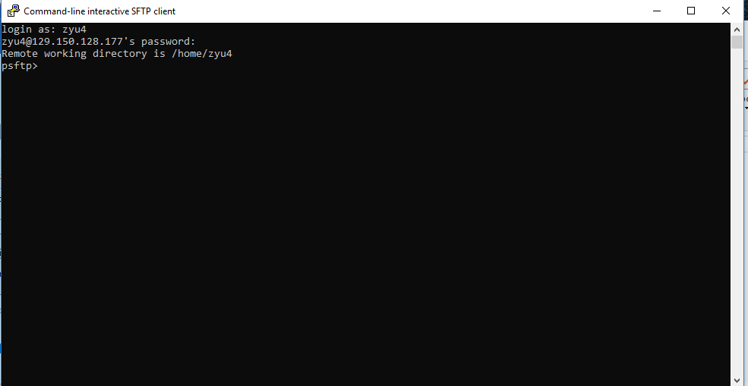

4.Use command ‘Put Parking_Violations_Issued_-_Fiscal_Year_2014_.csv’ to upload dataset.

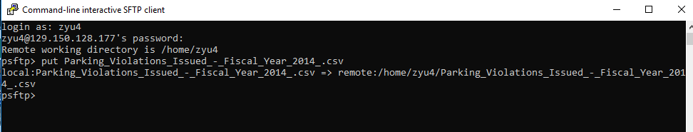

Step 2: Analyze data using Hive

1.aConnect to Oracle server with “ssh *username@ip”* with your password.

1b.Connect to beeline with provided beeline command.

1c.After choosing your database with “*USE username*” copy and paste the following Hive code to create the table

CREATE EXTERNAL TABLE group4_project (summons_number INT, PlateID STRING, Registration_state STRING, Plate_type STRING, issue_date STRING, Violation_code INT, vehicle_body_type STRING, Vehicle_make STRING, issuing_agenct STRING, street_code1 INT, street_code2 INT, street_code3 INT, vehicle_exp_date INT, violation_location STRING, violation_precinct INT, issuer_precinct INT, issuer_code INT, issuer_command STRING, issuer_squad STRING, vioaltion_time STRING, time_first_observed STRING, violation_country STRING, violation_in_front_of_or_opposite STRING, house_number STRING, street_name STRING, intersecting_street STRING, date_first_observed INT, law_section INT, sub_division STRING, violation_legal_code STRING, days_parking_in_effect STRING, from_hours_in_effect STRING, to_hours_in_effect STRING, vehicle_color STRING, unregistered_vehicle STRING, vehicle_year INT, meter_number STRING, feet_from_curb INT, violation_post_code STRING, violation_desc STRING, no_standing_or_stopping_violation STRING, hydrant_violation STRING, double_parking_violation STRING, latitude INT, longitude INT, community_board INT, community_council INT, census_tract INT, BIN INT, BBL INT, NTA STRING) ROW FORMAT DELIMITED FIELDS TERMINATED BY ',' location '/user/nyilmaz/Term_Project/' tblproperties ("skip.header.line.count"="1");

2. Ngram: Five most common trigrams

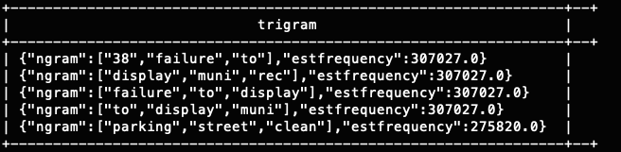SELECT explode(ngrams(sentences(lower(violation_desc)), 3, 5)) AS trigram from group4_project;

3. Show top 4 state occurrences

select w.registration_state from ( select registration_state, count(*) as cnt from group4_project group by registration_state order by cnt desc) w limit 4;

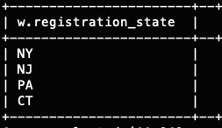

4. Show top 4 most occurred violation codes

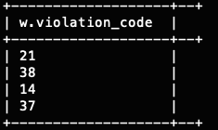select w.violation_code from ( select violation_code, count(*) as cnt from group4_project group by violation_code order by cnt desc) w limit 4;

(Violation code descriptions can be found at the github link in DOF_Parking_Violation_Codes.csv) [2]

5.Show top 4 vehicle body type

select w.vehicle_body_type from ( select vehicle_body_type, count(*) as cnt from group4_project group by vehicle_body_type order by cnt desc) w limit 4;

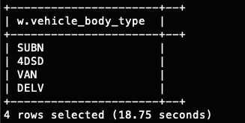

6. Show top 4 vehicle make

select w.vehicle_make from (select vehicle_make, count(*) as cnt from group4_project group by vehicle_make order by cnt desc) w limit 4;

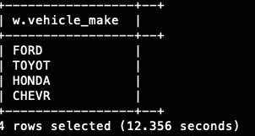

7. Show bottom 20 vehicle make

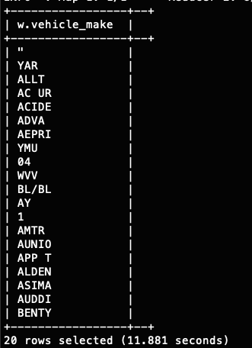select w.vehicle_make from (select vehicle_make, count(*) as cnt from group4_project group by vehicle_make order by cnt asc) w limit 20;

8. Top 5 violation time

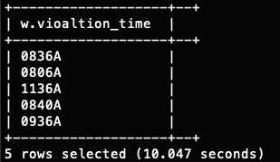select w.vioaltion_time from (select vioaltion_time, count(*) as cnt from group4_project group by vioaltion_time order by cnt desc) w limit 5;

References

* 1. https://www.kaggle.com/new-york-city/nyc-parking-tickets
  2. <https://github.com/nyilmaz1/NYC_parking-Hive.git>
  3. <https://www.dropbox.com/home/cis4560_5200Fall2018?preview=ch12Hive_p2_30.pdf>