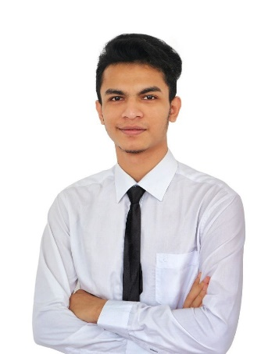Nyi Nyi Nay Naing

**Data Science**

# [LinkedIn/nyinyinaynaing](https://www.linkedin.com/in/nyi-nyi-nay-naing?utm_source=share&utm_campaign=share_via&utm_content=profile&utm_medium=android_app) | +60177215826 | nyinyinaynaing096@gmail.com

# Objective

A Computer Science fresh graduate specializing in Data Science with a foundation in Machine Learning, data engineering, database management, deep learning, and NLP. Dedicated to applying my skills to solve real-world problems and contribute to data-driven decision-making in an innovative, collaborative environment.

# Experience

## Machine Learning Projects

* Developed an algorithm to detect Languages in python using Pandas, NumPy and Sklearn libraries.
* Built and compared KNN, Random Forest, Logistic Regression and SVM in detecting human’s emotions.
* Developed a model to predict customer segmentation using Random Forest in RapidMiner and published at IEEE.

## Deep Learning Projects

* Authored a research paper featured in IEEE, investigating, and comparing weight initializers within the domain of Deep Learning.

## Final Year Project

* Students Hostel Leave Management System for Albukhary International University (AIU) using PHP, XAMPP, MySQL, HTML, CSS, and JavaScript.
* Led the development of a web-based system for AIU to automate leave management, reducing paperwork and approval time.
* Improved operational efficiency and reduced environmental impact.

## Industrial Training

## 

**Web Developer Intern**

*KOOLECT*

*April 2024 – May 2024*

* Contributed to the Keli project using Svelte.
* Fixed minor errors and enhanced functions.

**Data Analyst Intern**

*MEF (Malaysia Employers Federation)*

*June 2024 – September 2024*

* Worked within the Big Data Research & Information department.
* Created Dashboards for Salary Comparison, membership and more.
* Developed an HR web application for internal use.

# Education

## Albukhary International University - Alor Setar, Kedah Oct,2020 – Sep,2021

Foundation level studies | CGPA – 3.35

## Albukhary International University - Alor Setar, Kedah Oct,2021 – Dec,2024

Bachelor of Computer Science, Data Science | CGPA – 3.77

# Skills

**Programming languages:** Python, R, java, SQL, C, Html, CSS, JavaScript.

**Tools:** Jupyter Notebook, Google Collab, R Studio, Power BI, Rapid Miner, Tableau, VS Code, Cursor, Database Management (XAMPP, MySQL).

* Machine Learning
* Data Cleaning and Preprocessing
* Deep Learning
* Natural Language Processing

# Publications

* A Prediction of Customer Segmentation using Random Forest in RapidMiner, IEEE, 2023.
* A Comparison of Weight Initializers in Deep Learning, IEEE, 2023.