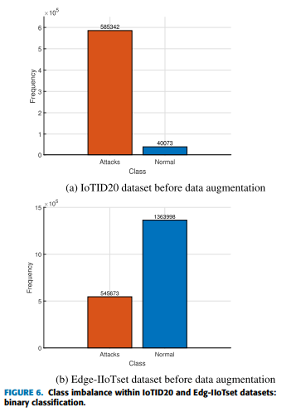

Class imbalance before and after augmentation graphs for 3 datasets

Likewise, inference time and Memory use based on three datasets

Legend at the top of the graph

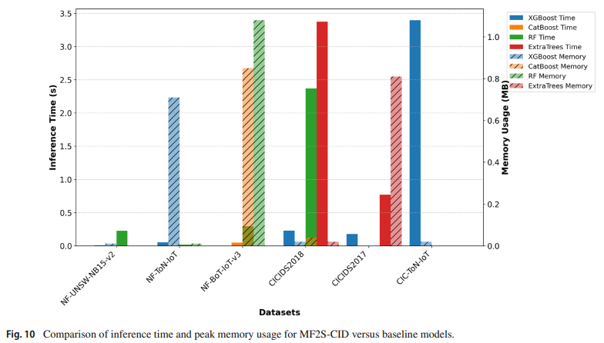

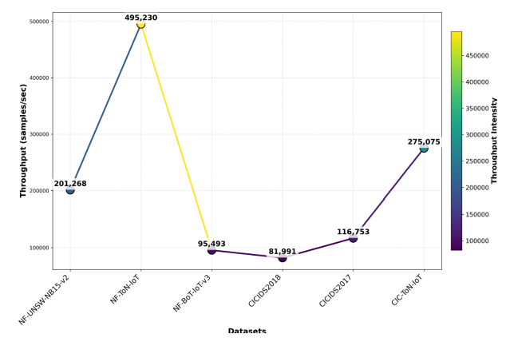

Based on the dataset, throughput and Throughput intensity

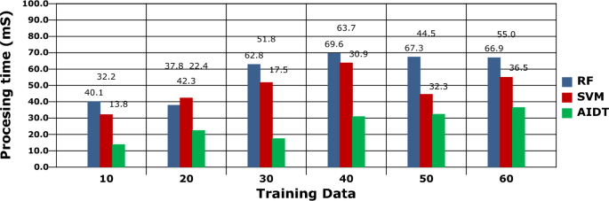

Change the values slightly,

In y axis, Processing time (ms) from 0 to 20

ABTD-ML, SRT-ADM, IoMT-SAF, MDPAC, HMLSF-IoMT

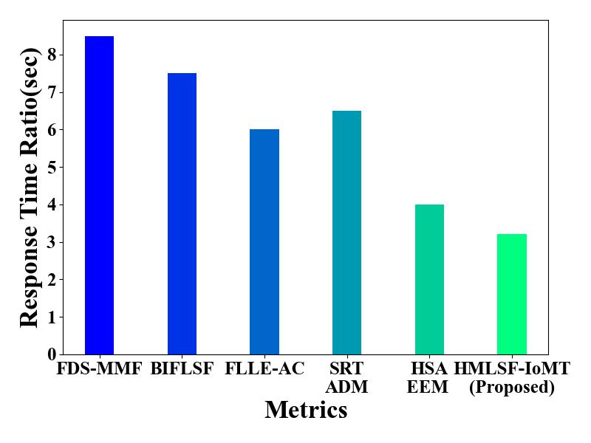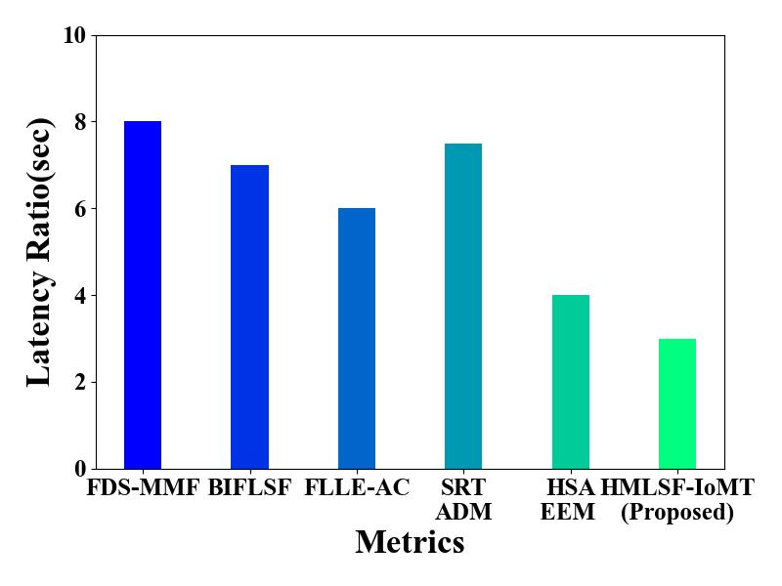

Not corrected these graphs

In X mention Techniques

In Y remove the word ratio

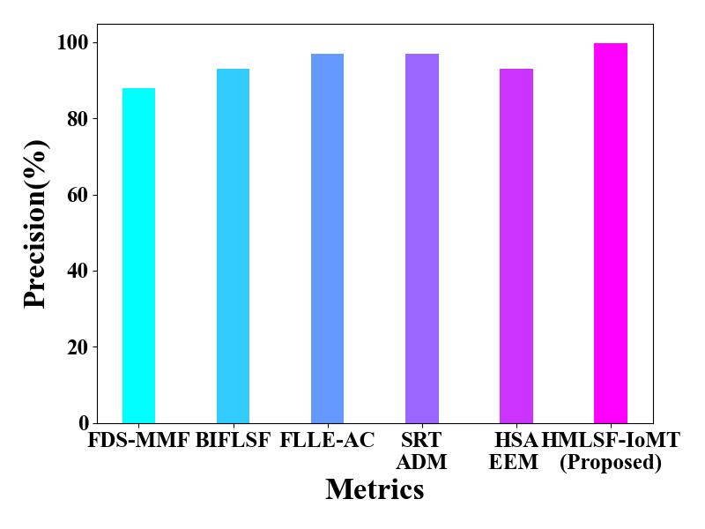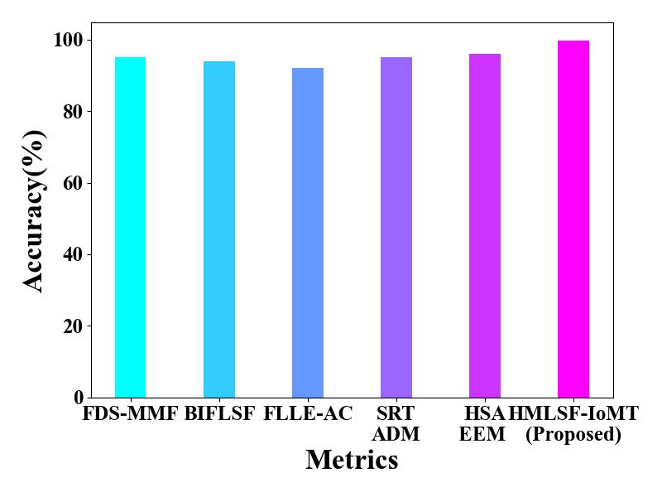

Not corrected these graphs

In X mention Techniques

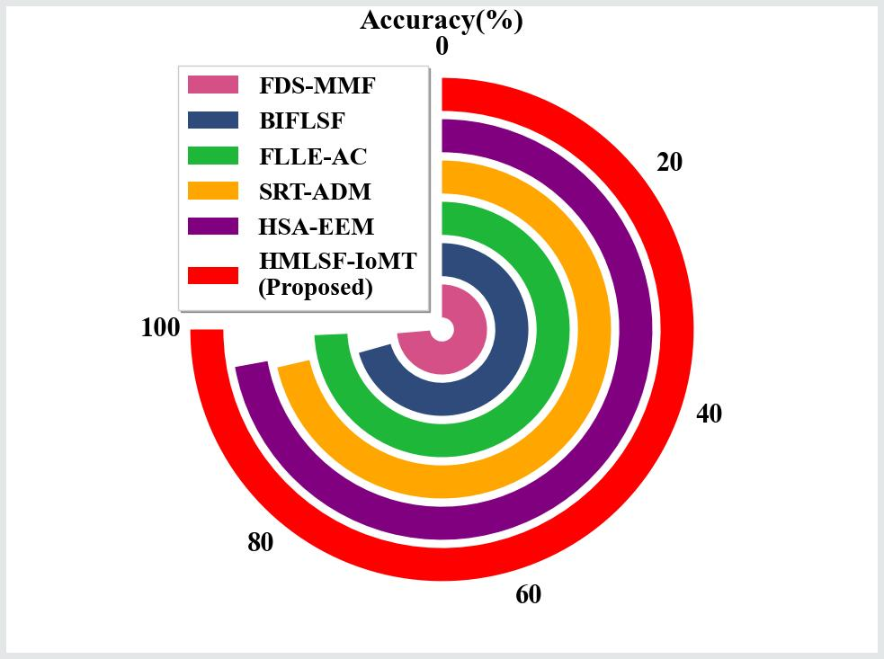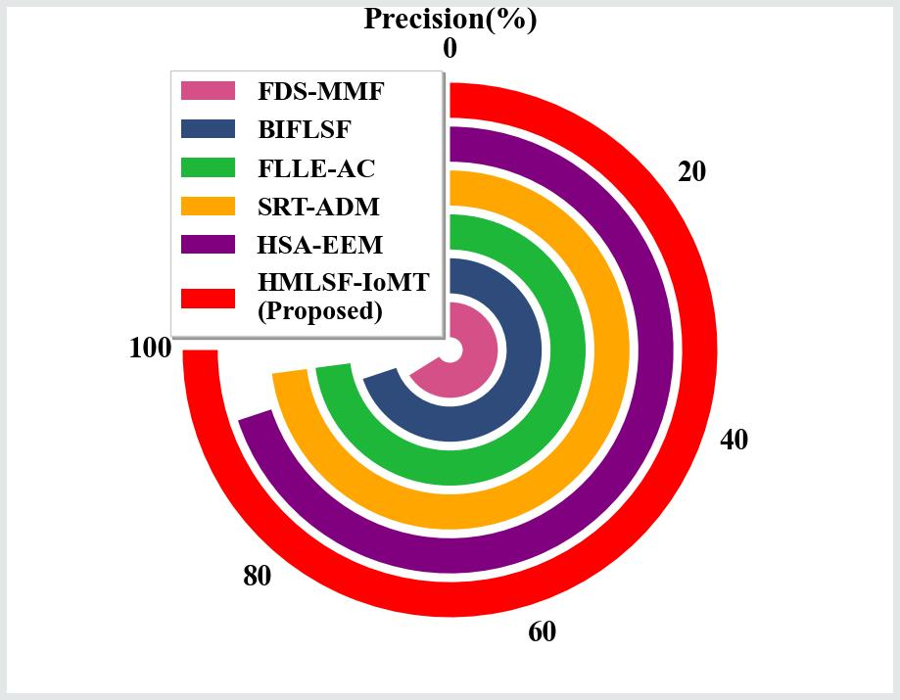

Not corrected these graphs

Change this to bar