**Exploring Suburbs of Melbourne City (Australia)**

**Nabeel Khan**

**September 06, 2019**

|  |
| --- |
| 1. **Introduction** |

**1.1 Problem Statement**

Find a reasonable suburb of Melbourne for living.

**1.2 Discussion**

Melbourne has been named the world’s most liveable city for seven years in a row [1]. In 2018, Melbourne performed best in healthcare, education and infrastructure. Melbourne not only maintained its score in stability but also gained points in culture and environment.

All these factors make Melbourne a natural choice for people to live, work, or study. But there are two issues:

* Firstly, all neighborhoods are not safe to live due to high crime rates
* Secondly, a neighborhood may be safe, but it can be very far away from the city center

The locals of Melbourne will know about the above information. But foreigners and immigrants will have no idea about these issues.

The property agents also not provide complete information. Therefore, it becomes essential to find such information (recommended suburbs) before relocating to Melbourne.

The safe suburbs should have a low or zero crime rate. At the same time, it will be good for a suburb to have some of the following venues in nearby premises

1. School
2. Park
3. Restaurants
4. Train Stations
   1. **Target Audience**

This project will suit people with young families, who are

* Relocating to Melbourne especially immigrants
  1. **Project Goal**

The project will help to determine a suitable neighborhood of Melbourne for living.

In this project, I will report:

* Top 5 suburbs of Melbourne (based on crime rate) using a map
* Worse 5 suburbs of Melbourne (based on crime rate) using a map
* Geospatial distribution of crimes using a map

|  |
| --- |
| **2. Data Acquisition** |

The crime statistics of Melbourne suburbs are required for this project. The crime stats can be download (excel sheet) from the following link

<https://www.crimestatistics.vic.gov.au/sites/default/files/embridge_cache/emshare/original/public/2016/06/dc/1f02f731b/offencesdatatable-yearending31march2016.xlsx>

The excel sheet has lots of information. I extracted the **“Offenses”** information, which reports the total number of crimes for five years, ranging from 2011 to 2016. The crimes are reported against the postcodes as shown below.

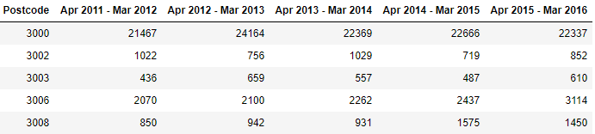

**2.1 Scrapping Melbourne Suburb Table from Wikipedia**

The following Wikipedia link has suburb names listed against the postcodes

<https://en.wikipedia.org/wiki/List_of_Melbourne_suburbs>

I extracted the suburb names and merged this with the crime data. Now, the table looks like

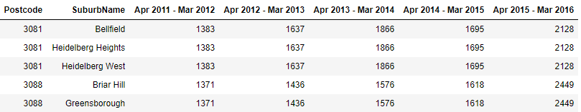

* 1. **Data Cleaning**

Some suburbs have similar postcodes. So, we get duplicate rows of crime statistics after merging it with the crime data. Though, we need to remove duplicates and store this information once only.

* Therefore, I grouped the suburbs with similar postcodes to record duplicates. This makes sure to have one crime statistics per post code.
* I also computed the mean and sum of the crimes for all years and kept it in the table.
* One suburb has a very high mean crime rate i.e. over 20000. It seems not correct compared to other crime rates. So, I treated it as an outlier and removed it.
* I removed the unnecessary columns

After cleaning, the new data looks like this

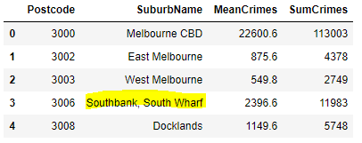

|  |
| --- |
| **3. Data Preparation** |

I need the location information for each suburb so that we can extract the information about nearby venues, such as schools or parks.

**3.1 Geolocator to retrieve location**

I have used ‘Geo locator api’ to obtain the location (latitude and longitude) information for each suburb.

* I removed any rows, where we cannot find the location information for a suburb
* For multiple suburbs against a postcode, I computed the mean location.

**3.2 Distance from City Center**

I recorded the location information for the Melbourne city center. Then, I calculated the distance of each suburb from the city center using Haversine formula [2].

In this project, I have considered suburbs, which are within 120 KM distance from the Melbourne city center. Otherwise, we may end up finding very remote suburbs.

The table now looks like this.

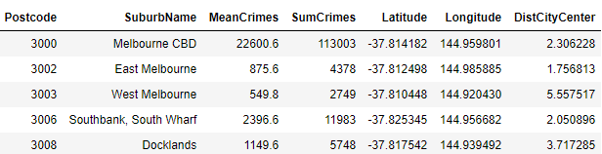

**3.3. Feature Selection using Foursquare API**

I have extracted the information about the following venues for each suburb using the “Foursquare API”

* The frequency of nearby schools
* The frequency of nearby parks
* The frequency of nearby train stations
* The frequency of nearby restaurants

The search radius is kept 3 km for each suburb. The above features will help to provide more insights about suburbs.

|  |
| --- |
| **3. Data Analysis** |

In this section, I have performed an exploratory analysis of data to understand the relationship between various features.

* Now, the data has frequencies of schools, parks, stations and restaurants as shown below.

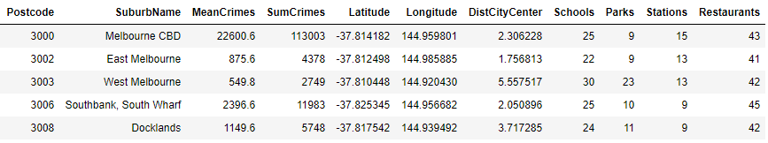

**3.1 Correlation**

We are mainly interested in correlating some features against the crime rates for insights.

I analysed the correlation between various features. From the correlation, we cannot identify a feature that is highly correlated to crimes. So, I decided to experiment with regression plots for further analysis.

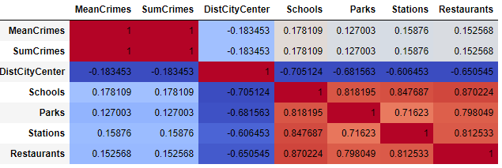

**3.2 Regression Plots**

**3.2.1 Crimes vs Distance from City Center**

I plotted mean crimes against the distance from the city center. The plots indicate an exciting pattern i.e. crime rates tend to decrease as we move away from the city center.

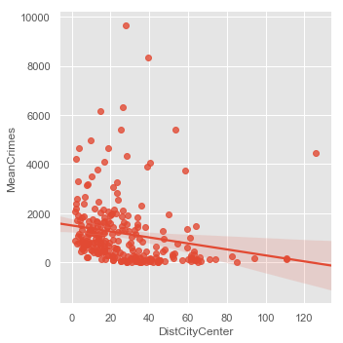

**3.2.2 Crimes vs Other Features**

I plotted the remaining features against the crime rates. But it is hard to make some hypothesis based on these plots.

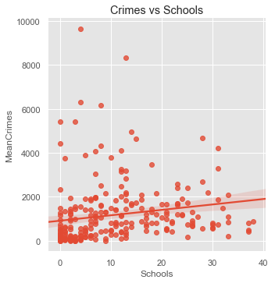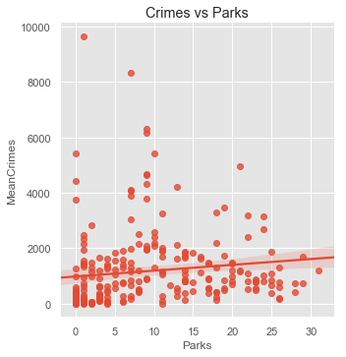

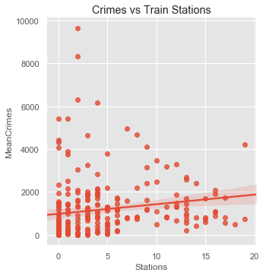 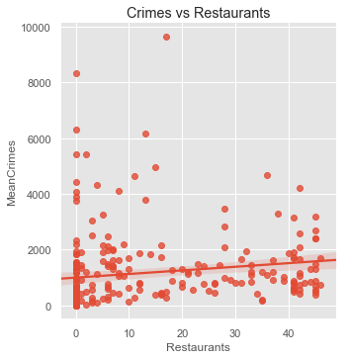

**3.2.3 Distance from City Center vs Other Features**

I used distance from the city center as a reference and plotted remaining features against it.

The regression plots reveal an interesting pattern. We get more schools, parks, stations and restaurants for suburbs, which are near to the city center. But, the frequency of these venues starts decreasing as we move away from the city center.

Please note that we are using a 3 km radius search for our suburbs. So, maybe, people need to drive more for faraway suburbs to get to these venues. This hypothesis is verified later in section 3.3.3.

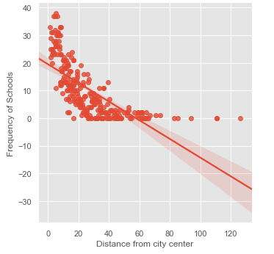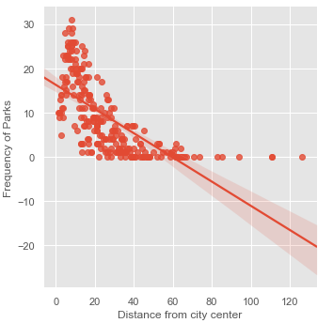

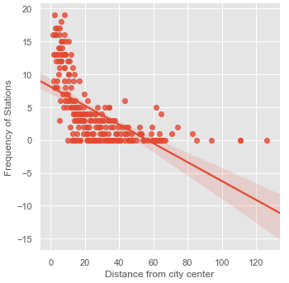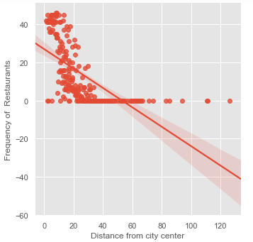

**3.3 Box Plots**

I decided to use a box plot because it handles large data easily and can provide better visualisation.

I applied the concept of binning or categorization with my data for better visualisation. In **binning**, I grouped the distances from city centers into categories. Such as, the 1st bin covers 0 -10 km, the 2nd bin covers 10-20 km and so on. And, then I plotted the features against these categories for analysis.

**3.3.1 Crimes vs Categories [Distance from City Center]**

The plot verifies our hypothesis that crime rates reduce with an increase in distance from the city center.

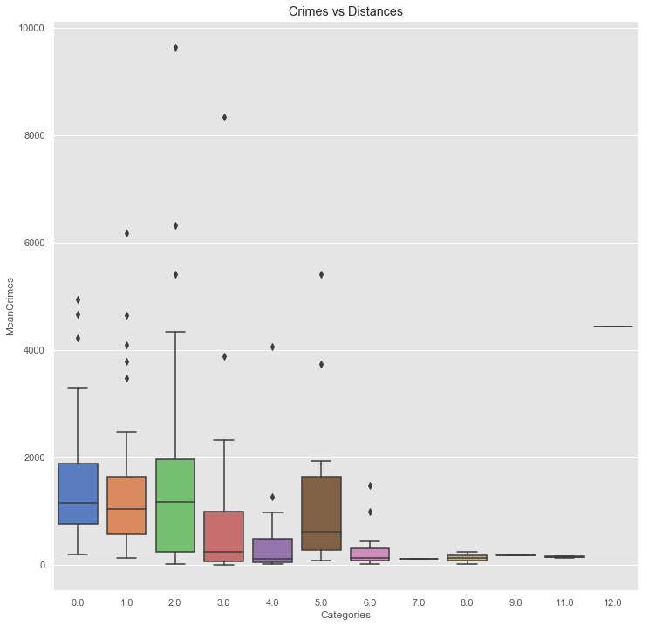

Interestingly, we find a very high crime rate for Category 5. The reason is that some of the suburbs in Category 5 have very high mean crime rates as shown below (suburbs with mean crimes less than 1000 are not shown).

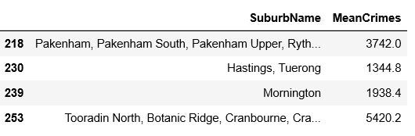

**3.3.2 Features vs Categories [Distance from City Center]**

I plotted frequencies of all features against the distance from the city center using the concept of binning.

The results verify the previous hypothesis i.e., the frequencies of features decrease with an increase in the distance from the city center. I have only reported box plots for schools and parks in this report.

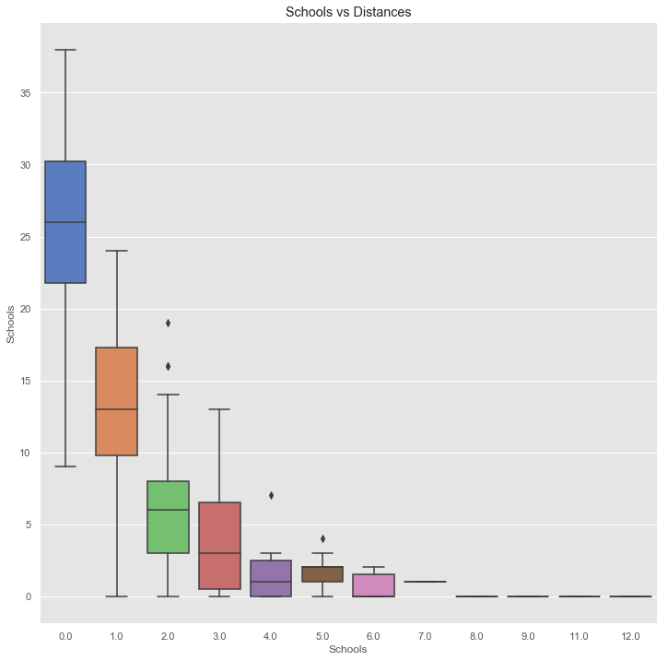

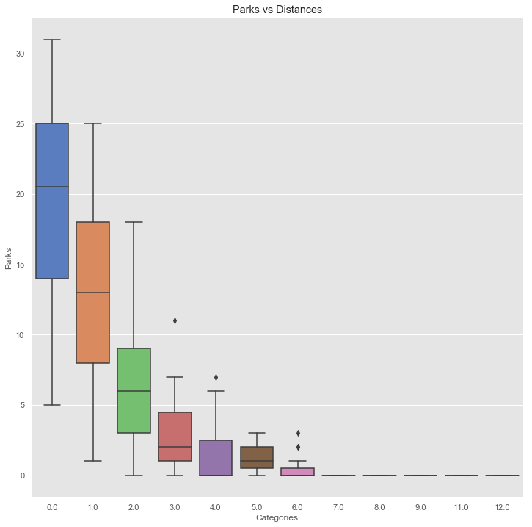

**3.3.3 Effect of increasing the Search Radius**

I hypothesised that the frequency of nearby venues decreases as we move away from the city center.

To verify this hypothesis, I increased the search radius from 3 km to 7 km. Then I used the ‘Foursquare Api’ to find the nearby venues (schools, or parks) for all suburbs. The bar plots indicate that the frequencies of all features (schools, parks or restaurants) increase compared to ones obtained using 3 km radius. These results validates the hypothesis that people living in faraway suburbs may have to drive more for basic things, such as groceries, or parks etc.

I have just included two plots in the report for illustration.

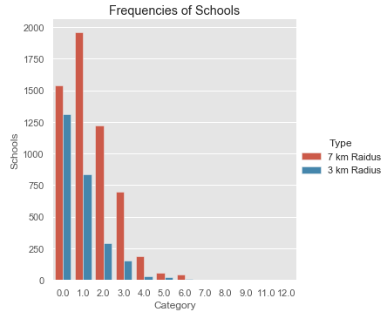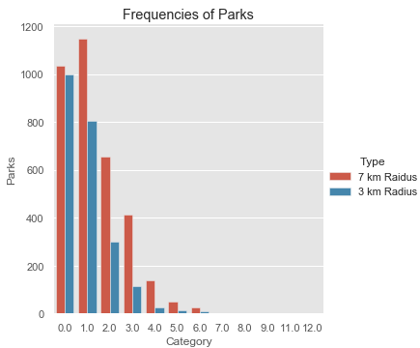

|  |
| --- |
| **4. Results** |

In the previous section, I have performed an analysis to get some insights from the data. In this section, I will report the

* Top 5 suburbs based on crime rates
  + Top 5 venues (within 10 km) for the top 5 suburbs for more insights
* Worse 5 suburbs based on crime rates
* Clustered suburbs (based on distance from the city center) on a map
  + The size of the marker is proportional to mean percent crime
  + The map provides geospatial distribution of crimes in Melbourne
  1. **Best Suburbs**

Overall, the crime rate gets lower as we move away from the city center. The suburbs from 40 km onwards (except for suburbs in 50 km range) have comparatively low crime rates.

As discussed before, we do not want to find a very remote suburb. So, I look for reasonable suburbs, which are 40 -70 km away from the city center and have the least crime rates.

I have used the folium map to highlight the best five suburbs (location icons) as shown below.

* The best suburb (least crime rate ) is indicated by a green icon (location type marker)
* The suburb name is ‘Kee Wee Rup North’ and it is around 44 km away from the city center

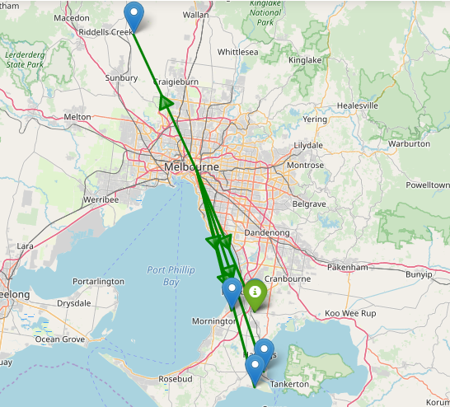

* 1. **Worse Suburbs**

I have identified the worse five suburbs and plotted them on a map

* The yellow markers indicate the worse suburbs with the highest crime rates. The size of the marker is proportional to mean crimes for that suburb
* Interestingly, the city center has the highest crime rate.

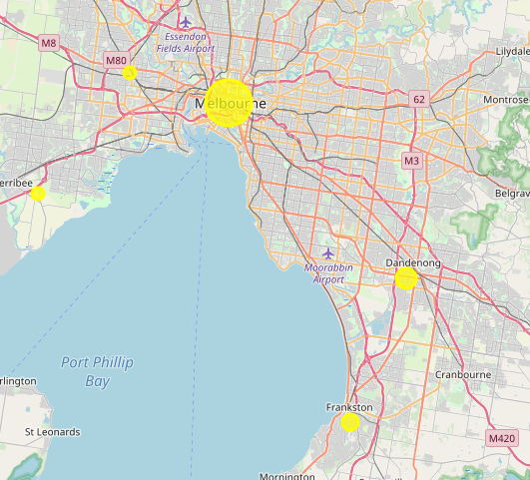

**4.3 Top Venues for best suburbs**

We already know the top five suburbs. I identified the top 5 venues for each suburbs as shown below.

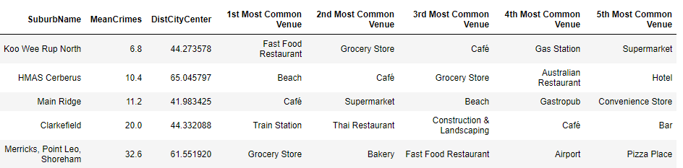

The top 3 suburbs have grocery stores as popular venues. This is important as everyone often visits them to buy grocery items.

However, if someone prefers a beach, then, there are two suburbs with nearby beaches.

This information provides comprehensive insight, and one can choose the suburb based on personal preferences.

**4.4 Clustered Suburbs with mean percent crimes**

In this map, I clustered the suburbs of Melbourne into 50 clusters using the distance from the city center.

Then, I computed the crime percentage for each cluster by dividing the sum of crimes (mean) for each cluster by the sum of crimes (mean) for the Melbourne city.

I plotted the clusters on a map, which provides a rough geospatial distribution of crimes in Melbourne. The size of the marker is proportional to the percent crime.

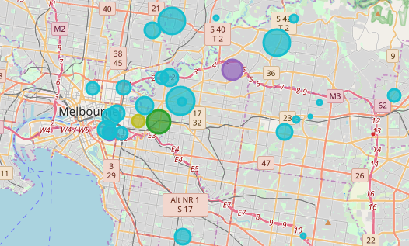

|  |
| --- |
| 1. **Conclusion** |

The project indicates that it is not safe to live in the city center due to high crime rates. The crime rates decrease as we move away from the city center. But the frequency of venues also starts decreasing and requires more commute to reach the famous places. I believe that this hypothesis will be valid for any big city in the world. Moreover, rental or house prices also reduce if we choose to live a bit away from the city center.

I have reported the top five suburbs to live based on the least crime rates.

* I have also shown the geospatial crime distribution using a map, which will be useful for immigrants to avoid areas with high crime rates.

|  |
| --- |
| 1. **Future Work** |

In the future, I will like to link this project with the housing market.

I will like to see the impact of crimes in a suburb on the sale or rent of houses. Such analysis will provide extra help to immigrants. Such as, if some home is available for an extra-low price, then that can be associated with crime rates in that suburb for more investigation.

|  |
| --- |
| 1. **References** |

1. <https://www.businessinsider.com.au/melbourne-liveable-city-vienna-2018-8?r=US&IR=T>
2. <https://en.wikipedia.org/wiki/Haversine_formula>