**Exploring Suburbs of Melbourne City (Australia)**

**Nabeel Khan**

**September 03, 2019**

|  |
| --- |
| 1. **Introduction** |

**1.1 Problem Statement**

Find a reasonable suburb to live in Melbourne.

**1.2 Discussion**

Melbourne has been named the world’s most liveable city for seven years in a row [1]. In 2018, Melbourne performed best in healthcare, education and infrastructure. Melbourne not only maintained its score in stability but also gained points in culture and environment.

This makes Melbourne a natural choice for people to live, work, or study. But there are two issues:

* Firstly, all neighborhoods are not safe to live due to high crime rates
* Secondly, a neighborhood may be safe but it can be very far away from the city center

The locals of Melbourne will know about it. But people living in other Australian states, foreigners, or immigrants will have no idea about a better suburb to re-locate. Property agents also not provide complete information. Therefore, it becomes important to find such information (recommended suburbs) before relocating to Melbourne.

The good suburbs should have very low crime rate. At the same time, it will be good for a suburb to have some of the following venues in nearby premises

1. School (important for young families)
2. Park (good for kids)
3. Restaurants (good outing)
4. Train Stations (necessary to commute if not driving)
   1. **Target Audience**

This project will suit those people (especially young families), who are

* Relocating to Melbourne especially immigrants
  1. **Project Goal**

The project will help to determine a suitable neighborhood of Melbourne for living.

In this project, we will report:

* Top 5 suburbs of Melbourne for living (based on crime rate and frequency of nearby venues)
  + All suburbs will be within 100 KM of distance from the city center
  + We will also report the best suburb
* Worse 5 suburbs of Melbourne (based on crime rate)

The main outputs of the project will comprise of two graphs:

**Graph-1**

1. The yellow markers indicate the worse suburbs
2. Top 5 suburbs are represented by “location” symbol

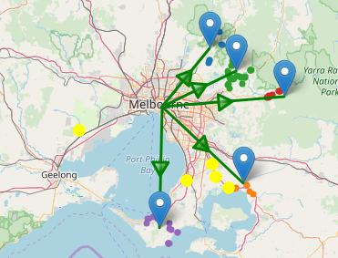

**Graph-2**

1. We cluster suburbs based on distance from the city center.
2. Then, we compute the percent crime for each cluster. The size of the cluster is proportional to the percent crime. This gives an overall pictures of crime stats in Melbourne

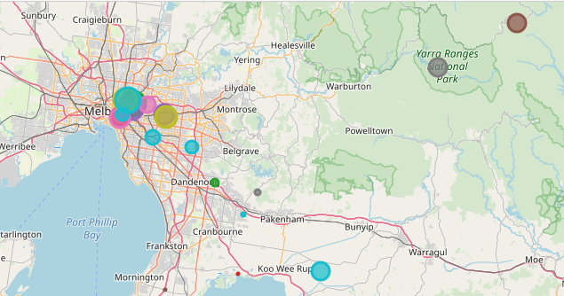

Refereces

1. https://www.businessinsider.com.au/melbourne-liveable-city-vienna-2018-8?r=US&IR=T