Git and Github for Beginners

What is GIT and why should you care?
Git is the most widely used version control system on the planet. Professionals use it to develop effectively when working in teams as well as a saftey net when working solo. To undestand the GIT, one simply needs to think about a world without version control.

Consider a big project employing many developers. Individual developers work on several components of a system parallely and completely independent of each other. These files need to then be organised and put together before release. Even after doing all this work, the codebase is filled with errors caused by friction between the components. It is difficult for any one developer to get access to the other’s code and just one bad file can begin a long debugging session to rectify the mistake.

Git provides a distributed system, ie, a system where each individual developer can access the entire codebase leading to increased efficiency. It supports rollback to previous versions of a project in case of unfixable errors and enables parallel workflow by making use of branching. Commit messages state exactly what changes, and bad commits are quickly identified. All these factors, (along with many others) make Git a worthwhile technology to learn.

Basic Git workflow
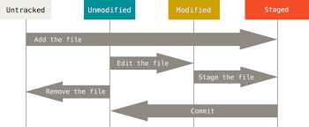
Alright, you want to learn Git. Great. First, it is important to have a clear understanding of how Git tracks and saves versions. See the below diagram.
Files are by default untracked. Git has no idea if it has changed or even what content it has. The files need to be staged for Git to know about them. Modified files after saving can be staged (ie, put into staging area). After staging commit the files to save this current version into the current branch. Be sure to give a commit message stating what has changed.

Trying it out
After completing installation of Git (which is completely free) open up the terminal of your choice and navigate to the target folder containing files to be tracked. Now, we have to initialise a git repository. A git repository is a folder where previous versions are stored. Use the ‘git init’ command to create a repository. See the example given below. Note that I am using a Linux machine and terminal commands (not git ones) can vary between operating systems.

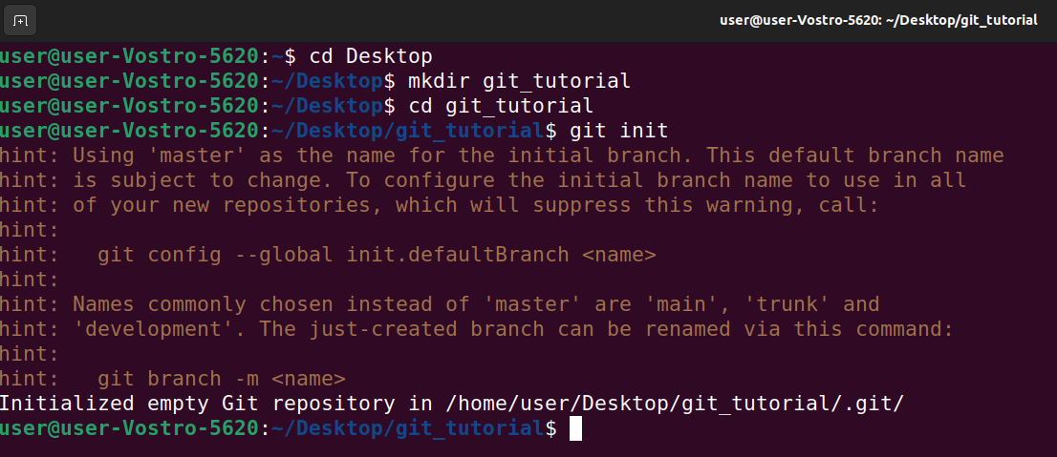
Now, create a file (preferably text file) and store some data in it. In this example I will be using a file ‘test.txt’ with content ‘Hello world’. Type ‘git status’ to check the staging area as well as check for any unmodified files. Then, use ‘git add <filename>’ to add file to staging area. Check the status again. You are now ready to commit your first change and git begins tracking the file.

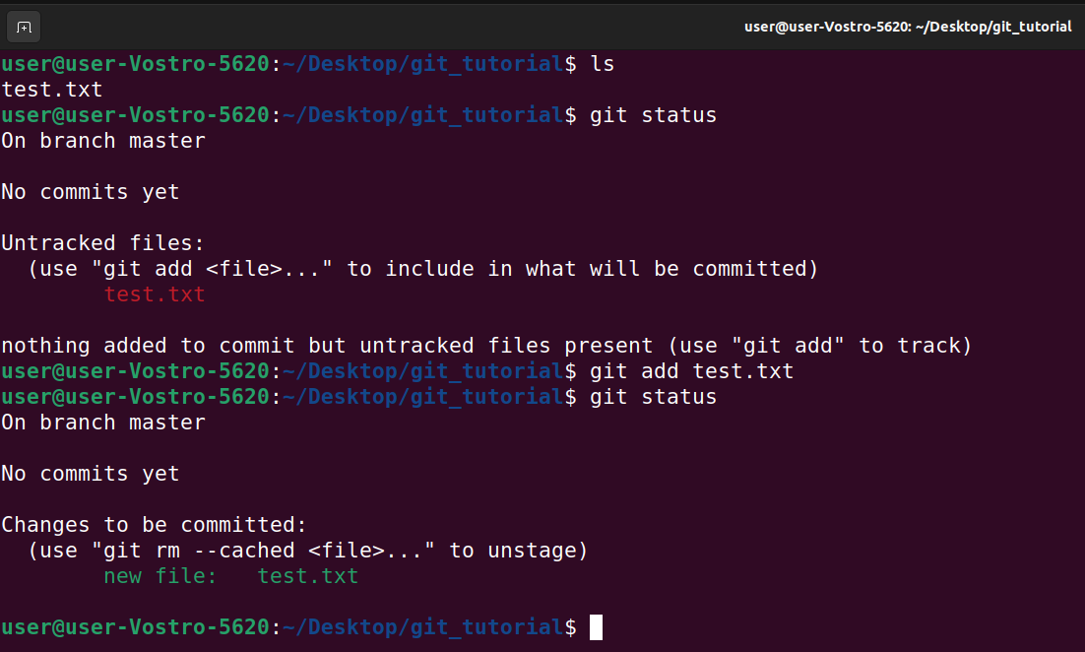

To commit a change use ‘git commit – m “<message>”’. Commit history can be viewed using ‘git log’. Note that you are now commiting to the main branch which is either ‘main’or ‘master’. Now change the content of the file, save, add to staging area and commit your second change with another message. Check the commit history again to verify.
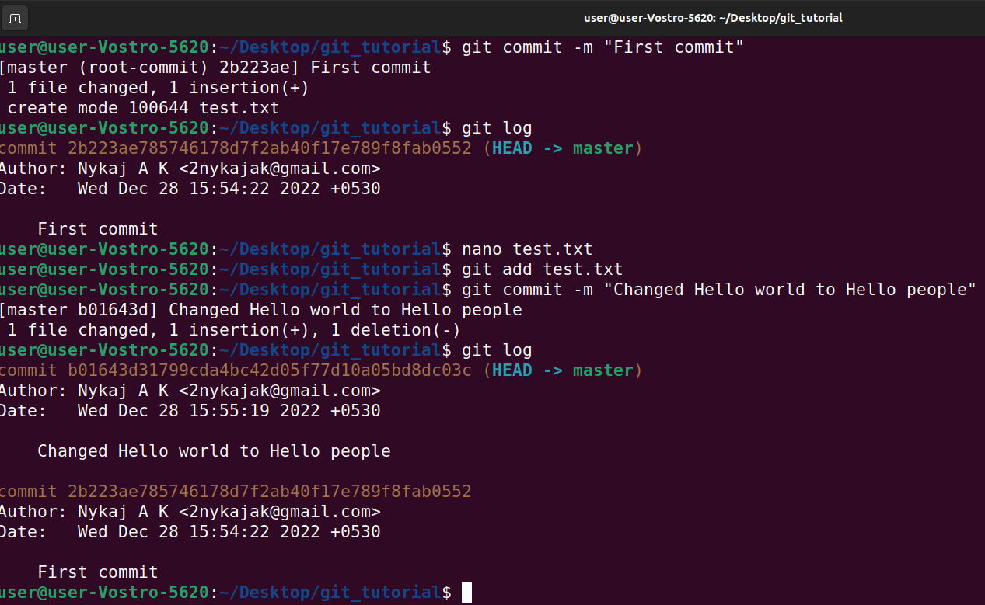
Congratulations! You have created two versions of your file and saved them in the repository. The git repository is hidden from users but can be accessed by ‘ls -a’. By default it is saved as a .git folder.

Version control.
This is all well and good. But how do you revert to a previous version? What is this ‘branch’ thing and where is the promised flexibility? Let’s walk through all that.

Reverting to previous versions.
In case of catastrophe, you need to load the backup. The previous versions which are stored in the .git folder can be accessed and loaded by their unique hash. Note that doing this using ‘git reset <hash>’ deletes all commits after the target making it dangerous to use. The preferred command to be used is ‘git revert <hash>’ which is safer but more difficult to use. This is the log after resetting to first commit. The file content will also be changed.

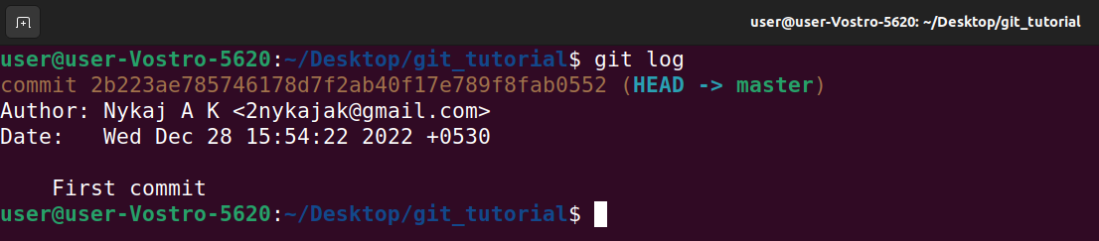
Using branches and merging
Git branches contain copies of the ‘main’ or ‘master’ branch which can be modified without modifiying the main branch. After a new feature is made this branch is merged with the main one to update it. Multiple branches allow parallel workflow and a more efficient team.

Use ‘git branch’ to see all current branches, ‘git branch <branchname>’ to create a new branch and ‘git switch <branchname>’ to jump to the named branch. Branches can be merged after changes into another one. This is done by navigating to the branch to which the other is to be merged and executing ‘git merge <targetbranch>’. See examples below.
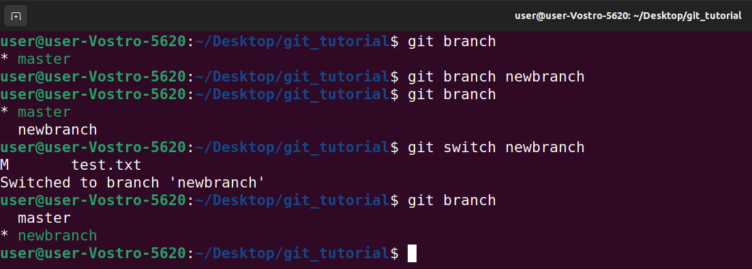

The above commands created a ‘newbranch’ branch and moves to it. I will change test.txt to contain ‘Hello everyone’ and merge ‘newbranch’ with master. See the below image.

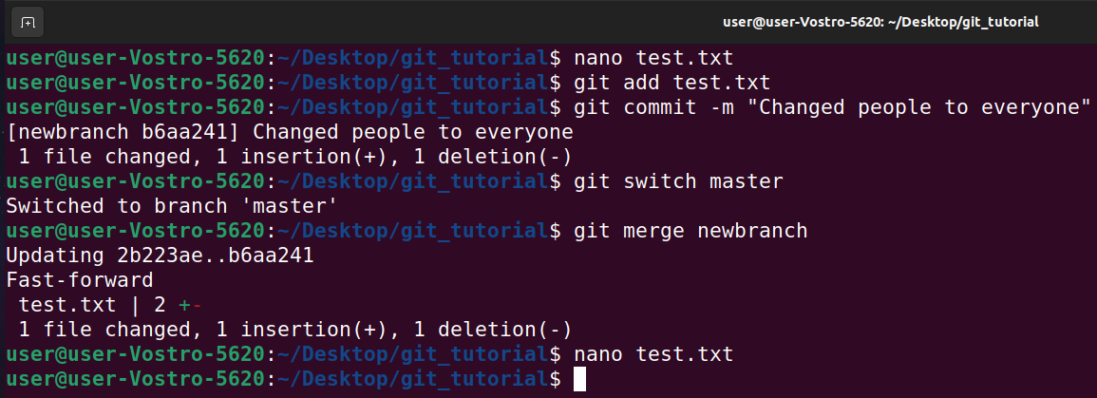
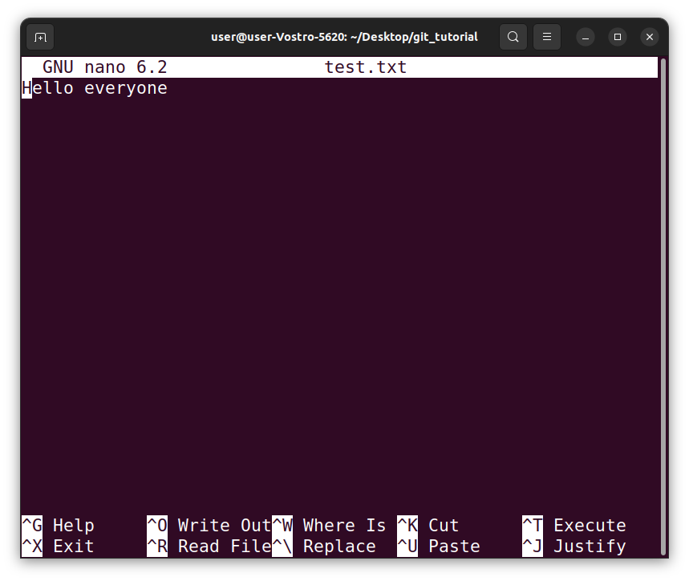
Github
It is an online service that provides various services, most notable among them being an online repository compatible with Git. Open source code is hosted on these repositories which can be improved upon by contributers. This website provides a unique opportunity to contribute to real world applications and learn from industry code. This provides a place for code to be hosted for easy access from anyplace and at any time.

