My first package

Moritz Nykamp

2017-07-19

# Load library

# Executing tests

The result of the first test is:

## [1] 11

and of the secon test:

## [1] 13

## Plot a figure

In figure 1 random numbers are plotted 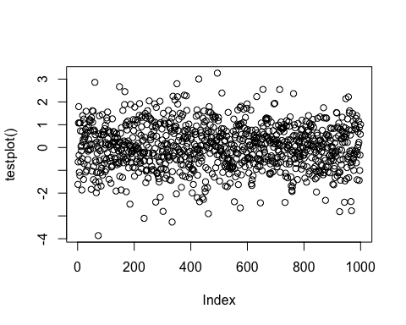

## Insert a table

Table 1 shows random numbers

Table 1 Random numbers

|  |
| --- |
| 1.0323756 |
| -0.7298257 |
| 1.4425642 |
| -0.6271676 |
| -0.3301199 |
| 0.3797488 |

Random numbers are random (Saxton et al., 1986; Shao et al., 1993; Erpul et al., 2003).

## References

Erpul, G., Norton, L., Gabriels, D., 2003. Sediment transport from interrill areas under wind-driven rain. Journal of Hydrology 276, 184–197.

Saxton, K., Rawls, W., Romberger, J., Papendick, R., 1986. Estimating generalized soil-water characteristics from texture. Soil Science Society of America Journal 50, 1031–1036.

Shao, Y., Raupach, M., Findlater, P., 1993. Effect of saltation bombardment on the entrainment of dust by wind. Journal of Geophysical Research: Atmospheres 98, 12719–12726.