Khmelnytskyi National University
Department of Information Technonogy

Report

Laboratory work №1

Discipline: “Programming”

Topic: “Linear algorithms”

Completed: 1st year student, group SE-26-1 Name, Surname
Name, Surname
Checked: ValeriyMartynyuk
Name, Surname

Khmelnytskyi, 2026
Purpose: To study the structure of the C language program; learn to work with the programming environment of the MS Visual Studio family; get acquainted with I/O operators; to gain skills in using simple data types in the program, compiling the simplest block diagrams of programs and programs in the C language.

Task 1
On the given sides a, b, c of a triangle (fig. 1) to find sizes according to variants. Provide input values a, b, c from the keyboard. Output of initial data to carry out with the corresponding explanatory text.
Develop an algorithm and program for finding the angle β and median m.
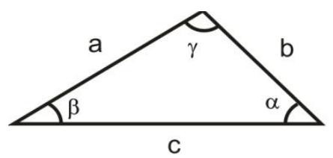
Fig. 1 - Triangle
1.1. Block diagram of the program algorithm
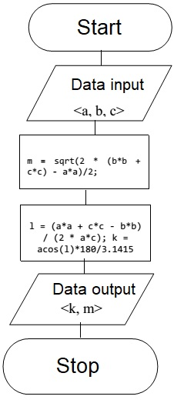
Fig. 2 - Block diagram of the program algorithm

1.2. Program text
#define _CRT_SECURE_NO_WARNINGS
#include <stdio.h>
#include <math.h>
int main()
{
float a, b, c, l, m, k; // variable declaration
printf("a = "); // reading variables
scanf("%f", &a);
printf("b = ");
scanf("%f", &b);
printf("c = ");
scanf("%f", &c);
m = sqrt(2 * (b*b + c*c) - a*a)/2; // determination of the median
l = (a*a + c*c - b*b) / (2 * a*c);
k = acos(l)*180/3.1415; // determining the angle β
// data output
printf("The angle is equal to %3.2f\n", k);
printf("The median is equal to %.2f\n", m);
getchar(); // screen delay
getchar();
return 0;
}
1.3. Program results:
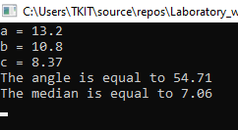
Task 2
Develop the calculation algorithm and the C language program to determine the values of the function:
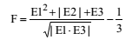
The functions E1, E2, E3 according to the options are given in table 2.1. Output of source data should be carried out with the appropriate explanatory text and formatted output.
2.1. Block diagram of the program algorithm
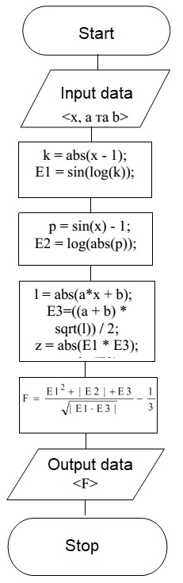
Fig. 3 - Block diagram of the program algorithm

2.2. Program text
#define _CRT_SECURE_NO_WARNINGS
#include <stdio.h>
#include <math.h>
int main()
{
// variable declaration
float F, E1, E2, E3, k, p, l, a, x, b, z, r;
printf("x = "); // reading variables
scanf("%f", &x);
printf("a = ");
scanf("%f", &a);
printf("b = ");
scanf("%f", &b);
k = abs(x - 1);
E1 = sin(log(k));
p = sin(x) - 1;
E2 = log(abs(p));
l = abs(a*x + b);
E3 = ((a + b) * sqrt(l)) / 2;
z = abs(E1 * E3);
r = abs(E2);
// finding the required value
F = (E1 * E1 + r + E3) / sqrt(z) - 1 / 3;
printf("F = %f\n", F); // display
getchar(); // screen delay
getchar();
return 0;
}

2.3. Program results:
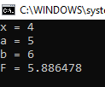
Task 3
By using Horner's algorithm, compile a program to calculate the value of the polynomial. According to the compiled program to calculate the value of the polynomial at a given value X. Output of the original data to carry out with the appropriate explanatory text and formatted output. Task options are given in table 3.1
3.1. Block diagram of the program algorithm
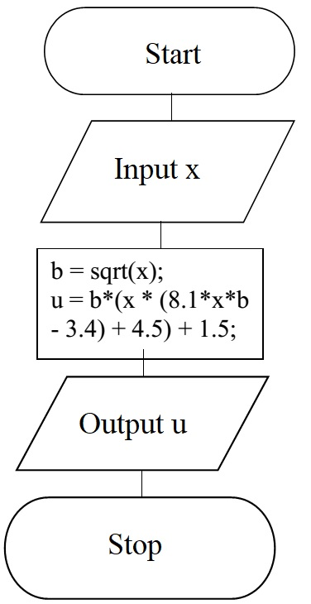
Fig. 4 - Block diagram of the program algorithm

3.2. Program text
#define _CRT_SECURE_NO_WARNINGS
#include <stdio.h>
#include <math.h>
int main()
{
float u, x, b; // variable declaration
printf("x = ");
scanf("%f", &x); // reading a variable
b = sqrt(x);
u = b*(x * (8.1*x*b - 3.4) + 4.5) + 1.5;
// display
printf("According to Gorner's scheme u = %.1f\n", u);
getchar(); // screen delay
getchar();
getchar();
getchar();
return 0;
}
3.3. Program results:
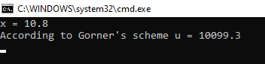

Task 4
Find the area of the shaded figure. Output the output data with the appropriate explanatory text and formatted output.
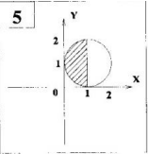
Fig. 5 - The shaded figure
4.1. Block diagram of the program algorithm
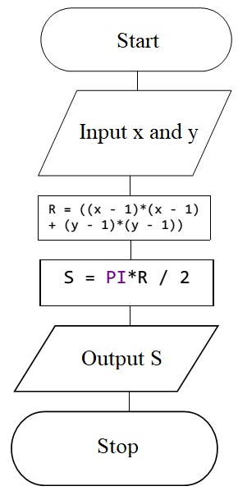
Fig. 6 - Block diagram of the program algorithm

4.2. Program text
#define _CRT_SECURE_NO_WARNINGS
#include <stdio.h>
#define PI 3.14
int main()
{
float x, y, R, S; // variable declaration
printf("x = "); // input of variables
scanf("%f", &x);
printf("y = ");
scanf("%f", &y);
R = ((x - 1)*(x - 1) + (y - 1)*(y - 1));
S = PI*R / 2;
// display
printf("The area of the shaded figure is equal to = %.1f\n", S);
getchar(); // screen delay
getchar();
return 0;
}
4.3. Program results:
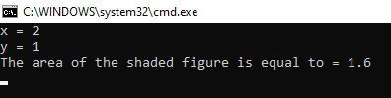
Conclusions
1. We studied the structure of the C language program.
2. MS Visual Studio programming environment has been studied.
3. We studied of the I/O operators and simple data types in the program, compiling the simplest block diagrams of programs and programs in C language.

