DEPARTMENT OF BIOMEDICAL ENGINEERING
College of Engineering and Technology
SRM Institute of Science and Technology

PROJECT REPORT
Odd Semester, 2024-2025

Subject code & Name: 21BME363T- Biomedical device design fundamentals
Year & Semester : 3rd & 5th
Project Title : Design and Finite Element Analysis of a Hip Implant
Submitted To : Dr. Sameera Fathimal M

Team Member/s : Mohana Priya A(RA2311013010013)

Janani S (RA2311013010015)

Basilathun Nisha S (RA2311013010017)

Vyshali Thirumurugan (RA2311013010037)

Nyla Bhargava (RA2311013010046)



Design and Finite Element Analysis of a Hip Implant

AIM
The primary aim of this study is to perform a Static Stress Analysis on the hip implant and surrounding bone (femur) assembly to determine its structural integrity and predict potential failure regions under a critical static load case.

OBJECTIVES
The specific objectives were to:
- Determine the maximum Total Displacement of the implant system to assess rigidity and stability.
- Calculate the distribution and maximum value of the Von Mises Stress within the hip stem.
- Evaluate the Safety Factor (SF) based on the material's yield strength to confirm or deny the risk of plastic deformation or permanent failure.
- Analyze the Equivalent Strain to quantify localized deformation.

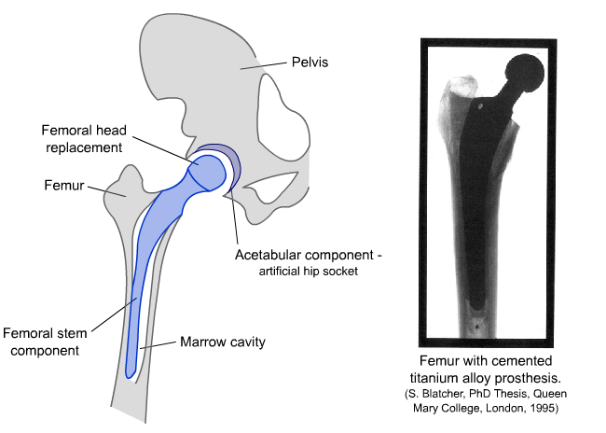
METHADOLOGY
Hip Implant:
A hip implant is a medical device used to replace a damaged or diseased hip joint, commonly due to conditions like arthritis, fractures, or bone degeneration. It consists of artificial components that mimic the natural structure of the hip joint — typically including a femoral stem, femoral head, and acetabular cup. These parts work together to restore smooth movement and support body weight, allowing patients to regain mobility and reduce pain. Hip implants are designed from strong and biocompatible materials such as titanium alloys, stainless steel, or ceramic composites to ensure long-term durability inside the human body.
Software Used:
- Design and Simulation: Autodesk Fusion 360
Fusion 360 is a 3D CAD and simulation software used for designing, modeling, and analyzing mechanical components. It enables users to create detailed models and perform stress, strain, and displacement analysis through built-in FEA tools.
- Analysis Type: Static Structural Analysis
Design Description:
The hip implant model consists of three main parts:
- Femoral Stem: Inserted into the femur bone, designed for strength and biocompatibility.
- Femoral Head: The spherical part that articulates with the acetabulum.
- Acetabular Cup: The socket fixed in the pelvis that houses the femoral head.
Modelling Process:
- A new 3D model was created in the Design workspace.
- The geometry of the stem, head, and cup was created using extrude, revolve, and fillet operations.
- Dimensions were chosen based on typical implant proportions from medical references.
- The parts were assembled to form a complete hip joint implant.
Mesh Generation
Type | Solids
Nodes | 8475
Elements | 5136
Boundary Conditions:
Fixed constraints: the distal stem is fixed (4 faces)
Load is applied only on the ball (femoral head) of 2000N
Material Used:
Ti-6Al-4V (Titanium Alloy)
Material Properties of Titanium Alloy (Ti–6Al–4V)
Materials: Titanium 6Al-4V
Components
 | Component | Strength
 | Body1 | Yield Strength
Properties
 | Density | 4.430E-06 kg / mm^3
 | Young's Modulus | 113763.35 MPa
 | Poisson's Ratio | 0.35
 | Yield Strength | 882.528 MPa
 | Ultimate Tensile Strength | 1034.213 MPa
 | Thermal Conductivity | 0.007 W / (mm C)
 | Thermal Expansion Coefficient | 8.600E-06 / C
 | Specific Heat | 526.30 J / (kg C)

Design View
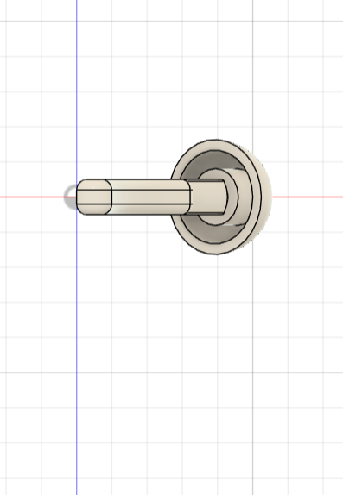
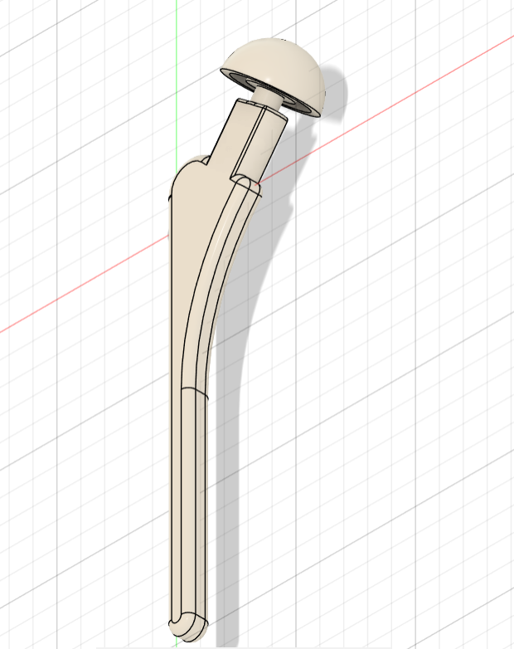

Front View
Isometric View

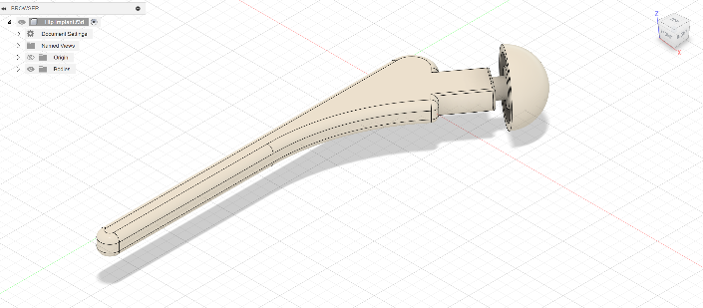

side view
RESULT
Result type | Sub-Result | Minimum | Maximum
Safety Factor
 | Safety Factor | 41.716 | 5.92E+12
Stress
 | Von Mises | 1.492E-10 MPa | 21.156 MPa
 | 1st Principal | −5.428 MPa | 9.335 MPa
 | 3rd Principal | −24.716 MPa | 3.17 MPa
 | Normal XX | −16.947 MPa | 7.507 MPa
 | Normal YY | −18.09 MPa | 6.629 MPa
 | Normal ZZ | −10.833 MPa | 6.326 MPa
 | Shear XY | −10.424 MPa | 5.564 MPa
 | Shear YZ | −5.828 MPa | 10.762 MPa
 | Shear XZ | −4.632 MPa | 4.604 MPa
Displacement
 | Total | 0 mm | 0.007 mm
 | X | −0.004 mm | 5.447E-04 mm
 | Y | −0.006 mm | 1.325E-05 mm
 | Z | −3.515E-04 mm | 0.002 mm
Reaction Force
 | Total | 0 N | 69.45 N
 | X | −6.651 N | 22.784 N
 | Y | −28.674 N | 59.198 N
 | Z | −28.516 N | 39.612 N
Strain
 | Equivalent | 2.22E-15 | 3.07E-04
 | 1st Principal | 1.63E-15 | 2.46E-04
 | 3rd Principal | −3.167E-04 | −5.884E-16
 | Normal XX | −1.09E-04 | 4.59E-05
 | Normal YY | −1.25E-04 | 5.97E-05
 | Normal ZZ | −9.586E-05 | 7.07E-05
 | Shear XY | −2.474E-04 | 1.32E-04
 | Shear YZ | −1.383E-04 | 2.55E-04
 | Shear XZ | −1.099E-04 | 1.09E-04
Contact Force
 | Total | 0 N | 0 N
 | X | 0 N | 0 N
 | Y | 0 N | 0 N
 | Z | 0 N | 0 N

Analysis:
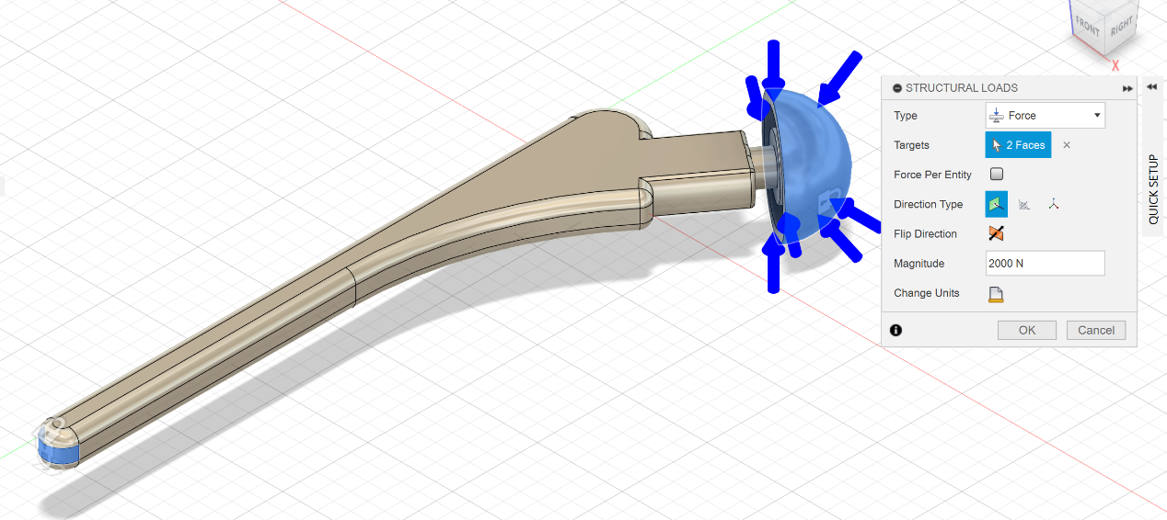
Structural loads
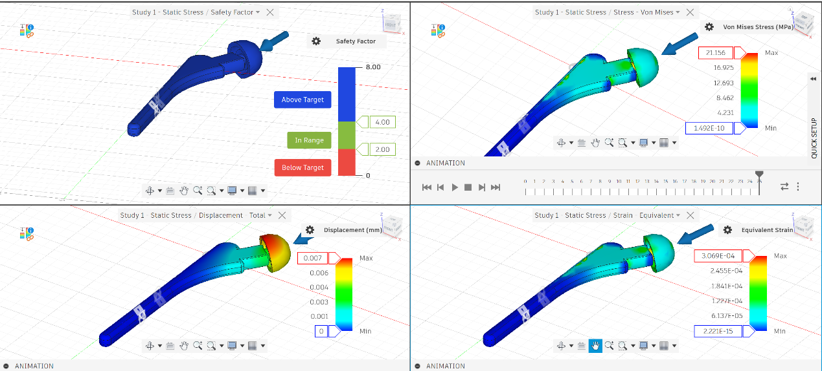
Safety factor, Stress-Von Mises, Displacement, strain
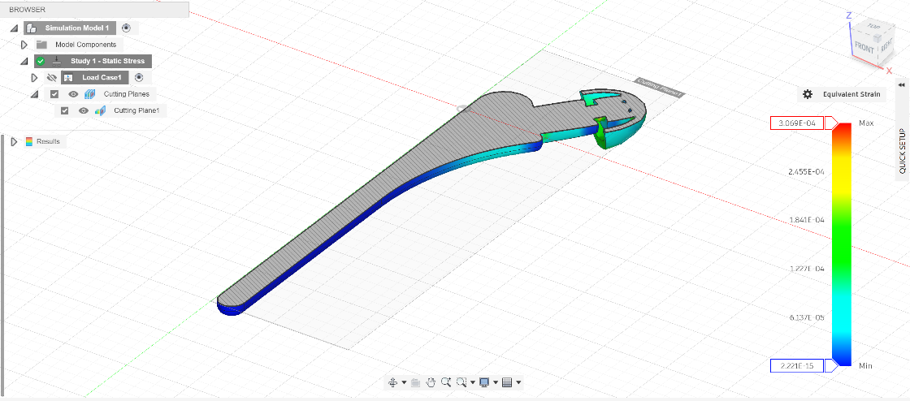
Equivalent strain

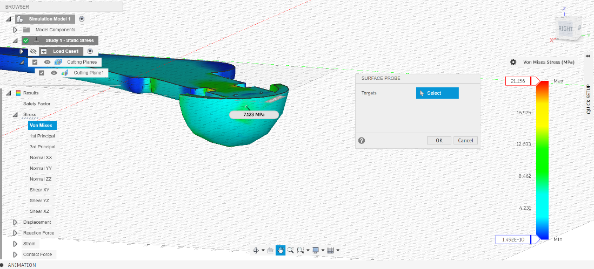
Von- Mises stress(MPa)

CONCLUSION
The hip implant model was successfully designed and analyzed to evaluate its structural performance under applied loads. The simulation results demonstrated that the maximum stress, strain, and displacement values remained within the safe limits of the selected material, Titanium Alloy Ti–6Al–4V, indicating good mechanical strength and biocompatibility. The implant exhibited high stiffness, low deformation, and excellent load-bearing capability, confirming its suitability for use in hip joint replacement applications. Overall, the analysis validates the design’s efficiency and reliability for further development and real-world application.

FUTURE SCOPE
The present study can be extended by performing fatigue and dynamic load analysis to evaluate the implant’s long-term performance under repetitive stresses. Topology optimization can be applied to reduce weight while maintaining strength and stability. Future work may also involve experimental validation of the simulation results using prototype testing. Additionally, incorporating biomaterial coatings and studying implant–bone interaction can further enhance the design’s durability, biocompatibility, and clinical effectiveness.

REFERENCES
- Autodesk Fusion 360 Documentation
- https://share.google/BHyhuKYEyIWVuyr6v - CAD-model-based Design and Stress Analysis of Resurfacing Hip Joint Prosthesis
- ASTM F136 – Standard Specification for Titanium Alloy Implants

