Overview

An electronic versions of forms are everywhere in software applications. It does matter application client are working in the telecommunications, financial, industry, or pharmaceutical industry. Someone will evidently filled out an online version of a form somewhere.

The typically design approach is design the service to manages to form around to purpose of the form and its inputted data.

Form Logical Data Model

Summary
Figure 2-1 - Form Logical Data Model
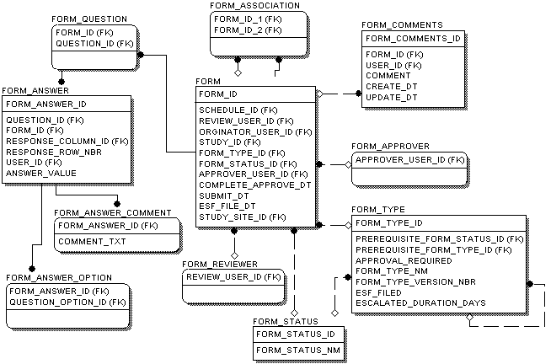
Table 2-1 - Logical Model Legend
Symbol | Description
 | Entity
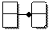 | Identify Relationship
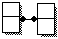 | Many-to-Many Relationship
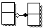 | Non-Identify Relationship

Table 2-2 - Logical Model Overview
Entity | Description
FORM | FORM contains the status, classification type, reviewer, originator and approver of a form/report. It contains links to the associated sites and protocols.
FORM_ANSWER | FORM_ANSWER contains answers to questions within forms. It can also represent an answer to a table entry within a question (in which case it has the row and column for the answer).
FORM_ANSWER_COMMENT | FORM_ANSWER_COMMENT contains comment descriptions entered for questions.
FORM_ANSWER_OPTION | FORM_ANSWER_OPTION indicates that a user has chosen a particular option within a selectable question (such as radio boxes, check boxes, list boxes, etc.).
FORM_COMMENTS | FORM_COMMENTS contains notes for the form entered by reviewers or approvers.
FORM_QUESTION | FORM_QUESTION contains the questions for a particular form. Note that this is only a logical entity.
FORM_TYPE | FORM_TYPE contains the possible classifications of a form. The following is a sample list of form classification types.

Form Questionnaire Logical Data Model

Summary
Figure 2-2 - Form Logical Data Model
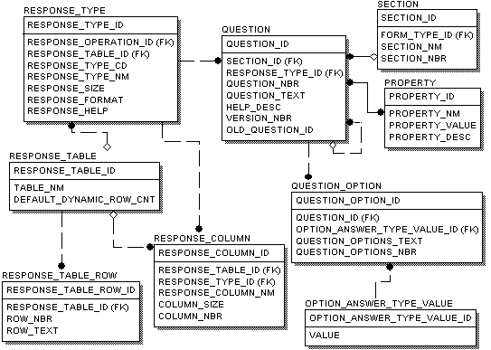

Table 2-3 - Form Questionnaire Logical Model Overview
Entity | Description
OPTION_ANSWER_TYPE_VALUE | OPTION_ANSWER_TYPE_VALUE contains the expected values of the selectable question such as radio boxes, check boxes, etc. Examples values are YES, NO, etc.
QUESTION | QUESTION contains the general question information such its text, help, section, etc.
QUESTION_OPTION | QUESTION_OPTION contains possible items of a selectable question. Selectable question have a response type of check boxes, radio boxes, etc.
PROPERTY | PROPERTY contains attributes related to a question that drives certain behavior. Sample question properties are the following;  readonly=true, required=true, background=gray, etc.
RESPONSE_COLUMN | RESPONSE_COLUMN defines the characteristics of a column within a table. It specifies the expected width and response type of the column answers.
RESPONSE_TABLE | RESPONSE_TABLE contains the definition for a question that has a table response type.
RESPONSE_TABLE_ROW | RESPONSE_TABLE_ROW contains rows to a fixed table. A fixed table has a predetermined number of rows.
RESPONSE_TYPE | RESPONSE_TYPE contains the expected format of the question answers. It assists the validation of answers. Answer values can be crossed checked against an expected format and type (numeric value, percentage 0-100, date format MM/DD/YYYY, etc.).  Examples response types are the following TEXT, TEXTAREA, NUMBER, CURRENCY, DATE PERCENTAGE, SELECTIONS, CHECKBOXES, and DYNAMIC SELECTIONS.
SECTION | SECTION contains a grouping of questions. Each section is associated with a particular type of form.

Data References
Table 2-4 - Form Management Field Descriptions
Entity | Attribute Name | Description
OPTION_ANSWER_TYPE_VALUE | OPTION_ANSWER_TYPE_VALUE_ID | Primary key identifier of the option answers type value.
OPTION_ANSWER_TYPE_VALUE | ANSWER_TYPE_VALUE | Value of the option answer.  Examples values (YES, NO, etc.).
QUESTION | QUESTION_TEXT | Text description of the question.
QUESTION | QUESTION_NBR | The question number (primarily used of sorting).
QUESTION | HELP_DESC | The help description of the question.
QUESTION | VERSION_NBR | The question’s version number. It is used to create a new version of the question within affecting existing submitted or completed forms the reference the question.
QUESTION | OLD_QUESTION_ID | Question foreign key that the new version replaces for all future forms.
QUESTION | QUESTION_ID | Primary key identifier of question.
QUESTION | RESPONSE_TYPE_ID | Foreign key of the response type.
QUESTION | OPTIONS_OPERATION_ID | Foreign key identifier of operation that builds the options for a selectable question (check boxes, radio boxes, etc.).
QUESTION | SECTION_ID | Foreign key identifier of the section the question belongs.
QUESTION_OPTION | QUESTION_OPT_ID | Primary key identifier of the question option.
QUESTION_OPTION | QUESTION_ID | Foreign key identifier of the question.
QUESTION_OPTION | OPTION_ANSWER_TYPE_VALUE_ID | Foreign key identifier of the expected optional answer type value.
QUESTION_OPTION | QUESTION_OPT_TXT | The labeled text description of the option.
QUESTION_OPTION | QUESTION_OPTIONS_NBR | Question option number used for ordering.
PROPERTY | PROPERTY_ID | Primary key identifier of the property.
PROPERTY | PROPERTY _NM | The question property’s name.
PROPERTY | PROPERTY _VALUE | The property’s value. For examples are "true" or "false" for Boolean properties.
PROPERTY | PROPERTY _DESC | The property description.
RESPONSE_COLUMN | RESPONSE_COL_NM | Column header name used in the displayed table.
RESPONSE_COLUMN | COL_SIZE | Column size uses the draw the on the browser table (pixels).
RESPONSE_COLUMN | COL_NBR | Column number used for sorting.
RESPONSE_COLUMN | RESPONSE_COL_ID | Primary key identifier of the response column.
RESPONSE_COLUMN | RESPONSE_TYPE_ID | Foreign key identifier of the response type.
RESPONSE_COLUMN | RESPONSE_TABLE_ID | Foreign key identifier of the response table.
RESPONSE_TABLE | RESPONSE_TABLE_ID | Primary identifier of the table.
RESPONSE_TABLE | TABLE_NM | Response table labeled name description.
RESPONSE_TABLE | DEFAULT_DYNAMIC_ROW_CNT | The default number of rows for the table.
RESPONSE_TABLE_ROW | RESPONSE_TABLE_ROW_ID | Primary key identifier of the fixed table row.
RESPONSE_TABLE_ROW | RESPONSE_TABLE_ID | Foreign key identifier to table definition.
RESPONSE_TABLE_ROW | ROW_NBR | The row number.
RESPONSE_TABLE_ROW | ROW_TEXT | The row’s text or title description.
RESPONSE_TYPE | RESPONSE_TYPE_ID | Primary key identifier of the response type.
RESPONSE_TYPE | RESPONSE_TABLE_ID | Foreign table identifier.
RESPONSE_TYPE | RESPONSE_TYPE_CD | Codes for (SECTIONHEADER, TEXT, TEXTAREA, NUMBER, CURRENCY, DATE, SELECTIONS, CHECKBOXES, PERCENTAGE).
RESPONSE_TYPE | RESPONSE_TYPE_NM | Full Name for HEAD ONLY TEXT TEXTAREA NUMBER CURRENCY DATE SELECTIONS CHECKBOXES PERCENTAGE.
RESPONSE_TYPE | RESPONSE_SIZE | Expected response size.
RESPONE_TYPE | RESPONSE_OPERATION_ID | Identifies an Operation that must be executed when questions of this response type are constructed. These types of operations are used to auto fill questions answers and dynamic options/table rows (see section ).
RESPONSE_TYPE | RESPONSE_FORMAT | Text describing the response format. This format can be expression in a regular expression.
RESPONSE_TYPE | RESPONSE_HELP | Contains a description of the expected value of the response.
SECTION | SECTION_ID | Primary key identifier section.
SECTION | FORM_TYPE_ID | Foreign key form type.
SECTION | SECTION_NM | The title of the section.
SECTION | SECTION_NBR | Section number used for sorting.

System Event Messages
This section is not applicable.

Assumptions
This section is not applicable.

Interfaces and External References
This section is not applicable.

Form Question Rules and Operations Logical Data Model

Summary
Figure 2-3 – Form Question Rules and Operations Logical Data Model
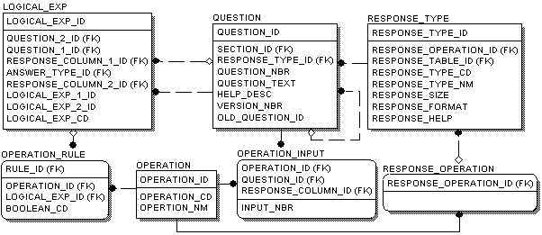

Table 2-5 - Form Question Rules and Operations Logical Model Overview
Entity | Description
LOGICAL_EXP | LOGICAL_EXP contains expressions that evaluate to true or false. The following is pseudo code of the possible logical expressions;  - Question 1 has an answer  - Question 1 has an answer option equal to the answer type  - Not logical expression 1  - Logical expression 1 and Logical expression 2  - Logical expression 1 or Logical expression 2  - Question 1’s numeric value > Question 2’s numeric value  - Question 1’s numeric value < Question 2’s numeric value  - Question 1’s numeric value <= Question 2’s numeric value  - Question 1’s numeric value > Question 2’s numeric value  - Question 1’s numeric value = Question 2’s numeric value  - Expression always true
OPERATION | OPERATION contains the business functions that can be performed on a question. A Java object that contains customizable logic represents each operation.
OPERATION_INPUT | OPERATION_INPUT provides input arguments to an operation. These input arguments assist with the operation’s processes.
RESPONSE_OPERATION | RESPONSE_OPERATION identifies operations used to dynamically generate options for a question, tables, etc. Example response operations are “Build Protocol Users” or “Build Site Users Build Roles”.
QUESTION | QUESTION contains the general information such as its text, section, etc.
OPERATION_RULE | OPERATION_RULE contains logical expressions that trigger execution of operations. The logical expression result (true or false) is compared against the expected Boolean result, if so the operation is executed.

Data References
Table 2-6 – Form Question Rules and Operations Field Descriptions
Entity | Attribute Name | Description
LOGICAL_EXP | LOGICAL_EXP_ID | Primary key identifier of the logical expression.
LOGICAL_EXP | QUESTION_2_ID | Foreign key identifier to a question.
LOGICAL_EXP | QUESTION_1_ID | Primary key identifier to a question.
LOGICAL_EXP | RESPONSE_COL_ID | Foreign key identifier of the first response column.
LOGICAL_EXP | ANSWER_TYPE_ID | Foreign key identifier of an expected answer type of a question option
LOGICAL_EXP | RESPONSE_COL_ID | Foreign key identifier to the second response column entity in the expression
LOGICAL_EXP | LOGICAL_EXP_1_ID | Foreign key identifier to logical expression 1.
LOGICAL_EXP | LOGICAL_EXP_2_ID | Foreign key identifier to logical expression 2.
LOGICAL_EXP | LOGICAL_EXP_CD | Code that indicates the type of logical expression.  - Q1 - Question 1 has an answer  - Q1OA - Question 1 has an option equal to the option answer type  - !E1 - Not logical expression 1  - E1&&E2 - Logical expression 1 and Logical expression 2  - E1||E2 - Logical expression 1 or Logical expression 2  - Q1>Q2 - Question 1’s numeric value > Question 2’s numeric value  - Q1<Q2 - Question 1’s numeric value < Question 2’s numeric value  - Q1<=Q2 - Question 1’s numeric value <= Question 2’s numeric value  - Q1>=Q2 - Question 1’s numeric value >= Question 2’s numeric value  - Q1=Q2 Question 1’s numeric value = Question 2’s numeric value  - T - Expression always true
OPERATION | OPERATION_ID | Primary key identifier of the operation.
OPERATION | OPERATION_CD | Specifies the Java class that implements the operation interface.
OPERATION | OPERTION_NM | Name of the operation to be executed.
OPERATION_INPUT | QUESTION_ID | Foreign key to the question used as an input argument to the operation.
OPERATION_INPUT | OPERATION_ID | Foreign key to the operation.
RESPONSE_OPERATION | RESPONSE_OPERATION_ID | Primary key identifier to the operation entity that populated the options or table data for a question.
OPERATION_RULE | LOGICAL_EXP_ID | Foreign key identifier to the logical expression.
OPERATION_RULE | BOOLEAN_CD | The expected logical expression’s outcome. Possible values are T=True or F=False.
OPERATION_RULE | RULE_ID | Primary key identifier of the question rule.
OPERATION_RULE | RESPONSE_COL_ID | Foreign key to the column affected by the rule.
OPERATION_RULE | OPERATION_ID | Foreign key identifier of the operation to be executed if the logical expression’s outcome equals the Boolean code (true or false).

System Event Messages
This section is not applicable.

Assumptions
This section is not applicable.

Interfaces and External References
This section is not applicable.

Questions Configuration

Summary
A question may be associated with zero or more property attributes (see section PROPERTY table). Each attribute has a corresponding functional meaning that drives the usage of the question.
Table 2-7 - Question Attributes Properties
Attribute Name | Type | Property Values | Description
required | Boolean | True or false | This question’s answer is not required to submit the form. Default value is false.
numbered | Boolean | True or false | This whether the number for this question should be displayed. If the “true” the numberLabel attribute is displayed.
numberLabel | String |  | The displayed question number. By default it uses the SECTION.SECTION_NBR+”-“+QUESTION.QUESTION_NBR value.  The following is a numbered question where;
readOnly | Boolean | True or false | The question’s answers can not be updated by the user. This is normally used when the question’s answer is populated by the system. Following shows the “Prepared on” question as read only.  Note that this attribute is ignored if the FORM is filed in ESF. All questions are displayed in their read only format.
style | String |  | CSS style used to present the question (i.e. yellow background, bold, etc.).  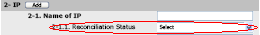
indent | Integer |  | Used to represent how far the question should be indented for presentation. Default value is 0. In following example “Name of IP” is has indent value of “1” and Reconciliation Status is indent value of “2”. The following “Name of IP” and “Reconciliation Status” question have a “grayBG” style.  The following “Prepared on” question has a “boldLabelwhiteBG” style.
commented | String |  | Indicates whether users can enter comments for clarify answers to questions. Default value is false.
commentLabel |  |  | This label is used to be displayed as a link for the user to enter a comment. Default value label is “Comment”. The following a commentLabel with a value of “Specify”.  The following popup is displayed when the user clicks “Specify” link.  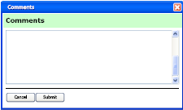
protocolSite | Boolean | True or false | Indicates that this question represents the protocol site combination. The following is an example protocol/site question.
protocolGrid | String |  | Indicates the unique identifier corresponding to the protocol grid entry (used as “Interview Guideline”) for this question. The default value is null. See the following figure (for more details see the Protocol Site detail design document).  Figure 2-4 - Protocol Grid Interview Helper Example  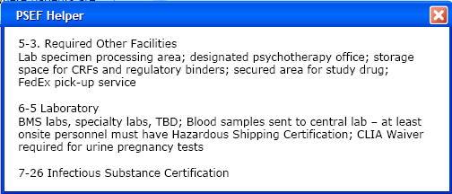

Each question will have a response type. The response type contains the expected answers for a question. The following table contains response type descriptions (see section RESPONSE_TYPE).
Table 2-8 - Response Types
Response Type | Description
TEXT | An input text field.
TEXTAREA | An input text area with a size limit of 4000 characters.
HIDDEN | A hidden input value.
INTEGER | A numerical integer input field.
CURRENCY | Input field representing a dollar value.
DATE | A date time value.
PERCENTAGE | Integer input field (range 0-100).
LISTBOX | Fixed list of the values in a drop down entries.
CHECKBOXES | Fixed list of check boxes.
DYNAMIC LISTBOX | Dynamic list of entries in a drop down (configured with an appropriate response operation). The number of items in the drop down depends on the results an operation to initial the list.
DYNAMIC CHECKBOXES | Dynamic number of check boxes (configured with an appropriate response operation). The number of check boxes depends on the result of a response operation to initial the list.
RADIOBOXES | Fixed number of radio boxes.
DYNAMIC RADIOBOXES | Dynamic number of radio boxes (configured with an appropriate response operation). The number of boxes depends on the result of an operation.
DYNAMIC HORIZONTAL TABLE | Table where the number of rows is based of an operation’s execution and displayed horizontally.
DYNAMIC VERTICAL TABLE | Table where the number of rows is based of an operation’s execution and displayed vertically.
MULTI-SELECT | The values entered for this response type are added and removed from a popup window. Users can select one or more values from a number of options.
DYNAMIC MUTLI-SELECT | Multi-select configured with an appropriate response operation.

Design Constraints
This section is not applicable.

Process Flow
This section is not applicable.

Algorithm/Process Details

Process Description
This section is not applicable.

Data References
See section Form Logical Data Model.

System Event Messages
This section is not applicable.

Assumptions
This section is not applicable.

Interfaces and External References
This section is not applicable.

Individual Design Elements

Form Rule Engine

Summary
The rule engine is a set of logical expressions, operations, and rules related to questions. The operations rules only works for server-side processing.
The Business Rule Engine (BRE) displayed in the Figure 3-5 - Business Rule Engine Class Diagram controls what operations/scripts are executed on questions when certain logical expressions are evaluated to true or false. Note that client side processing is handled by web browser scripts (JavaScript) see the question JSP tag in section .
Figure 3-5 - Business Rule Engine Class Diagram
. 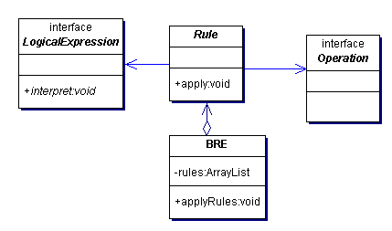
Table 3-9 - Business Rule Engine Classes
Object | Description
Operation | An operation represents an action to be performed of a question within a form. The operation concept is based on the command design pattern. Operations implements an execute method. It contains custom logic to satisfy the needed business processing.  Business operations deal with processing related to the retrieving data from the database and general logic that can only be performed on the server. For example, a business operation can populate a question on the current form with an answer a previous submitted form. Scripts should be used for client-side processing or offline form handling. Business rules provide a link between expressions and operations. Operations are executed when the form is retrieved for editing (in order to auto fill question answers see section RESPONSE_TYPE.RESPONSE_OPERATION_ID) and when saving and submitting a form. Note that the complete list of operations will be maintained in a separate document (see FORM INJECTION Form Questionnaire spreadsheet).
Rule | The rule object is used to make the link between expressions and operations for questions. The rule will execute an operation if a given logical expression is true or false.
BRE | This is the rule engine that contains all expressions, rules and operations/scripts to be performed and passed on to the form questions., In order to reduce database accessing and duplication of question rule information in memory, the BRE object is implemented as a singleton.
LogicalExpression | Logical expression provides an interface to determine whether a question or set of questions match a configured criteria. This design is based on the interpreter design pattern. Each object that implements this interpret interface must return a boolean result of true or false. AND, OR, NOT, greater than, and less than are examples of logical expressions.

Logical expressions are objects implementing an abstract method that states whether the expression is true or false. The follow is a diagram with the classes that implement logical expressions.
Figure 3-6 - Logical Expression with expressions Class Diagram
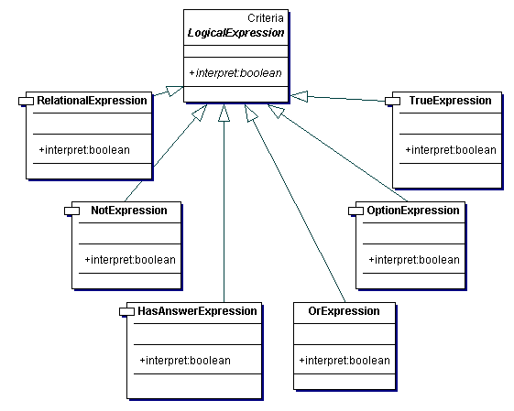
Object | Description
TrueExpression | Expression always true
HasAnswerExpression | Interprets to true if a question has been answered.
OptionExpression | Interprets to true if a question has an option equal with a given answer type
NotExpression | Interprets to true if a given logical expression is false.
OrExpression | Interprets to true if one of two given expression is true.
AndExpression | Interprets to true if two given expression are both true.
RelationalExpression | Returns the result of a relational operation of two questions’ values. Relational expressions are provided with two input arguments and an operation. The supported operands are “>”, “>”, “=”, “>=” or “<=”. Relational expressions can only be used for questions that have a numerical response type (integers, float, etc.).

Design Constraints
This section is not applicable.

Process Flow
See section .

Algorithm/Process Details

Process Description
This section is not applicable.

Data References
See section

Assumptions
This section is not applicable.

Interfaces and External References
This section is not applicable.

View Form

Summary
Users may view forms associated with a site. The form management component provides the ability to retrieve information such as the form’s answers, reviewer, originator, and site/protocol associations. Each form has a type. The form type determines the questions that are associated to the form.
The FormAction uses the FormService to retrieve the form information and forwards it the FormView for presentation. Only authorized users can view a form. The form’s originator, reviewer, approver, or users associate with the sites or studies are the only authorized users. The FormAction is responsible for authorization of form access based on the information retrieved from the FormService module.

The FormView using a set of custom JSP tags to render the form’s information and questions. Each of these custom JSP tags extends a Struts user interface component. Struts is the MVC controller framework used by the system. See the Development Standards and Common Services documents for details about Struts.
Figure 3-7 - Sample Form View
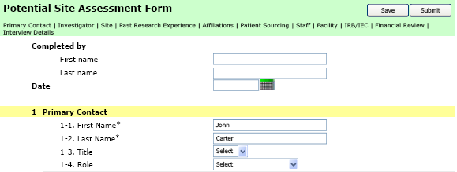

Figure 3-8 - Sample Form View JSP code
<!--
<%@ taglib uri="http://java.sun.com/jstl/core" prefix="c"%>
<%@ taglib uri="http://java.sun.com/jstl/fmt" prefix="fmt"%>
<%@ taglib uri="/WEB-INF/struts-bean.tld" prefix="bean" %>
<%@ taglib uri="http://Form Injection.bms.com/tld/form.tld" prefix="form"%>
-->
<form id="aForm" name="aForm" action="<c:url value="/do/formAction"/>" method="POST">
<table class="formHeader"width="100%" cellpadding="0">
<tr class="sectionHeader">
<td colspan="2"><form:sectionGlossary id="1,2,3,4,5,6,7,8,9"/></td>
</tr>
</table>
<!-- ======================================================= -->
<!-- SECTION 0 -->
<p>
<table width="100%" border="0" cellspacing="0" cellpadding="3">
<!-- Preparer -->
<form:questiona id="1" questionWidth="20%" answerWidth="80%"/>
</table>
</p>
<!-- ======================================================= -->
<!-- SECTION 1 -->
<p>
<form:sectionContainer id="1">
<tr>
<td class="indent">
<table width="95%">
<form:question id="2"/>
<tr>
<td colspan="2" style="height: 12px;"></td>
</tr>
</table>
</td>
</tr>
</form:sectionContainer>
</p>
</form>

Figure 3-8 - Sample Form View JSP code provides an example on how the form in Figure 3-7 is rendered. The JSP code contains a mixture of static HTML content in addition to using some custom JSP tags for presenting form user interface components such as section headers, sections, and questions.
In order to use the custom form tags the JSP code must reference the tag library by including the following text; <%@ taglib uri="http://Form Injection.bms.com/tld/form.tld" prefix="form"%>.
The prefix “form” tells the J2EE application server’s JSP Servlet engine that any tag that begins with the prefix “form” references the form’s custom component. This example used the sectionGlossary, sectionContainer and question custom tags.

The sectionGlossary displays the form’s sections where each section (Primary Contact, Investigator, Site and Past Research Experience in this example) is rendered as hyper-links to corresponding <form:sectionContainer> tag (rendered as a hyper-link anchor).
Figure 3-9 - Sample Section Headers Output
In following example the <form:sectionContainer id=”1”/> tag is included at the beginning the questions for the section “Primary Contact”. For example the “Primary Contact” will have an HTML href anchor to the section similar to the following;
Figure 3-10 - Sample Output for Section Header “Primary Contact”
JSP Code | HTML Output
<form:sectionGlossary id=”1”> | <A href="#section1" class=” sectionTitle”>Primary Contact</A>  …
<form:sectionContainer id="1" /> | <A name="section1" class=”yellowBG”>Primary Contact</A>  <!-- Questions in section 1-->  …

The question tag displays the HTML version of questions and theirs corresponding answers.

The versioning of forms and their corresponding questions/answers are based on the form’s type. All forms are associated with a particular form type and its questions. Each type may have one or more versions (see section ).

When creating a new form the highest version number of the type (with its questions) is retrieved and associated with the form. The form’s associated type/version cannot be altered after the form is initially created.
For example, if there two versions of the SMV form type (version 1 and 2), when a user schedules an SMV visit after the second form type/questions have been added in the database, then the form will used SMV type version 2 and all of its questions. All SMV forms created prior to the addition of version 2 of the SMV are associated with version 1.

A new version of a form type should always be added if changes to questions (such as the question’s text) are needed. This will allow new versions of created forms to be introduced without affecting previously submitted and or completed forms.

The form controller logic knows what view handles which version of the form type. The forward mapping between JSP and form type versions are stored in the form management’s STRUTS configuration file. The action forward name has the following format: ${formTypeCode}.version.${formTypeVersionNumber}. New versions of the JSPs and form layouts may be introduced by modifying this file.
Figure 3-11 – Struts Form Action Forward Mapping (Auto Versioning)
<action name="formAction" path="/formAction" type="com.bms.informatics.Form Injection.form.web.FormAction" parameter="op" validate="true">
<forward name="PE.version.1" path="bms.Form Injection.form.pe.layout"/>
<forward name="SMV.version.1" path="bms.Form Injection.form.smv.layout"/>
<forward name="PD.version.1" path="bms.Form Injection.form.pd.layout"/>
<forward name="SMP.version.1" path="bms.Form Injection.form.smp.layout"/>
<forward name="PSE.version.1" path="bms.Form Injection.form.pse.layout"/>
<forward name="PSA.version.1" path="bms.Form Injection.form.psa.layout"/>
<forward name="DRW.version.1" path="bms.Form Injection.form.drw.layout"/>
<forward name="OSIF.version.1" path="bms.Form Injection.form.osif.layout"/>
<forward name="SCV.version.1" path="bms.Form Injection.form.scv.layout"/>
<forward name="SIV.version.1" path="bms.Form Injection.form.siv.layout"/>
<forward name="SASC.version.1" path="bms.Form Injection.form.sasc.layout"/>
</action>

Design Constraints

Process Flow
Figure 3-12 - View Form Sequence Diagram
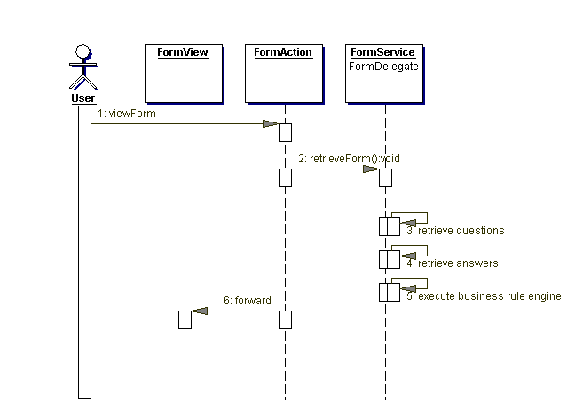

Algorithm/Process Details

Process Description
Table 3-10 - View Form Process Description
Step ID | Process Step Description
1 | User submits a viewForm request to the FormAction. The request refers to a new form that needs to be created or an existing form.
2 | FormAction calls the FormService’s retrieveForm method to get the form information from the database.
3 | FormService will retrieve questions based on the type of form.
4 | FormService will retrieve answers. This is for a pre-existing form; the request contains the form’s primary identifier in this case.
5 | FormService will execute the business rule engine to pre-populate questions.
6 | FormAction forwards the form with the questions and answers (if any answers previously exist) to the FormView. The previously existing forms are displayed with editable input fields if the user is originator and the form is incomplete.

Data References
The following is the complete list of supported custom tags with overview and example rendered output.
Table 3-11 - Form Management Questions/Response Output Descriptions
Response Type | Description
TEXT  INTEGER  CURRENCY  DATE  PERCENTAGE | Questions with a TEXT, INTEGER, CURRENCY, DATE, and PERCENTAGE response type are rendered with an HTML “input” of type “text”.
HIDDEN | Questions with a HIDDEN response type are rendered with an HTML “input” of type “hidden”.  <input type=”hidden value=”XXX”/>
TEXTAREA | Questions with a TEXTAREA response type are rendered with an HTML “textarea”.  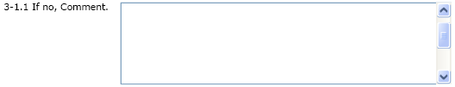
DATE | Questions with a DATE response type are rendered with an HTML “input” of type “text”.  An image icon displayed next to the input text field links to a calendar popup window. The input date field is populated with the selected date from calendar popup when the user clicks submit. All dates are displayed as ‘DD-MMM-YYYY,’ e.g. 17-MAR-2005.  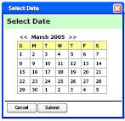
LISTBOX | Questions with a LISTBOX response type are rendered with an HTML “select” with a HTML “option” tag from each question option.
RADIOBOXES | Questions with a RADIOBOXES response type are rendered with an HTML “input” with type “radio” for each question option.
CHECKBOXES | Questions with a CHECKBOXES response type are rendered with an HTML “input” with type “checkbox” for each question option.  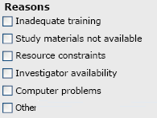
TABLE | Questions with a TABLE response type are rendered with an HTML “table”.  In the following example, “Specialty” and “Areas of interest” are RESPONSE COLUMNS. Each response column has a RESPONSE TYPE (such as TEXT, LISTBOX, etc. The input field in each row for these columns following standard displays conventions for the response type. Here “Specialty” and “Areas of interest” have a LISTBOX response type.  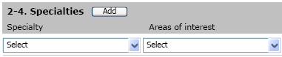  The “Add” button calls a custom “addRow” JavaScript function that uses DHTML to dynamically add a row “TR” at the end of the “table”. Each added row has an “x” icon that allows the user to be deleted it as show below.
VERTICAL TABLE | Questions with a VERTICALTABLE response type can be considered the same as a normal table except that all columns are display on separates line (i.e. vertically).  The “add” button calls a custom “addVerticalRow” JavaScript function that uses DHTML to dynamically add a row “TR” at the end of the “table”. In this example the “first name”, “last name” and “title” will be repeatedly showed under the last “Title” row.  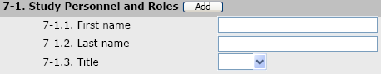
MULTI-SELECT-LISTBOX | Allow for one or more items to be selected in a list box style.  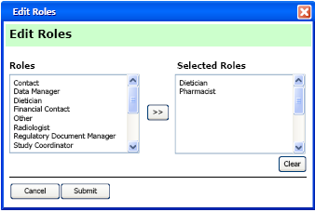

System Event Messages
This section is not applicable.

Assumptions
This section is not applicable.

Interfaces and External References
This section is not applicable.

Edit Submitted Form

Summary
The originator can request to edit submitted forms that have not been completed, approved, rejected, or not file in ESF. The forms cannot be edited if it has been submitted to ESF.

Design Constraints
This section is not applicable.

Process Flow
Figure 3-13 – Edit Submitted Form Sequence Diagram
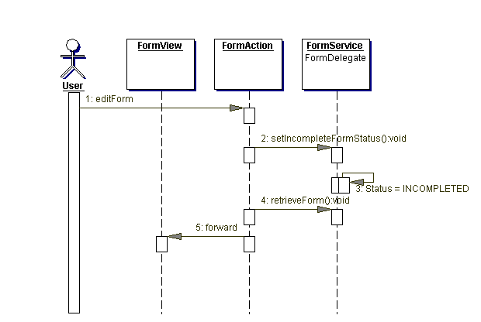

Algorithm/Process Details

Process Description
Table 3-12 - View Form Process Description
Step ID | Process Step Description
1 | User submits an editForm request to the FormAction. The request refers to an existing form that has been submitted but not sent to ESF.
2 | FormAction calls the FormService’s setIncompleteFormStatus method.
3 | FormService will set Status = INCOMPLETED for the form.
4 | FormAction calls the FormService’s retrieveForm to get the forms information from the database.
5 | FormAction forwards the form with the questions and answers to the FormView to the presented.

Data References
Table 3-13 - Edit Submitted Form Data References
Table/Column | Description
FORM.FORM_STATUS_ID | Update FORM.STATUS_FORM_ID = (select FORM_STATUS.FORM_STATUS_ID from FORM_STATUS where FORM_STATUS.STATUS_NM = “INCOMPLETE”)
FORM.SUBMIT_DT | NULL

System Event Messages
This section is not applicable.

Assumptions
This section is not applicable.

Interfaces and External References
This section is not applicable.

Save Form

Summary
Users may create or edit forms within the system. The status of the created or edited form prior to submission is “INCOMPLETE”. The form may be created and updated online and offline. Offline processing is very similar to online. Offline submission of forms is supported via BackWeb’s offline form handling mechanism. Data needed to submit an offline form (i.e. list of potential reviewers, approvers, etc.) is retrieved via BackWeb’s content acquisition server to the user’s laptop. The status of a form is set back to incomplete if the originator requests to edit a submitted form. Only the originator can answer form questions prior to submission.
Figure 3-14 - Form Save Button
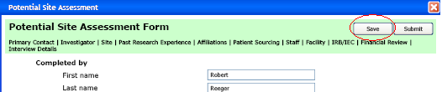

Design Constraints
This section is not applicable.

Process Flow
Figure 3-15 - Save Form Sequence Diagram
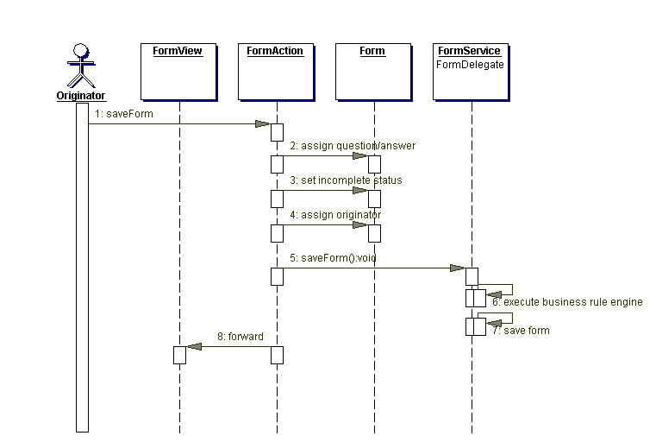

Algorithm/Process Details

Process Description
Table 3-14 - Save Form Process Description
Step ID | Process Step Description
1 | Originator initiates a saveForm request to the FormAction.
2 | FormAction will assign question/answers retrieved for the form to the user’s form data structure.
3 | FormAction will set an incomplete status on the form.
4 | FormAction assigns originator of the form to current user if it is not previously set.
5 | FormAction calls the FormService’s saveForm method.
6 | FormService executes business rule engine to execute operations; These operations include auto filling to answers and executing custom operations.
7 | FormService saves form to the database.
8 | FormAction forwards the saved form information the FormView for presentation.

Data References
Table 3-15 - Save From Data References
Table/Column | Description
FORM.FORM_STATUS_ID | Update FORM.STATUS_FORM_ID = (select FORM_STATUS.FORM_STATUS_ID from FORM_STATUS where FORM_STATUS.STATUS_NM = “INCOMPLETED”)
FORM.FORM_ID | Generate number
FORM.STUDY_ID | Populated with the site’s study identifier.
FORM.ORIGINATOR_USER_ID | ID of the current user.
FORM.FORM_TYPE_ID | Populated with the form’s type.
FORM.STUDY_SITE_ID | Populated with the site’s identifier.

System Event Messages
This section is not applicable.

Assumptions
This section is not applicable.

Interfaces and External References
This section is not applicable.

Submit Form

Summary
The form originator can submit a form. A single reviewer is responsible for reviewing most forms. The forms may be submitted online only. Only a form with a status of “INCOMPLETE” can be submitted. Only the originator can access the form prior to submission.

Figure 3-16 - Form Submit Button
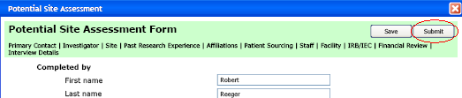

Design Constraints
This function is only available when the user is online.

Process Flow
Figure 3-17 - Submit Form Sequence Diagram
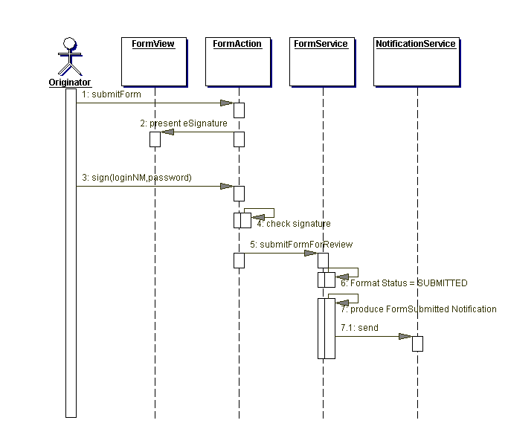

Algorithm/Process Details

Process Description
Table 3-16 - Submit Form Process Description
Step ID | Process Step Description
1 | Form Originator initiates a submitForm request. The signForm browser JavaScript function validates that all required fields have been populated prior to forward the requestion to the FormAction. Required questions are given an attribute “required=true” attribute. Each form input elements name has the following format:  “v_${required}_${response type}_${label}_${min size}_${max size}_q${questioned}[[col][row];tablePK=${tableID}  Example: v_true_listbox__0_2000_q7
2 | FormAction forwards to the FormView to present the eSignature windows (see section eSignature).  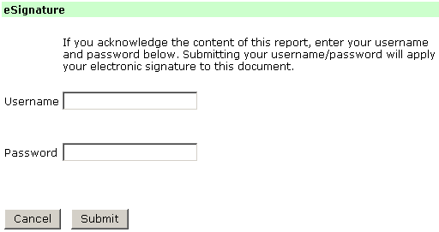
3 | Originator Signs with their user name and password by clicking the “Submit” button.  Alternately, if the user clicks “Cancel” instead of the “Submit” button the form will not be submitted. Instead the user will be presented with the form (see View Form).
4 | FormAction checks the signature username and password against LDAP. An error message is displayed if the username/password is not valid
5 | FormAction calls the FormService’s submitFormForReview method.
6 | FormService sets the Form Status = SUBMITTED in the database.
7 | FormService produces FormSubmitted message that is sent the notification service.
5 | FormService produces a FormSubmitted notification message (see Notification Management document).

Data References
Table 3-17 - Submit Form for Review Data References
Table/Column | Description
FORM.FORM_STATUS_ID | Update FORM.STATUS_FORM_ID = (select FORM_STATUS.FORM_STATUS_ID from FORM_STATUS where FORM_STATUS.STATUS_NM = “SUBMITTED”)
FORM.SUBMIT_DT | Current system time

System Event Messages
Table 3-18 - Submit form for Review Event Messages
Message No | Message  Type | Message Description
 | Notification | FormSubmitted is a notification message sent to registered consumers containing the form submission information (see Notification Management document). The submission of a form causes the creation of alerts. This is handled by an alert consumer that is registered with the notification module to receive a FormSubmitted message (see alert management document for details).
 | Required Question Error | This message is displayed to the user if a required question was not answered.

Assumptions
This section is not applicable.

Interfaces and External References
This section is not applicable.

System Event Messages
Table 3-19 - Submit form for Approval Event Messages
Message No | Message  Type | Message Description
 | Notification | FormSubmittedApproved is a notification message sent to registered consumers containing the form submission information (see Notification Management document).

Assumptions
This section is not applicable.

Interfaces and External References
This section is not applicable.

Complete Form

Summary
Most completed forms are sent to ESF. Filing a form depends on the configuration of the form’s type (see section FORM_TYPE.ESF_FILED). Note that the term completed includes approved or rejected forms. The protocol exception is the only form where the decision can be made to accept or reject the form (see Figure 3-18 - Protocol Exception Reject/Approve Decision User Interface). Forms can only be completed by reviewers or approvers.
Figure 3-18 - Protocol Exception Reject/Approve Decision User Interface
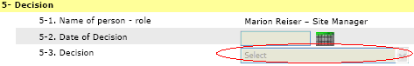

The information filed in ESF is the PDF version of the form. Apache’s FOP API is used to create the PDF version of the form. This XML format conforms to a standard schema. A XML style sheet is provided to transform the XML form information to Apache’s FOP XML structure. See http://xml.apache.org/fop for more information.
The notification service is used to send documents to ESF. The notification observer is registered to be notification of completed forms. This observer contains functionality to convert the form to a PDF document and store the results in ESF. Completing the form and submitting the PDF to ESF are two separate (independent) transactions. The notification framework error handling will be used to resend documents if ESF is down or not accessible (see notification management document for details). The FormCompletedObserver will also have full access to the form data itself so that it can provide the data needed for the ESF indexing process to the ESF Delegate.
Figure 3-19 - Sample Form XML
<?xml version="1.0" encoding="UTF-8"?>
<Form>
<status>COMPLETED</status>
<formSections>
<FormSection>
<name>section 1</name>
<number>1</number>
</FormSection>
<FormSection>
<name>section 1</name>
<number>2</number>
</FormSection>
</formSections>
<formQuestionaire>
<FormQuestion>
<sectionNumber>1</sectionNumber>
<text>question 1</text>
<number>1</number>
<answer>
<value>Hello 1</value>
</answer>
</FormQuestion>
<FormQuestion>
<sectionNumber>2</sectionNumber>
<text>question 2</text>
<number>2</number>
<answer>
<value>Hello 2</value>
</answer>
</FormQuestion>
</formQuestionaire>
</Form>

A reviewer reviews other forms. The reviewer is presented with a “Sign” button to file the document in ESF. When the Sign button is pressed for PSE, SIV, SMV, SC, and SSC the eSignature windows (see below) is invoked. This allows for the capture of user’s signature by entering their login security credentials (login and password).

Figure 3-20 - Form Reviewed with eSignature
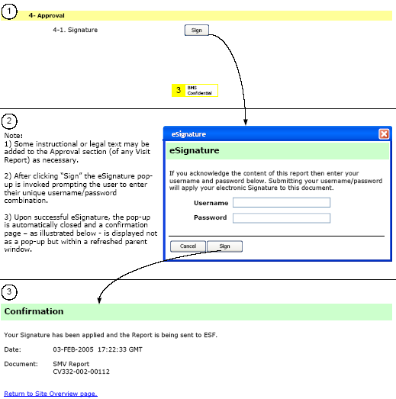

Design Constraints
This function is only available when the user is online.

Process Flow
Figure 3-21 - Complete Form Sequence Diagram
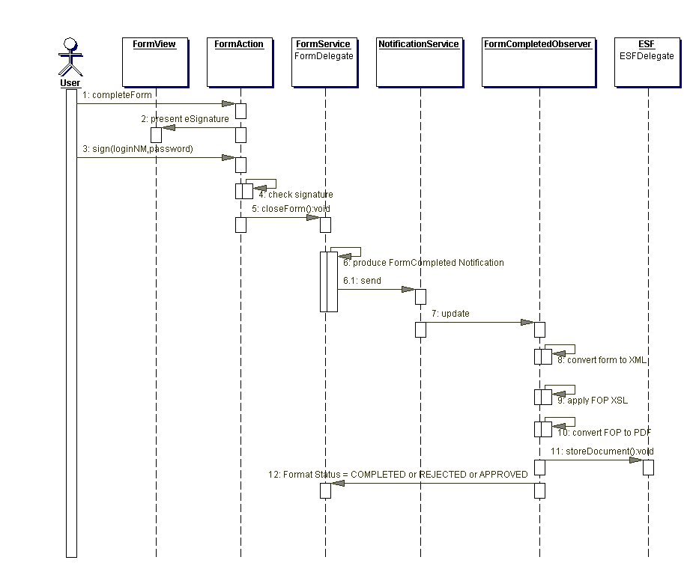

Algorithm/Process Details

Process Description
Table 3-20 - Submit Form Process Description
Step ID | Process Step Description
1 | User (reviewer or approver) submits completeForm request to the FormAction.
2 | FormAction forwards to the FormView to present eSignature page where users must enter their login name and password as their electronic signature.
3 | User submits a sign request with their login name and password to the FormAction.
4 | FormAction checks signature by authenticating the login and password against the LDAP server. An error message is displayed if the login and or password does not match, thus ending the request processing (see Security Management design document for details about the LDAP directory server).
5 | FormService produces a FormCompleted notification message.
5.1 | FormService calls the NotificationService’s send method to transmit the FormCompleted notification message to registered observers.
6 | NotificationService calls the FormCompletedObserver’s update method. A FormCompleteObserver is registered to receive updates of the FormCompleted message when the NotificationService initiates itself (see Notification Management document).
7 | FormCompletedObserver converts the form to XML. This conversion is based on the properties of the form’s JavaBean object.
8 | FormCompletedObserver will apply a FOP XSL to the XML. This XSL is part of the configuration of the system. The result of this transformation will be the FOP result of the form.
9 | FormCompletedObserver converts the form to XML. This conversion is based on the properties of the form’s JavaBean object.
10 | FormCompletedObserver calls the ESF integration’s storeDocument method passing the PDF document to be saved.
11 | FormCompletedObserver uses the FormService to mark Format Status = COMPLETED or REJECTED or APPROVED in the database.

Data References
Table 3-21 - Complete Form Data References
Table/Column | Description
FORM.FORM_STATUS_ID | If ProtocolException && REJECTED  Update FORM.STATUS_FORM_ID = (select FORM_STATUS.FORM_STATUS_ID from FORM_STATUS where FORM_STATUS.STATUS_NM = “REJECTED”)  Else If ProtocolException && ACCEPTED  Update FORM.STATUS_FORM_ID = (select FORM_STATUS.FORM_STATUS_ID from FORM_STATUS where FORM_STATUS.STATUS_NM = “ACCEPTED”)  Else  Update FORM.STATUS_FORM_ID = (select FORM_STATUS.FORM_STATUS_ID from FORM_STATUS where FORM_STATUS.STATUS_NM = “COMPLETED”)
FORM. COMPLETE_APPROVE_DT | Current system time

System Event Messages
Table 3-22 - Complete form Event Messages
Message No | Message  Type | Message Description
 | Notification | FormCompleted is a notification message sent to registered consumers containing the form submission information (see Notification Management document).

Assumptions
This section is not applicable.

Interfaces and External References
PDF version of the completed from is stored in ESF (see Document Management design for details).

Renew Form

Summary
Users will be able to create a new version of a report that has been filed in ESF. The new version of the form is a copy of the original form. The answers and questions from the original form are transfers to the new version. Only the originator can renew a completed form.

Design Constraints
This section is not applicable.

Process Flow
Figure 3-22 - Renew Form Sequence Diagram
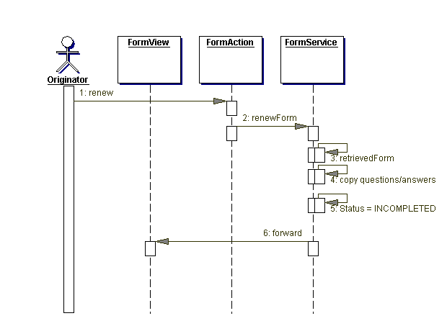

Algorithm/Process Details

Process Description
Table 3-23 - Renew Form Process Description
Step ID | Process Step Description
1 | Originator will execute renew form request (supplying the original form ID of a submitted/non-replaced application). Note that the form must not have been replaced by a subsequently created form.
2 | RenewAction will call the FormService’s renewForm method passing the form information.
3 | FormService’s calls its retrievedForm method to get original form information with its questions and answers.
4 | FormService will copy questions/answers on the original form to the new form.
5 | FormService will set the form’s Status = INCOMPLETED.
6 | FormAction will forward the new form information to the FormView to be displayed.

Data References
Table 3-24 - Renew for Review Data References
Table/Column | Description
FORM.FORM_STATUS_ID | Update FORM.STATUS_FORM_ID = (select FORM_STATUS.FORM_STATUS_ID from FORM_STATUS where FORM_STATUS.STATUS_NM = “COMPLETED”)
FORM.FORM_ID | New identification number is generated.

System Event Messages
This section is not applicable.

Assumptions
This section is not applicable.

Interfaces and External References
This section is not applicable.

Manage Offline Form Submission

Summary
FORM INJECTION supports the submission of forms online and offline. BackWeb is the product used to support offline forms. Note that most of the following design details are taken from Back Web's Offline Access Server Developers Guide.

With online forms, submission and processing are executed immediately. With offline forms, the form submission and processing are deferred until a network connection can be established between the user’s computer and the server. The users can check the Back Web’s Forms Outbox for the results of the submission. The following shows the option to open the offline forms outbox. This menu is displayed when the user right-clicks on the BackWeb Plug-in icon of the system tray on the computer’s Windows task bar (circled in red).
Figure 3-23 - Back Web Access Offline Forms Outbox
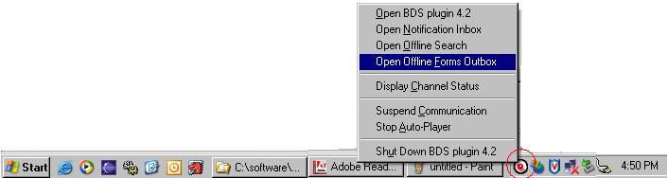
FORM INJECTION offline form submission displays a confirmation message page stating that the form has been successfully submitted offline. The form will be uploaded and submitted online when the user's computer can establish a network connection to the FORM INJECTION server.
Figure 3-24 - Offline Form Submission Confirmation
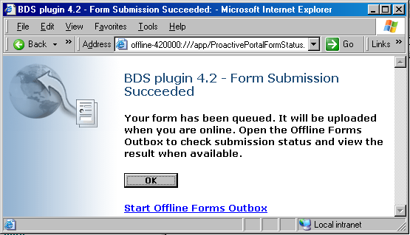

In the online form, the HTML <form/> ACTION attribute specifies the URL of a FORM INJECTION action that processes the form data. In the offline form, the ACTION attribute conveys instructions to the BackWeb Plug-in how to handle the form data. To implement a form's offline capability the FORM element is wrapped in an OTML tag, "OFFLINE-FORM". The following code sample shows how to use the OFFLINE-FORM tag to enclose the form.
Figure 3-25 - Sample Offline Form HTML
<OTML:OFFLINE-FORM OFFLINE-ID="SMVForm" TITLE="SMV Form Submission">
<form action="form.jsf">
<label for="firstName">First Name</label>
<input name="firstName" type="text"/>
<br/>
<label for="lastName">Last Name</label>
<input name="lastName" type="text"/>
<br/>
<br/>
<input type="submit" value="Submit"/>
<input type="reset" value="Reset"/>
<input type="button" value="Cancel" size="10"/>
</form>
</OTML:OFFLINE-FORM>

The OTML: OFFLINE-FORM tag will be ignored by the Web Browser because it is not standard HTML. This tag indicates that Back Web must support the submission of this form offline. When this form is acquired and pushed to the user’s computer, the ACTION attribute will contain a URL that uses Back Web’s offline protocol. This ensures that the BackWeb Plug-in, and not the FORM INJECTION Web Application, handles the form data when the user clicks Submit. The original ACTION URL is maintained within Back Web.
In the offline form, the enclosing OTML tags no longer appear in the code. This occurs since the OFFLINE-FORM tag is no longer necessary once the Back Web Server has reacted to it and has changed the ACTION attribute (see the following).
Figure 3-26 - Sample Offline Form Resulting HTML
<form action="offline-3014640:///forms/UI/ID=SMVForm/NAVIGATION=refresh">
<label for="firstName">First Name</label>
<input name="firstName" type="text"/>
<br/>
<label for="lastName">Last Name</label>
<input name="lastName" type="text"/>
<br/>
<br/>
<input type="submit" value="Submit"/>
<input type="reset" value="Reset"/>
<input type="button" value="Cancel" size="10"/>
</form>

Offline form submission status of completed or error depends on FORM INJECTION's response to the submission detected by Back Web. FORM INJECTION response to an offline form submission is an HTML page that will contain the status of the submission in a HMLT comment <!-- SUBMIT COMPLETED --> or <!-- SUBMIT ERROR -->. If an error occurs the original form with the user’s submitted input fields are return so the errors can be fixed and the form can be resubmitted to the FORM INJECTION server.
Figure 3-27 - Sample Offline Forms Output
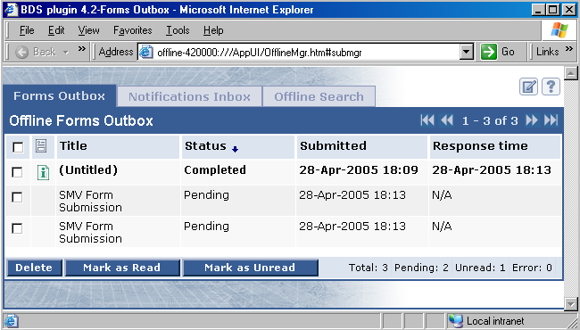
BackWeb processes the FORM INJECTION response so the resubmit works properly offline. Back Web acquires the response content from FORM INJECTION for offline presentation to the user's machine. The result page always contains a short message confirming the submission (or announcing a rejection because of some problem in the values).
Figure 3-28 - Sample Offline Submission Details Page
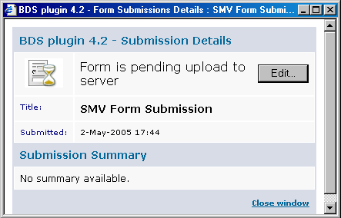

The following page may be displayed for an error offline submission when the user clicks the “view results” link of the results page on the submission error. The error in this example is displayed in red. Note that the majority of the form input field validation will be executed client-side (on the user’s local machine) so offline form submission errors should be rare if all the client validations are executed.
Figure 3-29 - Sample Submission Error Ready for Resubmission
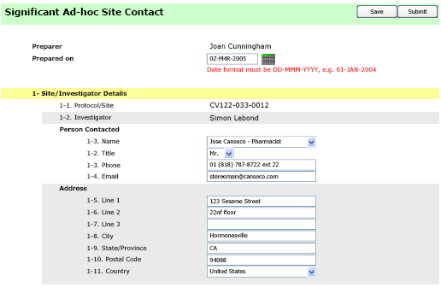

When the form result content item gets to the user, it is presented in the BackWeb Plug-in outbox. The FormView will render all submitted question inputs in the HTML results.
After a user has submitted a form, it may be necessary to modify some of the input that was filled in before the form executes on the server (for example, a changed phone number). To allow users to resubmit a form, the BackWeb OTML:OFFLINE-FORM's HTMLFOR-EDITING-SRC tag is used to display an "Edit" button to appear in the Form Submission Details window of the BackWeb Offline Forms Outbox (see Error: Reference source not found).
Figure 3-30 - Offline Form Error Results Page
<OTML:OFFLINE-FORM OFFLINE-ID="SMVForm" TITLE="SMV Form Submission"
HTML-FOR-EDITING-SRC="form.jsf?offlineEditing=true">
<form action="form.jsf">
<!-- SUBMIT ERROR -->
<span class=”error”> User John Jones not found in Personnel Files</span>
<label for="firstName">First Name</label>
<input name="firstName" type="text" value="John"/>
<br/>
<label for="lastName">Last Name</label>
<input name="lastName" type="text" value="Jones"/>
<br/>
<br/>
<input type="submit" value="Submit"/>
<input type="reset" value="Reset"/>
<input type="button" value="Cancel" size="10"/>
</form>
</OTML:OFFLINE-FORM>

The code HTML-FOR-EDITING-SRC= "form.jsf?offlineEditing=true" enables this form to be edited offline. In this case the form.jsf’s JSP and custom tags put special BackWeb Tags that allow a submitted form to be edited in its PENDING state (prior to it being submitted to the server). HTML-FOR-EDITING-SRC points to the original JSP with an “offlineEditing=true” JSP parameter. The results of this JSP (with offlineEditing=true) should be an HTML page, which is displayed to the user when they select "Edit" is similar to the Figure 3-31 - Offline Form Enabled offline editing. It will contain the form input fields submitted by the user.
The HTML below shows the JSP’s output that allows the input fields to be pre-populated (by the Back Web Plug-in) with data entered in the previously submitted form. This HTML accesses the saved form submission input parameters through the %INPUT hash of BackWeb’s outbox form submission. The name of the INPUT key must match the HTML input field name of the submitted form.
Figure 3-31 - Offline Form Enabled offline editing
<OTML:OFFLINE-FORM OFFLINE-ID="SMVForm" TITLE="SMV Form Submission"
HTML-FOR-EDITING-SRC="form.jsf?offlineEditing=true">
<form action="%OFFLINE-ACTION%">
<!-- SUBMIT ERROR -->
<span class=”error”> User John Jones not found in Personnel Files</span>
<label for="firstName">First Name</label>
<input name="firstName" type="text" value="%INPUT:firstName"/>
<br/>
<label for="lastName">Last Name</label>
<input name="lastName" type="text" value="%INPUT:lastName "/>
<br/>
<br/>
<input type="submit" value="Submit"/>
<input type="reset" value="Reset"/>
<input type="button" value="Cancel" size="10"/>
</form>
</OTML:OFFLINE-FORM>

Design Constraints
This section is not applicable.

Process Flow
Figure 3-32 – Manage Offline Form Sequence Diagram
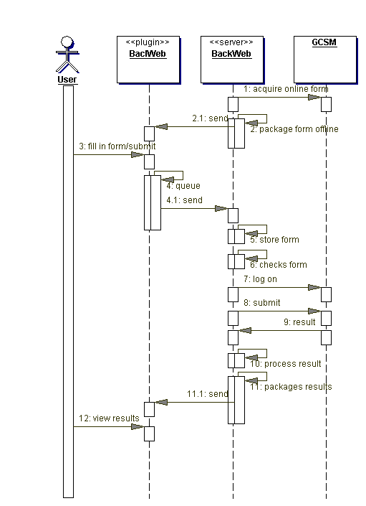

Algorithm/Process Details

Process Description
Table 3-25 - Manage Offline Form Process Description
Step ID | Process Step Description
1 | Back Web Server acquires online form (from the FORM INJECTION) during content acquisition.
2 | Back Web Server packages form offline with the current content item and then Back Web sends contents to the user's BackWeb Plug-in.
3 | The user fills in the form. The information with which the user completes the form is stored as a list of name-value pairs. This list has the same content and format as the name-value list contained in the HTTP GET or POST that would result if the form had been submitted online. The name is the form element's name. The value is the information the user entered for the form element (for textual input), or the value associated with an option (for any check box, select, and button input). For example, if the form has a "City" field, and the user entered "New York" in the field, one of the forms’ name-value pairs are: name="City", value="New York". The list of name-value pairs constitutes the form's data.The user can submit the form offline (in the Web browser), the form's data is sent to the BackWeb Plug-in.
4 | The BackWeb Plug-in queues form's data, and as soon as network connection is available, it sends it upstream to the BackWeb Server. While the form is pending upload in the BackWeb Plug-in. The form will be enabled for editing, the user can select to edit the form submission. While editing, the original submission is suspended, i.e. it cannot start uploading. If the user chooses to submit the edited form, it replaces the original submission. The user may also dismiss the new submission, and resume uploading the original.
5 | When the offline form submission reaches the BackWeb Server it stores form in its database.
6 | The Back Web Server checks form information to determine which FORM INJECTION URL action to submit the form.
7 | Back Web logs on as the user.
8 | Back Web submits the form to FORM INJECTION.
9 | FORM INJECTION returns a result HTML page to the BackWeb Server.
10 | Back Web Server script processes results HTML page containing the form output from FORM INJECTION. The script determines submission status (completed or error) by looking up hidden HTML text <!-- SUBMIT COMPLETED --> or <!-- SUBMIT ERROR --> in the result pages and sets the form submission status appropriately.
11 | Back Web Server packages results of form submission status and the form submission result in a content item and sends the content item to the BackWeb Plug-in.
12 | The user can then use the Offline Forms Outbox (in the Web browser) to view results of the form submission.

Data References
See Back Web documentation for details on how offline forms are stored.

System Event Messages
This section is not applicable.

Assumptions
This section is not applicable.

Interfaces and External References
This section is not applicable.

– SMV Data Mapping
Element | Auto Fill | Required | Read Only | Comments
Preparer | TRUE | TRUE | TRUE | Maps to the originator of the form; the USERS.FIRST_NM||USERS.LAST_NM join with the FORM.ORIGINATOR_ID = USERS.USER_ID.  Question Configuration  - responseType=TEXT  - Operation= com.bms.informatics.Form Injection.form.bre.operation.SetCreateUserOperation  - style=boldWhiteBG
Prepared on | TRUE | TRUE | TRUE | The date the form is submitted. The result is in FORM.CREATE_DT.  Question Configuration  - responseType=DATE  - Operation= com.bms.informatics.Form Injection.form.bre.operation.SetCreateDateOperation  - style=boldWhiteBG
Protocol/Site | TRUE | TRUE | TRUE | The protocol and site number that the form is associated. STUDY.PROTOCOL_NBR||STUDY_SITE.SITE_NBR (see Protocol Site Management document’s logical data model).  Question Configuration  - responseType=TEXT  - Operation= com.bms.informatics.Form Injection.form.bre.operation.SetProtocolSiteOperation  - indent = 0  - style=boldWhiteBG  - protocolSite=true
Study Status | TRUE | TRUE | TRUE | The study status states maps to STUDY_STATUS.STUDY_STATUS_NM joined with FORM.STUDY_ID = STUDY.STUDY_STATUS_ID = STUDY_STATUS.STUDY_STATUS_ID (see Protocol Site design document logical data model).  Question Configuration  - responseType=TEXT  - Operation= com.bms.informatics.Form Injection.form.bre.operation.SetStudyStatusOperation  - indent = 0  - style=boldWhiteBG
 | TRUE | TRUE | FALSE | Visit dates result will be stored in FORM_ANSWER.ANSWER_VALUE.  Question Configuration  - responseType=verticalTable  - From (Column)  - responseTypes=date  - Operation=SetCurrentDate  - To (Column)  - responseTypes=date Operation=SetCurrentDate
 | FALSE | TRUE | FALSE | The visit type stored as an answer option in FORM_ANSWER_OPTION. QUESTION_OPTION_ID.  Question Configuration  - responseType=LISTDOWN  - options  - Standard  - Non-Standard  - Un-blinded
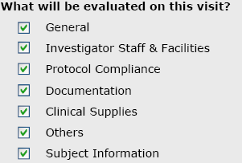 | FALSE | TRUE | FALSE | All checked options are stored as an answer option in FORM_ANSWER_OPTION. QUESTION_OPTION_ID.  Question Configuration  - responseType=CHECKBOXES  - options (see picture on left)
 | FALSE | TRUE | FALSE | Drop down list from Impact.  Question Configuration  - responseType=table  - Name (Column)  - responseType=LISTBOX  - Operation= com.bms.informatics.Form Injection.form.bre.operation.PopulateUserChoicesOperation  - Title (Column)  - responseType=TEXT
 | FALSE | TRUE | FALSE | Table of site users. The user are USERS .USER_ID = USER_ROLE.USER_ID and USER_ROLE.SITE_ID = current site.  Question Configuration  - responseType=table  - Name (Column)  responseType=TEXT  - Title (Column)  - responseType=TEXT
Investigator Name | TRUE | TRUE | TRUE | Primary investigator name;  INVESTIGATOR.TITLE|| INVESTIGATOR.FIRST_NM|| INVESTIGATOR.FIRST_NM joined with SITE.INVESTIGATOR_ID = INVESTIGATOR.INVESTIGATOR_ID.  The value is stored in the FORM_ANSWER.ANSWER_VALUE column for the question.  Question Configuration  - responseType=TEXT  - Operation= com.bms.informatics.Form Injection.form.bre.operation.SetInvestigatorOperation  - indent=1
Addres | TRUE | TRUE | TRUE | LOCATION.ADDRESS joined with  STUDY_SITE_TBL.PRIMARY_LOCATION_ID = LOCATION.LOCATION_ID.  The value is stored in the FORM_ANSWER.ANSWER_VALUE column for the question.  Question Configuration  - responseType=TEXT  - Operation= com.bms.informatics.Form Injection.form.bre.operation.SetPrimaryLocationOperation  - indent=1
City | TRUE | TRUE | TRUE | LOCATION.CITY joined with  STUDY_SITE_TBL.PRIMARY_LOCATION_ID = LOCATION.LOCATION_ID.  The value is stored in the FORM_ANSWER.ANSWER_VALUE column for the question.  Question Configuration  - responseType=TEXT  - Operation= com.bms.informatics.Form Injection.form.bre.operation.SetPrimaryLocationOperation  - indent=1
State/Province | TRUE | R | TRUE | LOCATION.STATE_PROVINCE joined with  STUDY_SITE_TBL.PRIMARY_LOCATION_ID = LOCATION.LOCATION_ID.  The value is stored in the FORM_ANSWER.ANSWER_VALUE column for the question.  Question Configuration  - responseType=TEXT  - Operation= com.bms.informatics.Form Injection.form.bre.operation.SetPrimaryLocationOperation  - indent=1
Postal Code | TRUE | R | TRUE | LOCATION.POSTAL_CODE joined with  STUDY_SITE_TBL.PRIMARY_LOCATION_ID = LOCATION.LOCATION_ID.  The value is stored in the FORM_ANSWER.ANSWER_VALUE column for the question.  Question Configuration  - responseType=TEXT  - Operation= com.bms.informatics.Form Injection.form.bre.operation.SetPrimaryLocationOperation  - indent=1
Country | TRUE | TRUE | TRUE | LOCATION.COUNTRY_NM joined with  STUDY_SITE_TBL.PRIMARY_LOCATION_ID = LOCATION.LOCATION_ID.  The value is stored in the FORM_ANSWER.ANSWER_VALUE column for the question.  Question Configuration  - responseType=TEXT  - Operation= com.bms.informatics.Form Injection.form.bre.operation.SetPrimaryLocationOperation  - indent=1
Have any changes occurred to the facility that impact the study? | FALSE | TRUE | FALSE | Selected answer is stored as an answer option in FORM_ANSWER_OPTION. QUESTION_OPTION_ID.  Question Configuration  - responseType=LISTBOX  - Options  - No  - Yes  - Not Applicable
Have changes occurred to the staff that impact the study? | FALSE | TRUE | FALSE | If the answer is “Yes” fill in the details that follow. Should generate an Issue/Alert for the Site Manager.  Selected answer is stored as an answer option in FORM_ANSWER_OPTION. QUESTION_OPTION_ID.  Question Configuration  - responseType=LISTBOX  - Options  - No  - Yes  - Not Applicable
Staff Changes  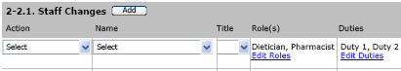 | FALSE | TRUE | FALSE | Selected answer is stored as an answer option in FORM_ANSWER_OPTION. QUESTION_OPTION_ID.  Question Configuration  - responseType=TABLE  - Action Column  - responseType=LISTBOX  - options  - Changed  - Left Site  - New  - Name Column  - responseType=LISTBOX  - Operation=ListUsers  - Title Column  - responseType=TEXT  - Roles  - responseType=multSelect  - Duties  - responseType=multSelect
Are the Investigator study facilities and staffing acceptable for continuation of the study? | FALSE | TRUE | FALSE | If the answer is “NO” to “Have any changes occurred to the facility that impact the study?” and “Have any changes occurred to the staff that impact the study?  This question should be defaulted to “Not Applicable” Otherwise Yes or No.  Selected answer is stored as an answer option in FORM_ANSWER_OPTION. QUESTION_OPTION_ID.  Question Configuration  - responseType=LISTBOX  - Options  - No  - Yes  - Not Applicable
Reasons  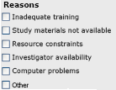 |  |  |  | All checked options are stored as an answer option in FORM_ANSWER_OPTION. QUESTION_OPTION_ID.  Question Configuration  - responseType=CHECKBOXES  options (see picture on left)
Other Reasons | FALSE | FALSE | FALSE | Question Configuration  - responseType=TEXT
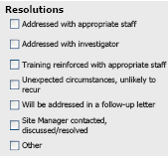 | FALSE | FALSE | FALSE | All checked options are stored as an answer option in FORM_ANSWER_OPTION. QUESTION_OPTION_ID.  Question Configuration  - responseType=CHECKBOXES  options (see picture on left)
Other Resolutions | FALSE | FALSE | FALSE | Question Configuration  - responseType=TEXT
Comments  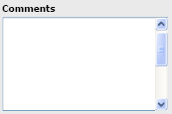 | FALSE | FALSE | FALSE | Question Configuration  - responseType=TEXTAREA
The Investigator is involved in the conduct of the study. | FALSE | TRUE | FALSE | Question Configuration  - responseType=LISTBOX  - Options  - No  - Yes  - Not Applicable
Are there any protocol revisions since the last monitoring visit | FALSE | TRUE | TRUE | Question Configuration  - responseType=LISTBOX  - Options  - No  - Yes  - Not Applicable
The staff are aware of protocol revisions | FALSE | TRUE | FALSE | Question Configuration  - responseType=LISTBOX  - Options  - No  - Yes  - Not Applicable
Was the Informed Consent Form revised since the last contact? | FALSE | TRUE | FALSE | Question Configuration  - responseType=LISTBOX  - Options  - No  - Yes  - Not Applicable  - Operation=CheckInformedConsentRevisedFromLastSMV
Are informed consents obtained and documented as described during the Pre-Study Visit.. | FALSE | TRUE | FALSE | Question Configuration  - responseType=LISTBOX  - Options  - No  - Yes  - Not Applicable
The blind has been maintained for blinded studies. | FALSE | TRUE | FALSE | If “No” fill in explanation  Question Configuration  - responseType=LISTBOX  - Options  - No  - Yes  - Not Applicable
Was it done as described in the protocol? | FALSE | TRUE | FALSE | Question Configuration  - responseType=LISTBOX  - Options  - No  - Yes  - Not Applicable
Have there been protocol deviations noted since the last monitoring visit? | FALSE | TRUE | FALSE | Question Configuration  - responseType=LISTBOX  - Options  - No  - Yes  - Not Applicable
Are there significant Protocol Deviations? | FALSE | TRUE | FALSE | If “Yes” has the Protocol Deviation must be filled out.  If “No” Deviation is entered in the SMVF  Question Configuration  - responseType=LISTBOX  - Options  - No  - Yes  - Not Applicable
Have there been protocol exceptions noted since the last monitoring visit? | TRUE | TRUE | FALSE | Question Configuration  - responseType=LISTBOX  - Options  - No  - Yes  - Not Applicable
Has the exception been received at the site? | FALSE | TRUE | FALSE | Question Configuration  - responseType=LISTBOX  - Options  - No  - Yes  - Not Applicable  - commented=true  - commentLabel=Specify
SAEs have been recorded since the last monitoring visit. | TRUE | TRUE | FALSE | Question Configuration  - responseType=LISTBOX  - Options  - No  - Yes  - Not Applicable
SAEs  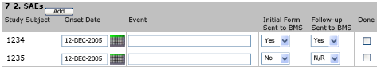 | TRUE | FALSE | FALSE | Question Configuration  - responseType=TABLE  - Operation= com.bms.informatics.Form Injection.form.bre.operation.smv.PopulateSaeTableOperation
Has the On-Site Investigator File been reviewed? | FALSE | TRUE | FALSE | Question Configuration  - responseType=LISTBOX  - Options  - No  - Yes  - Not Applicable
Has the Investigator received notification of any impending inspections? | FALSE | TRUE | FALSE | If “Yes” an Alert is to be created.  Question Configuration  - responseType=LISTBOX  - Options  - No  - Yes  - Not Applicable
The data being captured in the case report forms is adequately supported by the source documents. | FALSE | TRUE | FALSE | Question Configuration  - responseType=LISTBOX  - Options  - No  - Yes  - Not Applicable
The source documents are being accurately and consistently completed and support subjects being included in the study. | FALSE | TRUE | FALSE | Question Configuration  - responseType=LISTBOX  - Options  - No  - Yes  - Not Applicable
The CRFs are being accurately and consistently completed in a timely manner | FALSE | TRUE | FALSE | Question Configuration  - responseType=LISTBOX  - Options  - No  - Yes  - Not Applicable
CRF data is reviewed and approved by the investigator in a timely manner. | FALSE | TRUE | FALSE | Question Configuration  - responseType=LISTBOX  - Options  - No  - Yes  - Not Applicable
Data entry and data correction have been completed by authorized personnel listed on the Delegation of Authority form. | FALSE | TRUE | FALSE | Question Configuration  - responseType=LISTBOX  - Options  - No  - Yes  - Not Applicable
The case report forms have been submitted to BMS in accordance with the PIDMA (Process for Integrated Data Management and Assessment) guidelines. | FALSE | TRUE | FALSE | Question Configuration  - responseType=LISTBOX  - Options  - No  - Yes  - Not Applicable
If no, describe issue and possible action | FALSE | FALSE | FALSE | Question Configuration  - responseType=LISTBOX  - Options  - No  - Yes  - Not Applicable
The Query resolutions have been submitted to BMS in accordance with PIDMA guidelines? | FALSE | FALSE | FALSE | Question Configuration  - responseType=LISTBOX  - Options  - No  - Yes  - Not Applicable
If no, describe issue and possible action | FALSE | FALSE | FALSE | Question Configuration  - responseType=LISTBOX  - Options  - No  - Yes  - Not Applicable
Following source data verification at this visit, suggested CRF corrections were resolved by site staff. | FALSE | TRUE | FALSE | If “No”, trigger issue / flag for follow-up at next monitoring visit.  Question Configuration  - responseType=LISTBOX  - Options  - No  - Yes  - Not Applicable
Query/Discrepancy resolutions completed since the last monitoring visit have been confirmed with source documents. | FALSE | TRUE | FALSE | Question Configuration  - responseType=LISTBOX  - Options  - No  - Yes  - Not Applicable
The subject dose and/or therapy modifications are being documented | FALSE | TRUE | FALSE | Question Configuration  - responseType=LISTBOX  - Options  - No  - Yes  - Not Applicable
The BMS Visitor log was signed for this visit | FALSE | TRUE | FALSE | Question Configuration  - responseType=LISTBOX  - Options  - No  - Yes  - Not Applicable
The study drug is dispensed as per the protocol | FALSE | TRUE | FALSE | Question Configuration  - responseType=LISTBOX  - Options  - No  - Yes  - Not Applicable
If no, describe issue and possible action | FALSE | FALSE | FALSE | Question Configuration  - responseType=LISTBOX  - Options  - No  - Yes  - Not Applicable
Was the un-blinded drug monitoring log signed? | FALSE | TRUE | FALSE | Un-blinded visits only.  Question Configuration  - responseType=LISTBOX  - Options  - No  - Yes  - Not Applicable
The subject drug accountability records are up-to-date and accurate. | FALSE | TRUE | FALSE | Question Configuration  - responseType=LISTBOX  - Options  - No  - Yes  - Not Applicable
The drug supplies are properly stored. | FALSE | TRUE | FALSE | Question Configuration  - responseType=LISTBOX  - Options  - No  - Yes  - Not Applicable
The drug supply quantities and use date(s) are adequate. | FALSE | TRUE | FALSE | Question Configuration  - responseType=LISTBOX  - Options  - No  - Yes  - Not Applicable
Drug has been returned, transferred, or destroyed since the last visit. | FALSE | TRUE | FALSE | If “Yes” the following two questions are to be answered.  Question Configuration  - responseType=LISTBOX  - Options  - No  - Yes  - Not Applicable
Description of activity | FALSE | TRUE | FALSE | Question Configuration  - responseType=LISTBOX  - Options  - No  - Yes  - Not Applicable
Were copies of the inventory record sent to the site manager or unblinded BMS personnel? | FALSE | TRUE | FALSE | Question Configuration  - responseType=LISTBOX  - Options  - No  - Yes  - Not Applicable
All issues regarding previous monitoring visit(s) have been addressed or are being addressed. | FALSE | TRUE | FALSE | Question Configuration  - responseType=LISTBOX  - Options  - No  - Yes  - Not Applicable
All significant concerns have been discussed with the investigator. | FALSE | TRUE | FALSE | Question Configuration  - responseType=LISTBOX  - Options  - No  - Yes  - Not Applicable
Is the site complying with the project time lines? | FALSE | TRUE | FALSE | Question Configuration  - responseType=LISTBOX  - Options  - No  - Yes  - Not Applicable
Is the site recruiting subjects as agreed? | FALSE | TRUE | FALSE | If no please enter explanation.  Help Text – Document Barriers to  Question Configuration  - responseType=LISTBOX  - Options  - No  - Yes  - Not Applicable
Was site staff training conducted at this monitoring visit? | FALSE | TRUE | FALSE | If “Yes” select from a dropdown.  Question Configuration  - responseType=LISTBOX  - Options  - No  - Yes  - Not Applicable
A non-standard follow-up letter for this visit will be sent. | FALSE | TRUE | FALSE | Question Configuration  - responseType=LISTBOX  - Options  - No  - Yes  - Not Applicable

- Forms Configuration

FORM_TYPE Table
FORM TYPE ID | FORM TYPE NM | FORM TYPE CD | ESF FILED | APPROVAL  REQUIRED | FORM TYPE VERSION NBR | ESCALATED DURATION DAYS
1 | Protocol Exception | PE | Y | Y | 1 | 10
2 | Protocol Deviation | PD | Y | Y | 1 | 10
3 | Site Monitoring Visit | SMV | Y | Y | 1 | 10
4 | Site Closure Visit | SCV | Y | Y | 1 | 10
5 | Significant Ad-hoc Site Contact | SASC | Y | N | 1 | 10
6 | Site Initiation Visit | SIV | Y | Y | 1 | 10
7 | Pre-Study Evaluation | PSE | Y | Y | 1 | 10
8 | Potential Site Assessment | PSA | N | N | 1 | 10
9 | On-Site Investigator File | OSIF | N | N | 1 | 10
10 | Drug Reconciliation Worksheet | DRW | Y | N | 1 | 10
11 | Site Monitoring Plan | SMP | Y | Y | 1 | 10

OPERATION_RULE Table

FORM TYPE ID | RULE_ID | BOOLEAN CD | LOGICAL_EXP_CD | EXECUTE ORDER NBR | OPERATION ID | ALWAYS_APPLIED
1 | 101001 | T | if(complete) | 11 | 101001 | Y
1 | 101002 | T | if(complete and rejected(PE)) | 12 | 101002 | Y
2 | 102001 | T | if(complete) | 10 | 102001 | Y
2 | 102002 | T | if(complete and notSignificant(PD)) | 11 | 102002 | Y
3 | 4 | T | if(submit and metWitInv) | 4 | 27 | Y
3 | 103001 | T | if(complete) | 12 | 103001 | Y
3 | 103999 | T | if(submit) | 11 | 103999 | Y
4 | 104001 | T | if(complete) | 11 | 104001 | Y
4 | 104999 | T | if(submit) | 10 | 104999 | Y
5 | 105001 | T | if(complete) | 11 | 105001 | Y
6 | 1 | T | Always true | 1 | 6008 | Y
6 | 106001 | T | if(complete) | 11 | 106001 | Y
6 | 106999 | T | if(submit) | 10 | 106999 | Y
7 | 1 | T | Always true | 1 | 7008 | Y
7 | 2 | T | PSESubmit | 2 | 7009 | Y
7 | 107001 | T | if(complete) | 11 | 107001 | Y
7 | 107999 | T | if(submit) | 10 | 107999 | Y
8 | 108999 | T | if(submit) | 10 | 22 | Y
9 | 1 | T | if(reconcile) | 1 | 9999 | Y
10 | 1 | T | if(edited) | 1 | 28 | Y
10 | 110001 | T | if(complete) | 11 | 110001 | Y
11 | 11000 | T | formSubmit | 3 | 11004 | Y
11 | 11001 | T | formSubmit | 2 | 11003 | Y
11 | 11002 | T | formSave | 1 | 11004 | Y
11 | 111001 | T | if(complete) | 11 | 111001 | Y

LOGICAL_EXP Table

FORM TYPE ID | QUESTION 1 ID | LOGICAL EXP 1 CD | LOGICAL EXP 2 CD | INPUT ARG1 | LOGICAL EXP CD | RESPONSE TABLE ID | COL NBR | INPUT ARG2 | LOGIC_EXP_CLASS
1 |  | if(complete) | if(rejected(PE)) |  | if(complete and rejected(PE)) |  |  |  | com.bms.informatics.Form Injection.form.bre.exp.AndExpression
1 |  |  |  | event | if(submit) |  |  | submit | com.bms.informatics.Form Injection.form.bre.exp.FormAttributeNameArg1EqualsValueArg2Expression
1 |  |  |  | event | if(complete) |  |  | complete | com.bms.informatics.Form Injection.form.bre.exp.FormAttributeNameArg1EqualsValueArg2Expression
1 | 13 |  |  | 2 | if(rejected(PE)) |  |  |  | com.bms.informatics.Form Injection.form.bre.exp.OneEqualsArg1Expression
2 |  | if(complete) | if(notSignificant(PD)) |  | if(complete and notSignificant(PD)) |  |  |  | com.bms.informatics.Form Injection.form.bre.exp.AndExpression
2 |  | if(submit) | if(metWitInv) |  | if(submit and denialed) |  |  |  | com.bms.informatics.Form Injection.form.bre.exp.AndExpression
2 |  |  |  | event | if(submit) |  |  | submit | com.bms.informatics.Form Injection.form.bre.exp.FormAttributeNameArg1EqualsValueArg2Expression
2 |  |  |  | event | if(complete) |  |  | complete | com.bms.informatics.Form Injection.form.bre.exp.FormAttributeNameArg1EqualsValueArg2Expression
2 | 13 |  |  | 1 | if(notSignificant(PD)) |  |  |  | com.bms.informatics.Form Injection.form.bre.exp.OneEqualsArg1Expression
3 |  | if(submit) | if(metWitInv) |  | if(submit and metWitInv) |  |  |  | com.bms.informatics.Form Injection.form.bre.exp.AndExpression
3 |  |  |  | event | if(submit) |  |  | submit | com.bms.informatics.Form Injection.form.bre.exp.FormAttributeNameArg1EqualsValueArg2Expression
3 |  |  |  | event | if(complete) |  |  | complete | com.bms.informatics.Form Injection.form.bre.exp.FormAttributeNameArg1EqualsValueArg2Expression
3 | 10 |  |  | 11 | if(metWitInv) | 46 | 1 |  | com.bms.informatics.Form Injection.form.bre.exp.OneEqualsArg1Expression
4 |  |  |  | event | if(submit) |  |  | submit | com.bms.informatics.Form Injection.form.bre.exp.FormAttributeNameArg1EqualsValueArg2Expression
4 |  |  |  | event | if(complete) |  |  | complete | com.bms.informatics.Form Injection.form.bre.exp.FormAttributeNameArg1EqualsValueArg2Expression
5 |  |  |  | event | if(submit) |  |  | submit | com.bms.informatics.Form Injection.form.bre.exp.FormAttributeNameArg1EqualsValueArg2Expression
5 |  |  |  | event | if(complete) |  |  | complete | com.bms.informatics.Form Injection.form.bre.exp.FormAttributeNameArg1EqualsValueArg2Expression
6 |  |  |  | event | if(submit) |  |  | submit | com.bms.informatics.Form Injection.form.bre.exp.FormAttributeNameArg1EqualsValueArg2Expression
6 |  |  |  | event | if(complete) |  |  | complete | com.bms.informatics.Form Injection.form.bre.exp.FormAttributeNameArg1EqualsValueArg2Expression
6 |  |  |  |  | Always true |  |  |  | com.bms.informatics.Form Injection.form.bre.exp.TrueExpression
7 |  |  |  | event | PSESubmit |  |  | submit | com.bms.informatics.Form Injection.form.bre.exp.FormAttributeNameArg1EqualsValueArg2Expression
7 |  |  |  | event | if(complete) |  |  | complete | com.bms.informatics.Form Injection.form.bre.exp.FormAttributeNameArg1EqualsValueArg2Expression
7 |  |  |  | event | if(submit) |  |  | submit | com.bms.informatics.Form Injection.form.bre.exp.FormAttributeNameArg1EqualsValueArg2Expression
7 |  |  |  |  | Always true |  |  |  | com.bms.informatics.Form Injection.form.bre.exp.TrueExpression
8 |  |  |  | event | if(submit) |  |  | submit | com.bms.informatics.Form Injection.form.bre.exp.FormAttributeNameArg1EqualsValueArg2Expression
8 |  |  |  | event | if(complete) |  |  | complete | com.bms.informatics.Form Injection.form.bre.exp.FormAttributeNameArg1EqualsValueArg2Expression
9 |  |  |  | osifEvent | if(reconcile) |  |  | reconcile | com.bms.informatics.Form Injection.form.bre.exp.FormAttributeNameArg1EqualsValueArg2Expression
10 |  |  |  | event | if(edited) |  |  | edit | com.bms.informatics.Form Injection.form.bre.exp.FormAttributeNameArg1EqualsValueArg2Expression
10 |  |  |  | event | if(submit) |  |  | submit | com.bms.informatics.Form Injection.form.bre.exp.FormAttributeNameArg1EqualsValueArg2Expression
10 |  |  |  | event | if(complete) |  |  | complete | com.bms.informatics.Form Injection.form.bre.exp.FormAttributeNameArg1EqualsValueArg2Expression
11 |  |  |  | event | formSave |  |  | edit | com.bms.informatics.Form Injection.form.bre.exp.FormAttributeNameArg1EqualsValueArg2Expression
11 |  |  |  | event | formSubmit |  |  | submit | com.bms.informatics.Form Injection.form.bre.exp.FormAttributeNameArg1EqualsValueArg2Expression
11 |  |  |  | event | if(submit) |  |  | submit | com.bms.informatics.Form Injection.form.bre.exp.FormAttributeNameArg1EqualsValueArg2Expression
11 |  |  |  | event | if(complete) |  |  | complete | com.bms.informatics.Form Injection.form.bre.exp.FormAttributeNameArg1EqualsValueArg2Expression

OPERATION Table

ID | OPERATION_CLASS | OPERTION_NM
1 | com.bms.informatics.Form Injection.form.bre.operation.SetInvestigatorOperation | Set PE Investigator
2 | com.bms.informatics.Form Injection.form.bre.operation.SetCreateUserOperation | SMV Q#1 Set Preparer
3 | com.bms.informatics.Form Injection.form.bre.operation.SetProtocolSiteOperation | SMV Q#3 Set Protocol#-Site#
4 | com.bms.informatics.Form Injection.form.bre.operation.MacroOperation | SMV AutoFill Macro
5 | com.bms.informatics.Form Injection.form.bre.operation.SetCreateDateOperation | Set Create Date
6 | com.bms.informatics.Form Injection.form.bre.operation.SetPrimaryLocationOperation | Set Location address, city, state, etc
7 | com.bms.informatics.Form Injection.form.bre.operation.PopulateUserChoicesOperation | Populate User ChoicesOperation Column Choices
8 | com.bms.informatics.Form Injection.form.bre.operation.PopulateChoicesOperation | PopulateYesNoChoicesOperation
9 | com.bms.informatics.Form Injection.form.bre.operation.PopulateReasonChoicesOperation | PopulateReasonChoicesOperation
10 | com.bms.informatics.Form Injection.form.bre.operation.PopulateResolutionChoicesOperation | PopluationResolutions
11 | com.bms.informatics.Form Injection.form.bre.operation.PopulateLocationChoicesOperation | PopulateLocationChoicesOperation
12 | com.bms.informatics.Form Injection.form.bre.operation.SetStudyStatusOperation | SetStudyStatusOperation
13 | com.bms.informatics.Form Injection.form.bre.operation.PopulateChoicesOperation | Staffing Role Values Choices
14 | com.bms.informatics.Form Injection.form.bre.operation.PopulateChoicesOperation | Action Type Values Choices Population
15 | com.bms.informatics.Form Injection.form.bre.operation.PopulateChoicesOperation | Duties within Study Value Choices
16 | com.bms.informatics.Form Injection.form.bre.operation.PopulateChoicesOperation | Title Value Choices
17 | com.bms.informatics.Form Injection.form.bre.operation.PopulateChoicesOperation | Is Done Choice
18 | com.bms.informatics.Form Injection.form.bre.operation.PopulateChoicesOperation | Yes/No/Partial
19 | com.bms.informatics.Form Injection.form.bre.operation.PopulateCountryChoicesOperation | PopulateCountryChoicesOperation
20 | com.bms.informatics.Form Injection.form.bre.operation.SetVisitDateOperation | SetVisitDateOperation
21 | com.bms.informatics.Form Injection.form.bre.operation.SetVisitScheduleUserOperation | SetVisitScheduleUserOperation
22 | com.bms.informatics.Form Injection.form.bre.operation.CloseVisitOperation | CloseVisitOperation
23 | com.bms.informatics.Form Injection.form.bre.operation.SetPreparerOperation | SetPreparerOperation
24 | com.bms.informatics.Form Injection.form.bre.operation.SetPrepareDateOperation | SetPrepareDateOperation
25 | com.bms.informatics.Form Injection.form.bre.operation.PopulateChoicesOperation | Languages
26 | com.bms.informatics.Form Injection.form.bre.operation.PopulateChoicesOperation | Source Documents
27 | com.bms.informatics.Form Injection.form.bre.operation.AddFormProperty | Add metWithInv property
28 | com.bms.informatics.Form Injection.form.bre.operation.AddAnswerToFormPropertyOperation | Add description for form property
1001 | com.bms.informatics.Form Injection.form.bre.operation.PopulateChoicesOperation | Classification
1003 | com.bms.informatics.Form Injection.form.bre.operation.PopulateChoicesOperation | Decision
2003 | com.bms.informatics.Form Injection.form.bre.operation.PopulateChoicesOperation | Classification
3000 | com.bms.informatics.Form Injection.form.bre.operation.smv.PopulateSubjectVisitTableOperation | SMV Subject Visit Table
3002 | com.bms.informatics.Form Injection.form.bre.operation.smv.PopulateSaeTableOperation | SMV SAE TAble
3003 | com.bms.informatics.Form Injection.form.bre.operation.smv.PopulateInformedConsentTableOperation | SMV InformedConsent data
6000 | com.bms.informatics.Form Injection.form.bre.operation.SetInvestigatorDetailOperation | Investigator Detail
6004 | com.bms.informatics.Form Injection.form.bre.operation.PopulateProtocolSiteChoicesOperation | PopulateProtocolSiteChoicesOperation
6005 | com.bms.informatics.Form Injection.form.bre.operation.SetInvestigatorCountryOperation | Investigator Detail - Country
6006 | com.bms.informatics.Form Injection.form.bre.operation.SetStudyInfoOperation | Investigator Detail - Country
6008 | com.bms.informatics.Form Injection.form.bre.operation.pse.SelectCurrentProtocolSiteOperation | Current Protocol/Site and EdcStudy
7000 | com.bms.informatics.Form Injection.form.bre.operation.SetInvestigatorDetailOperation | Investigator Detail
7001 | com.bms.informatics.Form Injection.form.bre.operation.pse.PSESetSiteLocationTableOperation | Site Location (table level)
7002 | com.bms.informatics.Form Injection.form.bre.operation.pse.PSESetSiteLocationOperation | Drug Shipment Site Location (question level)
7004 | com.bms.informatics.Form Injection.form.bre.operation.PopulateProtocolSiteChoicesOperation | PopulateProtocolSiteChoicesOperation
7005 | com.bms.informatics.Form Injection.form.bre.operation.SetInvestigatorCountryOperation | Investigator Detail - Country
7006 | com.bms.informatics.Form Injection.form.bre.operation.SetStudyInfoOperation | Investigator Detail - Country
7007 | com.bms.informatics.Form Injection.form.bre.operation.PopulateChoicesOperation | Frequency Choices
7008 | com.bms.informatics.Form Injection.form.bre.operation.pse.SelectCurrentProtocolSiteOperation | Current Protocol/Site and EdcStudy
7009 | com.bms.informatics.Form Injection.form.bre.operation.CloseVisitOperation | Close visit and set contact date
8000 | com.bms.informatics.Form Injection.form.bre.operation.PopulateChoicesOperation | Specialities
8001 | com.bms.informatics.Form Injection.form.bre.operation.PopulateChoicesOperation | Degrees
8002 | com.bms.informatics.Form Injection.form.bre.operation.PopulateChoicesOperation | Affiliation Type
8003 | com.bms.informatics.Form Injection.form.bre.operation.PopulateChoicesOperation | Full time/Part time
8004 | com.bms.informatics.Form Injection.form.bre.operation.PopulateChoicesOperation | Areas of Interest
8005 | com.bms.informatics.Form Injection.form.bre.operation.CloseVisitOperation | Close visit and set contact date
8006 | com.bms.informatics.Form Injection.form.bre.operation.PopulateChoicesOperation | Therapeutic Areas
9000 | com.bms.informatics.Form Injection.form.bre.operation.PopulateChoicesOperation | OSIF Informed Consent Type
9001 | com.bms.informatics.Form Injection.form.bre.operation.PopulateChoicesOperation | OSIF Accreditation Body
9002 | com.bms.informatics.Form Injection.form.bre.operation.osif.PopulateProtocolTableOperation | OSIF populate protocol documents
9003 | com.bms.informatics.Form Injection.form.bre.operation.PopulateChoicesOperation | OSIF Type
9004 | com.bms.informatics.Form Injection.form.bre.operation.PopulateChoicesOperation | OSIF Status
9005 | com.bms.informatics.Form Injection.form.bre.operation.PopulateChoicesOperation | OSIF Type
9007 | com.bms.informatics.Form Injection.form.bre.operation.osif.PopulateDeviationTableOperation | OSIF PopulateDeviationTableOperation
9008 | com.bms.informatics.Form Injection.form.bre.operation.osif.PopulateExceptionTableOperation | OSIF PopulateExceptionTableOperation
9010 | com.bms.informatics.Form Injection.form.bre.operation.osif.PopulateSafetyTableOperation | OSIF PopulateSafetyTableOperation
9011 | com.bms.informatics.Form Injection.form.bre.operation.osif.PopulateSaeTableOperation | OSIF SAE Table
9088 | com.bms.informatics.Form Injection.form.bre.operation.osif.ReconcileOperation | OSIF ReconcileOperation
9089 | com.bms.informatics.Form Injection.form.bre.operation.ProduceNotificationOperation | OSIF ProduceNotificationOperation
9099 | com.bms.informatics.Form Injection.form.bre.operation.osif.PopulateUnreconciledOperation. | OSIF PopulateUnreconciledOperation
9999 | com.bms.informatics.Form Injection.form.bre.operation.MacroOperation | OSIF Submission Macro
11000 | com.bms.informatics.Form Injection.form.bre.operation.SetPreparerOperation | Set Preparer
11001 | com.bms.informatics.Form Injection.form.bre.operation.SetAssignedProtocolListOperation | Set Assigned Protocols in listbox
11002 | com.bms.informatics.Form Injection.form.bre.operation.PopulateChoicesOperation | Yes/No Only
11003 | com.bms.informatics.Form Injection.form.bre.operation.smp.SaveStudyInfoOperation | Saves Study Info and Protocol Help Text
11004 | com.bms.informatics.Form Injection.form.bre.operation.smp.ApplyStudyIDOperation | Applies the form study id
101000 | com.bms.informatics.Form Injection.form.bre.operation.AssignReviewerOperation | PE Assign reviewer
101001 | com.bms.informatics.Form Injection.form.bre.operation.esf.ESFSecretaryOperation | PE Set ESF information
101002 | com.bms.informatics.Form Injection.form.bre.operation.AddFormProperty | PE Denied Protocol Exceptions
102000 | com.bms.informatics.Form Injection.form.bre.operation.AssignReviewerOperation | PD Assign reviewer
102001 | com.bms.informatics.Form Injection.form.bre.operation.esf.ESFSecretaryOperation | PD Set ESF information
102002 | com.bms.informatics.Form Injection.form.bre.operation.AddFormProperty | PD Nonsignificant Deviations
103000 | com.bms.informatics.Form Injection.form.bre.operation.AssignReviewerOperation | SMV Assign reviewer
103001 | com.bms.informatics.Form Injection.form.bre.operation.esf.ESFSecretaryOperation | SMV Set ESF information
103999 | com.bms.informatics.Form Injection.form.bre.operation.MacroOperation | SMV Submit Macro
104000 | com.bms.informatics.Form Injection.form.bre.operation.AssignReviewerOperation | SCV Assign reviewer
104001 | com.bms.informatics.Form Injection.form.bre.operation.esf.ESFSecretaryOperation | SCV Set ESF information
104999 | com.bms.informatics.Form Injection.form.bre.operation.MacroOperation | SCV Submit Macro
105000 | com.bms.informatics.Form Injection.form.bre.operation.AssignReviewerOperation | SASC Assign reviewer
105001 | com.bms.informatics.Form Injection.form.bre.operation.esf.ESFSecretaryOperation | SASC Set ESF information
106000 | com.bms.informatics.Form Injection.form.bre.operation.AssignReviewerOperation | SIV Assign reviewer
106001 | com.bms.informatics.Form Injection.form.bre.operation.esf.ESFSecretaryOperation | SIV Set ESF information
106999 | com.bms.informatics.Form Injection.form.bre.operation.MacroOperation | SIV Submit Macro
107000 | com.bms.informatics.Form Injection.form.bre.operation.AssignReviewerOperation | PSE Assign reviewer
107001 | com.bms.informatics.Form Injection.form.bre.operation.esf.ESFSecretaryOperation | PSE Set ESF information
107999 | com.bms.informatics.Form Injection.form.bre.operation.MacroOperation | PSE Submit Macro
109000 | com.bms.informatics.Form Injection.form.bre.operation.AssignReviewerOperation | OSIF Assign reviewer
109001 | com.bms.informatics.Form Injection.form.bre.operation.esf.ESFSecretaryOperation | OSIF Set ESF information
110000 | com.bms.informatics.Form Injection.form.bre.operation.AssignReviewerOperation | DRW Assign reviewer
110001 | com.bms.informatics.Form Injection.form.bre.operation.esf.ESFSecretaryOperation | DRW Set ESF information
111000 | com.bms.informatics.Form Injection.form.bre.operation.AssignReviewerOperation | SMP Assign reviewer
111001 | com.bms.informatics.Form Injection.form.bre.operation.esf.ESFSecretaryOperation | SMP Set ESF information

OPERATION_INPUT Table

ID | Name | Value | #
1 | targetTrueQuestionPropBool | investigator | 0
2 | targetTrueQuestionPropBool | originator | 0
3 | targetTrueQuestionPropBool | protocolSite | 0
4 | operationPK | 1 | 0
4 | operationPK | 2 | 1
4 | operationPK | 3 | 2
5 | targetTrueQuestionPropBool | createDate | 0
7 | targetTrueColumnAttributeBool | personnel | 0
8 | defaultSelected |  | 1
8 | choice |  | 2
8 | choice | Yes | 3
8 | choice | No | 4
8 | choice | N/E | 5
13 | choice | Contact | 1
13 | choice | Data Manager | 2
13 | choice | Dietician | 3
13 | choice | Financial Contact | 4
13 | choice | Other | 5
13 | choice | Pharmacist | 6
13 | choice | Radiologist | 7
13 | choice | Regulatory Document Manager | 8
13 | choice | Study Coordinator | 9
13 | choice | Sub-Investigator | 10
13 | choice | Investigator | 11
14 | choice | Changed | 1
14 | choice | Left Site | 2
14 | choice | New | 3
15 | choice | CRF Completion | 1
15 | choice | Experience with CRF completion | 2
15 | choice | CRF Correction | 3
15 | choice | Drug Accountability | 4
15 | choice | Drug Dispensing | 5
15 | choice | Lab Sample Processing | 6
15 | choice | Medical Decision | 7
15 | choice | Medical Exam | 8
15 | choice | Non-medical conduct | 9
15 | choice | Obtain Patient Consent | 10
15 | choice | Other | 11
15 | choice | Specify | 12
15 | choice | Patient Enrollment /Randomization | 13
15 | choice | Rater/Assessor | 14
15 | choice | Regulatory Binder | 15
15 | choice | Signs CRF | 16
15 | choice | Submission of answers to queries | 17
15 | choice | Submission of CRF pages | 18
15 | choice | Unblinded drug responsibilities | 19
16 | choice |  | 1
16 | choice | Dr. | 2
16 | choice | Miss | 3
16 | choice | Mr. | 4
16 | choice | Mrs. | 5
16 | choice | Ms. | 6
16 | choice | Prof. | 7
17 | choice |  | 1
18 | choice | Yes | 1
18 | choice | No | 2
18 | choice | Partial | 3
25 | choice | Basque | 1
25 | choice | Bulgarian | 2
25 | choice | Catalan | 3
25 | choice | Chinese | 4
25 | choice | Croatian | 5
25 | choice | Czech | 6
25 | choice | Dutch | 7
25 | choice | English | 8
25 | choice | Estonian | 9
25 | choice | Flemish | 10
25 | choice | French | 11
25 | choice | Galician | 12
25 | choice | German | 13
25 | choice | Greek | 14
25 | choice | Hebrew | 15
25 | choice | Hungarian | 16
25 | choice | Indonesian | 17
25 | choice | Irish | 18
25 | choice | Italian | 19
25 | choice | Japanese | 20
25 | choice | Korean | 21
25 | choice | Latvian | 22
25 | choice | Lithuanian | 23
25 | choice | Malay | 24
25 | choice | Norwegian | 25
25 | choice | Polish | 26
25 | choice | Portuguese | 27
25 | choice | Romanian | 28
25 | choice | Russian | 29
25 | choice | Serbian | 30
25 | choice | Slovak | 31
25 | choice | Slovenian | 32
25 | choice | Spanish | 33
25 | choice | Swedish | 34
25 | choice | Tagalog | 35
25 | choice | Thai | 36
25 | choice | Turkish | 37
25 | choice | Urdu | 38
25 | choice | Vietnamese | 39
25 | choice | Visayan | 40
26 | choice | Study source document worksheets | 1
26 | choice | Office / clinic chart | 2
26 | choice | Shadow chart - copy of clinic chart for study visits only | 3
26 | choice | Hospital chart | 4
26 | choice | Medical records received from other facilities | 5
26 | choice | Laboratory reports | 6
26 | choice | X-Ray reports | 7
26 | choice | Medication records | 8
26 | choice | Other: Specify in Comments section below | 9
27 | metWithInv | TRUE | 1
28 | formPropertyName | description | 0
28 | targetTrueQuestionPropBool | description | 1
1001 | choice | Inclusion/Exclusion | 1
1001 | choice | Other | 2
1003 | choice | Approved | 1
1003 | choice | Rejected | 2
2003 | choice | Inclusion/Exclusion | 1
2003 | choice | Failure to discontinue subject | 2
2003 | choice | Errors in Treatment Assignment | 3
2003 | choice | Incorrect Dosing | 4
2003 | choice | Prohibited Concomitant Medication | 5
2003 | choice | Poor Study Drug Compliance | 6
2003 | choice | Other | 7
7007 | choice | Daily | 1
7007 | choice | Twice per week | 2
7007 | choice | Once per week | 3
7007 | choice | Twice per month | 4
7007 | choice | Once per month | 5
7007 | choice | Every other month | 6
7007 | choice | Once per quarter | 7
7007 | choice | Twice per year | 8
7007 | choice | Once per year | 9
7007 | choice | On as-needed basis only | 10
8000 | Specialties | ALLERGY | 1
8000 | Specialties | ANESTHESIOLOGY | 2
8000 | Specialties | BIOCHEMISTRY | 3
8000 | Specialties | CARDIOLOGY | 4
8000 | Specialties | CLINICAL CHEMISTRY | 5
8000 | Specialties | CLINICAL GENETICS MEDICINE | 6
8000 | Specialties | CLINICAL PHARMACOLOGY | 7
8000 | Specialties | DENTISTRY | 8
8000 | Specialties | DERMATOLOGY | 9
8000 | Specialties | DIABETES | 10
8000 | Specialties | EMERGENCY MEDICINE | 11
8000 | Specialties | ENDOCRINOLOGY / METABOLISM | 12
8000 | Specialties | GASTROENTEROLOGY | 13
8000 | Specialties | GENERAL FAMILY PRACTICE / PRIMARY CARE | 14
8000 | Specialties | GENITOURINARY | 15
8000 | Specialties | GERIATRICS | 16
8000 | Specialties | HEMATOLOGY | 17
8000 | Specialties | HIV | 18
8000 | Specialties | IMMUNOLOGY / TRANSPLANTATION | 19
8000 | Specialties | INFECTIOUS DISEASE / TROPICAL MEDICINE | 20
8000 | Specialties | INTERNAL MEDICINE | 21
8000 | Specialties | MICROBIOLOGY | 22
8000 | Specialties | RHEUMATOLOGY | 23
8000 | Specialties | NEPHROLOGY | 24
8000 | Specialties | NEUROLOGY | 25
8000 | Specialties | OBSTETRICS & GYNECOLOGY | 26
8000 | Specialties | ONCOLOGY | 27
8000 | Specialties | OPHTHALMOLOGY | 28
8000 | Specialties | ORTHOPEDICS | 29
8000 | Specialties | OTOLARYNGOLOGY | 30
8000 | Specialties | PALLIATIVE MEDICINE | 31
8000 | Specialties | PATHOLOGY | 32
8000 | Specialties | PEDIATRICS | 33
8000 | Specialties | PHYSICAL MEDICINE & REHABILITATION | 34
8000 | Specialties | PODIATRY | 35
8000 | Specialties | PSYCHIATRY | 36
8000 | Specialties | PULMONARY / RESPIRATORY MEDICINE | 37
8000 | Specialties | RADIOLOGY / NUCLEAR MEDICINE | 38
8000 | Specialties | SURGERY | 39
8001 | Degrees | MBBCh | 1
8001 | Degrees | MBBS | 2
8001 | Degrees | MD | 3
8001 | Degrees | PharmD | 4
8001 | Degrees | PhD | 5
8001 | Degrees | Other | 6
8002 | Affiliation Type | Clinic | 1
8002 | Affiliation Type | Hospital | 2
8002 | Affiliation Type | Medical School | 3
8002 | Affiliation Type | Network | 4
8002 | Affiliation Type | Private Practice | 5
8002 | Affiliation Type | SMO | 6
8003 | Full Time/Part Time | Full time | 1
8003 | Full Time/Part Time | Part time | 2
8004 | Areas of Interest | Asthma | 1
8004 | Areas of Interest | Angioedema | 2
8006 | Therapeutic Areas | Cardiovascular/Metabolics | 1
8006 | Therapeutic Areas | Infectious Diseases | 2
8006 | Therapeutic Areas | Immunology/Inflammatory/Pulmonary/Dermatology | 3
8006 | Therapeutic Areas | Neuroscience | 4
8006 | Therapeutic Areas | Oncology | 5
8006 | Therapeutic Areas | Cardiovascular | 6
8006 | Therapeutic Areas | Metabolics | 7
8006 | Therapeutic Areas | Other | 8
9000 | Informed Consent Type | Extension | 1
9000 | Informed Consent Type | Main | 2
9000 | Informed Consent Type | Pharmocogenomic | 3
9000 | Informed Consent Type | Sub-study | 4
9000 | Informed Consent Type | WOCBP | 5
9001 | Accreditation Body | CLIA | 1
9001 | Accreditation Body | CAP | 2
9001 | Accreditation Body | CLIA Waiver | 3
9001 | Accreditation Body | Other | 4
9001 | Accreditation Body | Not Applicable | 5
9003 | Type | Initial | 1
9003 | Type | Follow up | 2
9004 | Status | Present | 1
9004 | Status | Complete | 2
9004 | Status | Filed | 3
9004 | Status | N/A | 4
9005 | Type | 1572 form | 1
9005 | Type | Memo | 2
9005 | Type | Other | 3
9089 | topic | OSIFReconciled | 0
9999 | operationPK | 9088 | 0
9999 | operationPK | 9089 | 1
11002 | choice | Yes | 1
11002 | choice | No | 2
101000 | * | MM | 0
101001 | document_sub_type | Approval for Protocol Exceptions | 0
101001 | document_type | Monitoring | 1
101002 | documentSubType | Denied Protocol Exceptions | 0
102000 | * | PTM | 0
102001 | document_sub_type | Protocol Deviations | 0
102001 | document_type | Monitoring | 1
102002 | documentSubType | Nonsignificant Deviations | 0
103000 | Site Manager | PTM | 0
103000 | Protocol Manager | STM | 1
103000 | Site Monitor | STM | 2
103000 | Unblinded Site Monitor | STM | 3
103001 | document_type | Monitoring | 0
103001 | document_sub_type | Site Monitoring Visit Report | 1
103999 | operationPK | 22 | 1
104000 | Site Monitor | STM | 0
104001 | document_type | Monitoring | 0
104001 | document_sub_type | Site Closure Report | 1
104999 | operationPK | 22 | 1
105001 | document_type | Monitoring | 0
105001 | document_sub_type | Site Contact Report | 1
106000 | Site Monitor | STM | 0
106001 | document_type | Monitoring | 0
106001 | document_sub_type | Site Initiation Report | 1
106999 | operationPK | 22 | 1
107000 | Site Monitor | STM | 0
107001 | document_type | Monitoring | 0
107001 | document_sub_type | Prestudy Evaluation Report | 1
107999 | operationPK | 22 | 1
110001 | Site Monitor | STM | 0
110001 | document_type | Drug Supply | 0
110001 | document_sub_type | Drug Reconciliation | 1
111001 | Protocol Manager | PTM | 0
111001 | document_type | Plans | 0
111001 | document_sub_type | Monitoring Plan | 1

Operations Overview

The following table provides a brief description of all operations used in FORM INJECTION form management.

Operation Class | Overview
com.bms.informatics.Form Injection.form.bre.operation.AddAnswerToFormPropertyOperation | AddAnswerToFormPropertyOperation adds a given question's answer to a form property.  Operation parameters  - formPropertyName - the form property name to add  - targetTrueQuestionPropBool – the form question with this given attribute name and value=true will be used. Its answer will be added as a form property.
com.bms.informatics.Form Injection.form.bre.operation.AddFormProperty | AddFormProperty adds a property to a form. The form property name and value are configured via operation parameters (
com.bms.informatics.Form Injection.form.bre.operation.AssignReviewerOperation | AssignReviewerOperation provides a function to assign a reviewer to a form. The assignments are based on the role of the originator who submitted the form. For example, if the “Site Monitor” submitted a form then the “Site Manager” will be assigned as the reviewer.
com.bms.informatics.Form Injection.form.bre.operation.CloseVisitOperation | CloseVisitOperation closes the scheduled visit for a given form and sets the form’s contact date. The value of the contact date will be taken from an answer where its corresponding question or column has the attribute contactDate=true.
com.bms.informatics.Form Injection.form.bre.operation.MacroOperation | MacroOperation is an operation that executes other operations. One or more operation parameters (operationPK) are provided to determine what operations to execute.
com.bms.informatics.Form Injection.form.bre.operation.PopulateChoicesOperation | PopulateChoicesOperation provides a function to construct choices (list boxes, radio boxes, and check boxes) for a question and or column based on operation parameters.
com.bms.informatics.Form Injection.form.bre.operation.PopulateCountryChoicesOperation | PopulateCountryChoicesOperation constructs choices with a collection of countries.
com.bms.informatics.Form Injection.form.bre.operation.PopulateLocationChoicesOperation | PopulateLocationChoicesOperation provides a function to set question or column’s choices with the locations of a given site.
com.bms.informatics.Form Injection.form.bre.operation.PopulateProtocolSiteChoicesOperation | PopulateProtocolSiteChoicesOperation provides a function to set question or column’s choices with the study drug-protocol-site numbers of a given site.
com.bms.informatics.Form Injection.form.bre.operation.PopulateReasonChoicesOperation | PopulateReasonChoicesOperation provides a function to set question or column choices with reason values:  - Inadequate training  - Study materials not  - Investigator availability  - Computer problems  - Other
com.bms.informatics.Form Injection.form.bre.operation.PopulateResolutionChoicesOperation | PopulateResolutionChoicesOperation provides a function to set question or column choices with a resolutions values:  - Addressed with appropriate staff  - Addressed with investigator  - Unexpected circumstances, unlikely to recur  - Will be addressed in a follow-up letter  - Other
com.bms.informatics.Form Injection.form.bre.operation.PopulateUserChoicesOperation | PopulateUserChoicesOperation provides functions to populate a list of system users.
com.bms.informatics.Form Injection.form.bre.operation.ProduceNotificationOperation | ProduceNotificationOperation provides a function to publish a notification message with the form as the embedded object.
com.bms.informatics.Form Injection.form.bre.operation.SetAssignedProtocolListOperation | SetAssignedProtocolListOperation populates a given question with choices consisting of the protocol/sites that the originator has access to.
com.bms.informatics.Form Injection.form.bre.operation.SetCreateDateOperation | SetCreateDateOperation creates an answer to a question with the create date of the form.
com.bms.informatics.Form Injection.form.bre.operation.SetCreateUserOperation | SetCreateUserOperation creates an answer to a question with the create user’s title, first name, and last name.
com.bms.informatics.Form Injection.form.bre.operation.SetInvestigatorCountryOperation | SetInvestigatorCountryOperation provides an operation to set the investigator country on a given question.
com.bms.informatics.Form Injection.form.bre.operation.SetInvestigatorDetailOperation | SetInvestigatorDetailOperation provides a function to set the investigator information on a target question.
com.bms.informatics.Form Injection.form.bre.operation.SetInvestigatorOperation | SetInvestigatorOperation provides a function to set the investigator's name on a target question.
com.bms.informatics.Form Injection.form.bre.operation.SetPrepareDateOperation | SetPrepareDateOperation answers a question with the current date.
com.bms.informatics.Form Injection.form.bre.operation.SetPreparerOperation | SetPreparerOperation answers a question with the originator’s first and last name.
com.bms.informatics.Form Injection.form.bre.operation.SetPrimaryLocationOperation | SetLocationOperation provides a function to set the primary site location information on form questions.
com.bms.informatics.Form Injection.form.bre.operation.SetProtocolSiteOperation | SetProtocolSiteOperation provides a function to set the protocolNumber-siteNumber on a target question.  This operation will also set the study, site information if the form’s site ID is null and the given question has an answer.
com.bms.informatics.Form Injection.form.bre.operation.SetStudyInfoOperation | SetStudyInfoOperation provides a function to set the form study information.
com.bms.informatics.Form Injection.form.bre.operation.SetStudyStatusOperation | SetStudyStatusOperation operation that sets the study status on a given question.
com.bms.informatics.Form Injection.form.bre.operation.SetVisitDateOperation | SetVisitDateOperation answers a question with the form’s schedule visit date.
com.bms.informatics.Form Injection.form.bre.operation.SetVisitScheduleUserOperation | SetVisitScheduleUserOperation answers a question with the name of the user who scheduled the form visit.
com.bms.informatics.Form Injection.form.bre.operation.esf.ESFSecretaryOperation | ESFSecretaryOperation populates information such as the document type and sub document type needed to file form documents into ESF.
com.bms.informatics.Form Injection.form.bre.operation.osif.PopulateDeviationTableOperation | PopulateDeviationTableOperation BRE operation to populate OSIF Protocol Deviation section with data from the library.
com.bms.informatics.Form Injection.form.bre.operation.osif.PopulateExceptionTableOperation | PopulateExceptionTableOperation BRE operation to populate OSIF Protocol Exception section with data from the library.
com.bms.informatics.Form Injection.form.bre.operation.osif.PopulateProtocolTableOperation | PopulateProtocolTableOperation BRE operation to populate OSIF with data from the library.
com.bms.informatics.Form Injection.form.bre.operation.osif.PopulateSaeTableOperation | PopulateSAETableOperation BRE operation to populate the question SAE of the OSIF form with data from the SAE table.
com.bms.informatics.Form Injection.form.bre.operation.osif.PopulateSafetyTableOperation | PopulateSafetyTableOperation BRE operation to populate OSIF with data from the library.
com.bms.informatics.Form Injection.form.bre.operation.osif.ReconcileOperation | ReconcileOperation deletes completed OSIF records.
com.bms.informatics.Form Injection.form.bre.operation.pse.PSESetSiteLocationOperation | PSESetSiteLocationOperation populates location information on the PSE form based on a given location purpose.
com.bms.informatics.Form Injection.form.bre.operation.pse.PSESetSiteLocationTableOperation | PSESetSiteLocationTableOperation populates location information on the PSE form.
com.bms.informatics.Form Injection.form.bre.operation.pse.SelectCurrentProtocolSiteOperation | PSESetSiteLocationOperation associates the PSE with a given study.
com.bms.informatics.Form Injection.form.bre.operation.smp.ApplyStudyIDOperation | ApplyStudyIDOperation sets form study ID and protocol number.
com.bms.informatics.Form Injection.form.bre.operation.smp.SaveStudyInfoOperation | SaveStudyInfoOperation populates protocol grid information with data from the site monitoring plan.
com.bms.informatics.Form Injection.form.bre.operation.smv.PopulateInformedConsentTableOperation | PopulateInformedConsentTableOperation BRE operation to populate SMV Informed consent question with data from the reporting informed consent table.
com.bms.informatics.Form Injection.form.bre.operation.smv.PopulateSaeTableOperation | PopulateSAETableOperation BRE operation to populate SAE with data from the SAE reporting table.
com.bms.informatics.Form Injection.form.bre.operation.smv.PopulateSubjectVisitTableOperation | PopulateSubjectVisitTableOperation BRE operation to populate Subject Visits with data from the Patient visits reporting table.

