Evelyn Cheng

Quantitative Conservation Biology

Homework 6

3/5/2013

1.

a.) Make a simple demographic matrix model (no stochasticity, no density dependence) for the Leadbeater’s possum:

[Sjuv]*[Fjuv] = [0.7] * [(0*0.45)+(1*0.3)+(2*0.18)+(3*0.06)+(4*0.01)] = 0.616

> possum<-matrix(c(0,0.616,0.616,1,0,0,0,0.7,0.7),3,3,byrow=TRUE)

> possum

[,1] [,2] [,3]

[1,] 0 0.616 0.616

[2,] 1 0.000 0.000

[3,] 0 0.700 0.700

Lambda should be equal to the ideal population growth rate given in the table:

> eigen(possum)

1.209360

--------------------------------------------------------------------

b.)

* What is the elasticity value for adult survival?

Use the 'brute force' method to change the value for adult survival by 0.05, calculate lambda for the new matrix, and then find the proportion (δλ/λ)/(δaji/δaji).

First, to find the value of Fad: repro. value = ad. survival * Fad

0.616 = .700 * Fad

Fad = 0.88

Calculate new adult survival: 95%*0.700 = 0.665

Calculate new repro. value: 0.665*0.88 = 0.5852

> possum.as

[,1] [,2] [,3]

[1,] 0 0.616 0.585

[2,] 1 0.000 0.000

[3,] 0 0.700 0.665

New λ = eigen(possum.as) = 1.1848

(δλ/λ) = (1.209-1.185)/1.209 = 0.0199

0.0199/0.05 = 0.398.

* What is the elasticity value for juvenile survival?

New juvenile survival rate = 0.665

New repro. value = 0.585

> possum.js

[,1] [,2] [,3]

[1,] 0 0.585 0.616

[2,] 1 0.000 0.000

[3,] 0 0.665 0.700

New λ = eigen(possum.js) = 1.191

(δλ/λ) = (1.209-1.191)/1.209 = 0.0149

0.0149/0.05 = 0.298

* What is the elasticity value for mean number of female offspring per juvenile female?

First, to find the value of Fjuv: repro. value = juv. survival * Fjuv

0.616 = .700 * Fjuv

Fjuv = 0.88

Calculate new female offspring per juvenile Fjuv : 95% * 0.88 = 0.836

Calculate new repro. value: 0.7 * 0.836 = 0.585

> possum.jo

[,1] [,2] [,3]

[1,] 0 0.585 0.616

[2,] 1 0.000 0.000

[3,] 0 0.700 0.700

New λ = eigen(possum.jo) = 1.202

(δλ/λ) = (1.209-1.202)/1.209 = 0.00579

0.00579/0.05 = 0.116

* What is the elasticity value for mean number of female offspring per adult female?

> possum.ao

[,1] [,2] [,3]

[1,] 0 0.616 0.585

[2,] 1 0.000 0.000

[3,] 0 0.700 0.700

New λ = eigen(possum.jo) = 1.199

(1.209-1.199)/1.209 = 0.00827

0.00827/0.05 = 0.165

* Changes in these different rates for conservation varies in importance for each vital rate that is changed. The vital rates, in descending order of importance, are: adult survival, juvenile survival, mean number of female offspring per adult female, and mean number of female offspring per juvenile female. Elasticities measure the proportional change in population growth rate, when vital rate is changed by a proportional amount (e.g. 5%). The results of this exercise indicate that population growth rate would have a greater response to a change in adult survival than it would to the same proportion of change in mean number of female offspring per juvenile. Thus, conservation efforts should aim to focus mainly on adult survival.

----------------------------------------------------------------------------------

c.)

"The big conservation concern for this species is the effect of logging in fragmenting populations. This leads to small populations, the potential for genetic problems, and – what concerns us here - the likelihood of large increases in juvenile mortality, since juveniles disperse to find new places to live."

Make two figures:

* lambda values vs. values of juvenile survival ranging from 0.05 to 1.0:

> possum<-matrix(c(0,.616,.616,1,0,0,0,.7,.7),3,3,byrow=TRUE)

> pmatrix<-matrix(nrow=3,ncol=3) #makes an empty matrix

> pmatrix<-possum #stores the possum matrix in the pmatrix

> lams=NULL

> jsurv<-seq(0.05,1,by=0.01)

> for(i in jsurv) {

+ pmatrix[3,2]<-i

+ pmatrix[1,2]<-i*0.88

+ ev<-eigen(pmatrix)

+ lams<-c(lams,ev$values[1])

+ }

> lams<-as.matrix(lams)

> jsurv<-as.matrix(jsurv)

> plot(jsurv,lams,xlab="juvenile survival",ylab="lambda",type="l")

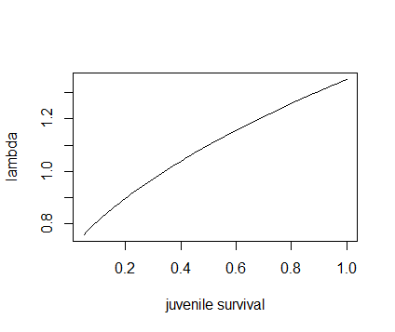

and

* % change in lambda values vs. % change in juvenile survival (ranging from the % changes needed to get from 0.05 to 1.0 in survival values):

plams=NULL

percjs=NULL

l=NULL

js=NULL

for(i in 1:length(jsurv)) {

l<-((lams[i]-1.209)/1.209)

js<-((jsurv[i]-0.7)/0.7)

plams<-c(plams,l)

percjs<-c(percjs,js)

}

percjs<-percjs*100

plams<-plams*100

plot(percjs,plams,xlab="percent change in juvenile survival",ylab="percent change in lambdas",type="l")

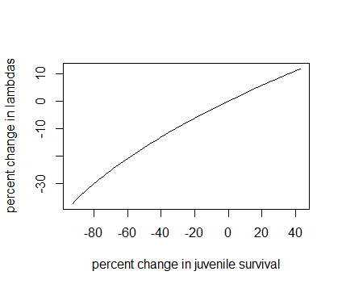

d.)

These figures show how moderate to large changes in juvenile survival can have an impact on population viability… For the first graph (lambda vs. juvenile survival), the slope of the graph at various chosen values of juvenile survival tells gives the sensitivity of lambda to juvenile survival at that value of juvenile survival. Since the slope of the graph is slightly steeper at the lower quarter of juvenile survival values, lambda is more sensitive to these lower values of juvenile survival. For "moderate to large" changes in juvenile survival (i.e. juvenile survival >0.3), there is less of a response in lambda.

The second graph (% change in λ vs. % change in juvenile survival) is similar to the first, but it shows the proportional change in lambda in response to proportional change in juvenile survival. In this graph, the slopes of tangent lines give elasticities. Elasticities are useful when comparing lambda's responses to changes in different vital rates, because they allow different vital rates to be compared on the same scale. According to this graph, if the juvenile survival rate decreased by ~20% (from 0.7), lambda would decrease by ~10%.

Though the simple elasticity values calculated above (by making small changes in vital rates and then calculating the effects of the changes on lambda), may be accurate estimates of the proportional sensitivites of lambda to changes in certain vital rates, care needs to be exercised before using the information to estimate the impacts of management on this species. Management actions don't only act on one vital rate at a time, and it can also be difficult to isolate the effects of these actions from other factors (environmental and demographic).

2. Matrices for 3 transitions observed during a 4 season study of the rare, short-lived naked stink rat of Nebraska:

> mx1

[,1] [,2]

[1,] 0.0 4.0

[2,] 0.2 0.1

> mx2

[,1] [,2]

[1,] 0.0 0.4

[2,] 0.3 0.8

> mx3

[,1] [,2]

[1,] 0.80 0.01

[2,] 0.05 0.10

a.) The long-term growth rates predicted by each of these matrices:

> eigen(mx1)

0.9458236

> eigen(mx2)

0.9291503

> eigen(mx3)

0.80071356

b.)

"Construct a simulation to estimate the long-term stochastic growth rate if these three matrices occur at random, and write a short paragraph that compares your answer to the results in part 2a."

Modify SimpleGrowthChooser.r:

mx1<-matrix(c(0,0.2,4,0.1),2,2)

mx2<-matrix(c(0,0.3,0.4,0.8),2,2)

mx3<-matrix(c(0.8,0.05,0.01,0.1),2,2)

# -----INPUT PARAMETERS----------------------

maxyr = 100 # the number of years to simulate

startN = c(500,500) # starting population size vector/matrix

Reps = 50 # number of replicate runs to make

#---- END OF INPUTS ---------------------------

Ns = matrix(0,maxyr,Reps) # set up a matrix for the pop sizes to fill

n<-c(1,2,3)

for (jj in 1:Reps) {

N0 = startN

Ns[1,jj]=sum(startN) # initialize with starting pop size

for (ii in 1:(maxyr-1)) {

#lam_t=lams[sample(ncol(lams),size=2,replace=TRUE) # choose a random lambda value

mx=NULL

choose <- sample(n,1,replace=TRUE)

if (choose == 1 ) {

mx = mx1

} else if (choose == 2) {

mx = mx2

} else {

mx = mx3

}

N0<-mx%*%N0

Ns[(ii+1),jj]<-sum(N0)

} # end of ii loop

} # end of jj loop

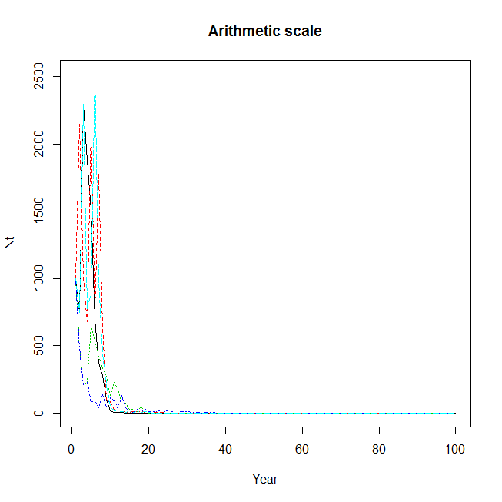

The long-term stochastic growth rate if the three matrices occur at random is:

> lambdas<-((Ns[2:l])/(Ns[1:(l-1)])) #calculate lambdas for each transition

> (prod(lambdas))^(1/99) #find geometric mean of the lambdas

[1] 0.7332189

This calculated long-term stochastic growth rate, which applies when all three matrices occur at random, is less than the long-term growth rates predicted by each matrix on its own; using all three matrices increases variability, which decreases long-term growth rate.