Evelyn Cheng

Quantitative Conservation Biology

Homework 2

1/29/2013

1.

a.) Plot population size vs. year for the Rindal, Norway rock ptarmigan population data set, to get a sense of trends and variability in the data from 1945-1967.

> year=1945:1967

> year

[1] 1945 1946 1947 1948 1949 1950 1951 1952 1953 1954 1955 1956 1957 1958 1959 1960 1961 1962 1963 1964 1965

[22] 1966 1967

> population<-scan()

> population

[1] 896 362 547 151 730 370 112 458 751 847 795 654 468 1602 1881 277 646 608 2685 545 712

[22] 1765 1454

> ptarmigan=cbind(year,population)

> plot(ptarmigan,type="o")

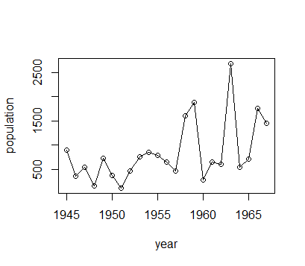

b.)

Make a scatterplot of lambda values vs. time (plot each lambda against the starting year for the estimate).

> l=length(year)

> l

[1] 23

> lambdas<-((population[2:l])/(population[1:(l-1)]))

> lams=cbind(year,lambdas)

> lams

year lambdas

[1,] 1945 0.4040179

[2,] 1946 1.5110497

[3,] 1947 0.2760512

[4,] 1948 4.8344371

[5,] 1949 0.5068493

[6,] 1950 0.3027027

[7,] 1951 4.0892857

[8,] 1952 1.6397380

[9,] 1953 1.1278296

[10,] 1954 0.9386068

[11,] 1955 0.8226415

[12,] 1956 0.7155963

[13,] 1957 3.4230769

[14,] 1958 1.1741573

[15,] 1959 0.1472621

[16,] 1960 2.3321300

[17,] 1961 0.9411765

[18,] 1962 4.4161184

[19,] 1963 0.2029795

[20,] 1964 1.3064220

[21,] 1965 2.4789326

[22,] 1966 0.8237960

[23,] 1967 0.4040179

> plot(lams,type="o")

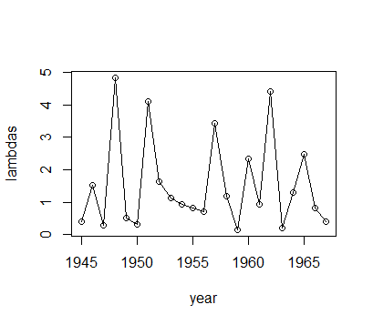

Make a histogram of the log(lambda) values.

> hist((log(lambdas)))

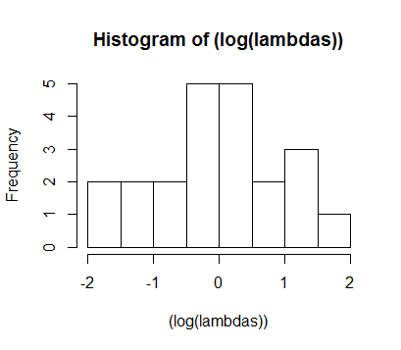

Looking at these two plots in 1b, it seems somewhat appropriate to use a simple stochastic exponential model to estimate extinction risk for this population. The best candidates for this type of model would show no evidence of density-dependence, but this population seems to almost consistently show increased λ values in years following low population sizes, and decreased λ values in years following high population sizes. However, there does not seem to be evidence of λ changing in a directed manner over time. Also, the histogram indicates that the log(lambda) values are somewhat normally distributed (it's difficult to tell with such a small sample size of λ values), which suggests that using a simple stochastic exponential model is a plausible way to estimate extinction risk.

Besides the evidence from the two plots, it is also important to know how well the collected data represents the actual population size. We can never really know whether or not the count data is "perfect", but in this case it seems safe to say that it shouldn't be too difficult to accurately count these ptarmigans, since they are slow-moving, live on rocks (i.e. are relatively exposed), and are known to be "approachable" (according to Wikipedia).

c.)

Plot lambda values against their starting population numbers.

> lams2=cbind(population,lambdas)

> plot(lams2,type="o")

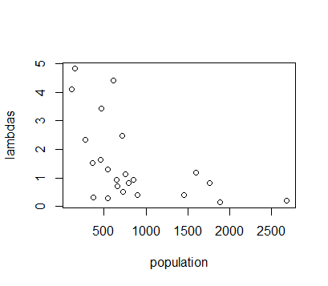

The significance of this plot is that it shows how much certain lambda values correspond to certain population sizes; it is a way to check density-dependence in this population. This plot indicates that there is some sort of density-dependence in this population because the higher population sizes only correspond to lower λ values, and higher λ values only correspond to lower population sizes. If this population truly showed no evidence of density-dependence, then we would expect to see a more "random", scattered distribution of λ's over all population sizes; there shouldn't be a pattern like there is in this plot. This plot would indicate that it's not very appropriate to use a simple stochastic exponential model to estimate extinction risk for this population!

d.)

Estimate µ:

> mu<-mean(log(lambdas))

> mu

[1] 0.02200606

Estimate λG:

> geomean<-exp(mu)

> geomean

[1] 1.02225

Estimate σ2:

> sigsq<-var(log(lambdas))

> sigsq

[1] 1.00093

e.)

Make an extinction CDF plot over 100 years for this population.

> mu<-mean(log(lambdas))

> mu

[1] 0.02200606

> sigsq<-var(log(lambdas))

> sigsq

[1] 1.00093

> geomean<-exp(mu)

> geomean

[1] 1.02225

> d<-log(population[7])-log(50)

> d

[1] 0.8064759

> tmax<-100

> #making an extinction CDF plot

> extcdf=function(mu,sigsq,d,tmax) {

+ t=1:tmax

+ G=pnorm((-d-mu*t)/sqrt(sigsq*t))+

+ exp(-2*mu*d/sigsq)*pnorm((-d+mu*t)/sqrt(sigsq*t))

+ return(G)

+ }

> sample=extcdf(mu,sigsq,d,tmax)

> plot(sample,ylab="Cumulative probability of extinction",xlab="Time (Years)")

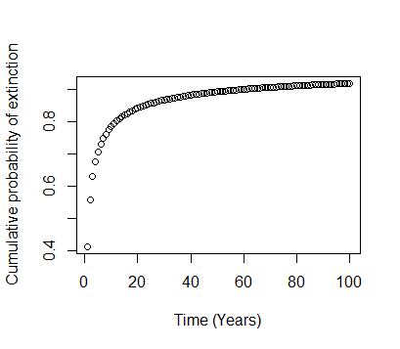

Make an extinction CDF plot over 500 years for this population.

> mu<-mean(log(lambdas))

> mu

[1] 0.02200606

> sigsq<-var(log(lambdas))

> sigsq

[1] 1.00093

> geomean<-exp(mu)

> geomean

[1] 1.02225

> d<-log(population[7])-log(50)

> d

[1] 0.8064759

> tmax<-500

> #making an extinction CDF plot

> extcdf=function(mu,sigsq,d,tmax) {

+ t=1:tmax

+ G=pnorm((-d-mu*t)/sqrt(sigsq*t))+

+ exp(-2*mu*d/sigsq)*pnorm((-d+mu*t)/sqrt(sigsq*t))

+ return(G)

+ }

> sample=extcdf(mu,sigsq,d,tmax)

> plot(sample,ylab="Cumulative probability of extinction",xlab="Time (Years)")

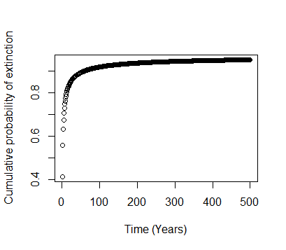

f.)

To make these extinction CDF plots I chose a starting population size of 112 (the population size in 1951) because I wanted to find probability of extinction in the "worst case scenario", which would start out with the smallest recorded population size. I also chose what I thought might be a relatively conservative quasi-extinction threshold of 50. I didn't want this threshold to be so low that a population that reached it could not recover, and I wanted it to be high enough to account for the potential genetic and ecological problems that the compromised population might encounter. This threshold of 50 ptarmigans assumes that they are at least 50% females that are able to reproduce.

Unfortunately, this population seems to have a grim outlook; it is almost guaranteed to go extinct within 100 years of time, which is interesting because the geometric mean of λ (i.e. the "average") is actually greater than one. The chances of extinction increase most alarmingly within the first 15 years.

2.

a.)

Modify the SimpleGrowthChooser.r program to investigate the probability of extinction for the ptarmigan population:

# -----INPUT PARAMETERS----------------------

lams = c(0.4,1.5,0.3,4.8,0.5,4.1,1.6,1.1,0.9,0.8,0.7,3.4,1.2,0.1,2.3,4.4,0.2,1.3,2.5,0.8) # list of lambdas that can occur

maxyr = 500 # the number of years to simulate

startN = 151 # starting population size

Reps = 1000 # number of replicate runs to make

Nqe = 50 # quasi-extinction threshold

#---- END OF INPUTS ---------------------------

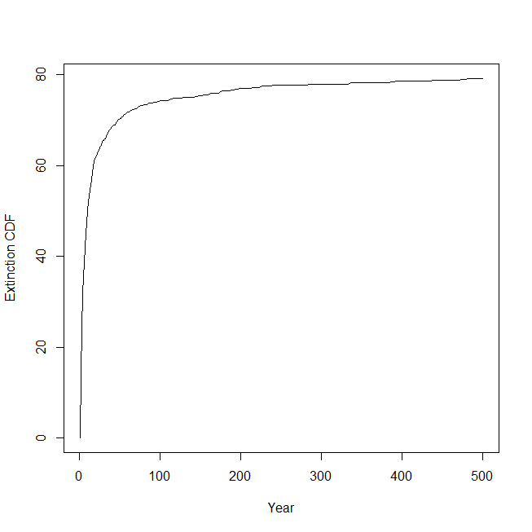

The extinction figure created by the SimpleGrowthChooser.r program is similar to the figure created by the previously used analytical method, though it is a little more optimistic. Again, there is the alarmingly huge increase in extinction probability in the first 15 years, and the population seems destined for extinction within 500 years, but unlike the plot created previously, the extinction asymptote seems to level out at the probability of 0.8 instead of 1.0.