Evelyn Cheng

Quantitative Conservation Biology

Homework 3

2/7/2013

1. Pick a data set to work on:

Taxon name: *Calathus melanocephalus*

Common name: Carabid beetle

Area size: 2 hectares (~2.47 acres) in the Netherlands

|  |  |  |  |
| --- | --- | --- | --- |
| Author(s) | Year | Title | Reference |
| Van Dijk, Th. S. & Den Boer, P.J. | 1992 | The life histories and population dynamics of two carabid species on a Dutch heathland. | Oecologia, 90:340-352 |

|  |  |
| --- | --- |
| year | population |
| 1972 | 978 |
| 1973 | 2339 |
| 1974 | 553 |
| 1975 | 306 |
| 1976 | 71 |
| 1977 | 227 |
| 1978 | 395 |
| 1979 | 1168 |
| 1980 | 274 |
| 1981 | 165 |
| 1982 | 203 |
| 1983 | 101 |
| 1984 | 36 |
| 1985 | 118 |
| 1986 | 300 |
| 1987 | 536 |

a.) Estimate mu, sigma2, and SE for the estimate of mu (using count_regression_for_musgma2.r).

> mu

mu = -0.04

sigma2 = 1.05

SE = 0.26

[1] -0.0400917

> sig2

[1] 1.050309

> sumregress

Coefficients:

Estimate Std. Error t value Pr(>|t|)

xx -0.04009 0.26461 -0.152 0.882

Residual standard error: 1.025 on 14 degrees of freedom

Multiple R-squared: 0.001637, Adjusted R-squared: -0.06967

F-statistic: 0.02296 on 1 and 14 DF, p-value: 0.8817

Plot of population size vs. year:

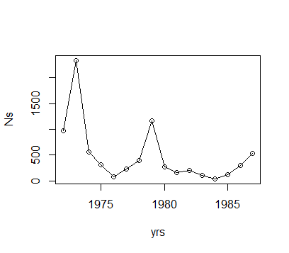

Plot of lambda vs. year:

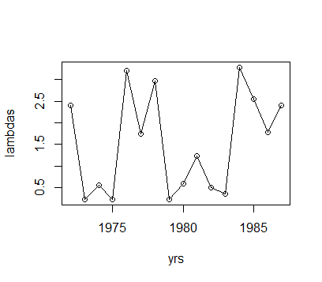

Plot of lambdas vs. population size:

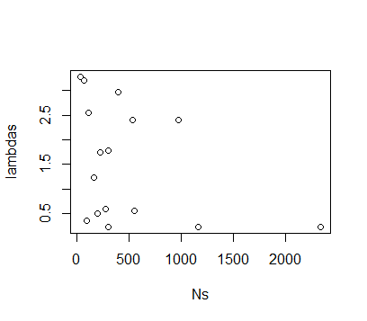

Histogram of log(lambdas):

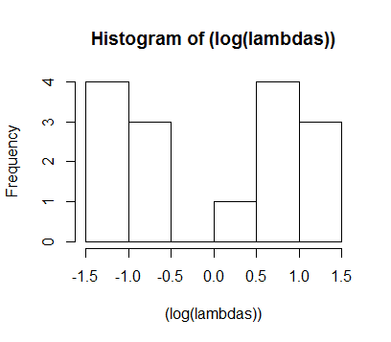

These plots show that the assumptions of simple, count-based extinction risk estimates are not met by this population data. The first plot alone (population size vs. year) is already suggestive that there is some sort of non-random trend in population sizes through time; it seems disquietingly cyclical. Then, aligning the first plot with the second plot (lambda vs. year), we can see that when population size increases there is a very conspicuous corresponding decrease in the lambda value. When population sizes are small, lambda seems to be large. The plot of log(lambda) values shows that they are not normally distributed; they are almost completely the opposite. The lambda vs. population size plot shows a slight density dependence because, though the lambdas seem evenly distributed throughout the lower population sizes, in the higher population sizes lambda values seem to only be small. If this population truly showed no evidence of density-dependence, then we would expect to see a more "random", scattered distribution of λ's over all population sizes; there shouldn't be a pattern like there is in this plot. These plots together are therefore strongly indicative that growth in this population is density-dependent. One way to guard against density dependence is to set higher quasi-extinction thresholds.

Other assumptions we are making, in order to use simple, count-based extinction risk estimates, are that:

- demographic stochasticity is unimportant, and that environmental stochasticity is the only determinant of σ2

- the estimates of µ and σ2 are unbiased from systematic effects of temporal environmental trends

- adjacent λt's are not more similar to one another than growth rates from years that are further apart

- there are no catastrophes or bonanzas that happened during the time frame of interest

- there is no observation error, and the data accurately represents the true number of individuals in the population

b.)

Use the extcdf function to make a cumulative risk of extinction figure:

> mu

[1] -0.0400917

> sig2

[1] 1.050309

#pick starting population size Ns and quasi-extinction population threshold

> d<-log(Ns[16])-log(100)

> d

[1] 1.678964

#pick time horizon

> tmax<-100

> #making an extinction CDF plot

> extcdf=function(mu,sig2,d,tmax) {

+ t=1:tmax

+ G=pnorm((-d-mu*t)/sqrt(sig2*t))+

+ exp(-2*mu*d/sig2)*pnorm((-d+mu*t)/sqrt(sig2*t))

+ return(G)

+ }

> sample=extcdf(mu,sig2,d,tmax)

> plot(sample,ylab="Cumulative probability of extinction",xlab="Time (Years)")

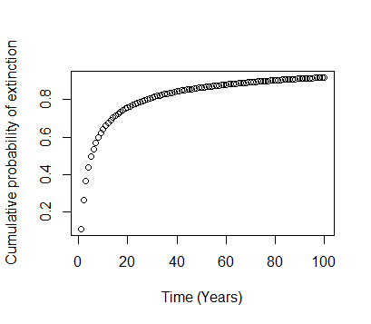

As the starting population size, I chose the last abundance estimate from the subsampled time series because I wanted to predict extinction risk from that point on. I chose what I thought was a relatively high quasi-extinction population size, to attempt to compensate for the apparent density dependence of this population of beetles. I also thought it should be relatively high because these beetles are small and must have high enough numbers to be able to find each other to mate. I chose the time horizon of 100 years because it allows the appropriate amount of resolution to visualize the amount of time in which the species has the highest risk of extinction.

2. Use the simple growth chooser program to estimate the extinction risk for these beetles, when there is and is not a cap on population numbers.

a.)

Lambdas for the chosen population:

> lambdas<-((Ns[2:l])/(Ns[1:(l-1)]))

> lambdas

2.3916155 0.2364258 0.5533454 0.2320261 3.1971831 1.7400881 2.9569620 0.2345890 0.6021898 1.2303030 0.4975369 0.3564356 3.2777778 2.5423729 1.7866667

b.)

Modify the chooser program from last week to run for the chosen species:

> # -----INPUT PARAMETERS----------------------

# list of lambdas that can occur

> lams=lambdas

> lams

2.3916155 0.2364258 0.5533454 0.2320261 3.1971831 1.7400881 2.9569620 0.2345890 0.6021898 1.2303030 0.4975369 0.3564356 3.2777778 2.5423729 1.7866667

> maxyr = 100 # the number of years to simulate

>

> startN = 536 # starting population size

>

> Reps = 1000 # number of replicate runs to make

>

> Nqe = 100 # quasi-extinction threshold

>

> maxcap = 1000

> #---- END OF INPUTS ---------------------------

c.)

Modify the program to set a maximum cap on numbers; if the population size is over the limit, the program should set it equal to that limit if it has exceeded it.

> for (jj in 1:Reps) {

+ Ns[1,jj]=startN # initialize with starting pop size

+ for (ii in 1:(maxyr-1)) {

+ lam_t=sample(lams,1) # choose a random lambda value

+

+ Ns[(ii+1),jj]=Ns[ii,jj]*lam_t # this grows the population one year

+

+ #enforcing the quasi-extinction threshold:

+ if (Ns[(ii+1),jj] <= Nqe) {Ns[(ii+1),jj]=0}

+ #enforcing the maximum cap on population numbers:

+ if (Ns[(ii+1),jj] >= maxcap) {Ns[(ii+1),jj]=maxcap}

+ } # end of ii loop

+ } # end of jj loop

Extinction cdf for the population without the cap:

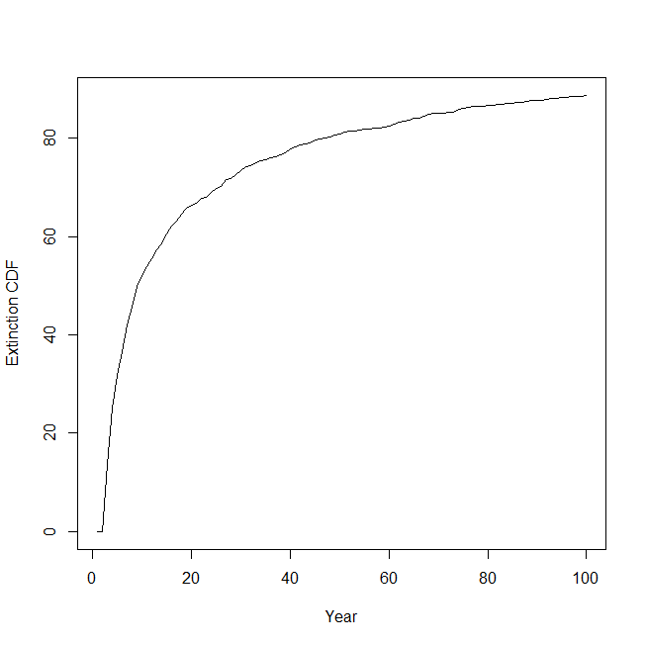

Extinction cdf for the population with the cap:

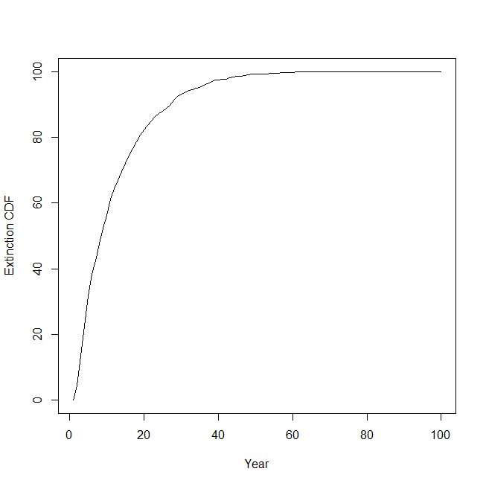

I set the cap to 1000 beetles because when population sizes increased to above 1000, λ became very low. The population sizes also were also always (with the exception of two years) lower than 1000. This indicates that the beetles became limited by resources when their populations were too high and that they are unable to sustain populations of that size. Adding a cap to population sizes in the growth chooser program significantly increased the risk of extinction for the population; with the cap, the beetles were set to face extinction in about 40 years, but without it they had over 100 projected years before certain extinction.