Evelyn Cheng

Quantitative Conservation Biology

Homework #4

2/21/2013

1.

a.) Plot of numbers vs. time:

> pops<-cbind(yrs,Ns)

> pops

yrs Ns

[1,] 1972 978

[2,] 1973 2339

[3,] 1974 553

[4,] 1975 306

[5,] 1976 71

[6,] 1977 227

[7,] 1978 395

[8,] 1979 1168

[9,] 1980 274

[10,] 1981 165

[11,] 1982 203

[12,] 1983 101

[13,] 1984 36

[14,] 1985 118

[15,] 1986 300

[16,] 1987 536

> plot(pops)

> plot(pops,type="o")

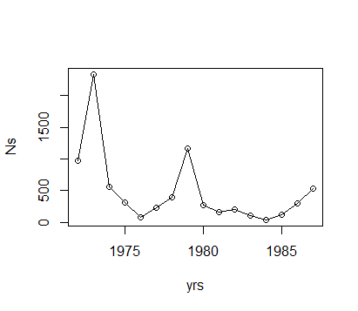

Plot of lambda vs. Nt:

> l=length(Ns)

> lambdas<-((Ns[2:l])/(Ns[1:(l-1)]))

> lambdas

[1] 2.3916155 0.2364258 0.5533454 0.2320261 3.1971831 1.7400881 2.9569620 0.2345890 0.6021898 1.2303030

[11] 0.4975369 0.3564356 3.2777778 2.5423729 1.7866667

> lams2=cbind(Ns,log(lambdas))

> plot(lams2,type="p")

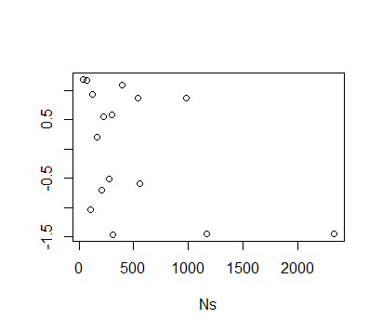

These plots show that there is a high possibility for density dependence in my chosen data set.

There is a negative relationship between the log population growth rate and population size, which indicates negative density dependence. Also, the cyclical nature of the population sizes in the first plot, that seems to 'hold' the population size at <500, and the low lambda values at high population sizes (>1000) in the second plot, also seem to indicate possible density dependence.

b.) Fit the exponential model, the Ricker model, and the theta logistic model for population growth to these data. Figures out which model is the best way to describe the negative density dependence, if it exists, in the data.

> modresults

r K theta res.variance num parameters

exp -0.0400917 0.0000 0.00000000 0.9802882 2

ricker 0.3407082 431.4923 0.00000000 0.7652357 3

theta 34.9789407 252.0035 0.01329818 0.7324081 4

> print("AIC values for the Exponential, Ricker, and Theta-Logistic Models")

[1] "AIC values for the Exponential, Ricker, and Theta-Logistic Models"

> print(AICs)

[1] 47.26953 46.73640 49.89689

These results show that the Ricker model, since it has the lowest AIC values, best describes the population growth of these beetles. Populations that follow the Ricker model rather than the density-independent model indicate that negative density dependence should be taken into consideration when estimating extinction risks for the population. A population described best by the Ricker model also shows that it is simpler and has fewer parameters to define than a population that matches better to the theta model. From the previous two plots and its fit to the Ricker model, this beetle population seems to be showing signs of density dependence.

2. Modify the chooser program, to get extinction risks for 2 circumstances:

a.) For a density-independent situation, where a new, random value for lambda is generated from the same distribution of lambda values each year.

> mu<-mean(log(lambdas))

> mu

[1] -0.0400917

> sig2<-var(log(lambdas))

> sig2

[1] 1.050309

> maxyr = 500 # the number of years to simulate

>

> startN = 151 # starting population size

>

> Reps = 1000 # number of replicate runs to make

>

> Nqe = 50 # quasi-extinction threshold

> for (jj in 1:Reps) {

+ Ns[1,jj]=startN # initialize with starting pop size

+ for (ii in 1:(maxyr-1)) {

+ lam_t=exp(rnorm(1,mu,sqrt(sig2))) #choose random non-log lambda value

+

+ Ns[(ii+1),jj]=Ns[ii,jj]*lam_t # this grows the population one year

+

+ #enforcing the quasi-extinction threshold:

+ if (Ns[(ii+1),jj] <= Nqe) {Ns[(ii+1),jj]=0}

+

+ } # end of ii loop

+ } # end of jj loop

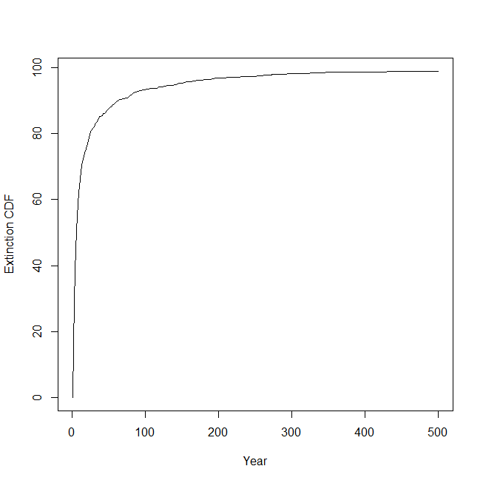

b.) Modify the chooser program to incorporate the Density-Dependent growth form that was best supported by AIC (the Ricker model), and plot the new line on top of the previous plot.

> #use the ricker equation to calculate new lambdas, mu, sigma2:

> r=0.34 #average log population growth rate when Nt is tiny relative to K

> K=431.49 #carrying capacity

> Nt=151 #starting population size

> l=length(Ns)

> munew=r*(1-(Nt/K)) #new, calculated, density-dependent log mean growth rate

> munew

[1] 0.2210169

> sig2new=0.77 #res. variance from the modresults table

> #-----------------------------------------

> maxyr = 500 # the number of years to simulate

>

> startN = 151 # starting population size

>

> Reps = 1000 # number of replicate runs to make

>

> Nqe = 50 # quasi-extinction threshold

> #---- END OF INPUTS ---------------------------

> for (jj in 1:Reps) {

+ Ns[1,jj]=startN # initialize with starting pop size

+ for (ii in 1:(maxyr-1)) {

+ lam_t=exp(rnorm(1,munew,sqrt(sig2new))) #choose a random lambda value w/new ricker model lambdas

+

+ Ns[(ii+1),jj]=Ns[ii,jj]*lam_t # this grows the population one year

+

+ #enforcing the quasi-extinction threshold:

+ if (Ns[(ii+1),jj] <= Nqe) {Ns[(ii+1),jj]=0}

+

+ } # end of ii loop

+ } # end of jj loop

> lines(allyrs,dead,type = "l",xlab="Year",ylab="Extinction CDF")

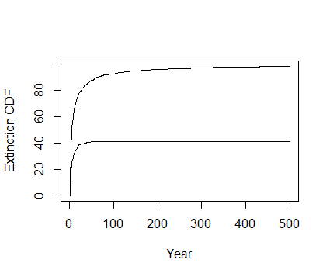

As this second plot shows, using the Ricker model to incorporate negative density dependence has a significantly lower predicted extinction probability than that of the density-independent model. The density-independent model does not account for the increase in average population growth rate when the population is small, so it tends to seem more "pessimistic" and claim a higher risk of extinction. The density-independent model also does not account for the contribution of density-dependence to some of the variation in log lambda values, so environmental variance ends up with a higher value in the density-independent model (and higher variability increases extinction risk).