Evelyn Cheng

Quantitative Conservation Biology

Homework 5

2/26/2012

1. Let a matrix for a 4 life stage fish species be:

> fishmatrix<-matrix(c(0,0,0,6.2,0.2,0.05,0,0,0,0.7,0.05,0,0,0,0.8,0.8),nrow=4,ncol=4,byrow=TRUE)

> fishmatrix

[,1] [,2] [,3] [,4]

[1,] 0.0 0.00 0.00 6.2

[2,] 0.2 0.05 0.00 0.0

[3,] 0.0 0.70 0.05 0.0

[4,] 0.0 0.00 0.80 0.8

where the first stage is newly hatched eggs, and the following stages are juveniles, subadults, and adults.

a.) The average total number of eggs produced by adult females who survive to breed each year:

6.2 = (F/2)\*Sad = (F/2)\*0.8

F = 15.5 eggs

b.) Let a vector for the initial population size be N0 = 100, 0, 0, 0.

> n0<-matrix(c(100,0,0,0),nrow=4,ncol=1,byrow=TRUE)

> n0

[,1]

[1,] 100

[2,] 0

[3,] 0

[4,] 0

> nt<-n0

> fullmatrix<-matrix(nrow=4,ncol=30) #creating a matrix to store all the

stages

> percmatrix<-matrix(nrow=4,ncol=30) #creating a matrix to store the

percentages

> summatrix<-matrix(nrow=1,ncol=30) #creating a matrix to store the sums

> for (j in 1:ncol(fullmatrix)) {

+ nt <- fishmatrix %\*% nt

+ fullmatrix[,j]<-nt

+ summatrix[,j]<-sum(nt)

+ percmatrix[,j]<-(nt/sum(nt))\*100

+ }

N1 will equal:

[,1]

[1,] 0

[2,] 20

[3,] 0

[4,] 0

N2 will equal:

[,1]

[1,] 0

[2,] 1

[3,] 14

[4,] 0

N10 will equal:

[,1]

[1,] 129.92763

[2,] 23.36408

[3,] 11.90525

[4,] 21.91730

Plot total numbers vs. year for 30 years into the future:

> summatrix

[,1] [,2] [,3] [,4] [,5] [,6] [,7] [,8] [,9]

100 20 15 12.65 79.6275 84.53913 79.95724 73.93046 115.4034

[,10] [,11] [,12] [,13] [,14] [,15] [,16] [,17]

156.6276 187.1143 207.0492 251.3567 318.2759 396.0576 474.4718 569.5285

[,18] [,19] [,20] [,21] [,22] [,23] [,24]

[1,] 695.2346 854.6964 1042.482 1264.593 1536.609 1874.205 2286.443

[,25] [,26] [,27] [,28] [,29] [,30] [,31]

[1,] 2784.383 3388.083 4125.584 5026.784 6123.997 7457.823 9081.67

> #create a matrix for years, to bind to matrix of sums

> yearsmatrix<-matrix(0:30,nrow=1,ncol=31)

> yearsmatrix

[,1] [,2] [,3] [,4] [,5] [,6] [,7] [,8] [,9] [,10] [,11] [,12] [,13]

0 1 2 3 4 5 6 7 8 9 10 11 12

[,14] [,15] [,16] [,17] [,18] [,19] [,20] [,21] [,22] [,23] [,24] [,25]

13 14 15 16 17 18 19 20 21 22 23 24

[,26] [,27] [,28] [,29] [,30] [,31]

25 26 27 28 29 30

> plot(yearsmatrix,summatrix,main="Projected Future Population Size",xlab="Years", ylab="Population size")

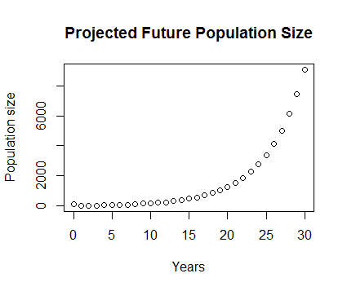

c.) Plot the percentage of the population that is in each of the 4 stages vs. time for 0 to 30 years.

> #plots stacked proportions

> barplot(percmatrix,main="Percentage of population in 4 life stages",xlab="Years in Future",ylab="Population proportions",col=rainbow(4))

> names.arg<-c("newly hatched eggs","juveniles","subadults","adults")

> legend(38,40,names.arg,cex=0.5,fill=rainbow(4))

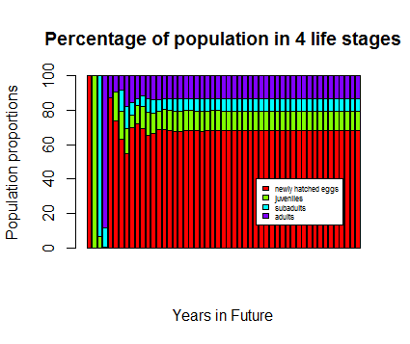

> #plots proportions side by side

> barplot(percmatrix,main="Percentage of population in 4 life stages",xlab="Years in Future",ylab="Population proportions",beside=TRUE,col=rainbow(4))

> legend("topright",c("newly hatched eggs","juveniles","subadults","adults"),cex=0.6,bty="n",fill=rainbow(4))

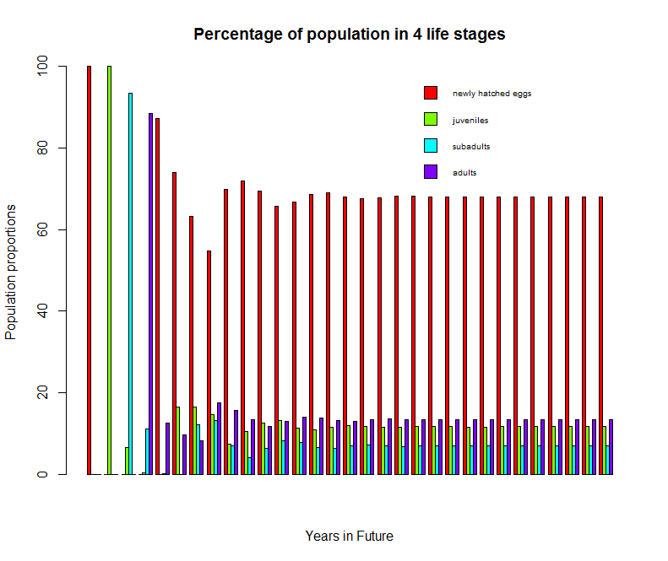

Plot the lambda values vs. year:

> l=length(summatrix)

> l

[1] 31

> lambdas<-((summatrix[2:l])/(summatrix[1:(l-1)]))

> lambdas

[1] 0.2000000 0.7500000 0.8433333 6.2946640 1.0616825 0.9458016 0.9246249 1.5609717 1.3572191 1.1946440

[11] 1.1065387 1.2139950 1.2662322 1.2443846 1.1979867 1.2003421 1.2207197 1.2293640 1.2197105 1.2130591

[21] 1.2151019 1.2197022 1.2199535 1.2177793 1.2168163 1.2176750 1.2184417 1.2182733 1.2178033 1.2177374

> lambdas<-as.matrix(lambdas)

plot(lambdas,type="o",xlab="years in future")

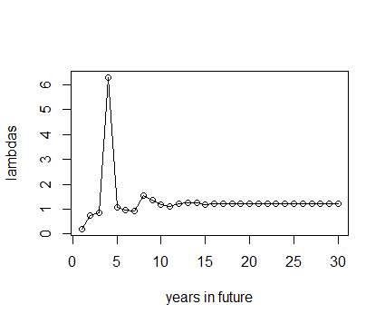

Around 33-35 years, this population reaches an annual growth rate that is stable to the 3rd decimal point (λ~1.217).

> eigen(fishmatrix)

$values

[1] 1.2179535+0.0000000i

d.)

The probability that a fish in the egg stage this year will still be alive 2 years from now:

(0.2\*0.7) + (0.2\*0.05) = 0.15

3 years from now:

(0.2\*0.05\*0.05) + (0.2\*0.05\*0.7) + (0.2\*0.7\*0.05) + (0.2\*0.7\*0.8) = 0.1265

2. Use the mean matrix shown for Borderia chouardii in Table 2 of Garcia's paper:

> plantmatrix

[,1] [,2] [,3] [,4] [,5] [,6]

[1,] 0.50 0.000 0.000 0.032 0.220 0.528

[2,] 0.03 0.000 0.000 0.002 0.011 0.026

[3,] 0.00 0.772 0.856 0.046 0.002 0.000

[4,] 0.00 0.019 0.095 0.759 0.079 0.000

[5,] 0.00 0.000 0.000 0.179 0.838 0.151

[6,] 0.00 0.000 0.000 0.003 0.074 0.845

a.) The long term growth rate predicted by this matrix is the dominant eigenvalue:

> eigen(plantmatrix)

1.00183667705

This value is a little higher than the value that Garcia reports (λ=1.00093), probably because the author is not consistent with the number of significant digits to which her matrix values are reported. When rounding error occurs, seemingly small differences in values can cause significant changes in calculated long term growth rates, especially when those rounding errors affect the vital rates for which lambda has a high sensitivity.

b.) Make a plot of the probabilities of surviving to different ages for a B. chouardii seed, based on the matrix. Plot out the probabilities until there is only a 0.1% chance of survival.

> survivalplantmatrix

[,1] [,2] [,3] [,4] [,5] [,6]

[1,] 0.50 0.000 0.000 0.000 0.000 0.000

[2,] 0.03 0.000 0.000 0.000 0.000 0.000

[3,] 0.00 0.772 0.856 0.046 0.002 0.000

[4,] 0.00 0.019 0.095 0.759 0.079 0.000

[5,] 0.00 0.000 0.000 0.179 0.838 0.151

[6,] 0.00 0.000 0.000 0.003 0.074 0.845

> n0<-matrix(c(1,0,0,0,0,0),nrow=6,ncol=1,byrow=TRUE)

> nt<-n0

> fullmatrix<-matrix(nrow=6,ncol=301) #creating a matrix to store all

> summatrix<-matrix(nrow=1,ncol=301) #creating a matrix to store the sums

> fullmatrix[1:6,1]<-n0 #filling the first column for n0

> summatrix[1,1]<-sum(n0) #filling the first column for n0

>

> for (j in 2:ncol(fullmatrix)) {

+ nt <- survivalplantmatrix %\*% nt

+ fullmatrix[,j]<-nt

+ summatrix[,j]<-sum(nt)

+ }

> summatrix

> plot(yearsmatrix,summatrix,main="Probability of a seed surviving",xlab="Years in future", ylab="Probability\*10",type="l")

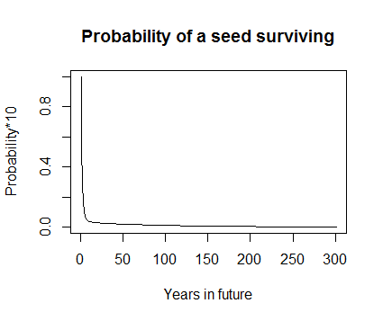

The probability of a seed surviving as a seed drops to ~0.1% at 294 years.

The mean future lifespan of a seed:

>prob.surv<-(summatrix[1:length(summatrix)-1]-summatrix[2:length(summatrix)])

> years<-1:(length(summatrix)-1)

> sum(years\*prob.surv)

[1] 4.702704

c.) Repeat the analyses in 2b, for an individual that starts in the F0 stage:

Everything remains the same, except:

> n0

[,1]

[1,] 0

[2,] 1

[3,] 0

[4,] 0

[5,] 0

[6,] 0

> sum(years\*prob.surv)

[1] 45.23771

For F1:

> n0

[,1]

[1,] 0

[2,] 0

[3,] 1

[4,] 0

[5,] 0

[6,] 0

> sum(years\*prob.surv)

[1] 55.58021

For F2:

> n0

[,1]

[1,] 0

[2,] 0

[3,] 0

[4,] 1

[5,] 0

[6,] 0

> sum(years\*prob.surv)

[1] 74.95117

For F3:

> n0

[,1]

[1,] 0

[2,] 0

[3,] 0

[4,] 0

[5,] 1

[6,] 0

> sum(years\*prob.surv)

[1] 80.55556

For F4:

> n0

[,1]

[1,] 0

[2,] 0

[3,] 0

[4,] 0

[5,] 0

[6,] 1

> sum(years\*prob.surv)

[1] 83.72712

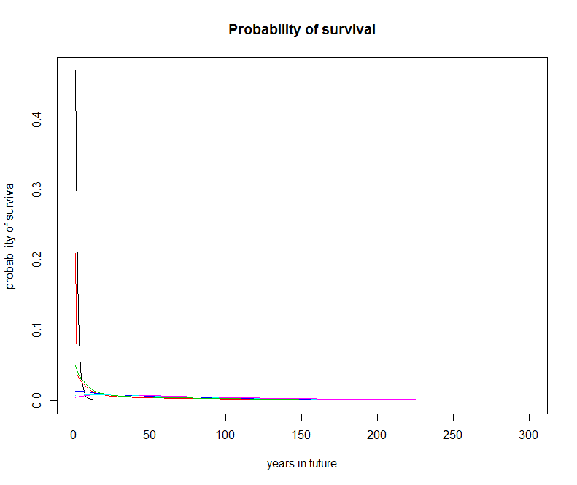

I think that what these results say about the life history of B. chouardii is that this plant has a remarkable ability to live a really long time, and it can relatively easily switch around to being in different classes (i.e. it can go from being a large female to being a small female and back). These analyses illustrate how it doesn't really matter to this population how many seeds exist; the population's low variance and the plant's high longevity allow this plant to keep its stable population growth rate.