1. X_hat = ratings(:,6); % Ratings for Education

Y_hat = ratings(:,4); % Ratings for Crimes

plot(X_hat,Y_hat,'b*');

xlabel(categories(6, :), 'FontSize',12,'FontWeight','bold');

ylabel(categories(4, :), 'FontSize',12,'FontWeight','bold');

title('Scatter between Education and Crimes');

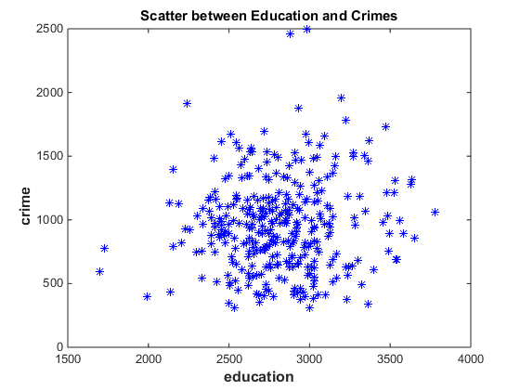

format short

sCov = cov(X_hat, Y_hat)

sCor = corr(X_hat, Y_hat)

sCov = 1.0e+05 *

1.0291 0.0853

0.0853 1.2756

sCor = 0.0744

The sample correlation is very large, which confirm the ratings of the two categories are positive correlated. We expect 0.7 unit of rating increasing for 'Crimes' by increasing one unit of rating for 'Education'

2. X_hat = ratings(:,1); % Ratings for Climate

Y_hat = ratings(:,2); % Ratings for Housing

plot(X_hat,Y_hat,'b*');

xlabel(categories(1, :), 'FontSize',12,'FontWeight','bold');

ylabel(categories(2, :), 'FontSize',12,'FontWeight','bold');

title('Scatter between Climate and Housing');

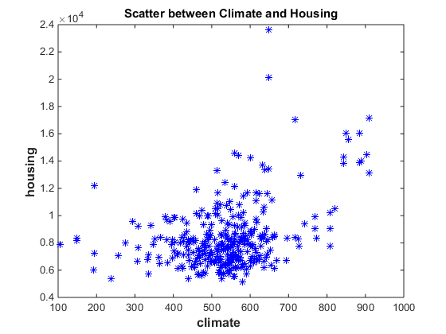

format short

sCov = cov(X_hat, Y_hat)

sCor = corr(X_hat, Y_hat)

sCov = 1.0e+06 *

0.0146 0.1113

0.1113 5.6895

sCor = 0.3863

The graph has cluster of correlation on X- Axis. It has positive correlated.

3. X_hat = ratings(:,2); % Ratings for Housing

Y_hat = ratings(:,5); % Ratings for Transportation

plot(X_hat,Y_hat,'b*');

xlabel(categories(2, :), 'FontSize',12,'FontWeight','bold');

ylabel(categories(5, :), 'FontSize',12,'FontWeight','bold');

title('Scatter between Housing and Transportation');

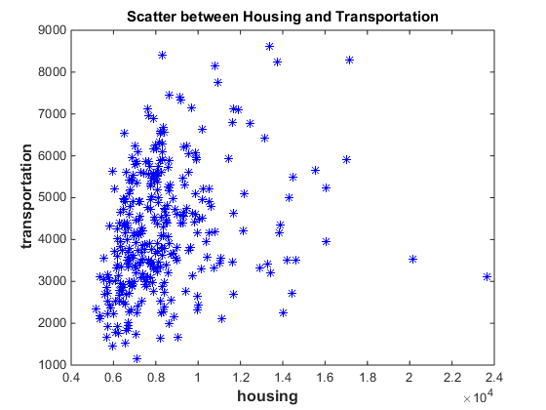

format short

sCov = cov(X_hat, Y_hat)

sCor = corr(X_hat, Y_hat)

sCov = 1.0e+06 *

5.6895 0.9412

0.9412 2.1059

sCor = 0.2719

This graph has a cluster of correlation on the y-axis and it’s scattered throughout the graph.

2. Housing and Transportation categories are least correlated, because it has correlation closets to 0.