**SWIGGY Restaurants Analysis**

**Author: Nayan Mishra**

[**LinkedIn**](https://www.linkedin.com/in/nyn-mishra/) **|** [**GitHub**](https://github.com/nyn-mishra)

**Table of Contents**

1. Introduction
2. About Swig
3. Overview
4. Objectives
5. Data Sources
6. Methodology
7. Analysis and Findings

* Excel Analysis
* Tableau Visualizations
* SQL Queries

1. Implications
2. Conclusion
3. Appendices

**1. Introduction**

The Swiggy Restaurants Analysis project aims to provide a comprehensive analysis of restaurant data sourced from Swiggy, a leading online platform for discovering and reviewing restaurants. This report presents a detailed overview of the project objectives, methodologies, analysis findings, implications, and conclusions.

**2. About Swiggy**

Swiggy is a popular online platform that provides information about restaurants, including location, ratings, reviews, menus, and photos. It operates in multiple states and has a vast database of restaurants, making it a valuable resource for diners and restaurant owners alike.

**3. Overview**

The project involves in-depth analysis of Swiggy restaurant data using various tools and techniques including Excel, SQL, and Tableau. The objective is to gain insights into restaurant industry trends related to location, opening trends, ratings, and price ranges.

**4. Objectives**

The main objectives of the project are:

* Develop a comprehensive Country Map Table.
* Construct a Calendar Table utilizing the Column Datekey.
* Determine the Number of Restaurants based on City and Country.
* Calculate the Number of Restaurants opening based on Year, Quarter, and Month.
* Compute the Count of Restaurants based on Average Ratings.
* Generate buckets based on the Average Price and determine the quantity of restaurants falling into each bucket.
* Analyze the Percentage of Restaurants with table booking and online delivery.
* Develop Charts based on Cuisines, City, and Ratings.

**5. Data Sources**

The primary data source for this project is Swiggy, which provides detailed information about restaurants, including location, ratings, price range, and amenities. Additional data sources may include public datasets or supplementary data collected from other sources.

**6. Methodology**

The methodology involves:

* Data extraction and cleaning using Excel and SQL.
* Analysis using advanced Excel functions and SQL queries.
* Visualization using Excel and Tableau to create interactive dashboards and visualizations.

**7. Analysis and Findings**

**Excel Analysis**

* Utilized advanced Excel functions for data cleaning, manipulation, and visualization.
* Developed charts and graphs to visualize restaurant data by location, ratings, price range, and cuisine.
* Conducted statistical analysis to identify trends and patterns in the data.

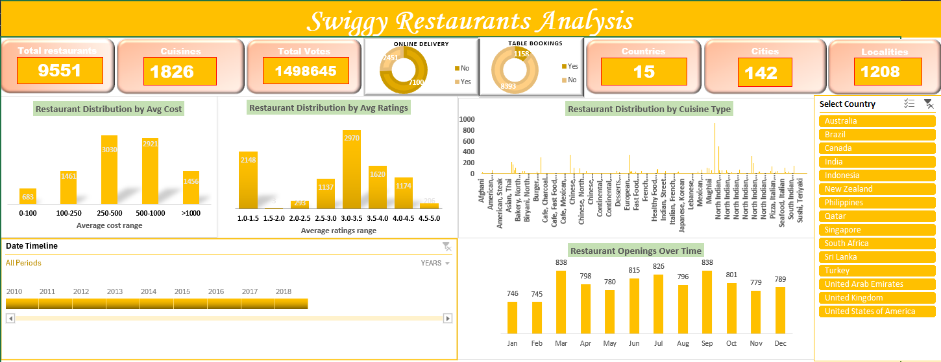

**Tableau Visualizations**

* Developed visualizations in Tableau to further explore and analyze Swiggy restaurant data.
* Created interactive dashboards to visualize trends in cuisine, city, ratings, and price range.
* Used advanced visualization techniques such as heatmaps, treemaps, and scatter plots to uncover insights into the data.

**SQL Queries**

* Executed SQL queries to extract and manipulate data from the database.
* Calculated various metrics such as the number of restaurants by city, opening trends, average ratings, and average prices.
* Used SQL joins and subqueries to merge data from multiple tables for analysis.

**8. Implications**

The insights generated from this analysis have significant implications for stakeholders within the restaurant industry. These include:

* Identifying popular restaurant locations and cuisines.
* Understanding opening trends and seasonal variations.
* Analyzing customer preferences and satisfaction levels.
* Informing marketing strategies, menu planning, and business expansion decisions.

**9. Conclusion**

In conclusion, the Swiggy Restaurants Analysis project provides valuable insights into the restaurant industry landscape. By leveraging advanced analytics techniques and visualization tools, we have gained valuable insights that can inform decision-making and strategy development within the industry. The detailed analysis and visualizations presented in this report offer a comprehensive understanding of restaurant trends and customer preferences, paving the way for data-driven decision-making in the restaurant industry.

**10. Appendices**

- Appendix A: Screenshots of Excel Analysis

- Appendix B: SQL Queries

- Appendix C: Tableau Visualizations

- Appendix D: Raw Data Sets

- Appendix E: Code Snippets

THANK YOU